Name Date Period
Lesson 7-6 · Session 1 · Practice · Form B
Distance Between Points on a Grid
Learning target — I can find the distance between two points that share a coordinate. · 6.NS.C.8

REMEMBER  • Same y-coordinate: the points are side to side. Use the x-coordinates.  • Same x-coordinate: the points are up and down. Use the y-coordinates.  • Opposite signs: add the absolute values. Same sign: subtract them. (5, −2) to (5, −9) is 9 − 2 = 7. | WORKED EXAMPLE  Each unit is 1 meter. Find the distance from P(−9, 4) to Q(3, 4), and from P to R(−9, 11).  Step 1 P and Q share y = 4, so use x. −9 and 3 have opposite signs: 9 + 3 = 12 m.  Step 2 P and R share x = −9, so use y. 4 and 11 are both positive: 11 − 4 = 7 m.  Answer PQ = 12 m and PR = 7 m
WORDS distance (distancia) · absolute value (valor absoluto) · coordinate plane (plano de coordenadas)
PRACTICE show your work · label units

1. Find the distance between each pair of points.
a. (2, 12) and (2, 5) | b. (−9, 3) and (7, 3)
c. (−12, 8) and (−12, −5) | d. (−5, 1) and (9, 1)

2. Town Map Walk. Each unit is 1 kilometer. Market (−6, 4), Museum (8, 4), Station (−6, −7).  a. Plot and label the three places.  b. Market to Museum km  c. Market to Station km | 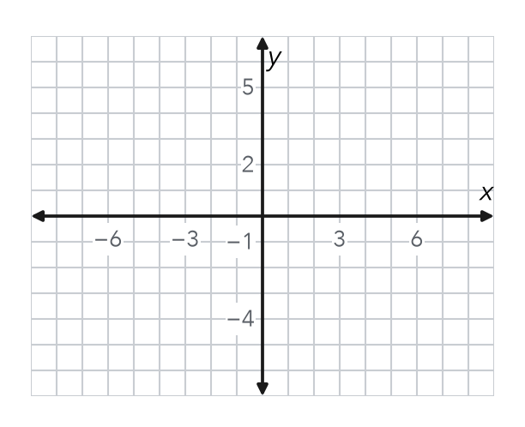

3. Drone Flight. A drone flies straight from (−6, 11) to (−6, −5). Each unit is 1 meter. How far does it fly?  Hint Same x, so use y. 11 and −5 have opposite signs.  Answer m | 4. One Quadrant. Find the distance from (−15, −8) to (−15, −20).  Hint Both y-values are negative, so subtract.  Answer units
  Show your work.
  Show your work.

5. Missing Point. Point G is at (9, −2). Point H is 14 units directly to the left of G. Name point H.  Hint Moving left changes only x: 9 − 14.  H = | 6. Window Washer. A window washer moves from (19, 17) to (19, 8). Each unit is 1 foot. How far does the washer move?  Hint Are 17 and 8 on the same side of 0?  Answer ft
  Show your work.
  Show your work.

7. Bus Route. Omar rides a bus straight from (−15, −3) to (13, −3). Each unit is 1 block. How far does he ride?

Show your work.
Answer blocks

8. City Grid. Each unit is 1 block. Daniel walks from a library at (−5, 4) to a school at (6, 4), then to a park at (6, −2). Plot the walk on the grid.  a. Library to school blocks  b. School to park blocks  c. Total walk blocks | 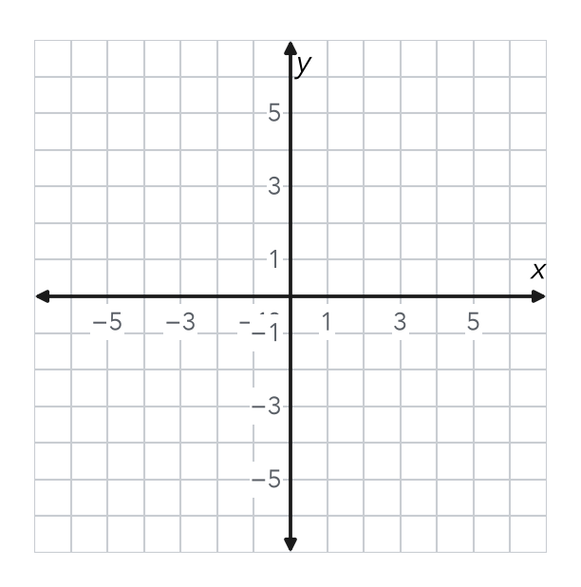

FIND THE ERROR explain the mistake, then fix it

9. Amina’s Work. To find the distance from (3, −8) to (3, 5), Amina wrote 8 − 5 = 3 units. Explain her mistake. Then find the correct distance.

TEST PRACTICE choose the best answer

10. The distance from (6, 1) to (6, 10) is —
A 4 units | B 9 units | C 11 units | D −9 units

11. Two points with the same x-coordinate lie on a —
A horizontal line | B vertical line | C diagonal line | D circle

SELF-CHECK CODE find your answer · copy its letter into that problem’s box · spell a math word
28  I | 9  G | 2  X | 25  J | 17  N | 16  O | 12  R | (23, −2)  Z | (9, −16)  Q | (−5, −2)  I

#3 | #4 | #5 | #6 | #7 | #8c

CHECK YOURSELF | □ I can do this on my own | □ I need a little help | □ I have a question about #

