Name Date Period
Lesson 7-6 · Session 2 · Practice · Form B
Comparing Distances on the Plane
Learning target — I can decide whether to add or subtract to find a distance, then compare two distances. · 6.NS.C.8

REMEMBER  • Find each distance first. Then compare the two numbers.  • Changing coordinates with opposite signs: add. Same sign: subtract.  • With a scale, change both distances to real units before you compare. A distance is never negative. | WORKED EXAMPLE  Jo walks from (−3, 10) to (−3, 2). Sam walks from (6, −8) to (−7, −8). Each unit is 1 block. Who walks farther?  Step 1 Jo: same x, both positive, so 10 − 2 = 8 blocks.  Step 2 Sam: same y, opposite signs, so 6 + 7 = 13 blocks.  Answer Sam walks farther, by 13 − 8 = 5 blocks.
WORDS distance (distancia) · quadrant (cuadrante) · compare (comparar)
PRACTICE show your work · label units

1. Add or subtract? Find each distance.
a. (4, −2) to (4, −13) | b. (4, −2) to (4, 8)
c. (−3, 2) to (6, 2) | d. (7, −9) to (7, −1)

2. Nature Center Map. The map shows a pond (P), a meadow (M) and a cabin (C). Each grid unit stands for 10 meters.  a. Pond to Meadow m  b. Pond to Cabin m  c. Which trip is longer? By how many meters? | 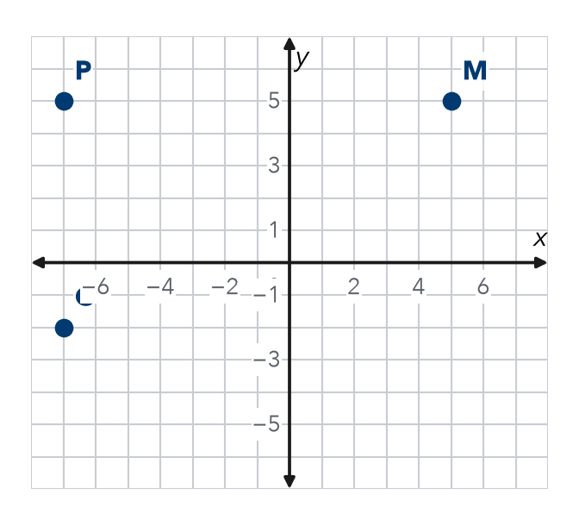

3. Two Riders. From (−8, 4), Rosa rides to (−8, −7) and Kofi rides to (6, 4). Each unit is 1 block. Who rides farther, and by how much?
Hint Each ride keeps one coordinate. Check the signs of the other one.

Show your work.
By

4. Partner Point. Point T is at (−3, 14). Point U is 20 units directly below T. Name point U.  Hint Moving down changes only y: 14 − 20.  U = | 5. Place the Stop. Point N is at (12, −4). Point M is 18 units directly to the left of N. Name point M.  Hint Moving left changes only x: 12 − 18.  M =
  Show your work.
  Show your work.

6. Two Hikes. Mei hikes from (−10, 13) to (−10, 4). Andre hikes from (−3, −14) to (11, −14). Each unit is 1 km. Who hikes farther, and by how much?

Show your work.
By

7. Two Walks. From (3.25, 4.75), Ana walks to (3.25, −2.25) and Ben walks to (3.25, 9.75). Who walks farther, and by how much?
Hint Decimals work the same way. Check the signs of the y-values.

Show your work.
By

8. Delivery Routes. A depot is at (0, 0). Stop 1 is at (0, 11), Stop 2 is at (0, −8) and Stop 3 is at (0, 5).
a. Find the distance from the depot to each stop.
b. Order the stops from closest to farthest.
c. Find the distance from Stop 1 to Stop 2. units

FIND THE ERROR explain the mistake, then fix it

9. Diego’s Work. To find the distance from (−6, 2) to (9, 2), Diego wrote 9 − 6 = 3 units. Explain his mistake. Then find the correct distance.

TEST PRACTICE choose the best answer

10. Two coordinates on opposite sides of zero call for —
A subtraction | B addition | C division | D doubling

11. The distance from (−7, 0) to (7, 0) is —
A 0 units | B 7 units | C 14 units | D 49 units

SELF-CHECK CODE find your answer · copy its letter into that problem’s box · spell a math word
(30, −4)  Z | 2  R | 3  M | 19  S | 1  X | (−3, −6)  E | 5  E | (−3, 34)  Q | 2.5  J | (−6, −4)  T

#3 | #4 | #5 | #6 | #7 | #8c

CHECK YOURSELF | □ I can do this on my own | □ I need a little help | □ I have a question about #

