Name Date Period
Lesson 7-6 · Session 1 · Prerequisite Practice B · Skill 1 of 2
Find Absolute Value
Builds on Lesson 7-3 Session 1 · 6.NS.C.7c
TODAY’S LESSON | The drone flies from y = 13 down to y = −4. |13| = 13 and |−4| = 4.
YOU NEED TO | Find the absolute value of a number, like |−4| = 4. You will use it in Practice Form A, problems 3 and 7.
STEPS TO FOLLOW use these same steps on every problem
1 | Find the number on the number line.
2 | Count the units from it to 0.
3 | That count is the absolute value. It is never negative.
WATCH ME the steps in action
Find |−3.5|.
Step 1 −3.5 is left of 0.
Step 2 It is 3.5 units from 0.
Step 3 |−3.5| = 3.5.
Answer 3.5
TRY IT WITH HELP fill in each step
1. Find |−17|.
Step 1 −17 is of 0.
Step 2 It is units from 0.
Step 3 |−17| =

2. Find |12|.
Step 1 12 is of 0.
Step 2 It is units from 0.
Step 3 |12| =

YOUR TURN use the steps on your own

3. Find each absolute value.
a. |−4| = | b. |13| = | c. |−8.5| =
d. |0| = | e. |−20| = | f. |6| =

Lesson 7-6 · Session 1 · Prerequisite Practice B · Skill 2 of 2
Find Distance on Number Lines
Builds on Lesson 7-3 Session 2 · 6.NS.C.7c
TODAY’S LESSON | The bus runs from (−17, −4) to (12, −4). That is the distance from −17 to 12.
YOU NEED TO | Find the distance between two numbers, like −8 and 7. You will use it in Practice Form A, problems 2 and 7.
STEPS TO FOLLOW use these same steps on every problem
1 | Find each number’s absolute value.
2 | Same side of 0: subtract. Opposite sides: add.
3 | Write the distance in units.
WATCH ME the steps in action
Find the distance from −8 to 7.  Step 1 |−8| = 8 and |7| = 7.  Step 2 Opposite sides: add. 8 + 7 = 15.  Step 3 15 units.  Answer 15 units | 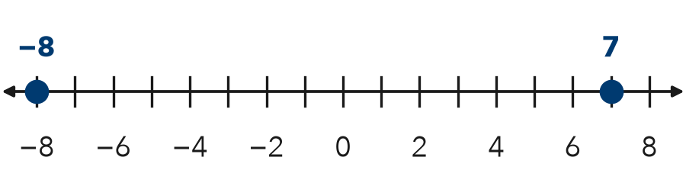

TRY IT WITH HELP fill in each step
4. Find the distance from −17 to 12.
Step 1 |−17| = and |12| =
Step 2 Opposite sides: + =
Step 3 units

5. Find the distance from −20 to −7.
Step 1 |−20| = and |−7| =
Step 2 Same side: − =
Step 3 units

YOUR TURN use the steps on your own

6. Find the distance between the numbers.
a. −5 and 13 | b. 2 and 9 | c. −11 and 6
d. −15 and −6 | e. −4 and 4 | f. 0 and −12

READY CHECK a problem like the one in today’s lesson

7. A bus runs from (−17, −4) to (12, −4). How many blocks does it go?
A 5 | B 29 | C −29 | D 17

CHECK YOURSELF | □ I can do this on my own | □ I need a little help | □ I have a question about #

