Name Date Period
Lesson 7-7 · Session 1 · Practice · Form A
Polygons and Perimeter on the Plane
Learning target — I can find the perimeter and area of a polygon drawn on the coordinate plane. · 6.G.A.3

REMEMBER  • A polygon is a closed shape with straight sides. Its corners are vertices.  • Find each side from matching coordinates: opposite signs add, same sign subtract.  • Perimeter = add all the sides. Area of a rectangle = length × width. | WORKED EXAMPLE  A rectangle has vertices (−2, 3), (5, 3), (5, −2) and (−2, −2). Each unit is 1 meter. Find its perimeter.  Step 1 Top side: same y, so 2 + 5 = 7 m.  Step 2 Right side: same x, so 3 + 2 = 5 m.  Step 3 Add all four sides: 7 + 5 + 7 + 5 = 24.  Answer Perimeter = 24 m
WORDS polygon (polígono) · vertex (vértice) · perimeter (perímetro)
PRACTICE show your work · label units

1. A rectangle has vertices (−3, 4), (6, 4), (6, −2) and (−3, −2). Find each measure.
a. side (−3, 4) to (6, 4) | b. side (6, 4) to (6, −2)
c. perimeter | d. area

2. Garden Plot. A garden plot has corners at (−4, 6), (9, 6), (9, −3) and (−4, −3). Each unit is 1 meter.  a. Plot the corners and connect them.  b. Top side m  c. Left side m  d. Perimeter m | 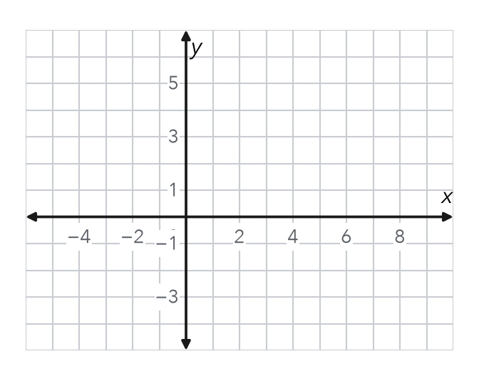

3. Dog Run. Dog run vertices: (−7, 10), (11, 10), (11, −1) and (−7, −1). Each unit is 1 meter. Find the perimeter.
Hint Find one side across and one side up and down.

Show your work.
Answer m

4. Missing Vertex. Three corners of a rectangle are (−2, 9), (8, 9) and (8, 1). Name the fourth corner.  Hint Match x with one corner and y with another.  Corner | 5. Right Triangle. A right triangle has vertices (−5, 2), (7, 2) and (7, −5). Find its area.  Hint Area = 1/2 × base × height.  Answer sq. units
  Show your work.
  Show your work.

6. Deck Area. Deck vertices: (−6, −2), (7, −2), (7, −9) and (−6, −9). Each unit is 1 yard. Find its area.
Hint Both y-values are negative, so subtract to find the height.

Show your work.
Answer sq. yd

7. Mural Outline. The mural outline has vertices (−6, 5), (6, 5), (6, −1), (1, −1), (1, −7) and (−6, −7). Each unit is 1 foot. Find the perimeter.  Hint Go around in order. Each side joins two vertices that share a coordinate.  Answer ft | 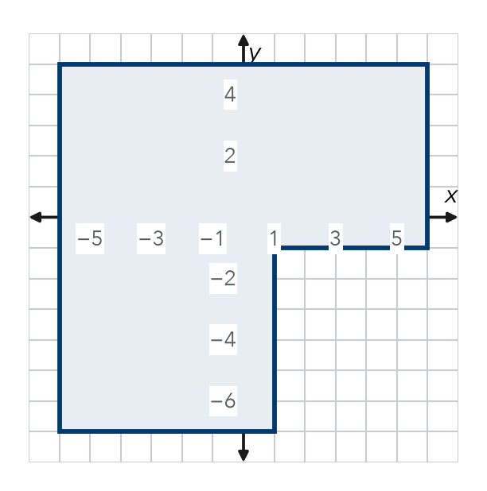
  Show your work.

8. Fence and Sod. A plot has vertices (−6, 5), (9, 5), (9, −4) and (−6, −4). Fencing costs $7 per unit. Sod costs $2 per square unit.
a. Find the length and the width.
b. Find the perimeter and the cost of fencing.
c. Find the area and the cost of sod.

FIND THE ERROR explain the mistake, then fix it

9. Jorge’s Work. For a side from (−5, 4) to (3, 4), Jorge wrote the length as 5 − 3 = 2 units. Explain his mistake. Then find the correct length.

TEST PRACTICE choose the best answer

10. A rectangle with sides 8 units and 5 units has a perimeter of —
A 13 units | B 26 units | C 40 units | D 80 units

11. A rectangle with sides 8 units and 5 units has an area of —
A 13 square units | B 26 square units | C 40 square units | D 80 square units

SELF-CHECK CODE find your answer · copy its letter into that problem’s box · spell a math word
143  J | $168  K | 29  Q | (−2, 1)  E | 58  V | 42  R | 48  E | $336  X | 91  T | 84  Z

#3 | #4 | #5 | #6 | #7 | #8b

CHECK YOURSELF | □ I can do this on my own | □ I need a little help | □ I have a question about #

