Name Date Period
Lesson 7-7 · Session 2 · Practice · Form A
Designing Polygons with Scale
Learning target — I can use a scale to find a missing dimension of a figure on the coordinate plane. · 6.G.A.3

REMEMBER  • A scale tells how long one grid unit is in real life: 1 unit = 4 m.  • Change each side to real length first (units × scale). Then find perimeter or area.  • Missing side = area ÷ known side. Area uses square units (ft², m²). | WORKED EXAMPLE  A plan uses 1 unit = 10 m. A field must cover 2,400 m² and is 4 units wide. Find its real length.  Step 1 Real width: 4 × 10 = 40 m.  Step 2 Real length: 2,400 ÷ 40 = 60 m.  Step 3 On the plan: 60 ÷ 10 = 6 units long.  Answer 60 m long (6 units on the plan)
WORDS scale (escala) · area (área) · dimensions (dimensiones)
PRACTICE show your work · label units

1. On a plan, 1 grid unit = 6 ft. Change each measure.
a. 4 units = ft | b. 9 units = ft
c. 42 ft = units | d. 90 ft = units

2. Courtyard. Three corners of a rectangular courtyard are (−5, 6), (6, 6) and (6, −3). Each unit is 10 feet.  a. Plot the corners. Name the fourth corner.  b. Width and height in feet  c. Area ft² | 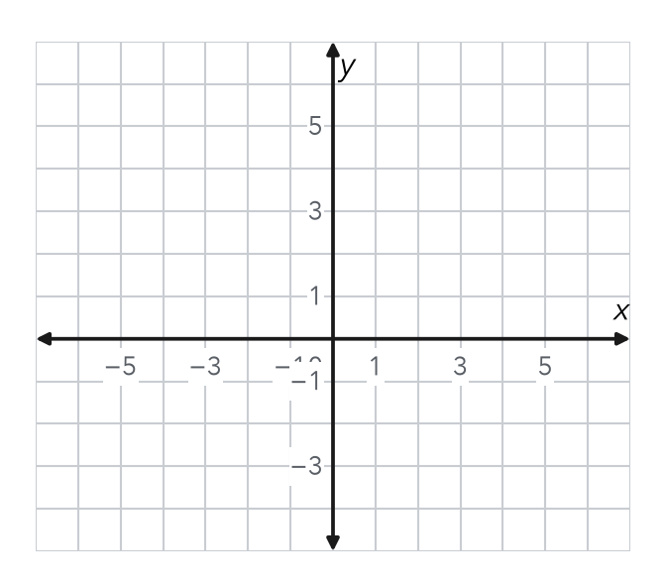

3. Parking Pad. Parking pad corners: (−7, 5), (5, 5), (5, −4) and (−7, −4). Each unit is 3 feet. Find the area in square feet.
Hint Change both sides to feet before you multiply.

Show your work.
Answer ft²

4. Using the Scale. On a plan, 1 unit = 25 feet. A rectangle is 6 units by 4 units. Find the real perimeter.  Answer ft | 5. Missing Dimension. A rectangular lot must cover 30,000 ft². One side is 150 ft. Find the other side.  Hint Divide the area by the known side.  Answer ft
  Show your work.
  Show your work.

6. Fence Cost. Yard corners: (−4, 3), (8, 3), (8, −5) and (−4, −5). Each unit is 4 feet. Fencing costs $6 per foot. Find the fence cost.
Hint Change both sides to feet, add all four, then multiply by 6.

Show your work.
Cost

7. Pen Design. Mara wants a pen with an area of 384 ft². One side runs from (−4, 6) to (8, 6). Each unit is 2 feet. Find the other side.
Hint Change the known side to feet first.

Show your work.
Answer ft

8. Playground Design. A plan uses 1 unit = 15 feet. A playground must cover 5,400 ft². On the plan it is 8 units wide.
a. Real width ft
b. Real length ft
c. Length on the plan units
d. Real perimeter ft

FIND THE ERROR explain the mistake, then fix it

9. Talia’s Work. A side runs from (−3, 4) to (9, 4). Each unit is 6 feet. Talia wrote the side length as 12 feet. Explain her mistake. Then find the correct length.

TEST PRACTICE choose the best answer

10. An area of 1,200 ft² with one side of 40 ft has another side of —
A 30 ft | B 1,160 ft | C 48,000 ft | D 20 ft

11. If 1 unit represents 20 feet, then 5 units represent —
A 4 feet | B 25 feet | C 100 feet | D 520 feet

SELF-CHECK CODE find your answer · copy its letter into that problem’s box · spell a math word
16  G | 20  J | 45  N | 500  E | 972  D | $960  I | $160  Z | 32  X | 108  Q | 200  S

#3 | #4 | #5 | #6 | #7 | #8b

CHECK YOURSELF | □ I can do this on my own | □ I need a little help | □ I have a question about #

