Name Date Period
Lesson 8-3 · Session 2 · Practice · Form B
Division Equations
Learning target — I can solve a division equation by multiplying both sides by the same number. · 6.EE.B.7

REMEMBER  • In n ÷ 4 = 7, the variable is the total before it was split.  • Multiplication undoes division. Multiply both sides by the divisor.  • The total must be greater than one share. Check by dividing. | WORKED EXAMPLE  Some cards are shared equally by 4 friends. Each friend gets 7. Solve n ÷ 4 = 7.  Step 1 Multiply both sides by 4: (n ÷ 4) × 4 = 7 × 4.  Step 2 Simplify: n = 28.  Step 3 Check: 28 ÷ 4 = 7.  Answer There were 28 cards.
WORDS divisor (divisor) · Multiplication Property of Equality (propiedad de multiplicación de la igualdad) · equal groups (grupos iguales)
PRACTICE show your work · label units

1. Solve each equation.
a. k ÷ 8 = 9 | b. p ÷ 5 = 14 | c. m ÷ 11 = 6
d. n ÷ 7 = 12 | e. y ÷ 4 = 2.5 | f. w ÷ 10 = 4.8

2. Class Pizza. A stack of s pizza slices is shared evenly among 6 tables. Each table gets 11 slices.
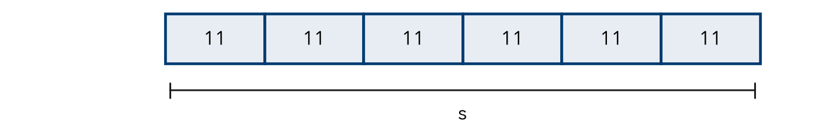
a. Write a division equation.
b. Solve it.
c. Check by dividing.

3. Trip Gas Money. A family split one gas bill evenly among 3 drivers. Each driver paid $31.50. Write and solve an equation for g, the whole bill.
Hint Whole bill ÷ 3 drivers = one share.

Show your work.
g =

4. Costume Sashes. A spool of ribbon is cut evenly into 7 sashes. Each is 18 inches. Solve n ÷ 7 = 18.  Hint Multiply both sides by 7.  n = | 5. Garden Rows. A gardener spreads s seeds evenly across 13 rows. Each row gets 15 seeds. Solve s ÷ 13 = 15.  s =
  Show your work.
  Show your work.

6. Water Jugs. A crew poured water evenly into 14 jugs. Each jug got 15 liters. Write and solve a division equation for the total liters.
Hint The total is split into 14 jugs, so undo the split.

Show your work.
Answer liters

7. Reading Log. Malik read the same number of pages each day for 6 days. His log shows 26 pages per day. Write and solve a division equation for his total pages.

Show your work.
Answer pages

8. Boxes of Tiles. A warehouse packs t tiles evenly into 16 boxes. Each box holds 35 tiles.
a. Write and solve an equation for the total tiles.
b. Four more boxes of the same size arrive. Find the new total.
c. How can you check part a?

FIND THE ERROR explain the mistake, then fix it

9. Kayla’s Work. To solve m ÷ 6 = 12, Kayla divided both sides by 6. She wrote m = 2. Explain her mistake. Then solve correctly.

TEST PRACTICE choose the best answer

10. Solve n ÷ 8 = 9.
A n = 1 | B n = 17 | C n = 72 | D n = 81

11. To solve a division equation, you —
A divide both sides by the divisor | B multiply both sides by the divisor
C add the divisor | D subtract the divisor

SELF-CHECK CODE find your answer · copy its letter into that problem’s box · spell a math word
17  Q | 210  U | 195  D | 560  T | 28  X | $94.50  R | $10.50  Z | 126  O | 156  C | 66  P

#2b | #3 | #4 | #5 | #6 | #7 | #8a

CHECK YOURSELF | □ I can do this on my own | □ I need a little help | □ I have a question about #

