Name Date Period
Lesson 8-3 · Homework Packet · Level 1 · Sheet 1 of 2
Multiplication Equations
Maryland Standard 6.EE.B.7 · Learning target — I can solve a multiplication equation by dividing both sides by the same number.

REMEMBER  • In 6x, the coefficient 6 means 6 × x.  • To solve ax = b, divide both sides by a. Division undoes multiplication.  • Check: the coefficient times your solution should equal the right side. | WORKED EXAMPLE  Solve 8p = 96.  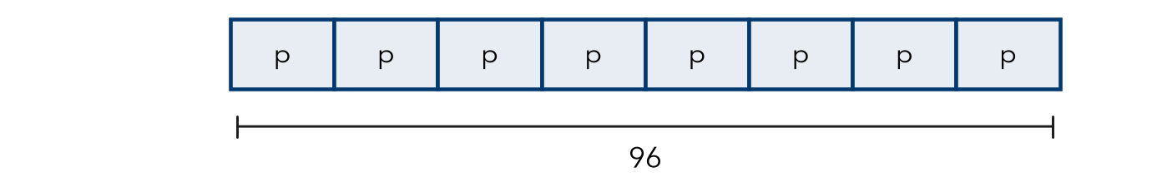  Step 1 Divide both sides by 8: p = 96 ÷ 8 = 12  Step 2 Check: 8 × 12 = 96, so it checks.  Answer p = 12

WORD BANK  coefficient — the number times the variable  divide both sides — undo the times | equal — the same amount
PRACTICE show your work · label units

1. Solve each equation.
a. 4x = 36 | b. 7n = 56 | c. 9y = 108
d. 12k = 84 | e. 5m = 85 | f. 3w = 4.5

2. Write a multiplication equation for the tape diagram. Then solve it.
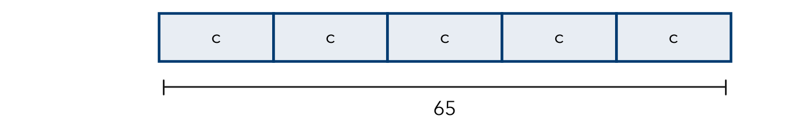
Equation and solution

3. Bus Fare. A family pays $11.25 for 5 bus fares. Each fare costs the same. Write and solve an equation for f, the cost of one fare. Check your answer.
Step 1 5 × one fare = total.
Step 2 Divide both sides by 5.

Show your work.
Answer dollars

4. Garden Rows. Ms. Bell plants 84 seedlings in 6 equal rows. Write and solve a multiplication equation for s, the seedlings in each row.
Step 1 Rows × seedlings in each row = all seedlings.
Step 2 Divide both sides by 6.
Answer seedlings

5. Compare. Without solving, tell which equation has the greater solution: 4n = 80 or 5n = 80. Explain. Then solve both to check.
Frame has the greater solution because the same total split into groups makes each group .

CHECK YOURSELF | □ I can do this on my own | □ I need a little help | □ I have a question about #
AT HOME Find a package with equal parts (eggs, juice boxes, crayons). Write a multiplication equation for it and solve for one part.
Name Date Period
Lesson 8-3 · Homework Packet · Level 1 · Sheet 2 of 2
Division Equations
Maryland Standard 6.EE.B.7 · Learning target — I can solve a division equation by multiplying both sides by the same number.

REMEMBER  • To solve x ÷ a = b, multiply both sides by a.  • The solution is the whole, so it is greater than b.  • Check: divide your solution by a. | WORKED EXAMPLE  Solve n ÷ 4 = 15.  Step 1 Multiply both sides by 4: n = 15 × 4 = 60  Step 2 Check: 60 ÷ 4 = 15, so it checks.  Answer n = 60

WORD BANK  divisor — the number you divide by  multiply both sides — undo the divide | share equally — split into equal groups
PRACTICE show your work · label units

1. Solve each equation.
a. n ÷ 7 = 6 | b. y ÷ 5 = 13 | c. k ÷ 10 = 4.5

2. Write a division equation for the tape diagram. Then solve it.

Equation and solution

3. Jump Rope. A rope is cut into 8 equal pieces. Each piece is 2.5 meters long. Write and solve a division equation for r, the whole rope.
Step 1 Whole rope ÷ 8 = one piece.
Step 2 Multiply both sides by 8.

Show your work.
Answer meters

4. Pizza Party. A pizza is cut into equal slices. 6 friends share it, and each gets 2 slices. Write and solve a division equation for z, the slices in the pizza.
Step 1 Slices ÷ friends = slices for each friend.
Step 2 Multiply both sides by 6.
Answer slices

5. Find the Error. Kayla and 3 friends share cards equally. Each gets 9 cards. Kayla writes c ÷ 3 = 9. Explain her mistake. Write and solve a correct equation.
Frame Kayla’s mistake is . The cards are shared by people, so c = .

TEST PRACTICE choose the best answer

6. Solve y ÷ 6 = 9.
A y = 1.5 | B y = 3 | C y = 15 | D y = 54

7. 12 students share p pretzels equally. Each gets 5. Which equation fits?
A p ÷ 12 = 5 | B 12 ÷ p = 5 | C 5p = 12 | D p − 12 = 5

CHECK YOURSELF | □ I can do this on my own | □ I need a little help | □ I have a question about #

