Name Date Period
Lesson 8-4 · Homework Packet · Level 1 · Sheet 1 of 2
Writing Inequalities
Maryland Standard 6.EE.B.8 · Learning target — I can write an inequality that describes a constraint in a real situation.

REMEMBER  • An inequality compares amounts using <, >, ≤, or ≥.  • more than: > less than, fewer than: <  • at least: ≥ at most, no more than: ≤  • “At least” and “at most” include the boundary. | WORKED EXAMPLE  A food pantry needs at least 40 volunteers on Saturday. Write an inequality for v, the number of volunteers.  Step 1 “At least 40” means 40 or more, so 40 is included.  Step 2 Use ≥ : v ≥ 40. Test: 40 and 52 work; 38 does not.  Answer v ≥ 40

WORD BANK  at least — that number or more (≥)  at most / no more than — that number or less (≤) | more than — greater, not equal (>)  fewer than / below — smaller, not equal (<)
PRACTICE show your work · label units

1. Write an inequality for each phrase. Use x.
Step 1 Find the key words.
Step 2 Is the number itself allowed? Yes: ≤ or ≥. No: < or >.
a. more than 12 | b. at most 30 | c. fewer than 8
d. at least 15 | e. no more than 6 | f. greater than −3
g. below 0 | h. a maximum of 100

2. Write an inequality for each sign. Use the variable given.
Sign | Inequality
Riders must be at least 54 inches tall. (h)
Speed limit: 35 miles per hour. (s)
Buy more than 10 items to get a discount. (n)
Fewer than 120 people may be in this room. (p)

3. City Bus. A city bus can carry no more than 48 riders. Write an inequality for r, the number of riders. Can the bus carry 48 riders? Can it carry 50 riders? Explain.
Step 1 “No more than” means that number or less.
Step 2 Test 48. Then test 50.
Inequality

4. Reverse It. Write a real-world situation for t < 60. Name two solutions.
Step 1 t < 60 means t is less than 60.
Step 2 Think of something that must stay under 60, like minutes.
Situation and solutions

5. Same or Different? Jordan says “x is at most 10” and “x is less than 10” mean the same thing. Is he right? Use the number 10 to explain.
Frame Jordan is because 10 a solution of x ≤ 10, but 10 a solution of x < 10.

CHECK YOURSELF | □ I can do this on my own | □ I need a little help | □ I have a question about #
AT HOME Look for a sign with a limit (speed limit, height rule, room capacity). Write an inequality for it and tell someone at home what it means.
Name Date Period
Lesson 8-4 · Homework Packet · Level 1 · Sheet 2 of 2
Representing Inequalities
Maryland Standard 6.EE.B.8 · Learning target — I can represent an inequality with a set of solutions and describe them.

REMEMBER  • Open dot: boundary not included (< or >).  • Closed dot: boundary is included (≤ or ≥).  • Arrow: left for < and ≤, right for > and ≥. | WORKED EXAMPLE  Graph x ≤ 3.  Step 1 ≤ includes 3, so draw a closed dot at 3.  Step 2 Shade left: the solutions are 3 and less.  Answer Closed dot at 3, arrow left

WORD BANK  open circle — the number is not a solution  closed circle — the number is a solution | arrow — points to all the solutions
PRACTICE use the number lines · show your work

1. Write the inequality shown on the number line. Use x.
Step 1 Find the number at the circle. Is it open or closed?
Step 2 Which way does the arrow point? Right means greater.
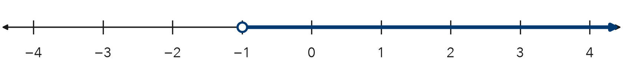
Inequality

2. Graph x ≥ 2 on the number line. Then name two solutions.
Step 1 ≥ includes 2, so the circle is closed.
Step 2 Draw the arrow toward the greater numbers.
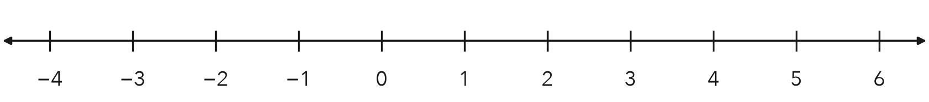
Two solutions

3. Each graph is described in words. Write the inequality for each graph. Use x.
a. open dot at 3, arrow right | b. closed dot at −2, arrow left

4. Water Bottle. A bottle holds at most 24 ounces of water. Write an inequality for w, the ounces of water. Graph it.
Step 1 “At most” means that number or less.
Step 2 Choose open or closed. Then choose the arrow direction.
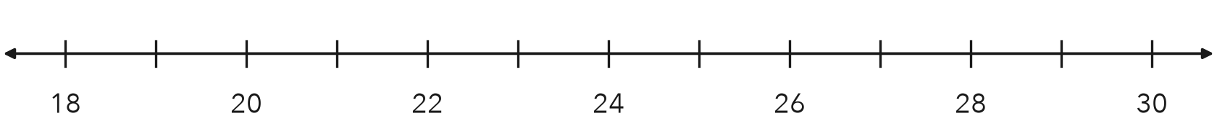
Inequality

5. Find the Error. Keon graphed n > 5 with a closed dot at 5 and an arrow to the right. Explain his mistake. Is 5 a solution?
Frame Keon should use an circle because 5 a solution of n > 5.

TEST PRACTICE choose the best answer

6. Which inequality is shown on the number line?
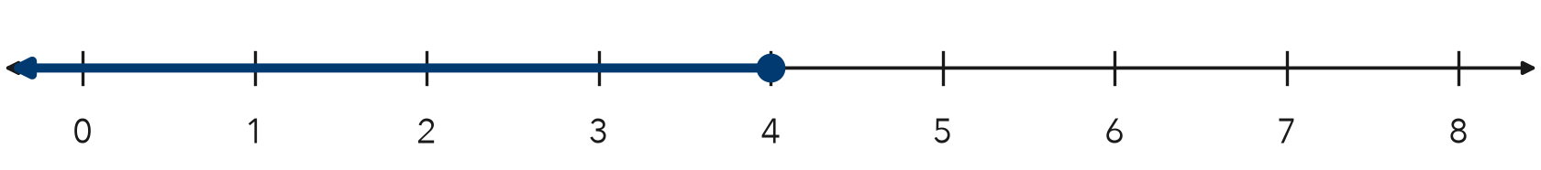
A x < 4 | B x ≤ 4 | C x > 4 | D x ≥ 4

7. Which number is a solution of n > −3?
A −5 | B −4 | C −3 | D 0

CHECK YOURSELF | □ I can do this on my own | □ I need a little help | □ I have a question about #

