Name Date Period
Lesson 8-4 · Session 2 · Prerequisite Practice A · Skill 1 of 2
Read Number Line Scales
Builds on Grade 4 · 4.MD.A.2
TODAY’S LESSON | You will graph “at most 120 people” on a number line from 112 to 128.
YOU NEED TO | Find what one jump is worth, then name a point. You will use it in Practice Form A, problems 2 and 3.
STEPS TO FOLLOW use these same steps on every problem
1 | Subtract two labels. Count the jumps between them.
2 | Divide: difference ÷ jumps = one jump.
3 | Count jumps from a label to the point.
WATCH ME the steps in action
What number is at point A?  Step 1 120 − 110 = 10. There are 5 jumps.  Step 2 10 ÷ 5 = 2. Each jump is 2.  Step 3 A is 3 jumps past 110: 110 + 6 = 116.  Answer 116 | 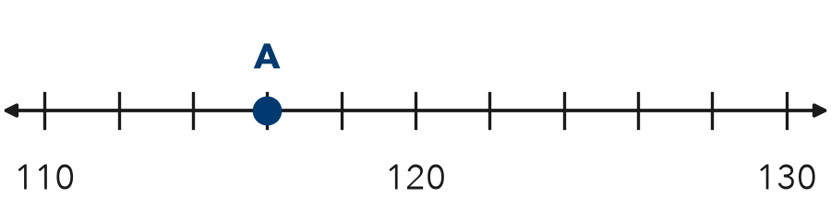

TRY IT WITH HELP fill in each step
1. What number is at point B?
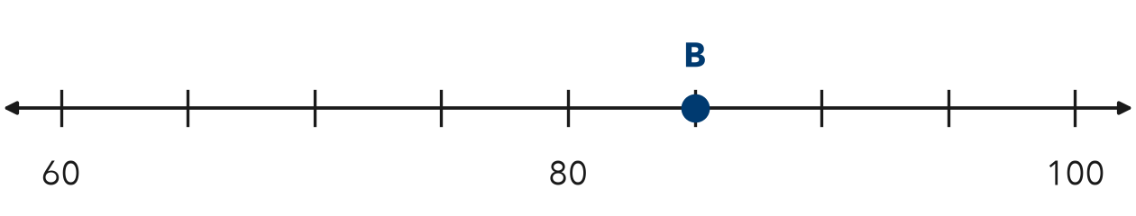
Step 1 80 − 60 = . There are jumps.
Step 2 20 ÷ 4 = . Each jump is 5.
Step 3 B is 1 jump past 80: .

2. A line has labels 0 and 50 with 5 jumps between. What number is 3 jumps past 0?
Step 1 50 − 0 = . There are 5 jumps.
Step 2 50 ÷ 5 = . Each jump is 10.
Step 3 3 jumps past 0: .

YOUR TURN use the steps on your own

3. Find what one jump is worth.
a. 0 to 50, 5 jumps | b. 100 to 140, 4 jumps | c. 30 to 40, 10 jumps
d. 70 to 80, 5 jumps | e. 112 to 114, 2 jumps | f. 0 to 100, 4 jumps

Lesson 8-4 · Session 2 · Prerequisite Practice A · Skill 2 of 2
Test Numbers Against a Limit
Builds on Grade 4 · 4.NBT.A.2
TODAY’S LESSON | For n > 7, you name three numbers that fit and one that does not.
YOU NEED TO | Decide if a number fits a rule like “less than 35.” You will use it in Practice Form A, problems 4 and 7.
STEPS TO FOLLOW use these same steps on every problem
1 | Read the rule: greater than or less than the limit?
2 | Compare the number to the limit with <, > or =.
3 | Decide: it fits only if it matches the rule.
WATCH ME the steps in action
Does 14 fit the rule “greater than 14”?
Step 1 Rule: greater than 14.
Step 2 14 = 14.
Step 3 14 is not greater than 14. It does not fit.
Answer No
TRY IT WITH HELP fill in each step
4. Does 34.5 fit the rule “less than 35”?
Step 1 Rule: than 35.
Step 2 34.5 35.
Step 3 Fits?

5. Does 7 fit the rule “greater than 7”?
Step 1 Rule: than 7.
Step 2 7 7.
Step 3 Fits?

YOUR TURN use the steps on your own

6. Does the number fit the rule? Write yes or no.
a. less than 35: 34 | b. less than 35: 35 | c. greater than 7: 7.5
d. greater than 7: 6 | e. under 22: 21 | f. over 50: 50

READY CHECK a problem like the one in today’s lesson

7. Which number is NOT a solution of n > 7?
A 8 | B 7.5 | C 7 | D 100

CHECK YOURSELF | □ I can do this on my own | □ I need a little help | □ I have a question about #

