Name Date Period
Lesson 8-4 · Session 2 · Prerequisite Practice B · Skill 1 of 2
Compare Integers
Builds on Lesson 7-4 Session 1 · 6.NS.C.7a
TODAY’S LESSON | A closed circle at −1 with an arrow left shows −1 and every number less than it.
YOU NEED TO | Compare integers like −6 and −3: farther right is greater. You will use it in Practice Form A, problem 1.
STEPS TO FOLLOW use these same steps on every problem
1 | Place both numbers on a number line.
2 | The number farther right is greater.
3 | Write <, >, or = between them.
WATCH ME the steps in action
Compare −6 and −3.  Step 1 Place −6 and −3.  Step 2 −3 is farther right. −3 is greater.  Step 3 −6 < −3.  Answer −6 < −3 | 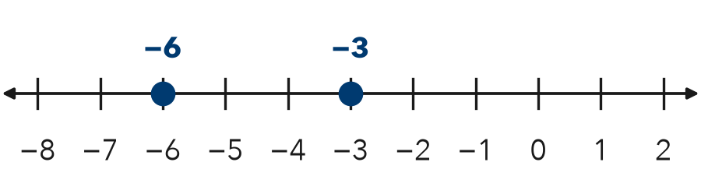

TRY IT WITH HELP fill in each step
1. Compare −1 and −5.
Step 1 Place and −5.
Step 2 is farther right.
Step 3 −1 −5.

2. Compare 0 and −3.
Step 1 Place 0 and .
Step 2 is farther right.
Step 3 0 −3.

YOUR TURN use the steps on your own

3. Write < or > in the box.
a. −4 □ 2 | b. −1 □ −5 | c. −8 □ −6
d. −7 □ 0 | e. −12 □ −8 | f. −2 □ −9

Lesson 8-4 · Session 2 · Prerequisite Practice B · Skill 2 of 2
Write Inequalities for Constraints
Builds on Lesson 8-4 Session 1 · 6.EE.B.8
TODAY’S LESSON | A room may hold at most 120 people. You write n ≤ 120 before you graph it.
YOU NEED TO | Turn a limit phrase into an inequality, like at least 54 is ≥ 54. You will use it in Practice Form A, problems 2, 4 and 5.
STEPS TO FOLLOW use these same steps on every problem
1 | Find the limit number and the phrase.
2 | Pick: more >, less <, at least ≥, at most ≤.
3 | Write the letter, the symbol, then the number.
WATCH ME the steps in action
A rider must be at least 54 inches tall. Write an inequality for h.
Step 1 Limit 54. Phrase “at least.”
Step 2 At least means ≥.
Step 3 h ≥ 54.
Answer h ≥ 54
TRY IT WITH HELP fill in each step
4. A bag may weigh at most 23 kg. Use w.
Step 1 Limit . Phrase “at most.”
Step 2 At most means .
Step 3 Inequality:

5. A team needs more than 20 players. Use p.
Step 1 Limit 20. Phrase “ .”
Step 2 More than means .
Step 3 Inequality:

YOUR TURN use the steps on your own

6. Write an inequality. Use x.
a. more than 12 | b. at most 30 | c. at least 5
d. less than 9 | e. fewer than 22 | f. no more than 40

READY CHECK a problem like the one in today’s lesson

7. A boat may carry at most 8 people. Which inequality fits?
A p < 8 | B p ≥ 8 | C p ≤ 8 | D p > 8

CHECK YOURSELF | □ I can do this on my own | □ I need a little help | □ I have a question about #

