Name Date Period
Lesson 8-5 · Session 1 · Practice · Form B
Graphing Inequalities
Learning target — I can graph an inequality on a number line using an open or a closed dot. · 6.EE.B.8

REMEMBER  • An open dot means the boundary is NOT a solution (< or >). A closed dot means it is (≤ or ≥).  • Point the arrow toward the numbers that work: > and ≥ point right; < and ≤ point left.  • At least means ≥. At most means ≤. Under means <. | WORKED EXAMPLE  Graph x < 6 on a number line.  Step 1 The boundary number is 6.  Step 2 < does not include 6, so draw an open dot at 6.  Step 3 Less than 6 means the arrow points left. Test: 5 < 6 is true.  Answer open dot at 6, arrow pointing left
WORDS boundary point (punto límite) · closed circle (círculo cerrado) · open circle (círculo abierto)
PRACTICE show your work · label units

1. Describe each graph: open or closed dot, and the arrow direction.
a. k ≤ −4 | b. n > 10
c. p < −2 | d. x ≥ 1

2. Roller Coaster. A roller coaster lets a rider on only when the rider is at least 52 inches tall. Let h be the height in inches.
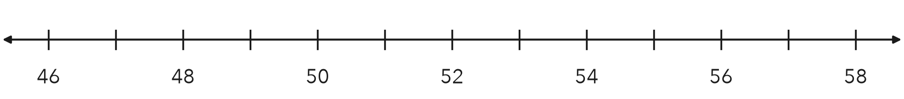
a. Write the inequality.
b. Graph it on the number line.
c. Name one value that works and one that does not.

3. Bike Rack. A bike rack outside the gym holds at most 36 bikes. Write an inequality using b. Then graph it.
Hint “At most” means the boundary is allowed, so fill the dot.
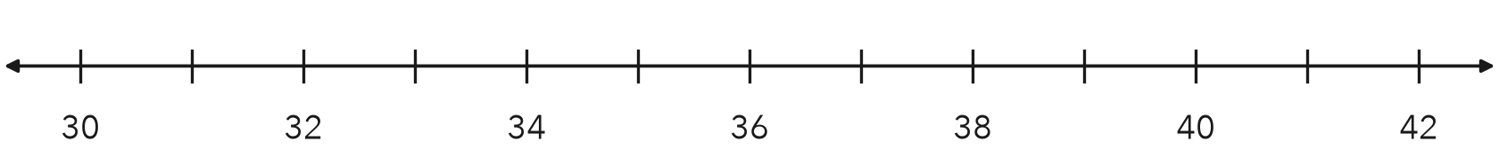
Inequality

4. Pool Closed. A pool closes when the air temperature drops to 65 degrees or lower. Write an inequality using t and describe its graph.  Hint “Or lower” means 65 itself counts.  Inequality | 5. Lap Lane. Swimmers must be at least 12 years old to use the lap lane. Write an inequality using a and describe its graph.  Hint “At least” means age 12 is allowed.  Inequality
  Show your work.
  Show your work.

6. Read a Graph. Use the graph below.
Hint An open dot leaves the boundary out; a closed dot keeps it.
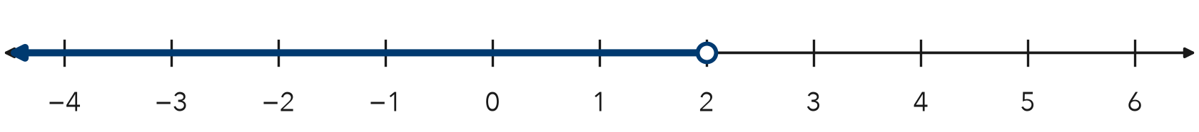
a. Write the inequality, using x.
b. Is 2 a solution? Explain.

7. Canned Food Drive. A homeroom wins a breakfast when it collects at least 180 cans. Let c be the number of cans.
Hint Any total of 180 or more wins the breakfast.
a. Write the inequality.
b. Name two totals under your arrow.

8. Two Signs. A ride sign says riders must be at least 48 inches tall. A bridge sign says trucks must weigh under 10 tons.
a. Write an inequality for the first sign, using h.
b. Write an inequality for the second sign, using w.
c. Explain why one graph uses a closed dot and the other an open dot.

Show your work.

FIND THE ERROR explain the mistake, then fix it

9. Omar’s Work. Omar graphed x ≤ 7. He drew a closed dot at 7 and then drew his arrow pointing to the right. Explain his mistake and describe the correct graph.

TEST PRACTICE choose the best answer

10. The graph of x < 8 has —
A a closed dot at 8, arrow left | B an open dot at 8, arrow right
C an open dot at 8, arrow left | D a closed dot at 8, arrow right

11. A closed dot at the boundary means the boundary value is —
A a solution | B not a solution | C negative | D zero

SELF-CHECK CODE find your answer · copy its letter into that problem’s box · spell a math word
x < 2  C | c ≥ 180  L | b ≥ 36  Z | h ≥ 52  C | h > 52  Q | w < 10  E | w ≤ 10  J | b ≤ 36  I | x ≤ 2  X | t ≤ 65  R

#2a | #3 | #4 | #6a | #7 | #8b

CHECK YOURSELF | □ I can do this on my own | □ I need a little help | □ I have a question about #

