Name Date Period
Lesson 8-5 · Session 2 · Practice · Form A
Testing Solutions to Inequalities
Learning target — I can test values against an inequality and graph the solution set. · 6.EE.B.8

REMEMBER  • To test a value, substitute it for the variable. A true statement means it is a solution.  • Test the boundary: true means a closed dot (≤, ≥); false means an open dot (<, >).  • More than means >. Fewer than and below mean <. At most means ≤. | WORKED EXAMPLE  Test 8, 9 and 10 in x < 9.  Step 1 8 < 9 is true, so 8 is a solution.  Step 2 9 < 9 is false, so use an open dot at 9.  Step 3 10 < 9 is false, so 10 is not a solution.  Answer 8 works; open dot at 9, arrow left
WORDS substitute (sustituir) · solution (solución) · true statement (enunciado verdadero)
PRACTICE show your work · label units

1. Is the value a solution? Write yes or no.
a. n ≥ 14; n = 14 | b. n ≥ 14; n = 13 | c. x < 9; x = 9
d. p > 8; p = 3 | e. k ≥ 7; k = 7 | f. w < 12; w = 9.5

2. Go-Kart Track. A go-kart track lets a driver race only when the driver weighs more than 80 pounds. Let w be the weight in pounds.
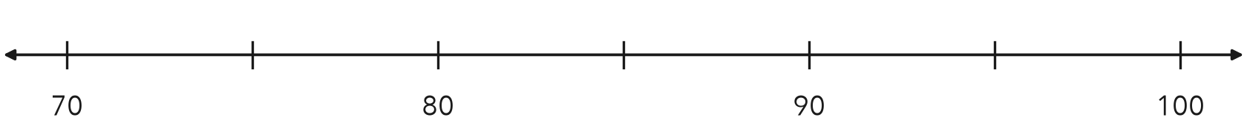
a. Write the inequality.
b. Substitute 95. Is it a solution?
c. Substitute 80. Is it a solution?
d. Graph the inequality.

3. Ride Line. A park closes a ride’s line when more than 45 people are waiting. Write an inequality using n. Test 45 and 52.
Hint Substitute each number. A true statement means a solution.

Show your work.
Inequality

4. Lab Liquid. An experiment works only while a liquid stays below 25 °C. Write an inequality using c. Test 25 and 19.  Hint “Below” leaves the boundary out.  Inequality | 5. Advanced Ramp. A skate park opens its advanced ramp only to riders older than 15. Write an inequality using a. Is 15 a solution?  Hint Is the boundary older than itself?  Inequality
  Show your work.
  Show your work.

6. Test and Graph. For x ≤ 5, test x = 5 and x = 6. Then graph the inequality.
Hint The boundary test tells you the dot.
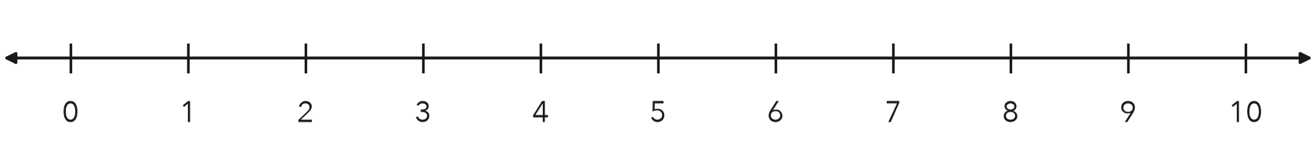
Solutions

7. Wind Speed. A rocket club launches only when the wind speed is less than 12 miles per hour. Write an inequality using w. Test 12, 9 and 15.

Show your work.
Inequality

8. Baggage Rule. An airline allows a bag that weighs at most 50 pounds. Three bags weigh 50, 51 and 38 pounds.
a. Write the inequality, using w.
b. Which bags are allowed?
c. Describe the graph. What does the dot tell you about a 50-pound bag?

Show your work.

FIND THE ERROR explain the mistake, then fix it

9. Ravi’s Work. Ravi graphed x > 26 with a closed dot at 26. He told his group that 26 is one of the solutions. Explain his mistake and fix the graph.

TEST PRACTICE choose the best answer

10. Which value is a solution of p > 8?
A 3 | B 8 | C 7.9 | D 8.5

11. Testing the boundary value tells you —
A the arrow direction | B whether the dot is open or closed
C which letter to use | D the units

SELF-CHECK CODE find your answer · copy its letter into that problem’s box · spell a math word
w ≤ 50  S | a > 15  U | w < 12  E | w > 80  V | c ≤ 25  Z | a ≥ 15  J | c < 25  L | n > 45  A | w ≥ 80  Q | w < 50  X

#2a | #3 | #4 | #5 | #7 | #8a

CHECK YOURSELF | □ I can do this on my own | □ I need a little help | □ I have a question about #

