EXIT TICKET · LESSON 8-5 · SESSION 1 Name
Graphing Inequalities

1. Describe each graph: dot and arrow direction.
a. x > 3 | b. m ≤ −2

2. Snack Money. A club may spend at most 40 dollars on snacks. Write an inequality using d. Then graph it.
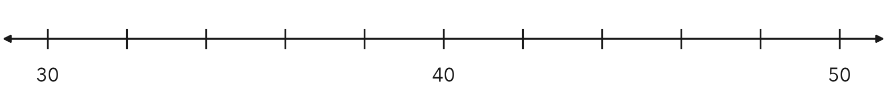
Inequality

3. Which inequality matches an open dot at 5 with an arrow pointing left?
A x ≤ 5 | B x > 5 | C x < 5 | D x ≥ 5

HOW DID IT GO? □ I got it □ Almost □ I need help
cut here
EXIT TICKET · LESSON 8-5 · SESSION 1 Name
Graphing Inequalities

1. Describe each graph: dot and arrow direction.
a. x > 3 | b. m ≤ −2

2. Snack Money. A club may spend at most 40 dollars on snacks. Write an inequality using d. Then graph it.
Inequality

3. Which inequality matches an open dot at 5 with an arrow pointing left?
A x ≤ 5 | B x > 5 | C x < 5 | D x ≥ 5

HOW DID IT GO? □ I got it □ Almost □ I need help
EXIT TICKET · LESSON 8-5 · SESSION 2 Name
Testing Solutions to Inequalities

1. Is the value a solution? Write yes or no.
a. x > 6; x = 6 | b. k ≤ 10; k = 10

2. Concert Volume. Music is allowed only while the volume stays under 85 decibels. Write an inequality using v. Test 85 and 60.

Show your work.
Inequality

3. Which value is not a solution of t ≥ −2?
A −2 | B −3 | C 0 | D 4

HOW DID IT GO? □ I got it □ Almost □ I need help
cut here
EXIT TICKET · LESSON 8-5 · SESSION 2 Name
Testing Solutions to Inequalities

1. Is the value a solution? Write yes or no.
a. x > 6; x = 6 | b. k ≤ 10; k = 10

2. Concert Volume. Music is allowed only while the volume stays under 85 decibels. Write an inequality using v. Test 85 and 60.

Show your work.
Inequality

3. Which value is not a solution of t ≥ −2?
A −2 | B −3 | C 0 | D 4

HOW DID IT GO? □ I got it □ Almost □ I need help

