Name Date Period
Lesson 8-5 · Session 1 · Guided Notes
Graphing Inequalities
Learning target — I can graph an inequality on a number line using an open or a closed dot. · 6.EE.B.8
WORDS TO KNOW fill in the missing words
WORD | WHAT IT MEANS | EXAMPLE
boundary point  punto límite | The number where the solutions or stop. | the 8 in x ≥ 8
closed circle  círculo cerrado | A filled dot: the boundary a solution. | used for ≤ and ≥
open circle  círculo abierto | An empty dot: the boundary is a solution. | used for < and >
solution set  conjunto solución | the numbers that make an inequality true. | x ≥ 8: 8, 9.5, 20, …
KEY IDEA complete each sentence
• Use a dot for ≤ and ≥. Use an dot for < and >.
• Draw the arrow toward the numbers that make the inequality .
WORKED EXAMPLE fill in the blanks as we solve
Graph x < 6 on a number line.
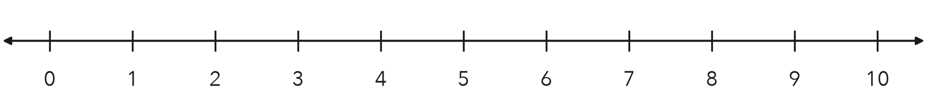
Step 1 The boundary number is .
Step 2 < does not include 6, so draw an dot at 6.
Step 3 x is less than 6, so the arrow points .
Answer Check: 5 < 6 is , and 5 is under the arrow.
YOU TRY use the example as a model

1. Graph y ≥ −2 on the number line.
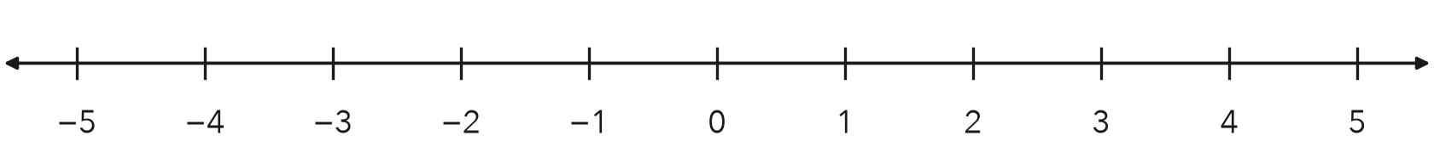

2. Write the inequality for each graph, using x.
a. closed dot at 4, arrow left | b. open dot at −1, arrow right

SUM IT UP in your own words
I choose an open or a closed dot by looking at , and I point the arrow .
Name Date Period
Lesson 8-5 · Session 2 · Guided Notes
Testing Solutions to Inequalities
Learning target — I can test values against an inequality and graph the solution set. · 6.EE.B.8
WORDS TO KNOW fill in the missing words
WORD | WHAT IT MEANS | EXAMPLE
substitute  sustituir | Put a number in of the variable. | x = 9 in x > 5 gives 9 > 5
solution  solución | A value that makes the inequality . | 9 is a solution of x > 5
true statement  enunciado verdadero | A comparison that is . | 9 > 5
KEY IDEA complete each sentence
• To test a value, substitute it and ask whether the statement is .
• For ≤ and ≥, the boundary a solution. For < and >, it is .
WORKED EXAMPLE fill in the blanks as we solve
Test 8, 9 and 10 in x < 9.
Step 1 8 < 9 is , so 8 is a solution.
Step 2 9 < 9 is , so the dot at 9 is .
Step 3 10 < 9 is false, so 10 is not a solution.
Answer Only works. Graph: open dot at 9, arrow left.
YOU TRY use the example as a model

1. Is the value a solution? Write yes or no.
a. y ≥ 3; y = 3 | b. m < −2; m = 0

2. Test −1, 2 and 5 in x > 2. Then graph x > 2.
Solutions

SUM IT UP in your own words
To decide whether a number is a solution, I , and the boundary is a solution only when .

