Name Date Period
Lesson 8-5 · Session 1 · Prerequisite Practice A · Skill 1 of 2
Read Number Line Scales
Builds on Grade 4 · 4.MD.A.2
TODAY’S LESSON | You will graph inequalities like p ≥ 250 on number lines that skip-count.
YOU NEED TO | Find the number at a tick mark, like 250 on a line that counts by 50s. You will use it in Practice Form A, problems 2, 3, and 7.
STEPS TO FOLLOW use these same steps on every problem
1 | Find the difference between two labels.
2 | Divide by the number of equal spaces. That is the step.
3 | Count on by the step to name the tick.
WATCH ME the steps in action
The labels are 200 and 300. Find the number at point A.  Step 1 300 − 200 = 100.  Step 2 There are 4 spaces. 100 ÷ 4 = 25. The step is 25.  Step 3 Count on: 200, 225, 250.  Answer A = 250 | 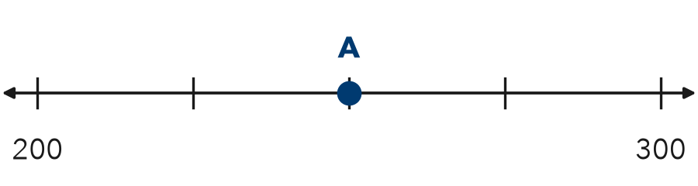

TRY IT WITH HELP fill in each step
1. The labels are 0 and 10. Find the number at point A.
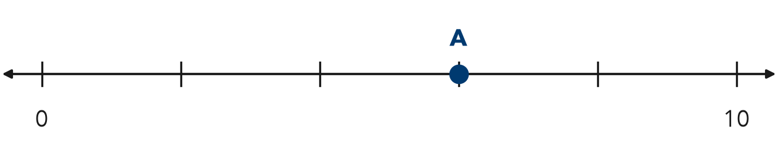
Step 1 10 − 0 = .
Step 2 There are 5 spaces. 10 ÷ 5 = . The step is 2.
Step 3 Count on: 0, 2, 4, . A = .

2. The labels are 0 and 100. There are 4 equal spaces. Point A is 3 ticks past 0.
Step 1 100 − 0 = .
Step 2 100 ÷ 4 = . The step is 25.
Step 3 Count on: 25, 50, . A = .

YOUR TURN use the steps on your own

3. Find the size of each step.
a. 0 to 50, 10 spaces: | b. 100 to 200, 4 spaces:
c. 500 to 1,000, 10 spaces: | d. 0 to 40, 8 spaces:

Lesson 8-5 · Session 1 · Prerequisite Practice A · Skill 2 of 2
Compare Multi-Digit Numbers
Builds on Grade 4 · 4.NBT.A.2
TODAY’S LESSON | You will name values that work for p ≥ 250, like 300.
YOU NEED TO | Tell which number is greater, like 260 > 250. You will use it in Practice Form A, problems 2 and 7.
STEPS TO FOLLOW use these same steps on every problem
1 | Count the digits. More digits means the greater number.
2 | Same number of digits? Compare digits from the left.
3 | The first different digit decides. Write <, >, or =.
WATCH ME the steps in action
875 900
Step 1 Both numbers have 3 digits.
Step 2 Compare hundreds: 8 and 9.
Step 3 8 is less than 9, so 875 < 900.
Answer 875 < 900
TRY IT WITH HELP fill in each step
4. 252 250
Step 1 Both numbers have digits.
Step 2 Hundreds match. Tens match. Compare ones: and .
Step 3 252 250

5. 999 1,001
Step 1 999 has digits. 1,001 has digits.
Step 2 Same number of digits?
Step 3 999 1,001

YOUR TURN use the steps on your own

6. Write <, >, or =.
a. 1,500 1,050 | b. 36 63 | c. 4,099 4,100
d. 18 18 | e. 245 250 | f. 1,650 1,605

READY CHECK a problem like the one in today’s lesson

7. A class needs at least 250 points: p ≥ 250. Which total works?
A 245 | B 205 | C 260 | D 25

CHECK YOURSELF | □ I can do this on my own | □ I need a little help | □ I have a question about #

