Name Date Period
Lesson 8-5 · Session 1 · Prerequisite Practice B · Skill 1 of 2
Compare Numbers on a Number Line
Builds on Lesson 7-4 Session 1 · 6.NS.C.7a
TODAY’S LESSON | You will graph x ≥ −3 and decide which way the arrow points.
YOU NEED TO | Tell which of two numbers is greater, like −1 > −3. You will use it in Practice Form A, problems 1 and 6.
STEPS TO FOLLOW use these same steps on every problem
1 | Find both numbers on the number line.
2 | The number farther right is greater.
3 | Write < or >. The symbol opens toward the greater number.
WATCH ME the steps in action
−8 −3  Step 1 Find −8 and −3 on the line.  Step 2 −3 is farther right, so −3 is greater.  Step 3 −8 < −3  Answer −8 < −3 | 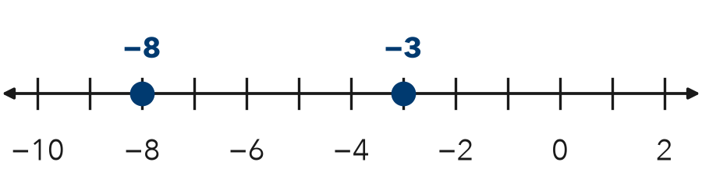

TRY IT WITH HELP fill in each step
1. −1 −6
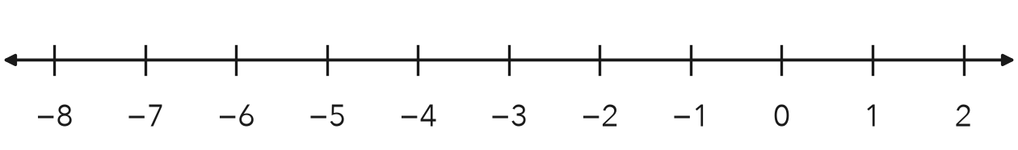
Step 1 Find −1 and on the line.
Step 2 is farther right, so it is greater.
Step 3 −1 −6

2. 0 −4
Step 1 Find 0 and on the line.
Step 2 is farther right, so it is greater.
Step 3 0 −4

YOUR TURN use the steps on your own

3. Write < or >.
a. −3 1 | b. −8 −7 | c. −12 −15
d. 6 −9 | e. −4 4 | f. −2 −5

Lesson 8-5 · Session 1 · Prerequisite Practice B · Skill 2 of 2
Write Inequalities from Words
Builds on Lesson 8-4 Session 1 · 6.EE.B.8
TODAY’S LESSON | You will turn “at least 15 pounds” into w ≥ 15 and graph it.
YOU NEED TO | Change a phrase like “at most 8” into t ≤ 8. You will use it in Practice Form A, problems 2, 3, 5, and 8.
STEPS TO FOLLOW use these same steps on every problem
1 | Find the phrase: at least, at most, more than, or under.
2 | Pick the symbol: at least ≥, at most ≤, more than >, under <.
3 | Write the letter, then the symbol, then the number.
WATCH ME the steps in action
A tent holds at most 6 campers. Use c.
Step 1 The phrase is “at most.”
Step 2 “At most” means ≤.
Step 3 c ≤ 6
Answer c ≤ 6
TRY IT WITH HELP fill in each step
4. A rider must be at least 52 inches tall. Use h.
Step 1 The phrase is .
Step 2 That phrase means .
Step 3 Write it:

5. A slide allows riders under 200 pounds. Use w.
Step 1 The phrase is .
Step 2 That phrase means .
Step 3 Write it:

YOUR TURN use the steps on your own

6. Write each sentence as an inequality.
a. x is at least 9: | b. n is under 30:
c. w is at most 50: | d. t is more than 100:
e. b is at least 18: | f. k is under 12:

READY CHECK a problem like the one in today’s lesson

7. A freezer stays at most 8 degrees. Which inequality matches? Use t.
A t ≥ 8 | B t ≤ 8 | C t < 8 | D t > 8

CHECK YOURSELF | □ I can do this on my own | □ I need a little help | □ I have a question about #

