Name Date Period
Lesson 8-5 · Session 2 · Prerequisite Practice B · Skill 1 of 2
Test Solutions of Equations
Builds on Lesson 8-1 Session 1 · 6.EE.B.5
TODAY’S LESSON | You will put 95 into w > 80 and check if it is true.
YOU NEED TO | Put a value into an equation, like m = 4 in 3m = 12, and check it. You will use it in Practice Form A, problems 1 and 2.
STEPS TO FOLLOW use these same steps on every problem
1 | Replace the letter with the value.
2 | Compute that side.
3 | Compare both sides. The same number means yes, a solution.
WATCH ME the steps in action
Is m = 4 a solution of 3m = 12?
Step 1 Replace m with 4: 3 × 4.
Step 2 Compute: 3 × 4 = 12.
Step 3 Compare: 12 = 12. Yes.
Answer Yes, m = 4 is a solution.
TRY IT WITH HELP fill in each step
1. Is n = 8 a solution of n − 3 = 6?
Step 1 Replace n with 8: − 3.
Step 2 Compute: 8 − 3 = .
Step 3 Compare: and 6. Solution?

2. Is y = 30 a solution of y ÷ 5 = 6?
Step 1 Replace y with 30: ÷ 5.
Step 2 Compute: 30 ÷ 5 = .
Step 3 Compare: and 6. Solution?

YOUR TURN use the steps on your own

3. Is the value a solution? Write yes or no.
a. k = 11 in k + 9 = 21: | b. p = 25 in 4p = 100:
c. w = 16 in w − 7 = 9: | d. a = 6 in 7a = 48:
e. t = 45 in t ÷ 9 = 5: | f. x = 12 in x ÷ 3 = 4:

Lesson 8-5 · Session 2 · Prerequisite Practice B · Skill 2 of 2
Graph Inequalities
Builds on Lesson 8-5 Session 1 · 6.EE.B.8
TODAY’S LESSON | You will graph x ≤ 5 after you test 5 and 6.
YOU NEED TO | Pick the dot and the arrow, like x ≤ 5: closed dot, arrow left. You will use it in Practice Form A, problems 2, 6, and 8.
STEPS TO FOLLOW use these same steps on every problem
1 | Put a dot on the number in the inequality.
2 | Closed dot for ≤ or ≥. Open dot for < or >.
3 | Arrow right for > or ≥. Arrow left for < or ≤.
WATCH ME the steps in action
Graph n > 45.  Step 1 Put a dot on 45.  Step 2 > has no equal part, so the dot is open.  Step 3 > means greater, so the arrow goes right.  Answer Open dot at 45, arrow right. | 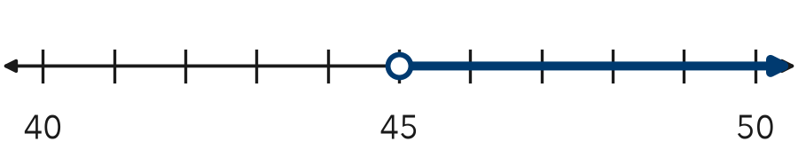

TRY IT WITH HELP fill in each step
4. Graph x ≤ 5.
Step 1 Put a dot on .
Step 2 ≤ includes equal, so the dot is .
Step 3 ≤ means less, so the arrow goes .

5. Graph c < 25.
Step 1 Put a dot on .
Step 2 < has no equal part, so the dot is .
Step 3 < means less, so the arrow goes .

YOUR TURN use the steps on your own

6. Write the dot (open or closed) and the arrow (left or right).
a. s ≥ 18 | b. t > 220 | c. p ≤ 50
d. w ≥ 9 | e. x ≤ −2 | f. j < 30

READY CHECK a problem like the one in today’s lesson

7. A bag can weigh at most 50 pounds: w ≤ 50. Which graph is right?
A Open dot at 50, arrow left | B Closed dot at 50, arrow left
C Closed dot at 50, arrow right | D Open dot at 50, arrow right

CHECK YOURSELF | □ I can do this on my own | □ I need a little help | □ I have a question about #

