Name Date Period
Lesson 9-1 · Session 1 · Prerequisite Practice A · Skill 1 of 2
Read Points on a Graph
Builds on Grade 5 · 5.G.A.2
TODAY’S LESSON | You will decide which variable goes on the x-axis of a taxi-cost graph.
YOU NEED TO | Read a point like (4, 2): 4 across the x-axis, 2 up the y-axis. You will use it in Practice Form A, problem 6.
STEPS TO FOLLOW use these same steps on every problem
1 | Start at the origin, (0, 0).
2 | Count across the x-axis. That is the first number.
3 | Count up the y-axis. That is the second number.
WATCH ME the steps in action
Name point A.  Step 1 Start at (0, 0).  Step 2 Count across the x-axis: 4.  Step 3 Count up the y-axis: 2.  Answer A = (4, 2) | 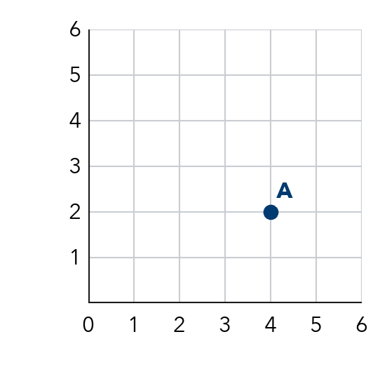

TRY IT WITH HELP fill in each step
1. How do you reach the point (3, 5)?
Step 1 Start at .
Step 2 Count across the x-axis: .
Step 3 Count up the y-axis: .

2. Where is the point (0, 9)?
Step 1 Start at .
Step 2 Count across the x-axis: .
Step 3 Count up the y-axis: 9. The point is on the -axis.

YOUR TURN use the steps on your own

3. Write x-axis or y-axis.
a. the axis that goes across: | b. the axis that goes up:
c. the axis for the first number: | d. the axis for the second number:
e. where (4, 0) sits: | f. where (0, 6) sits:

Lesson 9-1 · Session 1 · Prerequisite Practice A · Skill 2 of 2
Describe How Two Quantities Change
Builds on Grade 5 · 5.OA.B.3
TODAY’S LESSON | You will read “the more bags she sells, the more money she collects.”
YOU NEED TO | Tell how one amount changes when another goes up: more songs, more cost. You will use it in Practice Form A, problems 2 and 7.
STEPS TO FOLLOW use these same steps on every problem
1 | Name the first amount. It goes up.
2 | Name the second amount.
3 | Decide: does the second amount go up, down, or stay the same?
WATCH ME the steps in action
Songs bought and total cost.
Step 1 The first amount is songs bought.
Step 2 The second amount is total cost.
Step 3 More songs cost more money. Up.
Answer up
TRY IT WITH HELP fill in each step
4. Miles driven and gas left in the tank.
Step 1 The first amount is .
Step 2 The second amount is .
Step 3 More miles means less gas.

5. Days a plant grows and its height.
Step 1 The first amount is .
Step 2 The second amount is .
Step 3 More days means a taller plant.

YOUR TURN use the steps on your own

6. The first amount goes up. Write up, down, or same for the second amount.
a. friends sharing 1 pizza, slices each: | b. hours worked, money earned:
c. stamps bought, price of 1 stamp: | d. water poured out, water left:

READY CHECK a problem like the one in today’s lesson

7. Nia sells more bags. What happens to the money she collects?
A It goes down. | B It goes up.
C It stays the same. | D It goes up, then down.

CHECK YOURSELF | □ I can do this on my own | □ I need a little help | □ I have a question about #

