Name Date Period
Lesson 9-2 · Session 1 · Practice · Form B
From Table to Graph
Learning target — I can turn a table of values into points and plot them on a graph. · 6.EE.C.9

REMEMBER  • Each row of a table gives an ordered pair (x, y): the input first, then the output.  • To plot (x, y), start at (0, 0). Go right x, then up y.  • Points from a constant rate line up in a straight line. A starting fee moves the line up off (0, 0). | WORKED EXAMPLE  A table for y = 4x has x = 1, 2, 3. Plot the points.  Step 1 Write the pairs: (1, 4), (2, 8), (3, 12).  Step 2 Plot (1, 4): right 1, then up 4. Plot the others the same way.  Step 3 Check: the points line up.  Answer three points in a straight line
WORDS ordered pair (par ordenado) · coordinates (coordenadas) · axis (eje)
PRACTICE show your work · label units

1. Write each table row as an ordered pair (x, y).
a. x = 4, y = 28 | b. x = 7, y = 2
c. x = 0, y = 5 | d. x = 6, y = 54

2. Babysitting Pay. Lina earns $8 for every hour she babysits. Complete the table. Then plot the points on the grid. | 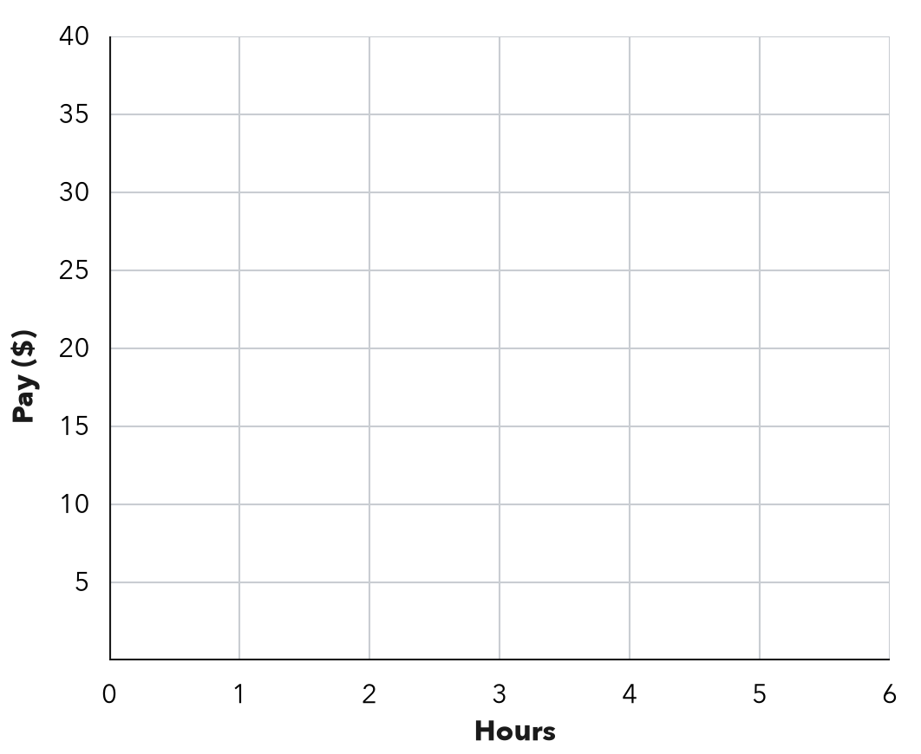
  Hours (x) | 1 | 2 | 3 | 5
  Pay in $ (y)

3. Elevator. A glass elevator rises 12 feet every second. Write the ordered pair for 8 seconds. What does it mean?  Hint Seconds come first; multiply by 12 for the feet.  Pair | 4. Reading Log. Marco’s table shows x: 1, 2, 3, 4 days and y: 15, 30, 45, 60 pages read. For the third day he plotted (45, 3). What did he do wrong? Give the correct point.  Hint Which quantity is x in the table?  Point

5. Party Balloons. A party store ties 16 balloons in every bunch. Complete the table. Then plot the points on the grid.  Hint Each row of the table is one point. | 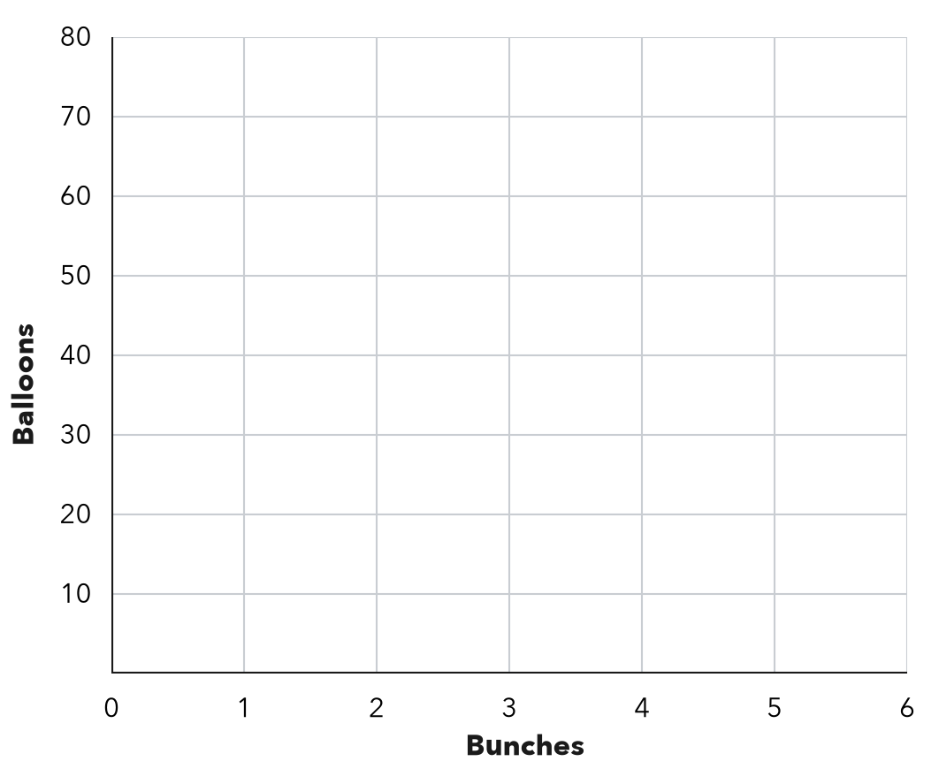
  Bunches (x) | 1 | 3 | 5
  Balloons (y)

6. Tile Rows. A floor has 14 tiles in every row. Write the ordered pair for 6 rows. Then tell what it means.
Hint Multiply 6 by 14.
Pair

7. From Pairs to a Pattern. A table gives the pairs (1, 4), (2, 8), (3, 12).
Hint Compare each y with its x.
a. Describe the rule.
b. What shape do the points make?
c. Write the pair for x = 9.

8. With a Fee. A service charges $3 plus $5 for each item. List the pairs for 1, 2 and 3 items. Plot them. Where does the line meet the y-axis?  y-axis point | 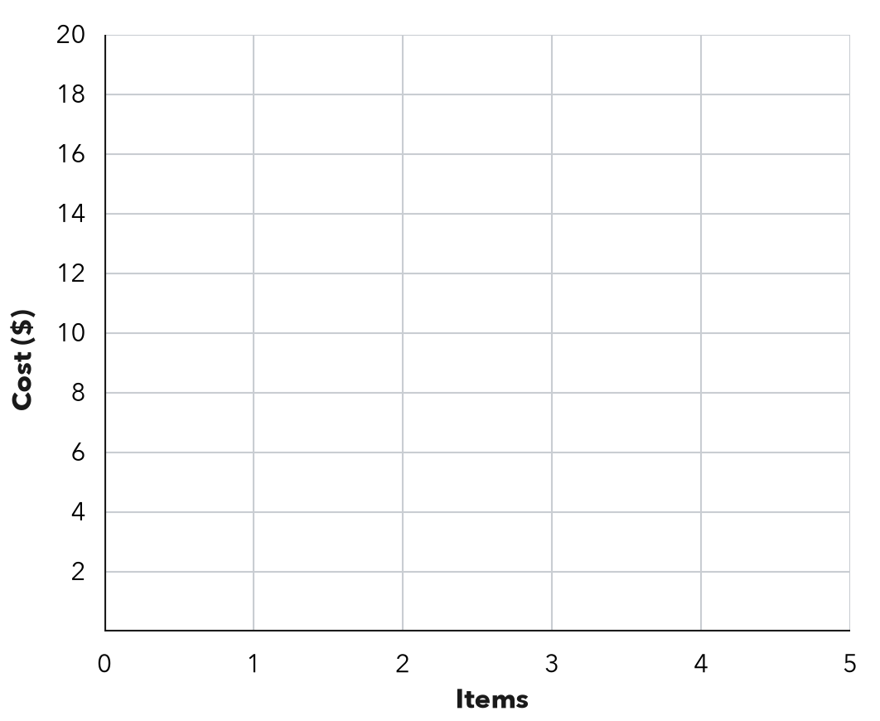

FIND THE ERROR explain the mistake, then fix it

9. Zuri’s Work. A car wash charges $6 per car. Zuri plotted the points (12, 2) and (30, 5). Explain her mistake and give the correct points.

TEST PRACTICE choose the best answer

10. A table row with x = 6 and y = 42 becomes the ordered pair —
A (42, 6) | B (6, 48) | C (6, 42) | D (7, 42)

11. At $8 per ticket, 5 tickets give the ordered pair —
A (8, 5) | B (5, 40) | C (40, 5) | D (5, 13)

SELF-CHECK CODE find your answer · copy its letter into that problem’s box · spell a math word
(8, 96)  P | (0, 3)  T | (84, 6)  X | (45, 3)  Q | (96, 8)  J | (3, 45)  O | (9, 36)  N | (0, 0)  Z | (6, 84)  I

#3 | #4 | #6 | #7c | #8

CHECK YOURSELF | □ I can do this on my own | □ I need a little help | □ I have a question about #

