Name Date Period
Lesson 9-2 · Session 2 · Practice · Form B
Analyzing a Graph
Learning target — I can read a relationship off a graph and describe the rate it shows. · 6.EE.C.9

REMEMBER  • The rate of change is how much y goes up when x goes up by 1: change in y ÷ change in x.  • If the line starts at (0, 0), divide y by x for one point: (4, 20) gives 20 ÷ 4 = 5.  • With the same scales, a steeper line has a greater rate. | WORKED EXAMPLE  A graph of hours (x) and dollars (y) passes through (2, 6) and (5, 15). Find the rate.  Step 1 Change in y: 15 − 6 = 9 dollars.  Step 2 Change in x: 5 − 2 = 3 hours.  Step 3 Divide: 9 ÷ 3 = 3.  Answer $3 per hour
WORDS rate of change (tasa de cambio) · unit rate (tasa unitaria) · steeper (más empinada)
PRACTICE show your work · label units

1. Find the rate of change of a line through the two points.
a. (1, 6) and (4, 24) | b. (3, 12) and (5, 20)
c. (2, 16) and (3, 24) | d. (1, 11) and (3, 33)

2. Kayak Rental. The graph shows the cost of renting a kayak.  a. What does (4, 24) mean?  b. Cost for 1 hour:  c. Cost for 3 hours: | 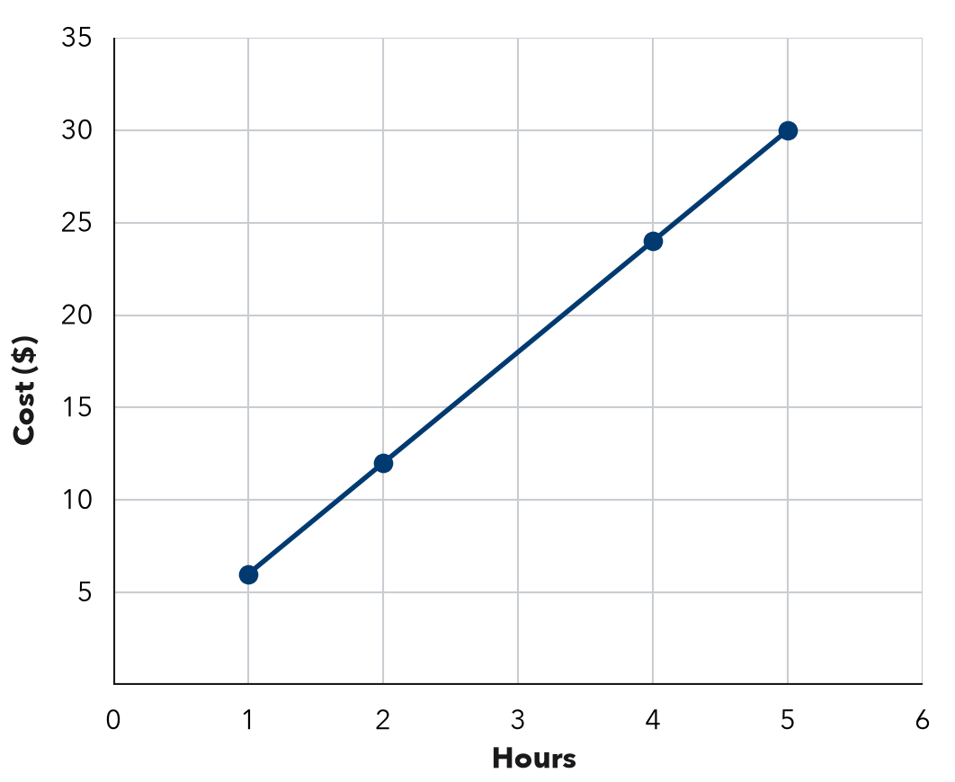

3. Bike Trail. A graph of hours (x) and miles (y) passes through (1, 3), (2, 6), (4, 12).  a. Miles each hour:  b. Miles after 7 hours: | 4. Photo Storage. A graph of photos (x) and megabytes (y) passes through (3, 15), (6, 30), (10, 50).  Hint Divide y by x.  a. Megabytes for one photo:  b. What does (6, 30) mean?

5. Bean Plant. A graph of weeks (x) and height in centimeters (y) passes through (2, 6), (4, 12), (6, 18).
Hint Two weeks apart: divide the jump by 2.
a. Find the rate of change.
b. Find the height at 11 weeks.

6. Two Pay Graphs. Job A’s pay graph passes through (1, 8) and (3, 24). Job B’s passes through (1, 5) and (3, 15). Which line is steeper? What does that mean?  Hint Find the pay for one hour on each line.  Steeper | 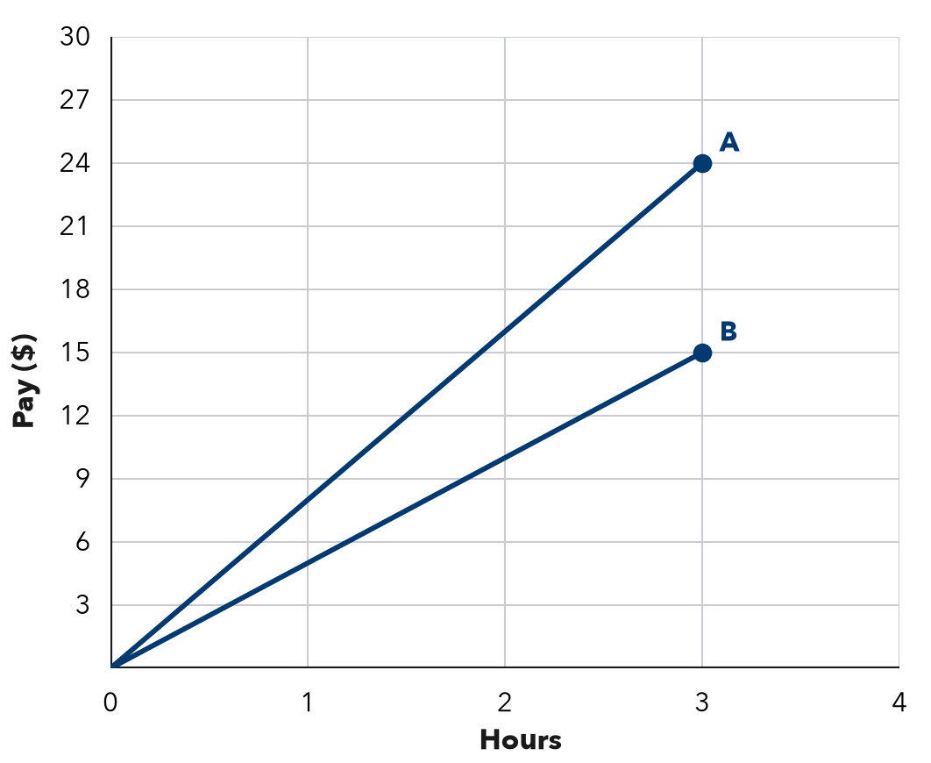
  Show your work.

7. Rain Barrel. A graph of hours (x) and liters (y) passes through (3, 60), (5, 100), (8, 160).
Hint Find the amount for 1 hour first.
a. Find the unit rate.
b. Write the ordered pair for 12 hours.

8. Cookie Boxes. A bake-sale graph shows boxes sold (x) and dollars raised (y). It passes through (4, 36) and (6, 54). Lena says (4, 36) means the club raises $36 for each box. Explain the mistake. How much is raised for each box?

Show your work.
$ per box

FIND THE ERROR explain the mistake, then fix it

9. Amir’s Work. A jogging graph shows minutes (x) and meters (y). It passes through (3, 120) and (6, 240). Amir said the jogger runs 120 meters each minute. Explain his mistake and find the rate.

TEST PRACTICE choose the best answer

10. A graph through (1, 7) and (2, 14) shows a rate of —
A 14 per unit | B 2 per unit | C 7 per unit | D 21 per unit

11. With the same scales, Line P is steeper than Line Q. This means —
A P has a smaller rate | B P has a greater rate
C P starts higher | D the rates are equal

SELF-CHECK CODE find your answer · copy its letter into that problem’s box · spell a math word
33  E | (12, 240)  E | 36  J | 24  Z | 66  Q | 18  S | 9  P | 21  T | (240, 12)  X

#2c | #3b | #5b | #7b | #8

CHECK YOURSELF | □ I can do this on my own | □ I need a little help | □ I have a question about #

