Name Date Period
Lesson 9-2 · Session 1 · Guided Notes
From Table to Graph
Learning target — I can turn a table of values into points and plot them on a graph. · 6.EE.C.9
WORDS TO KNOW fill in the missing words
WORD | WHAT IT MEANS | EXAMPLE
ordered pair  par ordenado | Two numbers (x, y) that tell where a is. | (3, 12)
coordinates  coordenadas | The numbers in an ordered pair. | x-coordinate 3, y-coordinate 12
axis  eje | One of the two on a graph. | x-axis across, y-axis up
plot  marcar | To a point on a graph. | right 3, up 12
KEY IDEA complete each sentence
• Each row of a table becomes an ordered pair: x , then y.
• To plot (x, y), start at (0, 0). Move x, then y.
WORKED EXAMPLE fill in the blanks as we solve
Plot the table for y = 4x with x = 1, 2, 3.
Step 1 The rows become ( , 4), (2, ) and (3, 12).
Step 2 Plot (1, 4): right 1, then up .
Answer The points line up in a line.
YOU TRY use the example as a model

1. Write the ordered pairs for y = 6x.
a. x = 1 | b. x = 2 | c. x = 4

2. Plot the points (1, 3), (2, 6) and (4, 12). What shape do they make?  Shape | 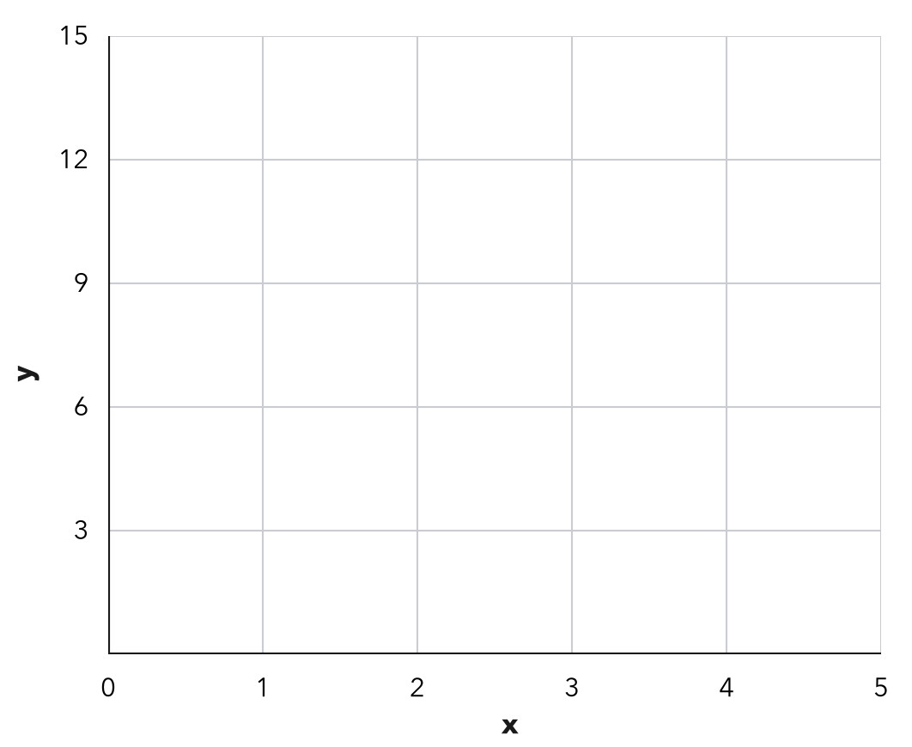

SUM IT UP in your own words
To turn a table into a graph, I , and I know the order matters because .
Name Date Period
Lesson 9-2 · Session 2 · Guided Notes
Analyzing a Graph
Learning target — I can read a relationship off a graph and describe the rate it shows. · 6.EE.C.9
WORDS TO KNOW fill in the missing words
WORD | WHAT IT MEANS | EXAMPLE
rate of change  tasa de cambio | How much y changes when x goes up by . | up $4 per hour
unit rate  tasa unitaria | The amount of y for unit of x. | 60 miles per hour
origin  origen | The point , where the two axes cross. | (0, 0)
steeper  más empinada | A line that rises as you move right. | up 9 per hour beats up 2
KEY IDEA complete each sentence
• Rate of change = change in y change in x.
• If a line goes through (0, 0), divide by x for any point on it.
WORKED EXAMPLE fill in the blanks as we solve
A graph of hours (x) and dollars (y) passes through (2, 6) and (5, 15). Find the rate.
Step 1 Change in y: 15 − 6 = dollars.
Step 2 Change in x: 5 − 2 = hours.
Step 3 Divide: 9 ÷ 3 = .
Answer The rate is $ per hour.
YOU TRY use the example as a model

1. A line passes through (0, 0) and the point. Find the unit rate.
a. (4, 20) | b. (6, 42)

2. A graph of hours (x) and miles (y) passes through (2, 8) and (5, 20). Find the rate. Then find the miles at 9 hours.

Show your work.
Rate; miles

SUM IT UP in your own words
A steeper line means because .

