Name Date Period
Lesson 2-1 · Homework Packet · Sheet 1 of 2
Statistical Questions
Maryland Standard 6.SP.A.1 · Learning target — I can tell whether a question is statistical by deciding if the answers will vary.

REMEMBER  • A statistical question expects answers that vary. You collect data to answer it.  • A non-statistical question has one fixed answer, like a fact you can look up.  • A number answer alone does not make a question statistical. Ask: “Will the answers be different?” | WORKED EXAMPLE  Is “How many minutes does each student in Room 12 ride the bus?” statistical?  Step 1 Who answers? Every student in Room 12.  Step 2 Will the answers differ? Yes: 5 min, 12 min, 25 min …  Step 3 The answers vary, so you need data.  Answer Statistical
PRACTICE show your work · label units
1. Write S if the question is statistical or N if it is non-statistical.
Question | S or N
How many feet are in one yard?
How many hours did each sixth grader sleep last night?
What is the price of a bus ticket in Baltimore today?
How many glasses of water does each person in my family drink a day?

2. Name Lengths. Ms. Adeyemi asks each student, “How many letters are in your first name?” Five students answer 5, 4, 7, 5, and 6. Is her question statistical? Use the answers to explain.
□ Statistical | □ Not statistical
Because

3. Survey Plan. Is “How far does each player live from the field?” statistical?
□ Statistical | □ Not statistical

4. Rewrite It. Carlos asks, “How tall is the oak tree in front of our school?” Explain why this is not statistical. Then rewrite it as a statistical question.

5. Your Turn. Write a statistical question you could ask the people in your family. Then list three answers you might get.

CHECK YOURSELF | □ I can do this on my own | □ I need a little help | □ I have a question about #
AT HOME Ask a family member one statistical question and one non-statistical question. Can they tell which is which?
Name Date Period
Lesson 2-1 · Homework Packet · Sheet 2 of 2
Dot Plots and Shape
Maryland Standard 6.SP.B.4 · Learning target — I can build a dot plot and describe the shape of the data it shows.

REMEMBER  • A dot plot shows one dot per data value.  • Peak: tallest stack. Gap: no dots. Outlier: far away.  • Symmetric: the sides match. Skewed right/left: the tail goes that way. | WORKED EXAMPLE  Pets owned: 0, 0, 1, 1, 1, 1, 2, 2, 3, 5. Name the shape.  Step 1 Stacks: 2 dots at 0, 4 at 1, 2 at 2, 1 at 3, 1 at 5.  Step 2 Peak at 1. The tail stretches right to 5.  Answer Skewed right
PRACTICE show your work · label units

1. Books Read. Books read in May by 12 students: 2, 3, 1, 3, 4, 2, 3, 5, 3, 2, 4, 4. Make a dot plot.  a. Peak:  b. Shape: | 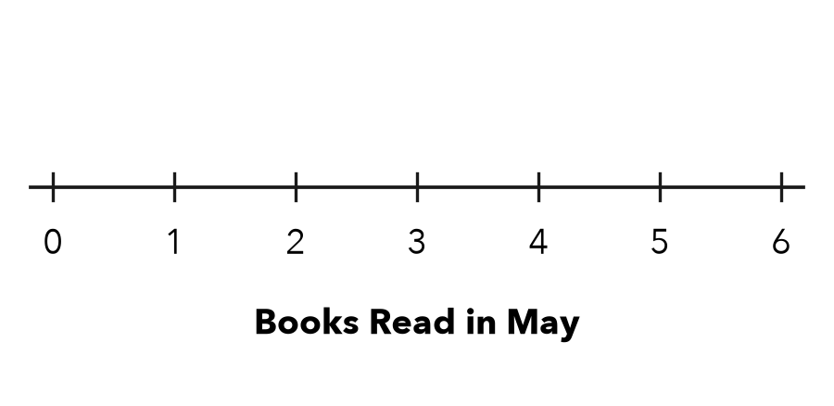

2. Arcade Tickets. Tickets won by 9 friends: 5, 3, 4, 5, 2, 5, 4, 6, 5. Picture the dot plot.
a. Dots at 5: | b. Peak: | c. Shape:

3. Soccer Goals. The dot plot shows the goals a team scored in each game.  a. Games played:  b. Most common:  c. Where is the gap? | 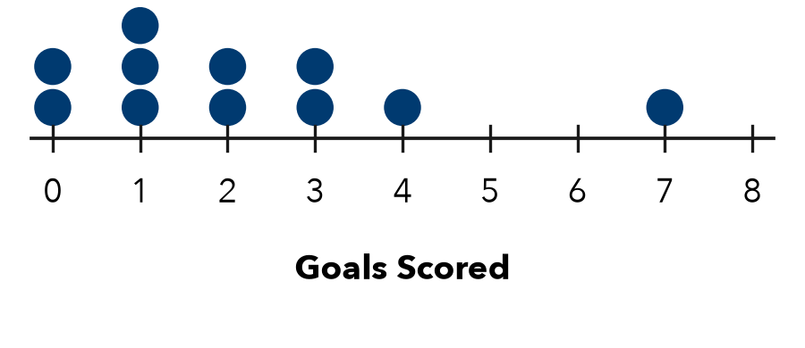

4. Find the Error. Leah says the Soccer Goals plot is skewed left. Explain her error.

5. Quiz Scores. 1 dot at 5, 1 at 6, 2 at 7, 4 at 8, 5 at 9, and 3 at 10. Name the shape.
□ Symmetric | □ Skewed left | □ Skewed right

TEST PRACTICE choose the best answer
6. Stacks of 1, 3, 5, 3, and 1 dots sit above 2, 3, 4, 5, and 6. Which word describes the shape?
A Symmetric | B Skewed left | C Skewed right | D Has a gap

7. A dot plot has 4 dots above 10, 6 above 11, 2 above 12, and 3 above 13. How many values?
A 4 | B 6 | C 13 | D 15

CHECK YOURSELF | □ I can do this on my own | □ I need a little help | □ I have a question about #
AT HOME Count the letters in each family member’s first name. Make a dot plot and name its shape.

Name Date Period
Lesson 2-2 · Homework Packet · Sheet 1 of 2
Building a Histogram
Maryland Standard 6.SP.B.4 · Learning target — I can group data into equal intervals and build a histogram from a frequency table.

REMEMBER  • A histogram groups data into equal intervals, like 0–9, 10–19, 20–29.  • The frequency is how many values fall in an interval. It sets the bar height.  • Intervals do not overlap, and the bars touch. | WORKED EXAMPLE  Minutes of practice: 4, 15, 22, 9, 18, 27, 13, 16, 21, 11. Make a frequency table.  Step 1 0–9: 4, 9, so the frequency is 2.  Step 2 10–19: 15, 18, 13, 16, 11, so it is 5.  Step 3 20–29: 22, 27, 21, so it is 3.  Answer 2, 5, 3
PRACTICE show your work · label units
1. Points Scored. A player scored these points in 12 games: 8, 14, 21, 5, 17, 12, 25, 19, 11, 23, 16, 9. Complete the frequency table.
Points | Tally | Frequency
0–9
10–19
20–29

2. Draw the histogram for Problem 1. Bars should touch.  a. Which interval has the tallest bar?  b. Games with 10 or more points: | 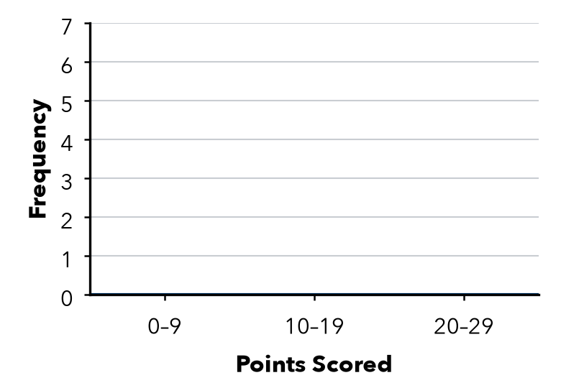

3. Picnic Ages. 34, 22, 41, 38, 27, 45, 31, 36, 29, 48 years. Find each frequency.
a. 20–29: | b. 30–39: | c. 40–49:

4. Missing Bar. A histogram shows the long-jump distances of 24 students. Three bars have heights 5, 9, and 3. There is one more bar. How tall is it?
Answer students

5. Find the Error. Marcus used the intervals 0–9, 10–14, and 15–29. Explain his mistake and fix it.

CHECK YOURSELF | □ I can do this on my own | □ I need a little help | □ I have a question about #
AT HOME Ask family members how many minutes they read today. Group the answers in intervals of 10.
Name Date Period
Lesson 2-2 · Homework Packet · Sheet 2 of 2
Describing Histogram Shape
Maryland Standard 6.SP.B.4 · Learning target — I can describe the shape of a histogram using its peak, spread, and balance.

REMEMBER  • Peak: the tallest bar. Symmetric: sides match.  • Skewed right: the tail stretches right. Skewed left: the tail stretches left.  • A histogram shows counts, not exact values. | WORKED EXAMPLE  Bars of height 2, 7, 4, 2, 1 over 0–9, 10–19, 20–29, 30–39, 40–49. Shape?  Step 1 The peak is 10–19, near the left.  Step 2 The bars shrink to the right: a tail on the right.  Answer Skewed right
PRACTICE show your work · label units

1. Test Scores. The histogram shows the scores on a class test.  a. Number of students:  b. Peak interval:  c. Shape:  d. Scores of 80 or more: | 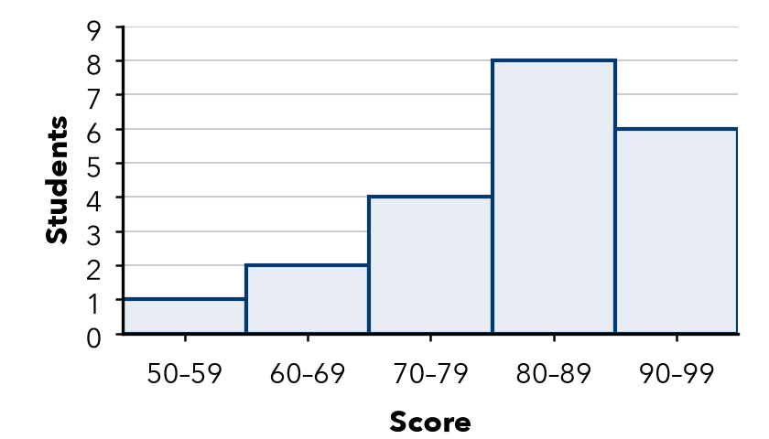

2. Bar heights are listed from left to right. Name each shape.
a. 1, 4, 8, 4, 1 | b. 9, 6, 3, 2, 1 | c. 1, 2, 3, 6, 10
d. 3, 5, 9, 5, 3 | e. 12, 8, 5, 3, 2 | f. 2, 3, 5, 8, 12

3. Race Times. Bars of 3, 8, 11, 6, 2 show 30 runners’ times: 20–24, 25–29, 30–34, 35–39, 40–44 min.
a. How many runners finished in less than 30 minutes?
b. How many finished in 35 minutes or more?

4. Stretch. Write 5 bar heights, from left to right, for a histogram of 20 values that is skewed left.
Bar heights

5. Explain. Ramon says the Test Scores histogram shows a score of 85. Is he right? Explain.

TEST PRACTICE choose the best answer
6. Bar heights are listed from left to right. Which histogram is skewed right?
A 2, 5, 9, 5, 2 | B 10, 7, 4, 2, 1 | C 1, 2, 4, 7, 10 | D 5, 5, 5, 5, 5

7. Bars of height 4, 7, and 5 sit over 0–9, 10–19, and 20–29. How many values are 10 or more?
A 7 | B 11 | C 12 | D 16

CHECK YOURSELF | □ I can do this on my own | □ I need a little help | □ I have a question about #

Name Date Period
Lesson 2-3 · Homework Packet · Sheet 1 of 2
Finding the Median
Maryland Standard 6.SP.B.5c · Learning target — I can find the median of a data set by ordering the values and taking the middle one.

REMEMBER  • The median is the middle value of a data set.  • First order the values from least to greatest.  • With an odd number of values, one value sits in the middle. | WORKED EXAMPLE  Find the median of 14, 9, 21, 6, 17.  Step 1 Order: 6, 9, 14, 17, 21  Step 2 Cross off one from each end until one is left: 14.  Answer Median = 14
PRACTICE show your work · label units
1. Find the median of each data set.
a. 8, 3, 6 | b. 12, 18, 10, 15, 11
c. 25, 40, 35, 30, 20 | d. 7, 2, 9, 4, 5, 8, 1

2. Sleep. The dot plot shows how many hours some students slept last night.  a. Number of students:  b. Median: hours | 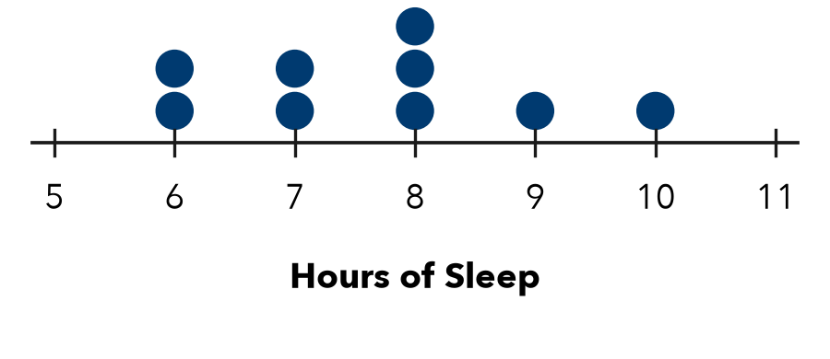

3. Bike Rides. Kiara rode her bike 7 times. She rode 4, 11, 7, 15, 9, 6, and 12 miles. Find the median distance.

Show your work.
Answer miles

4. Missing Score. Four of five scores are 82, 90, 75, 88. The median is 85. Find the fifth.
Answer points

5. Build a Set. Write a set of 5 different whole numbers that has a median of 12.
My set

6. Reason. The data set 4, 6, 9, 11, 30 has a median of 9. If 30 changes to 100, does the median change? Explain.

CHECK YOURSELF | □ I can do this on my own | □ I need a little help | □ I have a question about #
AT HOME Ask 5 people at home how many letters are in their first name. Find the median.
Name Date Period
Lesson 2-3 · Homework Packet · Sheet 2 of 2
Median of an Even Data Set
Maryland Standard 6.SP.B.5c · Learning target — I can find the median of a data set with an even number of values by averaging the two middle values.

REMEMBER  • With an even number of values, there are two middle values.  • The median is halfway between them: add the two, then divide by 2.  • The median does not have to be a data value. | WORKED EXAMPLE  Find the median of 12, 7, 15, 10, 20, 9.  Step 1 Order: 7, 9, 10, 12, 15, 20  Step 2 Two middle values: 10 and 12  Step 3 (10 + 12) ÷ 2 = 22 ÷ 2 = 11  Answer Median = 11
PRACTICE show your work · label units
1. Find the median of each data set.
a. 3, 9, 5, 7 | b. 20, 14, 18, 12
c. 11, 6, 9, 4, 13, 8 | d. 30, 45, 35, 50, 40, 25
e. 16, 9, 21, 12, 30, 14, 25, 10 | f. 5, 11, 8, 5

2. Cousins. The dot plot shows how many cousins 10 students have.  a. Two middle values:  b. Median: | 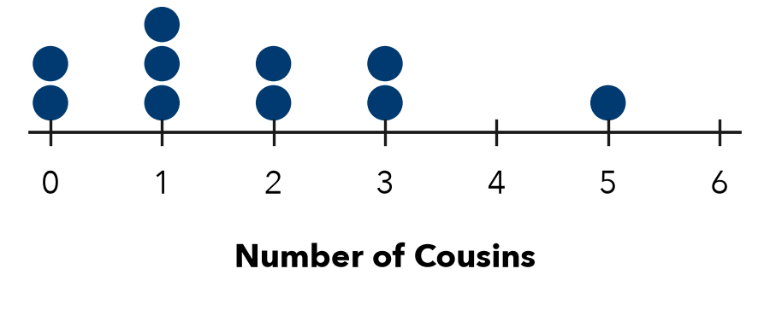

3. Puppies. Six puppies weigh 8, 12, 5, 15, 10, and 7 pounds. Find the median weight.
Answer pounds

4. Work Backward. Four values in order are 6, 10, , 20. The median is 12. Find the missing value.
Missing value

5. Find the Error. Ana says the median of 8, 2, 10, 6 is (2 + 10) ÷ 2 = 6. Explain her error.

TEST PRACTICE choose the best answer
6. What is the median of 15, 9, 12, 20?
A 13.5 | B 12 | C 14 | D 10.5

7. Six values have a median of 30. Which could be the two middle values?
A 28 and 32 | B 30 and 34 | C 25 and 30 | D 29 and 30

CHECK YOURSELF | □ I can do this on my own | □ I need a little help | □ I have a question about #
AT HOME Ask 4 or 6 people at home their shoe size. Find the median.

Name Date Period
Lesson 2-4 · Homework Packet · Sheet 1 of 2
Building a Box Plot
Maryland Standard 6.SP.B.4 · Learning target — I can find the five-number summary of a data set and use it to build a box plot.

REMEMBER  • Five-number summary: minimum, Q1, median, Q3, maximum.  • Q1 is the median of the lower half; Q3 of the upper half. Odd count: leave the median out.  • The box goes from Q1 to Q3, with a line at the median. Whiskers reach the min and max. | WORKED EXAMPLE  Find the five-number summary of 4, 6, 9, 10, 13, 15, 18.  Step 1 Min = 4, max = 18, median = 10  Step 2 Lower half 4, 6, 9, so Q1 = 6  Step 3 Upper half 13, 15, 18, so Q3 = 15  Answer 4, 6, 10, 15, 18
PRACTICE show your work · label units
1. Push-ups. Nine students did 22, 40, 10, 34, 18, 46, 25, 14, and 30 push-ups. Find the five-number summary.
Min | Q1 | Median | Q3 | Max

2. Draw a box plot of the push-up data from Problem 1.
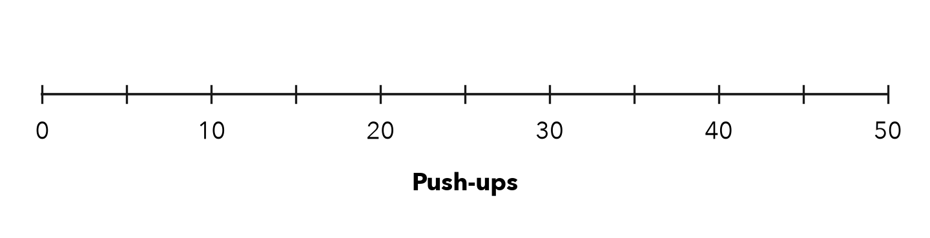

3. Temperatures. The box plot shows daily high temperatures (°F) for a month.  a. Median: °F  b. Q1 and Q3:  c. Fraction of days from 58 to 70°F: | 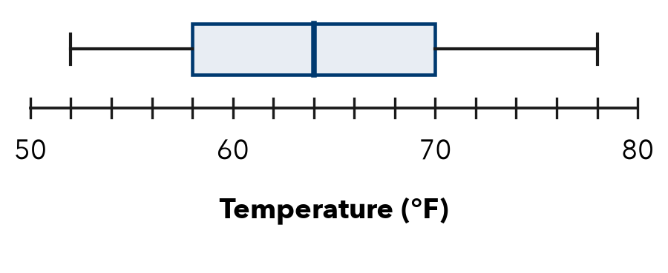

4. Homework Minutes. 26, 14, 39, 20, 11, 32, 18, 28. Find each value.
a. Q1: | b. Median: | c. Q3:

5. Find the Error. Grace says Q1 of 2, 5, 7, 8, 12, 14, 20 is 6. She used 2, 5, 7, 8 as the lower half. Explain her error and find Q1.

CHECK YOURSELF | □ I can do this on my own | □ I need a little help | □ I have a question about #
AT HOME Explain to someone at home what the box in a box plot shows.
Name Date Period
Lesson 2-4 · Homework Packet · Sheet 2 of 2
Comparing Box Plots
Maryland Standard 6.SP.B.4 · Learning target — I can compare two groups by reading the medians and box widths of their box plots.

REMEMBER  • Compare centers: use the medians.  • Compare spread: box width and range.  • A narrower box (Q3 − Q1) is more consistent. | WORKED EXAMPLE  A: median 18, box 14–22. B: median 24, box 20–26.  Step 1 Center: 24 > 18, so B scored higher.  Step 2 Box widths: A is 22 − 14 = 8; B is 26 − 20 = 6.  Answer B is higher and more consistent
PRACTICE show your work · label units

1. Reading Time. Minutes of reading per day for Class A and Class B.  a. Greater median: by min  b. Box widths: A B  c. More consistent: | 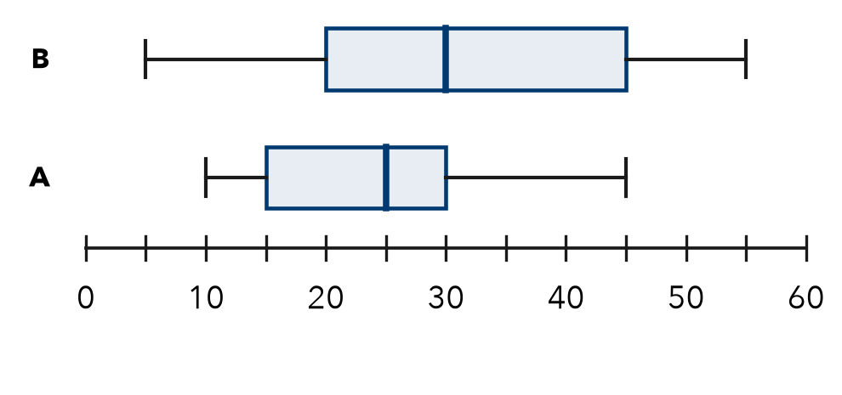

2. Find each measure of spread.
a. Q1 = 12, Q3 = 30. Box width: | b. Min = 5, max = 41. Range:

3. Bowling. Complete the table for two bowlers’ scores.
 | Min | Q1 | Median | Q3 | Max | Box width | Range
Maya | 80 | 95 | 102 | 110 | 125
Leon | 70 | 90 | 105 | 112 | 140
Who is more consistent?

4. Plant Heights. Both medians are 14 cm. Box S: 12–16 cm. Box T: 8–20 cm. Which varies more?
□ Group S | □ Group T

5. Choose a Bus. Both medians are 20 min. Boxes: A 18–22, B 14–26 min. Which is more reliable?

TEST PRACTICE choose the best answer
6. X: Q1 = 22, Q3 = 34. Y: Q1 = 25, Q3 = 31. Which middle half is more consistent?
A X | B Y | C They are equal | D Cannot tell

7. A box plot has the summary 8, 12, 15, 21, 30. How wide is the box?
A 9 | B 22 | C 15 | D 3

CHECK YOURSELF | □ I can do this on my own | □ I need a little help | □ I have a question about #

Name Date Period
Lesson 2-5 · Homework Packet · Sheet 1 of 2
Range and IQR
Maryland Standard 6.SP.B.5c · Learning target — I can find the range and the interquartile range of a data set.

REMEMBER  • Range = maximum − minimum. It is the spread of all the data.  • IQR (interquartile range) = Q3 − Q1. It is the spread of the middle half.  • One extreme value changes the range a lot but the IQR very little. | WORKED EXAMPLE  Find the range and IQR of 3, 7, 8, 10, 12, 15, 20.  Step 1 Range: 20 − 3 = 17  Step 2 Median 10. Q1 = 7 (of 3, 7, 8). Q3 = 15 (of 12, 15, 20).  Step 3 IQR: 15 − 7 = 8  Answer Range 17, IQR 8
PRACTICE show your work · label units
1. Find each measure.
a. Range of 14, 6, 21, 9: | b. Range of 52, 38, 47, 60:
c. IQR when Q1 = 18, Q3 = 31: | d. IQR when Q1 = 40, Q3 = 56:
e. Range of 75, 90, 68, 83: | f. IQR when Q1 = 7, Q3 = 25:

2. Pages Read. The box plot shows pages read by students in one week.  a. Range: pages  b. IQR: pages | 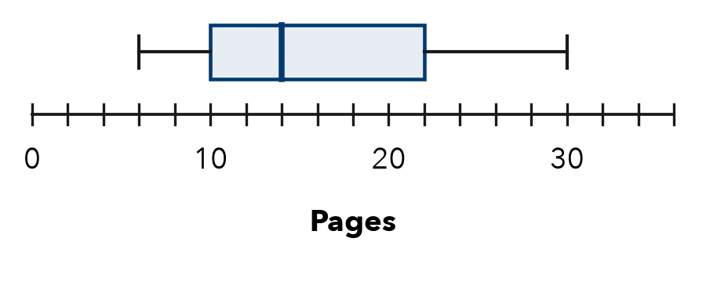

3. Jump Rope. Seven students jumped rope 35, 52, 41, 60, 28, 47, and 55 times. Find the range and the IQR.
a. Range:
b. IQR:

Show your work.

4. Work Backward. A data set has a minimum of 14 and a range of 29. Its Q1 is 20 and its IQR is 11.
a. Maximum:
b. Q3:

5. Find the Error. Mateo says the IQR is always half of the range. Use the Jump Rope data to explain why he is wrong.

CHECK YOURSELF | □ I can do this on my own | □ I need a little help | □ I have a question about #
AT HOME Ask family members their ages. Find the range of the ages.
Name Date Period
Lesson 2-5 · Homework Packet · Sheet 2 of 2
Comparing Variability
Maryland Standard 6.SP.B.5c · Learning target — I can compare the variability of two data sets using range and IQR.

REMEMBER  • More range or IQR = more variability.  • Less variability = more consistent. Compare range with range, IQR with IQR.  • With an extreme value, use the IQR. | WORKED EXAMPLE  Team P: IQR 6 points. Team Q: IQR 15 points. Which is more consistent?  Step 1 6 < 15, so Team P’s middle half is closer.  Answer Team P
PRACTICE show your work · label units
1. Find each IQR.
a. Set P: Q1 = 30, Q3 = 42 | b. Set Q: Q1 = 33, Q3 = 39

2. Basketball. Points per game: Player 1: 8, 10, 11, 12, 13, 14, 16. Player 2: 2, 6, 9, 12, 15, 18, 22.
 | Range | IQR
Player 1
Player 2
More consistent player

3. Spelling Scores. Group A scored 70, 72, 75, 78, 80. Group B scored 55, 65, 75, 85, 95.
Ranges: A B More consistent group:

4. Bus Routes. The box plots show ride times in minutes.  a. Ranges: 1 2  b. IQRs: 1 2 | 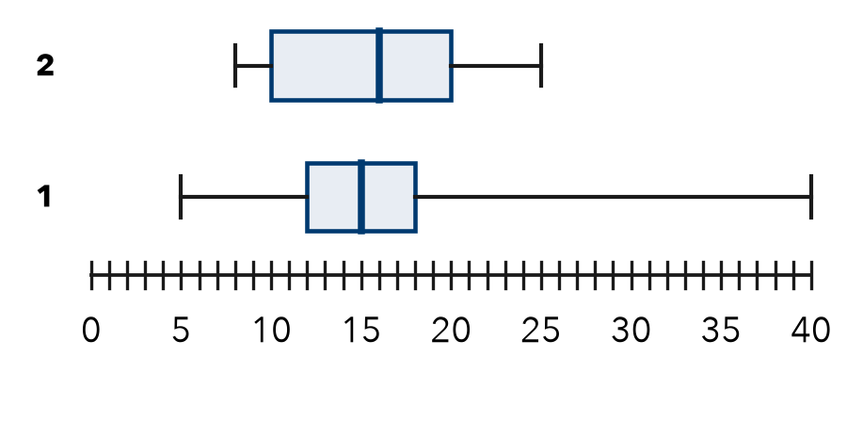

5. Jada says Route 2 is more consistent. Kwame says Route 1 is. Who is right? Why?

TEST PRACTICE choose the best answer
6. Class A’s scores have a range of 12. Class B’s have a range of 30. Whose scores vary less?
A Class A | B Class B | C Both the same | D Cannot tell

7. What is the IQR of 4, 6, 7, 9, 10, 12, 15?
A 6 | B 11 | C 4.5 | D 9

CHECK YOURSELF | □ I can do this on my own | □ I need a little help | □ I have a question about #

Name Date Period
Lesson 2-3 · Homework Packet · Sheet 1 of 2
Median and Outliers
Maryland Standard 6.SP.B.5d · Learning target — I can explain why the median is a better measure of center than the mean when a data set has an outlier.

REMEMBER  • An outlier is a value much greater or much less than the rest of the data.  • An outlier pulls the mean toward it. The median barely moves, so it is resistant to outliers.  • With an outlier, the median usually describes a typical value better. Still report the outlier; it is real data. | WORKED EXAMPLE  Six bike rides lasted 14, 18, 15, 16, 64, and 17 minutes. The mean is 24 minutes. Which measure better describes a typical ride?  Step 1 Order: 14, 15, 16, 17, 18, 64. The outlier is 64.  Step 2 Median: (16 + 17) ÷ 2 = 16.5. The mean, 24, is greater than 5 of the 6 rides.  Answer The median, 16.5 minutes
PRACTICE show your work · label units
1. Find the median of each data set. Circle the outlier in each set.
a. 9, 11, 10, 12, 13, 8, 48 | b. 3, 70, 72, 75, 78, 71, 74
c. 25, 28, 30, 31, 33, 95 | d. 40, 41, 43, 44, 46, 47, 150
e. 6, 7, 7, 8, 9, 10, 34 | f. 56, 52, 55, 54, 9, 53, 57, 58

2. Homework Minutes. The dot plot shows minutes 10 students spent on homework one night. The mean is 31 minutes.  a. Outlier:  b. Median: min  c. Students below the mean:  d. Better center: | 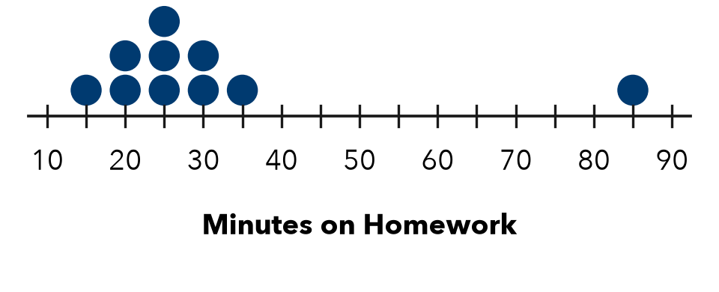

3. Library Visitors. Visitors on 7 days: 64, 58, 61, 66, 59, 63, and 4 (the library closed early for snow).
a. Median of all 7 days: | b. Median without the 4:

4. Car Wash. A club earned $10, $12, $13, $14, $15, $16, and $60 on 7 Saturdays.
a. Mean: $ | b. Median: $ | c. Better center:

5. Find the Error. Andre’s data are 31, 33, 34, 36, 37, 39, and 210. He says, “The outlier 210 makes the median much bigger, so the median is not a good measure.” Is he right? Find the median to support your answer.

CHECK YOURSELF | □ I can do this on my own | □ I need a little help | □ I have a question about #
AT HOME Ask someone at home about a normal trip and their slowest trip. Which trip is an outlier?
Name Date Period
Lesson 2-3 · Homework Packet · Sheet 2 of 2
Comparing Distributions
Maryland Standard 6.SP.B.5d · Learning target — I can compare two distributions using the median and the interquartile range together.

REMEMBER  • Compare centers with the medians. Compare spreads with the IQRs (IQR = Q3 − Q1).  • A smaller IQR means more consistent data. A full comparison names both measures for both groups, with numbers. | WORKED EXAMPLE  Team Red: median 14 points, IQR 6. Team Blue: median 18 points, IQR 15. Compare the teams.  Step 1 Centers: 18 > 14, so Blue usually scores more.  Step 2 Spreads: 6 < 15, so Red is more consistent.  Answer Blue scores more; Red is more consistent.
PRACTICE show your work · label units

1. Reading Minutes. The box plots show minutes read per day by Class A and Class B.  a. Medians: A B  b. IQRs: A B  c. Usually reads more:  d. More consistent: | 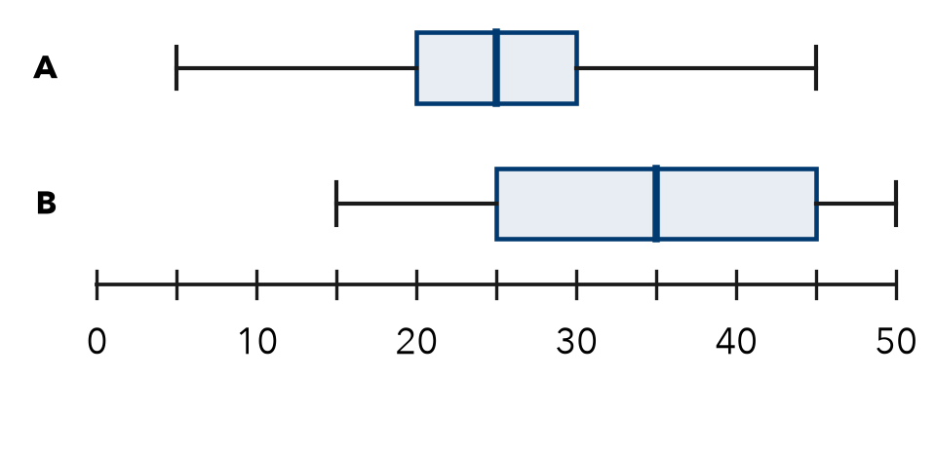

2. Bus Routes. Minutes late on 7 days. Route 3: 2, 3, 5, 6, 8, 9, 11. Route 8: 0, 1, 4, 6, 10, 14, 15.
a. Route 3: median IQR Route 8: median IQR
b. Which route is more predictable? Why?

3. Plant Heights (cm). Sun: 10, 12, 13, 15, 16, 18, 19, 21. Shade: 6, 7, 8, 8, 9, 10, 10, 12.
a. Sun: median cm IQR cm | b. Shade: median cm IQR cm

4. Delivery. Shop K: median 28 min, IQR 8 min. Shop L: median 36 min, IQR 8 min. What is the same?
□ the same center | □ the same spread | □ both center and spread

5. Find the Error. Set E: median 70, IQR 25. Set F: median 64, IQR 6. Jada says, “Set E is higher and more consistent.” Explain her error.

TEST PRACTICE choose the best answer
6. Group 1: median 12 cm, IQR 3 cm. Group 2: median 12 cm, IQR 9 cm. Which is more consistent?
A Group 1 | B Group 2 | C Both the same | D Cannot tell

7. What is the IQR of 3, 5, 6, 8, 10, 12, 13?
A 7 | B 8 | C 10 | D 17

CHECK YOURSELF | □ I can do this on my own | □ I need a little help | □ I have a question about #
AT HOME Tell someone at home why a bus with a small IQR is easier to plan around.

Name Date Period
Lesson 2-7 · Homework Packet · Sheet 1 of 2
Dividing a Decimal by a Whole Number
Maryland Standard 6.NS.B.3 · Learning target — I can divide a decimal by a whole number and place the decimal point correctly.

REMEMBER  • Divide as you do with whole numbers. Put the decimal point in the quotient straight above the point in the dividend.  • If an amount is left over, annex a zero (write 0 after the last digit) and keep dividing.  • Check: quotient × divisor = dividend. Estimate first to catch a misplaced point. | WORKED EXAMPLE  Four friends share 22.2 kg of potting soil equally. How much does each get?  Step 1 Estimate: 22 ÷ 4 is about 5.5. Put the point straight above.  Step 2 22 ÷ 4 = 5 R2. Then 22 tenths ÷ 4 = 5 tenths R2.  Step 3 Annex a zero: 20 hundredths ÷ 4 = 5 hundredths.  Answer 5.55 kg each (5.55 × 4 = 22.2)
PRACTICE show your work · label units
1. Find each quotient.
a. 9.6 ÷ 3 = | b. 18.5 ÷ 5 = | c. 2.94 ÷ 7 =
d. 0.56 ÷ 8 = | e. 31.2 ÷ 6 = | f. 9.3 ÷ 6 =

2. Bulk Rice. A 12-pound bag of rice costs $16.80. What is the cost per pound?

Show your work.
Answer per pound

3. Relay Race. 8 runners split a 10.2-kilometer relay equally. How far does each runner go?

Show your work.
Answer km

4. Better Buy. Store A sells 4 cans of beans for $3.56. Store B sells 6 cans for $5.10.
a. A, per can: $ | b. B, per can: $ | c. Better buy:

5. Find the Error. Marcus wrote 4.35 ÷ 5 = 8.7. Use an estimate to explain his mistake. Then give the correct quotient.

CHECK YOURSELF | □ I can do this on my own | □ I need a little help | □ I have a question about #
AT HOME At the store, find a pack of several items. Divide the price by the number of items to find the cost of one.
Name Date Period
Lesson 2-7 · Homework Packet · Sheet 2 of 2
Dividing by a Decimal
Maryland Standard 6.NS.B.3 · Learning target — I can divide by a decimal by making the divisor a whole number first.

REMEMBER  • Make the divisor whole: move both decimal points the same number of places right. The quotient does not change: 4.8 ÷ 0.6 = 48 ÷ 6.  • Annex zeros in the dividend if needed. Dividing by a number less than 1 gives a quotient greater than the dividend. | WORKED EXAMPLE  How many 0.15-liter cups can be filled from 4.5 liters of juice?  Step 1 Make 0.15 whole: 0.15 × 100 = 15.  Step 2 Do the same to 4.5: 4.5 × 100 = 450.  Step 3 450 ÷ 15 = 30. Check: 30 × 0.15 = 4.5  Answer 30 cups
PRACTICE show your work · label units
1. Rewrite with a whole-number divisor. Then divide.
a. 4.8 ÷ 0.6 = | b. 2.75 ÷ 0.5 = | c. 0.96 ÷ 0.12 =
d. 9 ÷ 0.3 = | e. 1.68 ÷ 0.04 = | f. 13.2 ÷ 1.1 =

2. Pillows. Leon has 7.5 yards of fabric. Each pillow uses 1.25 yards. How many pillows can he make?

Show your work.
Answer pillows

3. Juice Glasses. A pitcher holds 2.4 liters of juice. How many glasses can it fill?
a. 0.3-liter glasses: | b. 0.2-liter glasses:

4. Walking Path. One lap of a park path is 0.75 mile. How many laps make each distance?
a. 4.5 miles: laps | b. 6 miles: laps

5. Find the Error. Keisha wrote 2.4 ÷ 0.08 = 24 ÷ 8 = 3. Explain her error. Find the correct quotient.

TEST PRACTICE choose the best answer
6. Which division has the same quotient as 6.72 ÷ 0.8?
A 672 ÷ 8 | B 67.2 ÷ 8 | C 6.72 ÷ 8 | D 67.2 ÷ 80

7. How many 0.4-pound bags can be filled from 15.6 pounds of trail mix?
A 3.9 | B 6.24 | C 39 | D 390

CHECK YOURSELF | □ I can do this on my own | □ I need a little help | □ I have a question about #
AT HOME Tell someone at home why 6 ÷ 0.5 is greater than 6.

Name Date Period
Lesson 2-8 · Homework Packet · Sheet 1 of 2
Finding the Mean
Maryland Standard 6.SP.B.5c · Learning target — I can find the mean of a data set by sharing the total equally among the values.

REMEMBER  • The mean is a fair share: add all the values, then divide by how many values there are.  • Mean = sum ÷ number of values. Count every value, including repeats and zeros.  • The mean is between the least and greatest values. It does not have to be in the data set. | WORKED EXAMPLE  Kiara read 12, 9, 15, 8, and 11 pages on five nights. Find the mean.  Step 1 Add: 12 + 9 + 15 + 8 + 11 = 55  Step 2 Count: there are 5 values.  Step 3 Divide: 55 ÷ 5 = 11. Check: 11 is between 8 and 15.  Answer 11 pages
PRACTICE show your work · label units
1. Find the mean of each data set.
a. 6, 9, 12 | b. 15, 20, 25, 40 | c. 7, 0, 5, 8
d. 3, 3, 9, 4, 6 | e. 2.5, 3.5, 4.5 | f. 18, 22, 14, 26, 30

2. Soccer Goals. The dot plot shows the goals a team scored in each game this season.  a. Total goals:  b. Number of games:  c. Mean goals per game: | 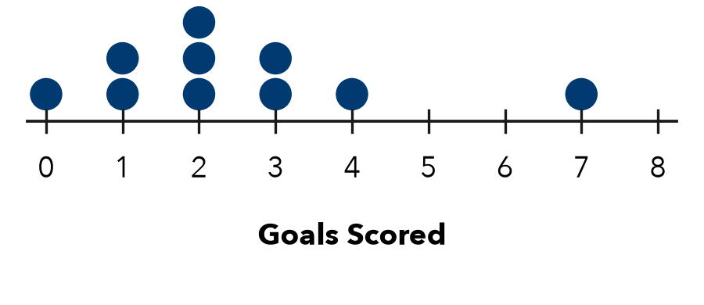

3. Rainfall. Rain fell on five days: 0.4 in, 1.2 in, 0 in, 0.9 in, and 0.5 in. Find the mean daily rainfall.

Show your work.
Answer in

4. New Value. The mean of 8, 10, and 12 is 10. A fourth value, 20, is added. What happens to the mean?
□ It goes up. | □ It goes down. | □ It stays the same.
New mean

5. Find the Error. To find the mean of 8, 0, 6, and 10, Darnell added to get 24. Then he divided by 3 because “zero does not count.” Explain his error and find the mean.

CHECK YOURSELF | □ I can do this on my own | □ I need a little help | □ I have a question about #
AT HOME Ask 4 people at home how many glasses of water they drink in a day. Find the mean.
Name Date Period
Lesson 2-8 · Homework Packet · Sheet 2 of 2
Reaching a Target Mean
Maryland Standard 6.SP.B.5c · Learning target — I can find the value a data set still needs in order to reach a target mean.

REMEMBER  • Target total = target mean × number of values (count the missing value too).  • Missing value = target total − sum so far. Check: the new total ÷ count should equal the target mean. | WORKED EXAMPLE  Jamal’s quiz scores are 78, 85, and 90. What score on quiz 4 gives a mean of 85?  Step 1 Target total: 85 × 4 = 340  Step 2 Sum so far: 78 + 85 + 90 = 253  Step 3 Missing: 340 − 253 = 87. Check: 340 ÷ 4 = 85  Answer 87 points
PRACTICE show your work · label units
1. Complete the table.
 | Values | Target mean | Target total | Sum so far | Missing value
A | 3 | 12 |  | 25
B | 4 |  | 64 | 49

2. Bowling. Aaliyah bowled 112, 98, 105, and 121. What score in game 5 gives her a mean of 110?
Answer points

3. Car Wash. A club raised $45, $60, $52, and $38 on four Saturdays. What must it raise on the fifth Saturday for a mean of $50?
Answer

4. Push-Ups. The dot plot shows how many push-ups Nia did on each of 7 days.  a. Mean for the 7 days:  b. Day 8 for a mean of 14: | 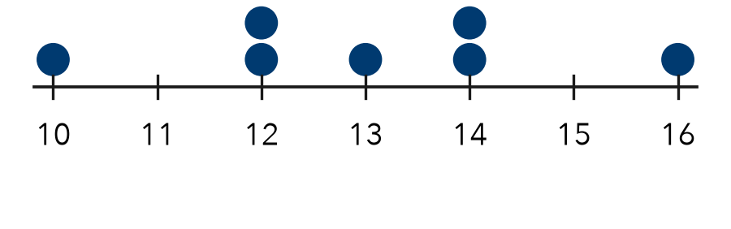

5. Find the Error. Brianna scored 82, 86, and 78. For a mean of 85 on 4 tests, she wrote 85 × 3 − 246 = 9. Explain her error. What score does she need?

TEST PRACTICE choose the best answer
6. Four numbers have a mean of 9. Three of them are 7, 10, and 8. What is the fourth number?
A 9 | B 11 | C 2 | D 36

7. A player’s points in 5 games have a mean of 14. What is her total number of points?
A 2.8 | B 19 | C 70 | D 9

CHECK YOURSELF | □ I can do this on my own | □ I need a little help | □ I have a question about #

Name Date Period
Lesson 2-9 · Homework Packet · Sheet 1 of 2
Finding Mean Absolute Deviation (MAD)
Maryland Standard 6.SP.B.5c · Learning target — I can find the mean absolute deviation of a data set and explain what it measures.

REMEMBER  • The MAD (mean absolute deviation) is the average distance of the values from the mean. Distances are never negative.  • Find the mean. Find each value’s distance from the mean. Then find the mean of the distances. | WORKED EXAMPLE  Ruth’s quiz scores are 6, 8, 9, and 13. Find the MAD.  Step 1 Mean: 36 ÷ 4 = 9  Step 2 Distances from 9: 3, 1, 0, 4  Step 3 Mean of distances: 8 ÷ 4 = 2  Answer MAD = 2 points
PRACTICE show your work · label units
1. The mean of 5, 7, 10, 12, and 16 is 10. Complete the table. Then find the MAD.
Value | 5 | 7 | 10 | 12 | 16
Distance from 10
MAD

2. The mean is given. Find the MAD.
a. 1, 3, 5, 7 (mean 4) | b. 20, 25, 35, 40 (mean 30)
c. 6, 6, 6, 6, 6 (mean 6) | d. 2, 5, 8, 9, 11 (mean 7)

3. Pets. The dot plot shows the number of pets 8 students have.  a. Mean: pets  b. MAD: pets | 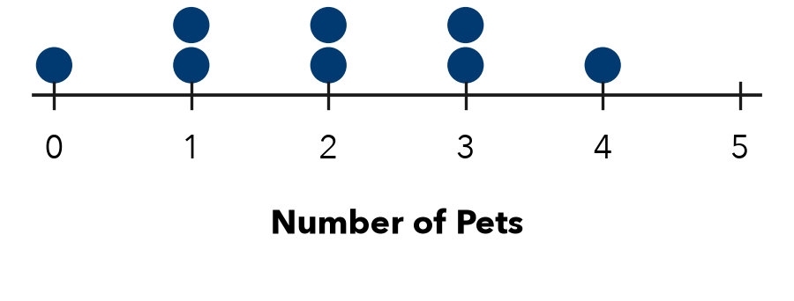

4. Wait Times. Six patients waited 10, 14, 15, 17, 18, and 22 minutes at a clinic. Find the mean and the MAD.

Show your work.
Mean and MAD

5. Find the Error. For 3, 5, 9, 11, 12 (mean 8), Eli found the distances 5, 3, 1, 3, 4. Their sum is 16. He wrote MAD = 16 ÷ 8 = 2. Explain his error and find the MAD.

CHECK YOURSELF | □ I can do this on my own | □ I need a little help | □ I have a question about #
AT HOME Tell someone at home what a MAD of 0 would mean for a set of test scores.
Name Date Period
Lesson 2-9 · Homework Packet · Sheet 2 of 2
Comparing Data Sets Using MAD
Maryland Standard 6.SP.B.5c · Learning target — I can compare two data sets that share a mean by comparing their mean absolute deviations.

REMEMBER  • When two data sets have the same mean, compare their MADs. State both numbers.  • A smaller MAD means values are closer to the mean: more consistent. A larger MAD means more variability. | WORKED EXAMPLE  Baker A’s loaves: 496, 500, 500, 504 g. Baker B’s: 488, 496, 504, 512 g. Both means are 500 g. Who is more consistent?  Step 1 A’s distances: 4, 0, 0, 4. MAD = 8 ÷ 4 = 2 g  Step 2 B’s distances: 12, 4, 4, 12. MAD = 32 ÷ 4 = 8 g  Answer Baker A (MAD 2 g versus 8 g)
PRACTICE show your work · label units
1. Basketball. Both players have a mean of 12 points. Kai: 10, 11, 12, 13, 14. Leo: 4, 8, 12, 16, 20.
a. Kai’s MAD: | b. Leo’s MAD: | c. More consistent:

2. Summer Reading. The dot plot shows the books read by 8 students in Club B. Club A has a mean of 6 books and a MAD of 0.5 book.  a. Club B mean:  b. Club B MAD:  c. More spread out: | 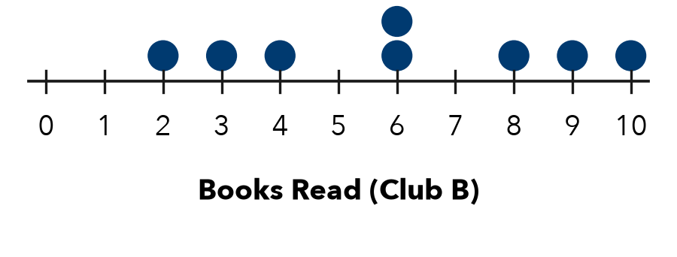

3. Tomatoes Picked. Both means are 20. Garden A: 18, 19, 21, 22. Garden B: 12, 16, 24, 28.
a. A’s MAD: | b. B’s MAD: | c. More consistent:

4. Bus Routes. Both routes have a mean time of 24 min. Route 5: MAD 1.5 min. Route 9: MAD 6 min. Which is more predictable?
□ Route 5 | □ Route 9 | □ They are the same

5. Find the Error. Jordan says Set R (49, 50, 50, 51) must have a greater MAD than Set S (2, 6, 14, 18) because its numbers are bigger. Find both MADs and explain.

TEST PRACTICE choose the best answer
6. Sets A and B both have a mean of 40. A’s MAD is 2.5. B’s MAD is 8. Which is true?
A A varies less. | B B varies less. | C Same spread. | D Cannot tell.

7. What is the MAD of 3, 5, 7, 9?
A 0 | B 2 | C 6 | D 8

CHECK YOURSELF | □ I can do this on my own | □ I need a little help | □ I have a question about #

Name Date Period
Lesson 2-10 · Homework Packet · Sheet 1 of 2
Mean or Median?
Maryland Standard 6.SP.B.5d · Learning target — I can choose the mean or the median to describe a data set based on its shape.

REMEMBER  • Symmetric data with no outliers: the mean and median are close. Use the mean.  • Skewed data or data with an outlier: the mean is pulled toward the tail. Use the median. If the mean and median are far apart, the median is safer. | WORKED EXAMPLE  Eight commutes took 12, 14, 15, 15, 16, 17, 18, and 61 minutes. Which center is better?  Step 1 61 is an outlier, so the data is skewed right.  Step 2 Median: (15 + 16) ÷ 2 = 15.5. Mean: 168 ÷ 8 = 21, greater than 7 of the 8 times.  Answer The median, 15.5 minutes
PRACTICE show your work · label units
1. Write mean or median for the better measure of center.
a. 40, 42, 44, 46, 48 | b. 3, 40, 42, 44, 46, 48 | c. 8, 9, 10, 11, 12, 13, 75

2. Shoe Sizes. The dot plot shows the shoe sizes of 9 students.  a. Shape:  b. Mean:  c. Median:  d. Better center: | 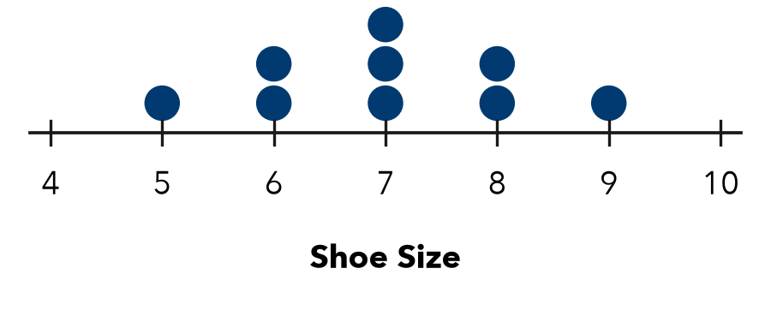

3. Used Bikes. The histogram shows the prices of 20 used bikes.  a. Shape:  b. Greater, mean or median?  c. Better center: | 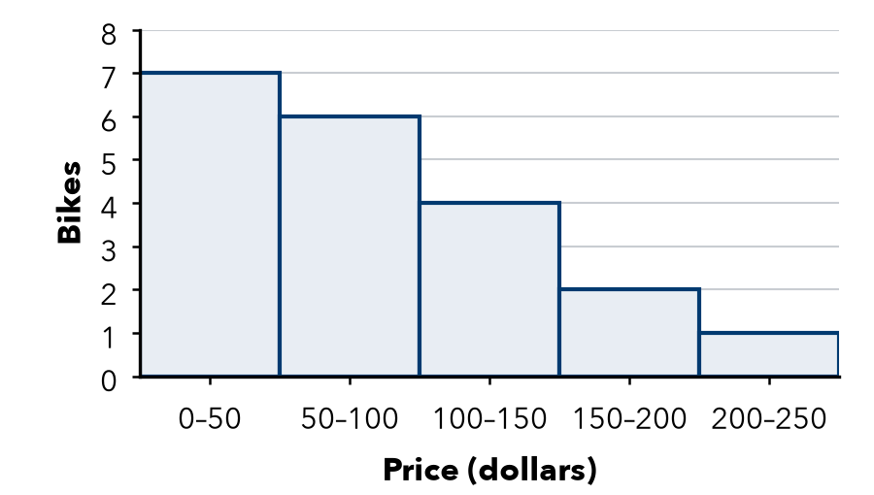

4. Allowances. Six friends get weekly allowances of $5, $6, $8, $8, $10, and $41.
a. Mean: $ | b. Median: $ | c. Better center:

5. Honest Ads. A shop pays its 5 workers $30,000, $32,000, $34,000, $36,000, and $178,000 a year. Its ad says, “Average pay: $62,000!” Why is this misleading? What center is better?

CHECK YOURSELF | □ I can do this on my own | □ I need a little help | □ I have a question about #
AT HOME Ask someone at home: for house prices, is the mean or the median greater? Why?
Name Date Period
Lesson 2-10 · Homework Packet · Sheet 2 of 2
Matching Center and Spread
Maryland Standard 6.SP.B.5d · Learning target — I can match a measure of center and a measure of spread to the shape of a data set.

REMEMBER  • Symmetric, no outliers: mean and MAD. Skewed or outliers: median and IQR.  • Do not mix the pairs. A summary names the shape, center, and spread. | WORKED EXAMPLE  Seven friends sent 3, 4, 5, 6, 7, 8, and 40 texts. Summarize the data.  Step 1 40 is an outlier: use the median and IQR.  Step 2 Median = 6. Q1 = 4, Q3 = 8, IQR = 4  Answer Median 6 texts, IQR 4 texts
PRACTICE show your work · label units
1. Write the pair you would report: mean and MAD, or median and IQR.
a. 15, 16, 17, 18, 19 | b. 15, 16, 17, 18, 19, 20, 95

2. Books Read. Books read by 8 students in a month.  a. Pair to report:  b. Center: books  c. Spread: books | 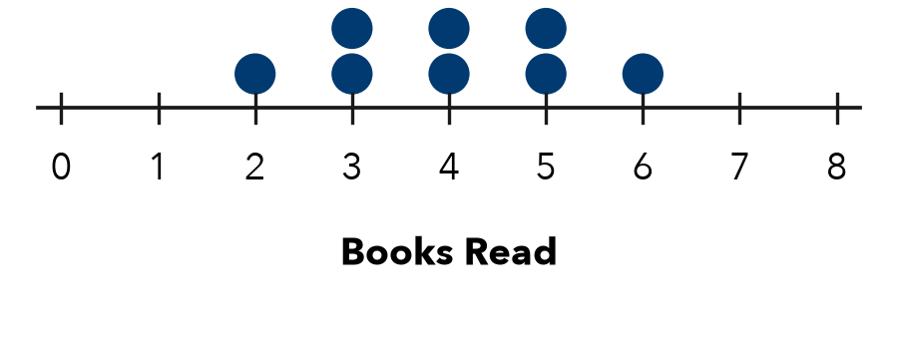

3. Wait Times. Deli wait times, in minutes.  a. Shape:  b. Median: min  c. IQR: min | 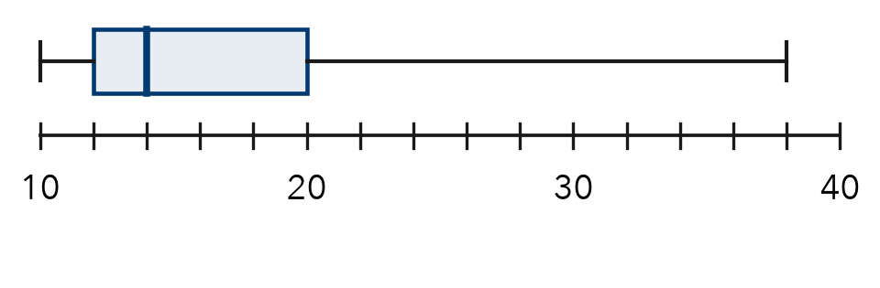

4. Phone Calls. Seven calls lasted 12, 15, 16, 18, 20, 22, and 70 minutes.
a. Pair: | b. Median: min | c. IQR: min

5. Find the Error. Kenji says 2, 20, 21, 22, 23, 24, 25 is not skewed because no value is far above the rest. He reports the mean and MAD. Explain his error.

TEST PRACTICE choose the best answer
6. Which pair best describes 21, 23, 24, 25, 26, 27, 80?
A mean and MAD | B median and IQR | C mean and IQR | D median and MAD

7. A histogram is tall in the middle, with short, equal bars on both ends. Which pair should you report?
A mean and MAD | B median and IQR | C mean and IQR | D median and MAD

CHECK YOURSELF | □ I can do this on my own | □ I need a little help | □ I have a question about #
AT HOME Ask someone at home: for the prices of all cars on a street, would you report the mean or the median? Why?

