Name Date Period
Lesson 4-1 · Homework Packet · Sheet 1 of 2
Percent Means Per Hundred
Maryland Standard 6.RP.A.3c · Learning target — I can write a ratio as a percent by finding the equivalent ratio out of 100.

REMEMBER  • Percent means “per hundred.” 37% = 37 out of 100.  • On a hundred grid, each square is 1%.  • Make an equivalent ratio out of 100: multiply both terms by the same number. | WORKED EXAMPLE  Out of every 20 students, 7 ride the bus. What percent of the students ride the bus?  Step 1 20 × 5 = 100, so multiply both terms by 5.  Step 2 7 × 5 = 35, so 7 out of 20 = 35 out of 100.  Step 3 35 out of 100 = 35%.  Answer 35%
PRACTICE show your work · label units

1. The grid has 100 equal squares.  a. What percent of the grid is shaded? %  b. What percent is not shaded? % | 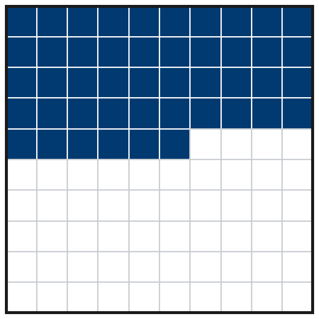

2. Write each ratio as a percent. First scale it to an equivalent ratio out of 100.
a. 3 out of 10 = % | b. 7 out of 25 = % | c. 1 out of 2 = %
d. 17 out of 50 = % | e. 2 out of 5 = % | f. 3 out of 20 = %
g. 13 out of 25 = % | h. 9 out of 10 = %

3. Animal Shelter. Out of every 25 dogs at a shelter, 9 are puppies. Complete the ratio table. Then write the percent of dogs that are puppies.
Puppies | 9 | 18
All dogs | 25 | 50 | 75 | 100
Percent of puppies %

4. Garden Plants. A garden has 50 plants. 22 of them are tomato plants.
a. What percent are tomato plants? %
b. What percent are not tomato plants? %

5. Find the Error. To write 7 out of 20 as a percent, Ana added 80 to both numbers. She got 87 out of 100, so she wrote 87%. Explain her mistake and find the correct percent.

CHECK YOURSELF | □ I can do this on my own | □ I need a little help | □ I have a question about #
AT HOME Find a percent on a label, sign, or screen at home. Tell someone what it means “out of 100.”
Name Date Period
Lesson 4-1 · Homework Packet · Sheet 2 of 2
Percents Greater Than 100%
Maryland Standard 6.RP.A.3c · Learning target — I can use percents greater than 100% to describe an amount larger than the whole.

REMEMBER  • 100% is one whole. Over 100% is more than the whole.  • 200% = 2 times the whole. 150% = 1.5 times.  • “Times as much” to percent: multiply by 100. 2.5 times = 250%. | WORKED EXAMPLE  A puppy grew from 10 lb to 13 lb. Write 13 lb as a percent of 10 lb (the whole).  Step 1 Scale by 10: 13 to 10 = 130 to 100.  Step 2 130 out of 100 = 130%, more than the whole.  Answer 130%
PRACTICE show your work · label units
1. Write each amount as a percent of the whole.
a. 3 times as much = % | b. 1.75 times as much = %

2. Library Books. Monday (40 books) is the whole. Tuesday: 70 books. Fill in the double number line. Write Tuesday as a percent of Monday.
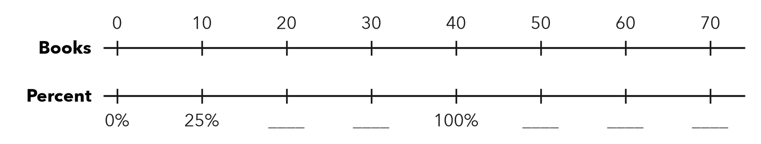
Tuesday %

3. Bake Sale. A class set a goal of $200. They raised $260. What percent of the goal did they raise?
Answer %

4. Chess Club. Last year a chess club had 20 members (the whole). This year it has 33 members. Write this year’s members as a percent of last year’s.
Answer %

5. Find the Error. Malik says 60 cm is 60% of 30 cm. Explain his mistake and fix it.

TEST PRACTICE choose the best answer
6. 45 points is what percent of 30 points?
A 15% | B 45% | C 115% | D 150%

7. 250% of an amount is how many times the amount?
A 0.25 times | B 2.5 times | C 25 times | D 250 times

CHECK YOURSELF | □ I can do this on my own | □ I need a little help | □ I have a question about #
AT HOME Tell someone at home what 200% of their age would be.

Name Date Period
Lesson 4-2 · Homework Packet · Sheet 1 of 2
Fractions, Decimals, Percents
Maryland Standard 6.RP.A.3c · Learning target — I can write the same value as a fraction, a decimal, and a percent.

REMEMBER  • A percent is a fraction out of 100: 45% = 45/100 = 0.45.  • Fraction to percent: make the denominator 100.  • Decimal to percent: read hundredths. 0.07 = 7%, 0.4 = 40%. | WORKED EXAMPLE  Write 3/20 as a decimal and as a percent.  Step 1 20 × 5 = 100, so 3/20 = 15/100.  Step 2 15 hundredths = 0.15.  Step 3 15/100 = 15%.  Answer 3/20 = 0.15 = 15%
PRACTICE show your work · label units

1. Write the shaded part of the grid three ways.  a. Fraction (simplest form)  b. Decimal  c. Percent % | 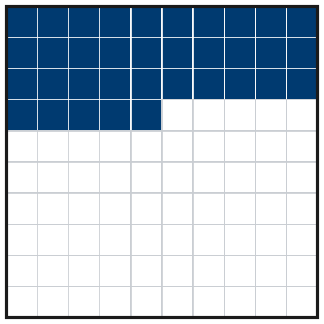

2. Complete the table. Write fractions in simplest form.
Fraction | Decimal | Percent
1/4
 | 0.7
 |  | 8%
 |  | 65%
3/5

3. Soccer Practice. Amara scored on 11 of her 25 shots. Write this as a fraction, a decimal, and a percent.

Show your work.
Fraction, decimal, percent

4. Find the Error. Destiny wrote 3/4 = 0.34 = 34%. Explain her mistake. Write 3/4 correctly.

CHECK YOURSELF | □ I can do this on my own | □ I need a little help | □ I have a question about #
AT HOME Find a fraction, a decimal, or a percent at home (a recipe, a price tag, a battery icon). Write it the other two ways.
Name Date Period
Lesson 4-2 · Homework Packet · Sheet 2 of 2
Compare and Order
Maryland Standard 6.RP.A.3c · Learning target — I can compare and order values written as fractions, decimals, and percents.

REMEMBER  • Write every value in the same form (all percents).  • Hundredths are the bridge: 0.4 = 0.40 = 40%.  • Benchmarks: 1/4 = 25%, 1/2 = 50%, 3/4 = 75%. | WORKED EXAMPLE  Order from least to greatest: 0.3, 7/20, 32%.  Step 1 0.3 = 0.30 = 30%  Step 2 7/20 = 35/100 = 35%  Step 3 Compare: 30% < 32% < 35%  Answer 0.3, 32%, 7/20
PRACTICE show your work · label units
1. Write <, >, or = in each blank.
a. 0.6 58% | b. 3/4 0.8 | c. 0.09 1/10

2. Order each set from least to greatest.
a. 0.72, 7/10, 75% | b. 1/4, 0.2, 22% | c. 1.3, 125%, 6/5

3. Field Trip Vote. Room A: 0.55 of students chose the aquarium. Room B: 3/5 chose it. Room C: 52% chose it. Order the rooms from least to greatest share.

Show your work.
Order

4. Stretch. Write one value that is between 3/5 and 0.7. Write it as a fraction, a decimal, and a percent.
Fraction, decimal, percent

5. Find the Error. Nico says 3/8 is greater than 0.4 because 8 is greater than 4. Explain his mistake and compare the values correctly.

TEST PRACTICE choose the best answer
6. Which list is ordered from least to greatest?
A 2/5, 0.35, 38% | B 0.35, 2/5, 38% | C 0.35, 38%, 2/5 | D 38%, 0.35, 2/5

7. Which value is the greatest?
A 0.62 | B 3/5 | C 64% | D 0.6

CHECK YOURSELF | □ I can do this on my own | □ I need a little help | □ I have a question about #
AT HOME Ask someone at home which is more: 3/4 of a pizza or 70% of the same pizza. Show them how you know.

Name Date Period
Lesson 4-3 · Homework Packet · Sheet 1 of 2
Estimate with Benchmarks
Maryland Standard 6.RP.A.3c · Learning target — I can estimate a percent by comparing an amount to benchmark percents.

REMEMBER  • Benchmarks: 10%, 25%, 50%, 75%, 100%.  • Find benchmark amounts of the whole. Which one is the part about equal to?  • A double number line lines up amounts with percents. | WORKED EXAMPLE  A water jug holds 40 cups. There are 29 cups left. About what percent of the jug is left?  Step 1 Benchmarks of 40: 50% = 20 and 75% = 30.  Step 2 29 is very close to 30.  Step 3 So 29 out of 40 is about 75%.  Answer about 75%
PRACTICE show your work · label units
1. Reading Goal. Jada’s goal is to read 160 pages. She has read 42 pages. Fill in the double number line. Then estimate the percent of her goal she has read.
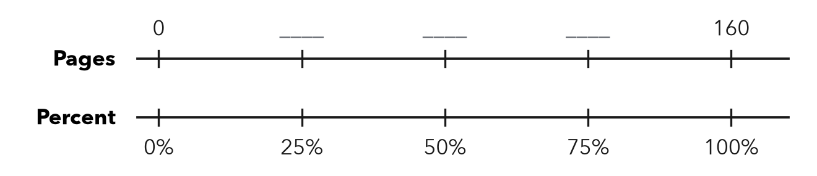
About %

2. About what percent? Name the closest benchmark: 10%, 25%, 50%, 75%, or 100%.
a. 7 out of 60 ≈ % | b. 38 out of 50 ≈ % | c. 23 out of 90 ≈ %
d. 19 out of 40 ≈ % | e. 49 out of 50 ≈ % | f. 11 out of 45 ≈ %
g. 16 out of 150 ≈ % | h. 61 out of 80 ≈ %

3. Class Fundraiser. A class wants to raise $500. So far they have raised $96. Use 10% of the goal to estimate the percent they have raised.
a. 10% of $500 =
b. About what percent have they raised? %

4. Bus Seats. A bus has 48 seats. 35 seats are filled. About what percent of the seats are filled? Name the benchmark you used.
About %

5. Compare. Which is closer to 50%: 26 out of 50, or 26 out of 60? Explain how you know.

CHECK YOURSELF | □ I can do this on my own | □ I need a little help | □ I have a question about #
AT HOME Look at a battery icon or a gas gauge. Estimate the percent it shows and explain your benchmark to someone at home.
Name Date Period
Lesson 4-3 · Homework Packet · Sheet 2 of 2
Estimate a Percent of a Number
Maryland Standard 6.RP.A.3c · Learning target — I can estimate a percent of a number using friendly percents and rounded amounts.

REMEMBER  • Round to friendly numbers first.  • 10%: divide by 10. 5% = half of 10%.  • 25% = 1/4, 50% = 1/2, 75% = 3/4. | WORKED EXAMPLE  Estimate 24% of 83.  Step 1 Round: 25% of 80.  Step 2 25% = 1/4, and 80 ÷ 4 = 20.  Answer about 20
PRACTICE show your work · label units
1. Estimate. Round to friendly numbers first.
a. 11% of 59 ≈ | b. 74% of 41 ≈ | c. 26% of 203 ≈

2. Sneaker Sale. Sneakers cost $198 and are 30% off. Round to $200. Each part of the tape is 10% of $200.
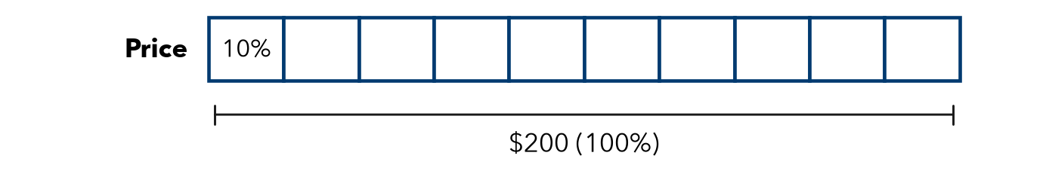
a. About how many dollars is one part (10%)?
b. About how much is the discount (30%)?

3. School Lunch. About 48% of 412 students buy lunch. About how many students is that?
About students

4. Apple Orchard. A farm picked 798 apples. About 24% of them were too small to sell. About how many apples were too small?
About apples

5. Find the Error. Mia estimated 19% of 512 by writing 20 × 500 = 10,000. Explain her mistake. Give a good estimate.

TEST PRACTICE choose the best answer
6. Which is the best estimate of 26% of 79?
A 2 | B 20 | C 26 | D 40

7. A coat costs $119. It is 40% off. Which is the best estimate of the discount?
A $4.80 | B $40 | C $48 | D $72

CHECK YOURSELF | □ I can do this on my own | □ I need a little help | □ I have a question about #
AT HOME Find a sale sign. Estimate the discount out loud with someone at home.

Name Date Period
Lesson 4-4 · Homework Packet · Sheet 1 of 2
Find the Percent of a Number
Maryland Standard 6.RP.A.3c · Learning target — I can find the percent of a number exactly.

REMEMBER  • The whole comes after “of.” In 30% of 80, the whole is 80.  • Percent to decimal, then multiply: 0.3 × 80 = 24.  • Or use 10%: 10% of 80 = 8, so 30% = 3 × 8 = 24. | WORKED EXAMPLE  Find 35% of 60.  Step 1 Write 35% as a decimal: 0.35.  Step 2 Multiply: 0.35 × 60 = 21.  Step 3 Check with 10%: 6 + 6 + 6 + 3 = 21.  Answer 21
PRACTICE show your work · label units
1. Find each part.
a. 20% of 45 = | b. 75% of 64 = | c. 6% of 350 =
d. 45% of 80 = | e. 150% of 30 = | f. 12% of 250 =

2. Lunch from Home. A grade has 180 students. 40% of them bring lunch from home. Fill in the double number line. Then find how many students bring lunch.
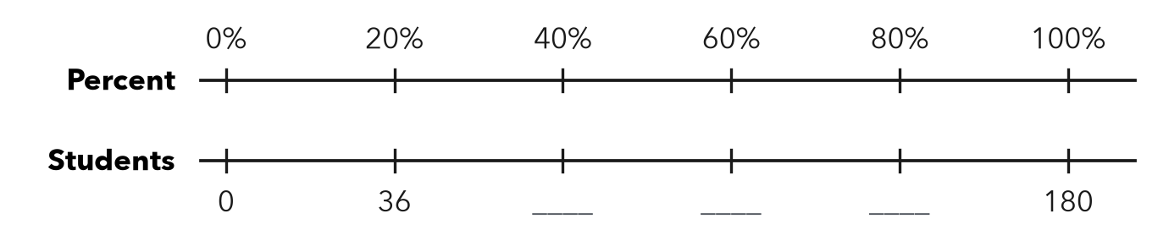
Answer students

3. Jacket Sale. A jacket costs $64. It is on sale for 25% off. How much money is taken off? What is the sale price?
a. Discount:
b. Sale price:

Show your work.

4. Soccer Team. A soccer team has 40 players. 15% of the players are new this year. How many players are new?
Answer players

5. Compare. Which is greater: 30% of 90, or 90% of 30? Show both amounts. Explain what you notice.

CHECK YOURSELF | □ I can do this on my own | □ I need a little help | □ I have a question about #
AT HOME Find a sale sign or a tip suggestion. Work out the exact amount with someone at home.
Name Date Period
Lesson 4-4 · Homework Packet · Sheet 2 of 2
Compare Percents
Maryland Standard 6.RP.A.3c · Learning target — I can compare two records fairly by converting each one to a percent.

REMEMBER  • Compare records fairly: write each as a percent.  • Scale to out of 100, or divide part ÷ whole.  • More hits is not always a better rate. | WORKED EXAMPLE  Mia made 14 of 20 shots. Leo made 18 of 25. Who has the better rate?  Step 1 Mia: 14/20 = 70/100 = 70%. Leo: 18/25 = 72/100 = 72%.  Step 2 Compare: 72% > 70%.  Answer Leo has the better rate.
PRACTICE show your work · label units
1. Write each record as a percent.
a. 21 out of 30 = % | b. 13 out of 20 = % | c. 9 out of 12 = %

2. Softball Hits. Complete the table. Circle the player with the best record.
Player | Hits | At bats | Percent
Ava | 9 | 20
Ben | 12 | 25
Cruz | 22 | 50

3. Spelling Tests. Rosa spelled 34 of 40 words correctly. Kai spelled 42 of 50 words correctly. Write each as a percent. Who did better?
Percents and who did better

4. Select all the records that are greater than 70%.
□ A 15 out of 20 | □ B 17 out of 25 | □ C 36 out of 50 | □ D 7 out of 10

5. Find the Error. Deja says 18 out of 24 = 24 out of 30. Is she right? Explain.

TEST PRACTICE choose the best answer
6. Which record has the greatest percent?
A 13 out of 20 | B 16 out of 25 | C 33 out of 50 | D 6 out of 10

7. Team A won 12 of 16 games. Team B won 15 of 25 games. Which is true?
A B did better. It won more games. | B A won 75%, B won 60%. A did better.
C Both teams did equally well. | D A won 12%, B won 15%.

CHECK YOURSELF | □ I can do this on my own | □ I need a little help | □ I have a question about #
AT HOME Compare two game records at home by changing both to percents.

Name Date Period
Lesson 4-5 · Homework Packet · Sheet 1 of 2
Find the Whole
Maryland Standard 6.RP.A.3c · Learning target — I can find the whole when I know a part and the percent it represents.

REMEMBER  • The part is what you know. The whole is 100%.  • Step down to a friendly percent, then build up to 100%.  • Percent below 100%? The whole is greater than the part. | WORKED EXAMPLE  24 is 40% of what number?  Step 1 40% is 24, so 10% is 24 ÷ 4 = 6.  Step 2 100% is 10 × 6 = 60.  Step 3 Check: 0.4 × 60 = 24, so it checks.  Answer 60
PRACTICE show your work · label units
1. Bike Helmet. Andre has saved $36. That is 40% of the cost of a bike helmet. Fill in the double number line. Then find the cost of the helmet.
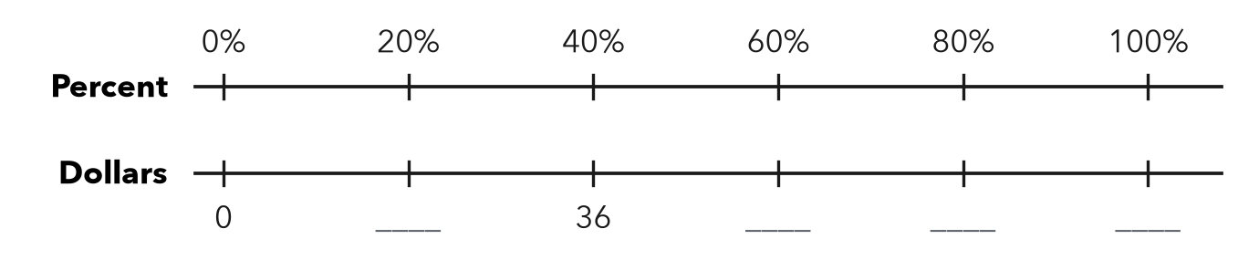
Cost dollars

2. Find each whole.
a. 13 is 10% of | b. 11 is 25% of | c. 21 is 30% of
d. 32 is 40% of | e. 7 is 5% of | f. 54 is 60% of

3. Water Tank. A water tank is 75% full. It holds 18 gallons now. Each part of the tape diagram is 25% of the full tank. How many gallons does the tank hold when it is full?
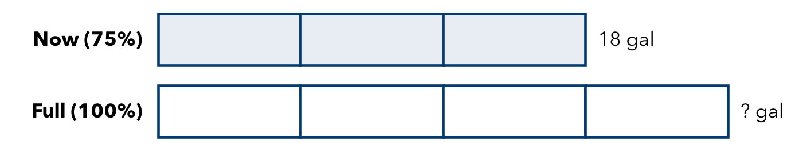
Answer gallons

4. Chapter Book. Lena has read 120 pages. That is 75% of her book. How many pages long is it?
Answer pages

5. Reason. 20 is 40% of number A. 20 is also 80% of number B. Without solving, which number is greater, A or B? Explain. Then find both numbers.

CHECK YOURSELF | □ I can do this on my own | □ I need a little help | □ I have a question about #
AT HOME Tell someone at home: if 10 is 50% of a number, what is the number? Explain how you know.
Name Date Period
Lesson 4-5 · Homework Packet · Sheet 2 of 2
Solve for the Whole
Maryland Standard 6.RP.A.3c · Learning target — I can write and solve an equation to find the whole from a part and a percent.

REMEMBER  • Write part = percent × whole, with w for the whole.  • Solve by dividing: w = part ÷ decimal.  • Check: decimal × whole should give the part. | WORKED EXAMPLE  $18 is 60% of a shirt’s first price. Find the first price.  Step 1 Write the equation: 0.6 × w = 18  Step 2 Divide: w = 18 ÷ 0.6 = 180 ÷ 6 = 30  Step 3 Check: 0.6 × 30 = 18, so it checks.  Answer $30
PRACTICE show your work · label units
1. Solve each equation for w.
a. 0.2 × w = 14 | b. 0.25 × w = 12 | c. 0.8 × w = 64

2. 33 is 55% of what number? Write an equation and solve it.
a. Equation:
b. w =

3. Field Trip. A class has collected $315 for a trip. That is 75% of the total cost. Find the total cost. How much more does the class need?

Show your work.
Total and still needed

4. Savings Goal. Tasha has saved $42. That is 35% of her goal. Write an equation and find her goal.
Equation and goal

5. Find the Error. Jamal solved “28 is 35% of w” as w = 28 ÷ 35 = 0.8. Explain his mistake. Solve and check.

TEST PRACTICE choose the best answer
6. 45 is 30% of a number w. Which equation can you use to find w?
A 0.3 × 45 = w | B 0.3 × w = 45 | C 45 × w = 30 | D w ÷ 45 = 0.3

7. A team won 18 games. That is 60% of its games. How many games did it play?
A 10.8 | B 24 | C 30 | D 78

CHECK YOURSELF | □ I can do this on my own | □ I need a little help | □ I have a question about #
AT HOME Explain to someone at home why the whole must be bigger than the part when the percent is less than 100%.

