Name Date Period
Lesson 5-1 · Homework Packet · Sheet 1 of 2
Area of Parallelograms
Maryland Standard 6.G.A.1 · Learning target — I can find the area of a parallelogram by multiplying the base by the perpendicular height.

REMEMBER  • Cut a triangle off a parallelogram and slide it over to make a rectangle: A = b × h.  • The height h is perpendicular to the base. Do not use the slanted side.  • Area is in square units (cm², in², ft²). | WORKED EXAMPLE  Find the area: base 15 in, slanted side 8 in, height 6 in.  Step 1 Use the perpendicular height: h = 6 (skip the 8 in side)  Step 2 A = b × h = 15 × 6  Step 3 Multiply: 15 × 6 = 90  Answer 90 in²
PRACTICE show your work · label units

1. Find the area of the parallelogram.  Answer cm² | 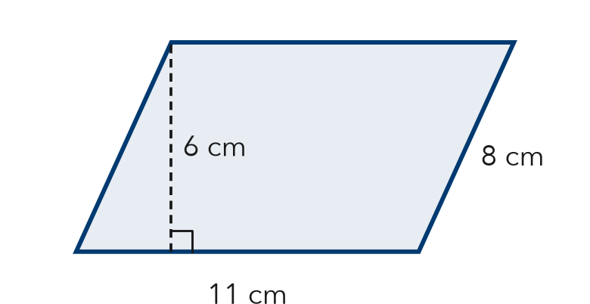
  Show your work.

2. Find the area of each parallelogram with base b and height h.
a. b = 12 ft, h = 7 ft ft² | b. b = 9 m, h = 9 m m²
c. b = 20 in, h = 4 in in² | d. A = 63 m², h = 7 m; b = m

3. Parking Lot. A lot has 10 parking spaces. Each space is a parallelogram with a base of 9 ft and a perpendicular height of 18 ft. What total area do the spaces cover?

Show your work.
Answer ft²

4. Mural. A mural is painted on a parallelogram-shaped wall section. The area is 108 ft² and the base is 12 ft. What is the perpendicular height?
Answer ft

5. Find the Error. A parallelogram has a base of 10 cm, a slanted side of 7 cm, and a height of 5 cm. Kiara says its area is 70 cm². Explain her mistake and find the correct area.

CHECK YOURSELF | □ I can do this on my own | □ I need a little help | □ I have a question about #
AT HOME Find a parallelogram shape at home or on the street (a tile, a sign, a parking space). Show someone where its base and height are.
Name Date Period
Lesson 5-1 · Homework Packet · Sheet 2 of 2
Area of Rhombuses
Maryland Standard 6.G.A.1 · Learning target — I can find the area of a rhombus using the base and height or the two diagonals.

REMEMBER  • A rhombus is a parallelogram, so A = b × h works.  • With the diagonals: A = (d1 × d2) ÷ 2. Do not forget to divide by 2. | WORKED EXAMPLE  Find the area: diagonals 12 cm and 9 cm.  Step 1 Multiply the diagonals: 12 × 9 = 108  Step 2 Divide by 2: 108 ÷ 2 = 54  Answer 54 cm²
PRACTICE show your work · label units

1. Find the area of the rhombus.  Answer cm² | 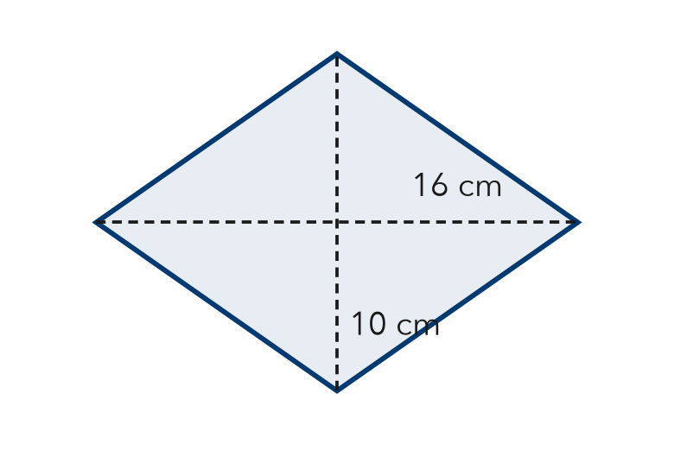
  Show your work.

2. Find the area of each rhombus. Choose the formula that fits.
a. diagonals 14 m and 10 m m² | b. base 9 ft, height 7 ft ft²

3. Window. A rhombus window has an area of 60 ft². One diagonal is 10 ft. Find the other diagonal d.  Answer ft | 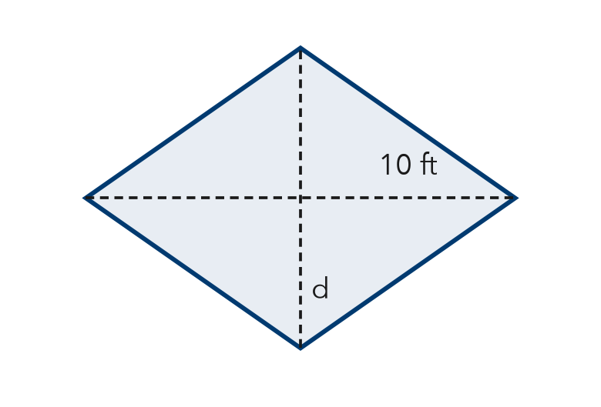

4. Stretch. Rhombus A has diagonals of 12 ft and 8 ft. Rhombus B has a base of 8 ft and the same area as Rhombus A. What is the height of Rhombus B?
Answer ft

5. Find the Error. Ravi says a rhombus with diagonals of 18 in and 8 in has an area of 144 in². Explain his mistake and find the correct area.

TEST PRACTICE choose the best answer
6. A rhombus has sides of 7 m and a perpendicular height of 5 m. What is its area?
A 12 m² | B 17.5 m² | C 35 m² | D 49 m²

7. A rhombus has diagonals of 20 in and 9 in. What is its area?
A 29 in² | B 45 in² | C 90 in² | D 180 in²

CHECK YOURSELF | □ I can do this on my own | □ I need a little help | □ I have a question about #

Name Date Period
Lesson 5-2 · Homework Packet · Sheet 1 of 2
Area of Triangles
Maryland Standard 6.G.A.1 · Learning target — I can find the area of a triangle using one half the base times the height.

REMEMBER  • A triangle is half of a parallelogram with the same base and height: A = ½ × b × h.  • The height meets the base at a right angle. It can fall outside the triangle.  • Area is in square units (cm², in², ft²). | WORKED EXAMPLE  Find the area of a triangle with base 14 cm and height 9 cm.  Step 1 Write the formula: A = ½ × b × h  Step 2 Substitute: A = ½ × 14 × 9  Step 3 Multiply: ½ × 14 = 7, and 7 × 9 = 63  Answer 63 cm²
PRACTICE show your work · label units

1. Find the area of the triangle.  Answer cm² | 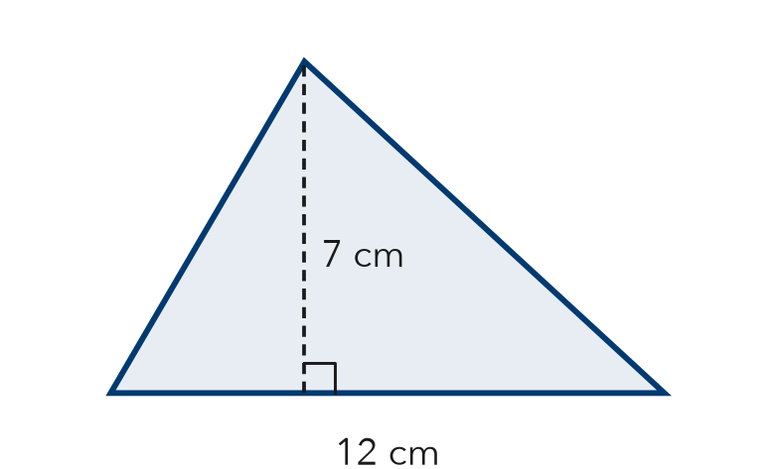
  Show your work.

2. Find the area of the triangle. The height falls outside the triangle.  Answer in² | 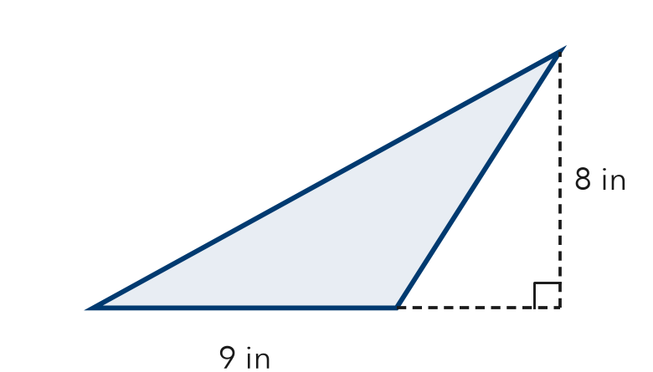
  Show your work.

3. Find the area of each triangle with base b and height h.
a. b = 10 cm, h = 9 cm cm² | b. b = 5 ft, h = 11 ft ft²

4. Garden Bed. Maya builds a triangular garden bed with a base of 15 feet and a height of 6 feet. One bag of soil covers 9 square feet. How many bags does she need?

Show your work.
Answer bags

5. Find the Error. Jon says the area of a triangle with base 8 m and height 5 m is 40 m². Explain his mistake and find the correct area.

CHECK YOURSELF | □ I can do this on my own | □ I need a little help | □ I have a question about #
AT HOME Find a triangle at home (a sign, a sandwich half, a roof). Estimate its base and height and its area.
Name Date Period
Lesson 5-2 · Homework Packet · Sheet 2 of 2
Missing Measures in Triangles
Maryland Standard 6.G.A.1 · Learning target — I can find a missing base or height of a triangle when I know its area.

REMEMBER  • Know the area and one measure? Double the area, then divide by the measure you know: h = 2A ÷ b and b = 2A ÷ h.  • Check: ½ × b × h should equal the given area. | WORKED EXAMPLE  Area = 30 in², base = 12 in. Find the height.  Step 1 Double the area: 2 × 30 = 60  Step 2 Divide by the base: 60 ÷ 12 = 5  Step 3 Check: ½ × 12 × 5 = 30, so it checks  Answer h = 5 in
PRACTICE show your work · label units
1. Complete the table. Each row describes one triangle.
 | Base | Height | Area
Triangle A | 8 in |  | 28 in²
Triangle B |  | 9 ft | 54 ft²

2. The area of the triangle is 48 m². Find the height h.  Answer m | 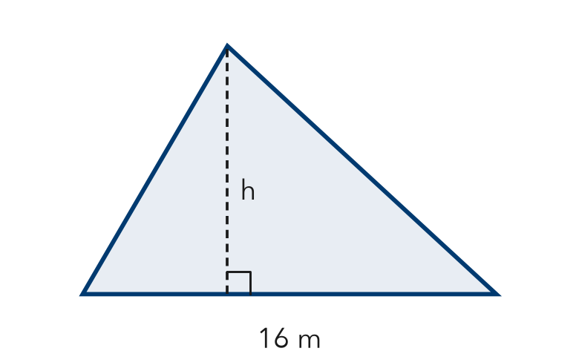
  Show your work.

3. Find the missing measure of each triangle.
a. A = 40 m², b = 10 m; h = m | b. A = 27 in², h = 6 in; b = in

4. Sail. A triangular sail has an area of 35 square feet. Its height is 10 feet. How long is its base?
Answer ft

5. Compare. Triangle P: base 12 cm, height 5 cm. Triangle Q: base 6 cm, height 10 cm. Which has more area? Explain.

TEST PRACTICE choose the best answer
6. A triangle has an area of 24 square units and a height of 4 units. What is the length of its base?
A 3 units | B 6 units | C 12 units | D 48 units

7. Which expression gives the area of a triangle with base 18 m and height 5 m?
A 18 × 5 | B ½ × 18 × 5 | C 18 + 5 | D 2 × 18 × 5

CHECK YOURSELF | □ I can do this on my own | □ I need a little help | □ I have a question about #

Name Date Period
Lesson 5-3 · Homework Packet · Sheet 1 of 2
Trapezoids by Decomposing
Maryland Standard 6.G.A.1 · Learning target — I can find the area of a trapezoid by decomposing it into a rectangle and triangles.

REMEMBER  • Decompose a trapezoid into a rectangle and one or two triangles.  • Find the area of each piece, then add the areas.  • When you cut off a rectangle, the triangle bases together equal the difference of the two parallel sides. | WORKED EXAMPLE  Parallel sides 6 m and 12 m, height 5 m. Find the area.  Step 1 Rectangle: 6 × 5 = 30  Step 2 Triangle bases: (12 − 6) ÷ 2 = 3 m each  Step 3 Triangles: 2 × (½ × 3 × 5) = 15  Step 4 Add: 30 + 15 = 45  Answer 45 m²
PRACTICE show your work · label units

1. The trapezoid is cut into a rectangle and two matching triangles.  a. Area of the rectangle cm²  b. Area of one triangle cm²  Area of trapezoid cm² | 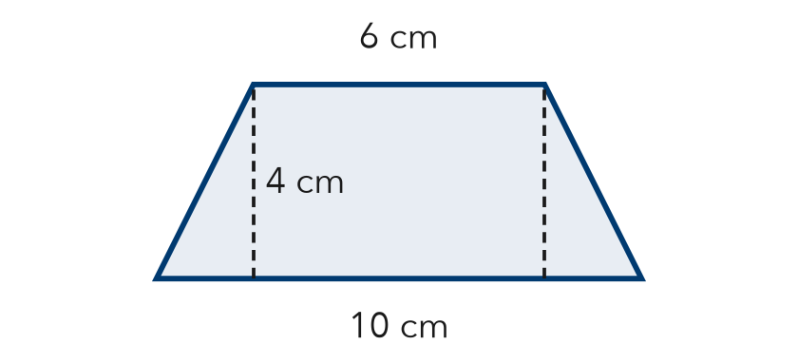

2. Decompose the trapezoid into a rectangle and one triangle. Find its area.  Answer in² | 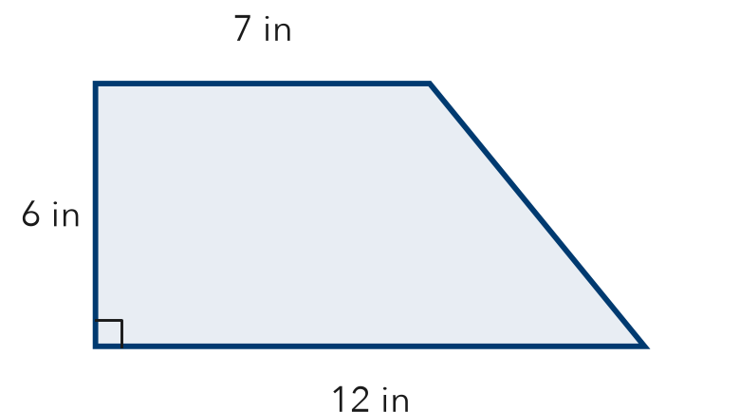
  Show your work.

3. Skate Ramp. The side of a skate ramp is a trapezoid with one square corner. Its parallel sides are 3 ft and 8 ft, and its height is 4 ft. Find the area by decomposing.

Show your work.
Answer ft²

4. Table Top. A table top is a trapezoid with parallel sides of 5 ft and 11 ft and a height of 3 ft. It is cut into a rectangle and two matching triangles. Find its area.
Answer ft²

5. Find the Error. A trapezoid has parallel sides 9 cm and 15 cm and height 4 cm. Tomás says each of its 2 matching triangles has a base of 6 cm. Explain his mistake and find the area.

CHECK YOURSELF | □ I can do this on my own | □ I need a little help | □ I have a question about #
AT HOME Find a trapezoid shape at home or outside (a lampshade side, a bag, a roof). Show someone how to cut it into a rectangle and triangles.
Name Date Period
Lesson 5-3 · Homework Packet · Sheet 2 of 2
The Trapezoid Area Formula
Maryland Standard 6.G.A.1 · Learning target — I can find the area of a trapezoid using the trapezoid area formula.

REMEMBER  • A = ½ × (b1 + b2) × h. The bases b1 and b2 are the parallel sides.  • Add the bases first, then multiply by the height h, then take half. | WORKED EXAMPLE  Parallel sides 7 cm and 11 cm, height 6 cm. Find the area.  Step 1 Add the bases: 7 + 11 = 18  Step 2 Multiply by the height: 18 × 6 = 108  Step 3 Take half: 108 ÷ 2 = 54  Answer 54 cm²
PRACTICE show your work · label units

1. Find the area of the trapezoid.  Answer m² | 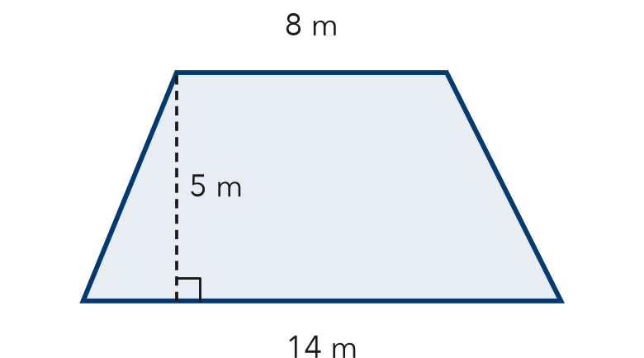
  Show your work.

2. Find the area of each trapezoid with bases b1 and b2 and height h.
a. 4 ft, 10 ft; h = 6 ft ft² | b. 5 in, 9 in; h = 8 in in²
c. 6 m, 12 m; h = 3 m m² | d. 3 cm, 7 cm; h = 9 cm cm²

3. Garden Plot. A garden plot is a trapezoid with parallel sides of 16 ft and 24 ft and a height of 10 ft. One bag of mulch covers 25 ft². How many bags are needed?
Answer bags

4. Missing Base. The area of the trapezoid is 60 in². Find the missing base b.  Answer in | 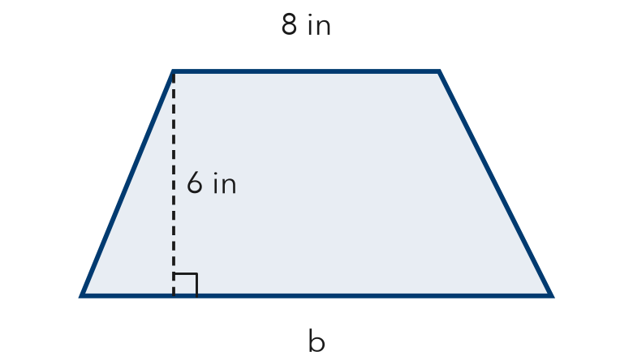
  Show your work.

TEST PRACTICE choose the best answer
5. A trapezoid has parallel sides of 6 cm and 10 cm and a height of 5 cm. What is its area?
A 21 cm² | B 40 cm² | C 80 cm² | D 300 cm²

6. Which expression finds the area of a trapezoid with bases 3 m and 9 m and height 4 m?
A ½ × 3 × 9 × 4 | B (3 + 9) × 4 | C ½ × (3 + 9) × 4 | D ½ × 3 + 9 × 4

CHECK YOURSELF | □ I can do this on my own | □ I need a little help | □ I have a question about #
AT HOME Measure a trapezoid shape at home, like the side of a bag. Estimate its area with the formula.

Name Date Period
Lesson 5-4 · Homework Packet · Sheet 1 of 2
Area of Regular Polygons
Maryland Standard 6.G.A.1 · Learning target — I can find the area of a regular polygon by finding the area of one triangle and multiplying.

REMEMBER  • Regular polygon: equal sides, equal angles.  • Lines from the center to each vertex make n congruent triangles. Each one’s height is the apothem.  • A = n × (½ × side × apothem). Use ≈ if rounded. | WORKED EXAMPLE  Regular hexagon: side 8 cm, apothem ≈ 6.9 cm.  Step 1 A hexagon makes 6 congruent triangles.  Step 2 One triangle: ½ × 8 × 6.9 = 27.6  Step 3 Six triangles: 6 × 27.6 = 165.6  Answer ≈ 165.6 cm²
PRACTICE show your work · label units

1. Find the area of the regular octagon. The apothem is rounded.  Answer m² | 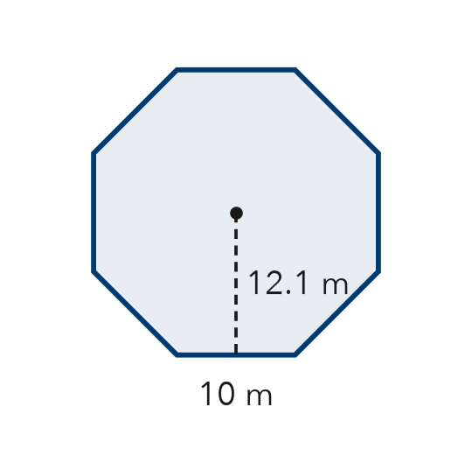
  Show your work.

2. Complete the table. Each apothem is rounded, so mark each area with ≈.
Regular polygon | Side | Apothem | Perimeter | Area
Hexagon | 4 cm | 3.5 cm
Pentagon | 10 ft | 6.9 ft

3. Each regular polygon has perimeter P and rounded apothem a. Find each area. Mark it with ≈.
a. pentagon: P = 30 cm, a ≈ 4.1 cm cm² | b. hexagon: P = 60 ft, a ≈ 8.7 ft ft²

4. Gazebo Floor. A gazebo floor is a regular hexagon with sides of 6 ft and an apothem of about 5.2 ft. Tile costs $3 per square foot. About how much will the tile cost?

Show your work.
Answer

5. Find the Error. Andre says a regular pentagon with sides of 8 cm and an apothem of 5.5 cm has area ½ × 8 × 5.5 = 22 cm². Explain his mistake and find the area.

CHECK YOURSELF | □ I can do this on my own | □ I need a little help | □ I have a question about #
Name Date Period
Lesson 5-4 · Homework Packet · Sheet 2 of 2
Composite Figures
Maryland Standard 6.G.A.1 · Learning target — I can find the area of a composite figure by adding or subtracting the areas of simpler shapes.

REMEMBER  • A composite figure is made of simpler shapes.  • Add the areas of joined shapes. Subtract a piece that is cut out.  • Use the sides you know to find missing sides. | WORKED EXAMPLE  House front: a 10 ft × 6 ft rectangle with a triangular roof on top. The roof’s base is 10 ft and it is 4 ft tall.  Step 1 Rectangle: 10 × 6 = 60  Step 2 Triangle: ½ × 10 × 4 = 20  Step 3 The shapes are joined, so add: 60 + 20 = 80  Answer 80 ft²
PRACTICE show your work · label units

1. Find the area of the L-shaped figure. All corners are right angles.  Answer m² | 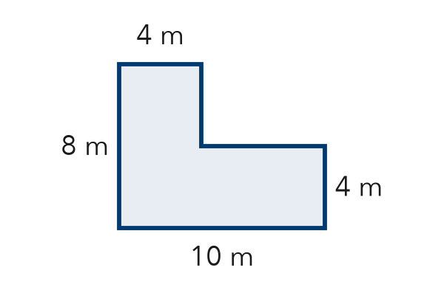
  Show your work.

2. Write add or subtract to tell how you would find each area.
a. a wall, not counting its window: | b. a bedroom plus its closet:

3. Find the area of the T-shaped figure. All corners are right angles.  Answer in² | 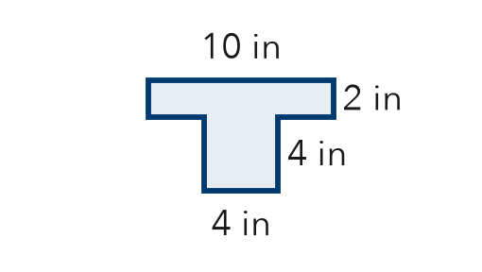

4. A triangle notch 4 cm deep is cut from the top of a rectangle. Find the area that is left.  Answer cm² | 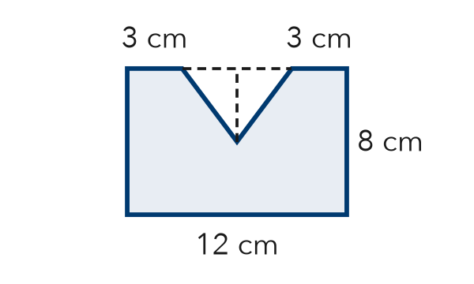

5. Backyard. A yard is a rectangle 20 ft by 12 ft. A square garden 5 ft on each side sits in one corner and will not be paved. Find the paved area.
Answer ft²

TEST PRACTICE choose the best answer
6. A rectangle 9 m by 6 m has a square 2 m by 2 m cut out. What area is left?
A 50 m² | B 58 m² | C 54 m² | D 13 m²

7. A 10 in by 4 in rectangle is joined to a triangle with base 4 in and height 3 in. What is the total area?
A 34 in² | B 40 in² | C 46 in² | D 52 in²

CHECK YOURSELF | □ I can do this on my own | □ I need a little help | □ I have a question about #

Name Date Period
Lesson 5-5 · Homework Packet · Sheet 1 of 2
Volume of Rectangular Prisms
Maryland Standard 6.G.A.2 · Learning target — I can find the volume of a rectangular prism by multiplying length, width, and height.

REMEMBER  • Volume counts the unit cubes that fill a solid. Use cubic units (cm³, in³, ft³).  • V = l × w × h, or V = B × h, where B is the area of the base. | WORKED EXAMPLE  A box is 7 cm long, 3 cm wide, and 5 cm tall.  Step 1 One layer of cubes: B = 7 × 3 = 21  Step 2 Stack 5 layers: 21 × 5 = 105  Answer 105 cm³
PRACTICE show your work · label units

1. Each small cube is 1 cm³. Find the volume of the prism.  Answer cm³ | 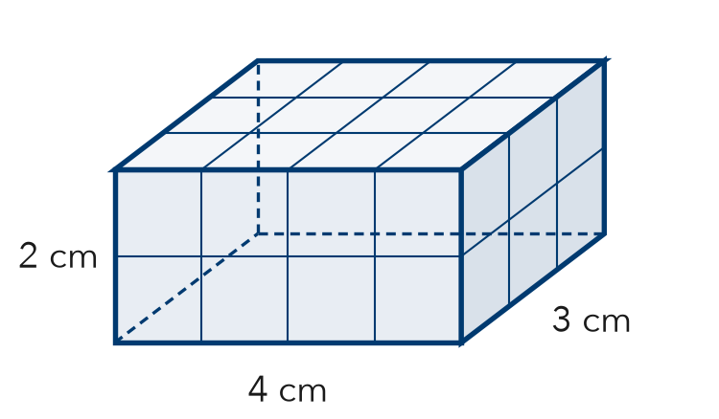
  Show your work.

2. Find the volume of each rectangular prism.
a. 8 in × 5 in × 2 in in³ | b. 10 cm × 10 cm × 4 cm cm³
c. 6 ft × 6 ft × 6 ft ft³ | d. B = 45 m², h = 7 m m³
e. 12 m × 3 m × 5 m m³ | f. B = 32 in², h = 9 in in³

3. Sandbox. A sandbox is 6 ft long, 4 ft wide, and 1 ft deep. One bag of sand fills 2 ft³. How many bags fill the sandbox?  Answer bags | 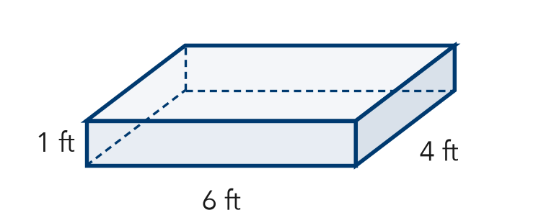
  Show your work.

4. Fish Tank. A fish tank is 20 in long and 10 in wide. It holds 3,000 in³ of water when full. How tall is the tank?
Answer in

5. Compare. Box A is 6 in × 4 in × 2 in. Box B is 3 in × 4 in × 4 in. Mika says Box A holds more because it is longer. Is she right? Explain.

CHECK YOURSELF | □ I can do this on my own | □ I need a little help | □ I have a question about #
AT HOME Find a box at home. Measure or estimate its length, width, and height, and find its volume.
Name Date Period
Lesson 5-5 · Homework Packet · Sheet 2 of 2
Missing Fractional Edges
Maryland Standard 6.G.A.2 · Learning target — I can find a missing edge of a prism and find volumes with fractional edge lengths.

REMEMBER  • V = l × w × h works with fractions too. Write mixed numbers as fractions first.  • Missing edge: divide the volume by the product of the other two edges. | WORKED EXAMPLE  A box is 2 ½ ft × 2 ft × 1 ½ ft. Find its volume.  Step 1 Write as fractions: 5/2 × 2/1 × 3/2  Step 2 Multiply: (5 × 2 × 3)/(2 × 1 × 2) = 30/4  Step 3 Simplify: 30/4 = 7 ½  Answer 7 ½ ft³
PRACTICE show your work · label units

1. Find the volume of the prism.  Answer in³ | 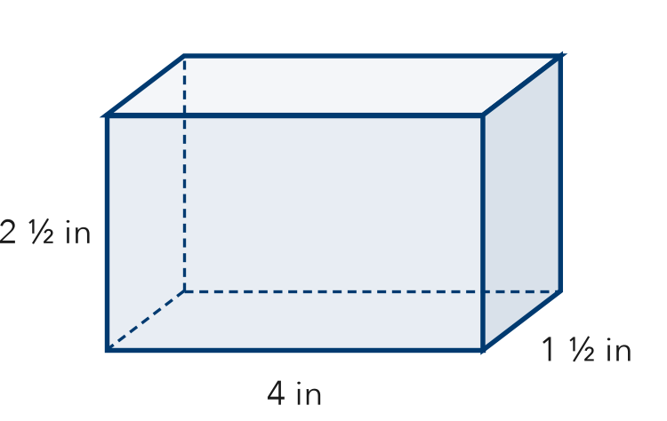
  Show your work.

2. Find each volume.
a. ½ ft × 6 ft × 8 ft ft³ | b. 3 ½ m × 2 m × 4 m m³
c. 2 ½ cm × 4 cm × 3 cm cm³ | d. 1 ½ in × 1 ½ in × 4 in in³
e. 4 ft × ½ ft × 5 ft ft³ | f. 6 cm × 1 ½ cm × 3 cm cm³

3. Planter. A planter box is 3 ft long and 1 ½ ft wide. It holds 9 ft³ of soil when full. How deep is it?
Answer ft

4. Small Cubes. A box is 2 in long, 1 in wide, and 1 ½ in tall. It is packed with cubes that are ½ in on each edge.
a. How many cubes fill the box?
b. Each cube is 1/8 in³. What is the volume of the box? in³

TEST PRACTICE choose the best answer
5. A box is 5 in long, 2 in wide, and 1 ½ in tall. What is its volume?
A 8 ½ in³ | B 10 in³ | C 15 in² | D 15 in³

6. A prism has a volume of 96 ft³. Its base is 4 ft by 6 ft. What is its height?
A 4 ft | B 16 ft | C 24 ft | D 576 ft

CHECK YOURSELF | □ I can do this on my own | □ I need a little help | □ I have a question about #
AT HOME Find a box at home with a fraction edge (like 2 ½ in). Estimate its volume.

Name Date Period
Lesson 5-6 · Homework Packet · Sheet 1 of 2
Drawing Nets of Solids
Maryland Standard 6.G.A.4 · Learning target — I can draw the net of a solid by unfolding its faces onto a flat surface.

REMEMBER  • A net is a flat pattern that folds into a solid. Each face appears once, with no overlaps.  • Rectangular prism: 6 rectangles. Square pyramid: 1 square + 4 triangles. Triangular prism: 2 triangles + 3 rectangles. | WORKED EXAMPLE  Plan a net for a box 5 cm × 3 cm × 2 cm.  Step 1 Faces come in pairs: 5 × 3, 5 × 2, 3 × 2  Step 2 Draw the 5 × 3 base. Attach a 5 × 2 face to each long edge.  Step 3 Attach a 3 × 2 face to each short edge. Add the 5 × 3 top to one 5 × 2 face.  Answer 6 rectangles, two of each size
PRACTICE show your work · label units

1. Draw a net for this box. Label the length and width of every face.  Face sizes | 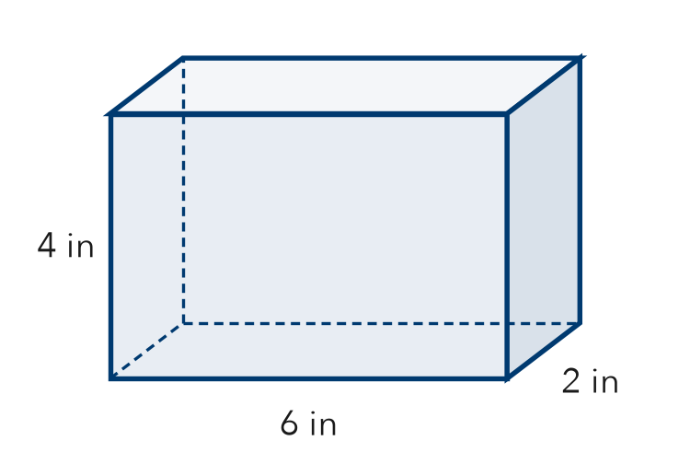
  Draw the net here.

2. How many of each shape are in the net?
a. cube: squares | b. square pyramid: triangles
c. triangular prism: rectangles | d. pentagonal pyramid: triangles

3. The net of this square pyramid has a square and 4 triangles.  a. Area of the square cm²  b. Area of one triangle cm²  All 4 triangles cm² | 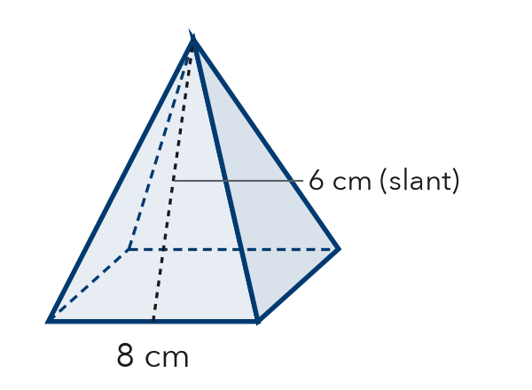

4. Cereal Box. A cereal box is 8 in long, 3 in wide, and 12 in tall. List the sizes of the 3 pairs of matching faces in its net.
Face pairs

5. Will It Fold? Jamal draws 6 squares in one long row and says it is a net for a cube. Is he right? Explain.

CHECK YOURSELF | □ I can do this on my own | □ I need a little help | □ I have a question about #
AT HOME Open an empty cereal box along its edges. Show someone its net.
Name Date Period
Lesson 5-6 · Homework Packet · Sheet 2 of 2
Reading Nets and Solids
Maryland Standard 6.G.A.4 · Learning target — I can name the solid a net makes by reading the shapes in the net.

REMEMBER  • Prism: 2 matching bases + rectangles. Pyramid: 1 base + triangles that meet at a point.  • The base shape names the solid (triangular, square, pentagonal …). | WORKED EXAMPLE  A net has 1 hexagon and 6 triangles.  Step 1 One base with triangles around it means a pyramid.  Step 2 The base is a hexagon.  Answer hexagonal pyramid
PRACTICE show your work · label units

1. Look at the net. | 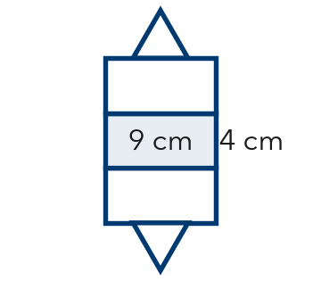
  a. Solid:
  b. Number of faces:

2. Name the solid each net makes.
a. 1 rectangle + 4 triangles: | b. 2 hexagons + 6 rectangles:
c. 2 triangles + 3 rectangles: | d. 1 pentagon + 5 triangles:
e. 6 squares: | f. 2 pentagons + 5 rectangles:

3. This net folds into a square pyramid. | 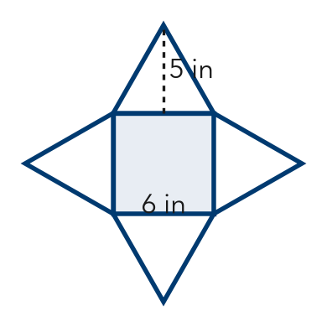
  a. Area of the base: in²
  b. Area of all 4 triangles: in²

4. Mystery Box. A net has 2 squares, 4 cm on each side, and 4 rectangles, 4 cm × 9 cm. Name the solid and its dimensions.
Answer

TEST PRACTICE choose the best answer
5. A triangular prism has 5 faces. How many edges does it have?
A 5 | B 6 | C 9 | D 12

6. How many faces does a hexagonal pyramid have?
A 6 | B 7 | C 8 | D 12

CHECK YOURSELF | □ I can do this on my own | □ I need a little help | □ I have a question about #
AT HOME Find a box at home. Tell someone what shapes its net would have and how many of each.

Name Date Period
Lesson 5-7 · Homework Packet · Sheet 1 of 2
Surface Area of Rectangular Prisms
Maryland Standard 6.G.A.4 · Learning target — I can find the surface area of a rectangular prism by adding the areas of its six faces.

REMEMBER  • Surface area is the total area of all the faces, in square units.  • A rectangular prism has 3 pairs of matching faces: SA = 2lw + 2lh + 2wh. | WORKED EXAMPLE  A box is 8 in × 3 in × 2 in. Find its surface area.  Step 1 One face from each pair: 8 × 3 = 24, 8 × 2 = 16, 3 × 2 = 6  Step 2 Add: 24 + 16 + 6 = 46  Step 3 Each face has a twin, so double: 2 × 46 = 92  Answer 92 in²
PRACTICE show your work · label units

1. Find the surface area of the prism.  Answer cm² | 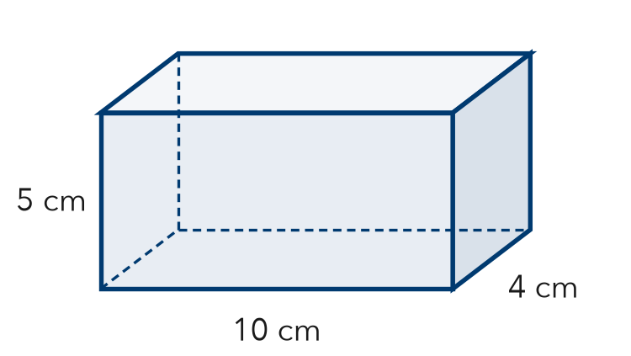
  Show your work.

2. Find the surface area of each solid.
a. cube, edges 3 cm cm² | b. cube, edges 10 ft ft²
c. prism 4 m × 2 m × 1 m m² | d. prism 5 in × 5 in × 2 in in²
e. cube, edges 5 in in² | f. prism 6 cm × 3 cm × 2 cm cm²

3. Gift Box. Nadia wraps a box that is 12 in long, 8 in wide, and 4 in tall. Her paper covers 400 in². Is that enough to cover the box? Explain.

Show your work.
Answer

4. Toy Chest. A toy chest is 4 ft long, 2 ft wide, and 3 ft tall. Leo paints all faces but the bottom. How many ft² does he paint?
Answer ft²

5. Find the Error. Diego says the surface area of a cube with 2 cm edges is 8 cm² because 2 × 2 × 2 = 8. Explain his mistake and find the surface area.

CHECK YOURSELF | □ I can do this on my own | □ I need a little help | □ I have a question about #
AT HOME Pick a box at home. Point to each pair of matching faces and tell someone how you would find its surface area.
Name Date Period
Lesson 5-7 · Homework Packet · Sheet 2 of 2
Surface Area of Triangular Prisms
Maryland Standard 6.G.A.4 · Learning target — I can find the surface area of a triangular prism using its net.

REMEMBER  • A triangular prism has 2 triangle bases and 3 rectangles.  • Each rectangle is one side of the triangle × the prism’s length. Add all 5 faces. | WORKED EXAMPLE  Prism 10 cm long. Ends are right triangles with sides 3, 4, 5 cm.  Step 1 Triangles: 2 × (½ × 3 × 4) = 12  Step 2 Rectangles: 30 + 40 + 50 = 120  Step 3 Add: 12 + 120 = 132  Answer 132 cm²
PRACTICE show your work · label units

1. Find the surface area. The triangle ends have sides 5 m, 5 m, and 6 m.  Answer m² | 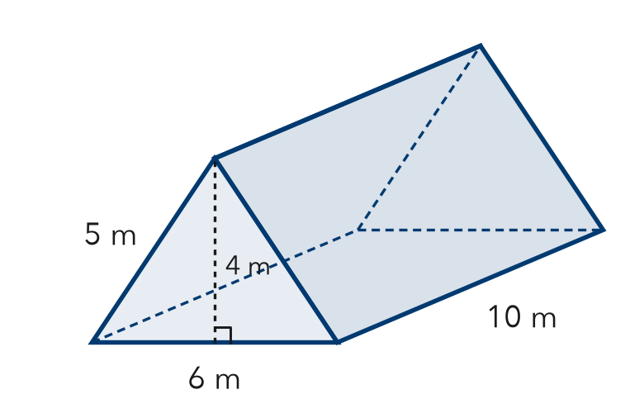
  Show your work.

2. Find each area.
a. 2 triangles, base 8 ft, height 3 ft: ft² | b. 1 rectangle, 5 ft by 9 ft: ft²

3. Tent. A tent is a triangular prism 9 ft long. Each end is a triangle with base 8 ft, height 3 ft, and two 5 ft sides. Find the fabric needed for all 5 faces, including the floor.
Answer ft²

4. Doorstop. A wooden doorstop is a triangular prism 4 in long. Its ends are right triangles with sides 5 in, 12 in, and 13 in. Find its surface area.
Answer in²

5. Find the Error. For the prism in Exercise 1, Lucas found the rectangles as 6 × 10, 4 × 10, and 4 × 10. Explain his mistake.

TEST PRACTICE choose the best answer
6. Triangle ends: 9 cm² each. Rectangles: 20, 20, and 24 cm². What is the surface area?
A 64 cm² | B 73 cm² | C 82 cm² | D 146 cm²

7. A prism is 8 cm long. Its triangle ends have sides 6, 8, and 10 cm. What is the total area of the 3 rectangles?
A 24 cm² | B 192 cm² | C 240 cm² | D 480 cm²

CHECK YOURSELF | □ I can do this on my own | □ I need a little help | □ I have a question about #

Name Date Period
Lesson 5-8 · Homework Packet · Sheet 1 of 2
Surface Area of Pyramids
Maryland Standard 6.G.A.4 · Learning target — I can find the surface area of a pyramid by adding the base area and the areas of its triangular faces.

REMEMBER  • SA of a pyramid = base area + area of all the triangular faces.  • Each triangle’s height is the slant height, not the height of the pyramid. | WORKED EXAMPLE  Square pyramid: base 8 cm, slant height 7 cm.  Step 1 Base: 8 × 8 = 64  Step 2 One triangle: ½ × 8 × 7 = 28; four: 112  Step 3 Add: 64 + 112 = 176  Answer 176 cm²
PRACTICE show your work · label units

1. Find the surface area of the square pyramid.  Answer m² | 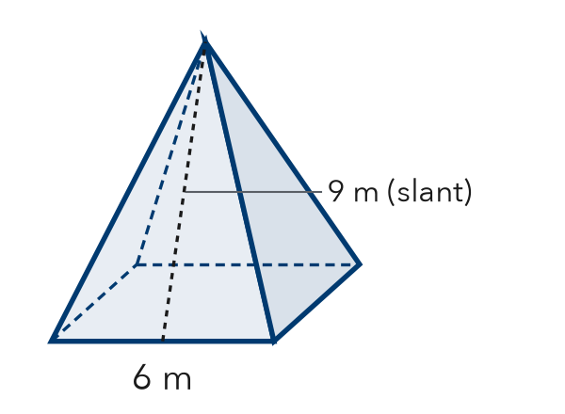
  Show your work.

2. Use the net of the square pyramid.  a. Area of the base cm²  b. Area of one triangle cm²  Surface area cm² | 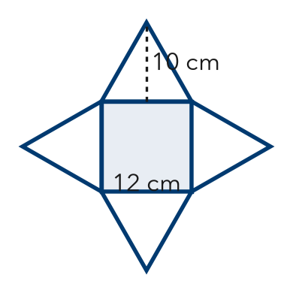

3. Find the surface area of each square pyramid.
a. base 4 in, slant height 5 in in² | b. base 10 cm, slant height 12 cm cm²

4. Gift Box. A gift box is a square pyramid with a base 9 in on each side and a slant height of 11 in. How much paper covers every face?

Show your work.
Answer in²

5. Find the Error. A square pyramid has a base 6 ft on each side, a height of 4 ft, and a slant height of 5 ft. Kofi wrote SA = 36 + 4 × (½ × 6 × 4) = 84 ft². Explain his mistake and find the surface area.

CHECK YOURSELF | □ I can do this on my own | □ I need a little help | □ I have a question about #
AT HOME Use a folded paper tent to show someone a pyramid’s height and its slant height.
Name Date Period
Lesson 5-8 · Homework Packet · Sheet 2 of 2
Lateral Area of Pyramids
Maryland Standard 6.G.A.4 · Learning target — I can find the lateral area of a pyramid, which covers only its slanted faces.

REMEMBER  • Lateral area is the area of the slanted faces only. Do not include the base.  • Lateral area = surface area − base area. | WORKED EXAMPLE  Square pyramid: base 10 m, slant height 13 m. Find the lateral area.  Step 1 One face: ½ × 10 × 13 = 65  Step 2 Four faces: 4 × 65 = 260  Answer 260 m²
PRACTICE show your work · label units

1. Find the lateral area of the square pyramid.  Answer ft² | 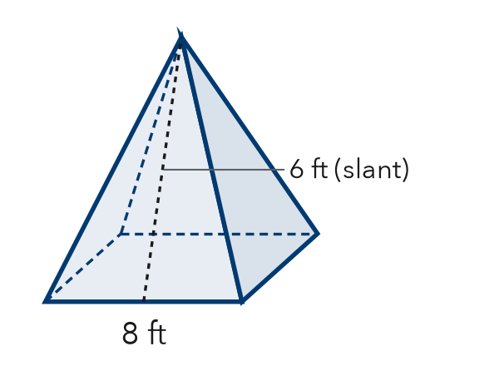
  Show your work.

2. Find each lateral area.
a. SA = 200 in², base = 64 in² in² | b. 4 faces, each 18 cm² cm²
c. square base, side 6 m; slant height 10 m m² | d. square base, side 3 ft; slant height 4 ft ft²

3. Tower Roof. A roof is a square pyramid with a base 14 ft on each side and a slant height of 10 ft. Shingles cover only the slanted faces. One bundle covers 35 ft². How many bundles are needed?
Answer bundles

4. Lampshade. A lampshade is a square pyramid with no base. Its lateral area is 160 in² and each base edge is 8 in. What is its slant height?
Answer in

5. Play Tent. A play tent is a square pyramid with a base 5 ft on each side and a slant height of 6 ft. It has no floor. Sasha says it needs 85 ft² of fabric. Is she right? Explain.

TEST PRACTICE choose the best answer
6. A square pyramid has a base 4 cm on each side and a slant height of 7 cm. What is its lateral area?
A 14 cm² | B 56 cm² | C 72 cm² | D 112 cm²

7. A pyramid has a surface area of 120 m² and a lateral area of 84 m². What is its base area?
A 204 m² | B 120 m² | C 36 m² | D 42 m²

CHECK YOURSELF | □ I can do this on my own | □ I need a little help | □ I have a question about #

