Name Date Period
Lesson 6-1 · Homework Packet · Sheet 1 of 2
Dividing by a Unit Fraction
Maryland Standard 6.NS.A.1 · Learning target — I can divide a whole number by a unit fraction and explain what the quotient counts.

REMEMBER  • Dividing by a unit fraction asks: how many pieces of that size fit into the number?  • 1 whole holds 4 fourths, so 3 ÷ 1/4 = 3 × 4 = 12.  • The quotient is greater than the number you divide. Check: 12 × 1/4 = 3. | WORKED EXAMPLE  How many 1/3-cup scoops are in 5 cups of rice?  Step 1 Each cup holds 3 thirds.  Step 2 5 cups hold 5 × 3 = 15 thirds, so 5 ÷ 1/3 = 15.  Step 3 Check: 15 × 1/3 = 5, so it checks.  Answer 15 scoops
PRACTICE show your work · label units
1. Each bar is 1 whole. Use the fraction bars to find 4 ÷ 1/3. How many thirds are in 4 wholes?
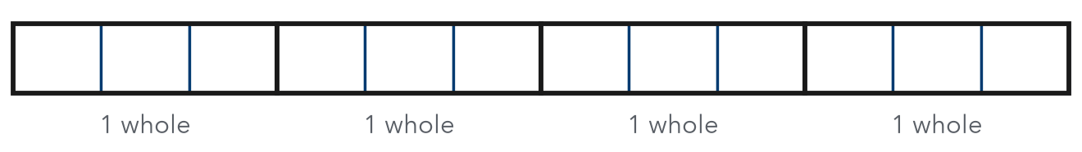
4 ÷ 1/3 =

2. Divide.
a. 6 ÷ 1/2 = | b. 3 ÷ 1/5 = | c. 8 ÷ 1/4 =
d. 2 ÷ 1/9 = | e. 7 ÷ 1/3 = | f. 10 ÷ 1/6 =
g. 5 ÷ 1/7 = | h. 12 ÷ 1/3 =

3. Trail Mix. Jamal has 6 cups of trail mix. He fills snack bags that each hold 1/4 cup. How many bags can he fill?
Answer bags

4. Ribbon Bows. Ms. Carter has 5 yards of ribbon. She cuts it into pieces that are each 1/6 yard long. She uses 18 pieces to make bows. How many pieces are left?

Show your work.
Answer pieces

5. Find the Error. Tanya says 8 ÷ 1/2 = 4. Explain her mistake. Then find the correct quotient.

CHECK YOURSELF | □ I can do this on my own | □ I need a little help | □ I have a question about #
AT HOME Count how many 1/4-cup scoops fill 2 cups. Does it match 2 ÷ 1/4?
Name Date Period
Lesson 6-1 · Homework Packet · Sheet 2 of 2
Dividing a Fraction by a Whole Number
Maryland Standard 6.NS.A.1 · Learning target — I can divide a fraction by a whole number and explain the result.

REMEMBER  • Dividing by a whole number shares a fraction into equal parts.  • Multiply by the reciprocal: 2/3 ÷ 4 = 2/3 × 1/4 = 2/12 = 1/6.  • Dividing by a whole number greater than 1 gives a quotient less than the fraction. Check: 1/6 × 4 = 2/3. | WORKED EXAMPLE  3 friends share 3/4 of a sandwich equally. What part of the whole does each get?  Step 1 3/4 ÷ 3 = 3/4 × 1/3 = 3/12  Step 2 Simplify: 3/12 = 1/4  Answer 1/4 of the sandwich
PRACTICE show your work · label units
1. Divide. Write each quotient in simplest form.
a. 1/2 ÷ 3 = | b. 4/5 ÷ 2 = | c. 3/8 ÷ 3 =
d. 2/3 ÷ 6 = | e. 6/7 ÷ 2 = | f. 5/6 ÷ 10 =

2. Find each share. Write it in simplest form.
a. 4 people share 1/2 lb of cheese: lb | b. 5 cups share 5/6 L of juice: L

3. Paint Cans. Kiara has 3/5 gallon of paint. She pours it equally into 6 small cans. How much paint is in each can?

Show your work.
Answer gallon

4. Clay. Mr. Okafor has 2/3 pound of clay. He splits it equally among 4 students. How much clay does each student get?
Answer pound

5. Reason. Without dividing, decide: is 5/8 ÷ 4 greater than or less than 5/8?
□ greater than 5/8 | □ less than 5/8

TEST PRACTICE choose the best answer
6. Which expression has the same value as 5/6 ÷ 5?
A 5/6 × 5 | B 5/6 × 1/5 | C 6/5 × 5 | D 5/6 − 5

7. 4 people share 4/9 of a pizza equally. What fraction of the whole pizza does each get?
A 1/9 | B 16/9 | C 1/36 | D 4/9

CHECK YOURSELF | □ I can do this on my own | □ I need a little help | □ I have a question about #
AT HOME Share 1/2 of a sandwich equally among 2 people at home. What fraction of the whole sandwich does each get?

Name Date Period
Lesson 6-2 · Homework Packet · Sheet 1 of 2
Dividing a Fraction by a Fraction
Maryland Standard 6.NS.A.1 · Learning target — I can divide a fraction by another fraction using the reciprocal.

REMEMBER  • To divide by a fraction, multiply by its reciprocal: 3/4 ÷ 3/8 = 3/4 × 8/3.  • Keep the first fraction, change ÷ to ×, and flip only the second fraction.  • Check: quotient × divisor = dividend. 2 × 3/8 = 6/8 = 3/4. | WORKED EXAMPLE  How many 3/8-cup servings are in 3/4 cup of yogurt?  Step 1 Write the division: 3/4 ÷ 3/8  Step 2 Multiply by the reciprocal: 3/4 × 8/3 = 24/12  Step 3 Simplify: 24/12 = 2  Answer 2 servings
PRACTICE show your work · label units
1. The bar is 1 whole. The shaded part is 4/5 of the bar. How many 1/10 pieces fit in 4/5? Write the division and the quotient.
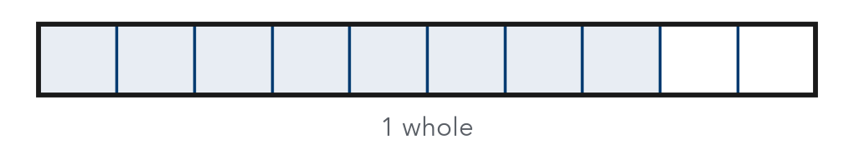
Division

2. Divide. Write each quotient in simplest form.
a. 3/4 ÷ 1/8 = | b. 2/3 ÷ 2/9 = | c. 5/6 ÷ 1/3 =
d. 7/10 ÷ 2/5 = | e. 1/2 ÷ 3/4 = | f. 8/9 ÷ 4/9 =

3. Pancakes. A pancake recipe needs 2/3 cup of milk. Rosa has only 1/2 cup of milk. What fraction of the recipe can she make?

Show your work.
Answer of the recipe

4. Bookmarks. Jae has 5/6 yard of ribbon. Each bookmark needs 5/12 yard. How many bookmarks can Jae make?
Answer bookmarks

5. Find the Error. Imani wrote 4/5 ÷ 2/3 = 4/5 × 2/3 = 8/15. Explain her mistake. Then find the correct quotient.

CHECK YOURSELF | □ I can do this on my own | □ I need a little help | □ I have a question about #
AT HOME With a measuring cup, show someone at home how many 1/4-cup scoops are in 3/4 cup.
Name Date Period
Lesson 6-2 · Homework Packet · Sheet 2 of 2
Dividing with Mixed Numbers
Maryland Standard 6.NS.A.1 · Learning target — I can divide mixed numbers by writing them as improper fractions first.

REMEMBER  • Write each mixed number as an improper fraction: 2 3/4 = 11/4.  • Then multiply by the reciprocal of the divisor.  • Simplify. Write an improper answer as a mixed number. | WORKED EXAMPLE  A board is 5 1/4 feet long. How many 3/4-foot pieces can be cut?  Step 1 5 1/4 = 21/4, so 21/4 ÷ 3/4 = 21/4 × 4/3  Step 2 Multiply and simplify: 84/12 = 7  Answer 7 pieces
PRACTICE show your work · label units
1. Divide. Write each quotient in simplest form.
a. 4 1/2 ÷ 3/4 = | b. 3 1/3 ÷ 5/6 = | c. 2 1/4 ÷ 1 1/2 =
d. 6 ÷ 1 1/3 = | e. 5 5/6 ÷ 1 1/6 = | f. 1 7/8 ÷ 2 1/2 =

2. Write each mixed number as an improper fraction.
a. 3 2/5 = | b. 4 5/6 =

3. Soup Bowls. A pot holds 8 3/4 cups of soup. Each bowl holds 1 1/2 cups. How many bowls can be filled completely? How much soup is left over?

Show your work.
Answer

4. Hiking. A trail is 7 1/2 miles long. Kenji hikes 1 1/4 miles each hour. How many hours will it take him to hike the whole trail?
Answer hours

5. Reason. Without dividing, decide: is 6 1/2 ÷ 1 1/4 greater than or less than 6 1/2?
□ greater than 6 1/2 | □ less than 6 1/2

TEST PRACTICE choose the best answer
6. What is 3 1/2 ÷ 1 3/4?
A 1/2 | B 2 | C 3 2/3 | D 6 1/8

7. A rope is 6 2/3 feet long. It is cut into pieces that are each 5/6 foot long. How many pieces are there?
A 1/8 | B 5 5/9 | C 8 | D 12

CHECK YOURSELF | □ I can do this on my own | □ I need a little help | □ I have a question about #
AT HOME Measure 1 1/2 cups of water with a 1/4-cup scoop. Does the number of scoops match 1 1/2 ÷ 1/4?

Name Date Period
Lesson 6-3 · Homework Packet · Sheet 1 of 2
Writing Repeated Factors as Powers
Maryland Standard 6.EE.A.1 · Learning target — I can write repeated multiplication as a power and name its base and exponent.

REMEMBER  • A power shows a repeated factor: 5 × 5 × 5 = 5³.  • The base is the repeated factor. The exponent tells how many times it is a factor.  • Read 5³ as “5 to the third power” or “5 cubed.” Read 5² as “5 squared.” | WORKED EXAMPLE  Write 6 × 6 × 6 × 6 × 6 as a power. Name the base and the exponent.  Step 1 The repeated factor is 6. It is the base.  Step 2 Count the factors: there are 5. That is the exponent.  Step 3 Write the base with a raised exponent: 6⁵  Answer 6⁵; base 6, exponent 5
PRACTICE show your work · label units
1. Write each product as a power.
a. 4 × 4 × 4 = | b. 9 × 9 =
c. 2 × 2 × 2 × 2 × 2 × 2 × 2 = | d. 10 × 10 × 10 × 10 =
e. 1/3 × 1/3 × 1/3 = | f. 0.5 × 0.5 =
g. 6 × 6 × 6 × 6 × 6 = | h. 2/5 × 2/5 =

2. Complete the table.
Power | Base | Exponent | Expanded form
8³
 | 7 | 4
 |  |  | 11 × 11

3. Phone Tree. A coach calls 3 players. Each player calls 3 more players, and so on. In round 5, the number of calls is 3 × 3 × 3 × 3 × 3. Write this as a power.
Power

4. Find the Error. Rafael wrote 4 × 4 × 4 × 4 × 4 as 5⁴. Explain his mistake. Then write the correct power.

CHECK YOURSELF | □ I can do this on my own | □ I need a little help | □ I have a question about #
AT HOME Explain to someone at home why 2⁴ does not mean 2 × 4.
Name Date Period
Lesson 6-3 · Homework Packet · Sheet 2 of 2
Finding the Value of a Power
Maryland Standard 6.EE.A.1 · Learning target — I can find the value of a power by multiplying the base the number of times the exponent shows.

REMEMBER  • Write the expanded form, then multiply one factor at a time.  • 4³ = 4 × 4 × 4 = 64, not 4 × 3 = 12.  • Fraction and decimal bases work the same way: (1/2)² = 1/2 × 1/2 = 1/4. | WORKED EXAMPLE  Find the value of 2⁵.  Step 1 Expanded form: 2 × 2 × 2 × 2 × 2  Step 2 Multiply: 2 × 2 = 4, 4 × 2 = 8, 8 × 2 = 16, 16 × 2 = 32  Answer 2⁵ = 32
PRACTICE show your work · label units
1. Find the value of each power.
a. 7² = | b. 3⁴ = | c. 5³ =
d. 10⁵ = | e. 2⁶ = | f. 1⁸ =

2. Find the value. Write fractions in simplest form.
a. (1/2)³ = | b. 0.3² =

3. Write each number as a power of the given base.
a. 27 as a power of 3: | b. 10,000 as a power of 10:

4. Storage Cube. A storage cube has edges that are 7 inches long. Its volume is 7³ cubic inches. Find the volume.  Answer in³ | 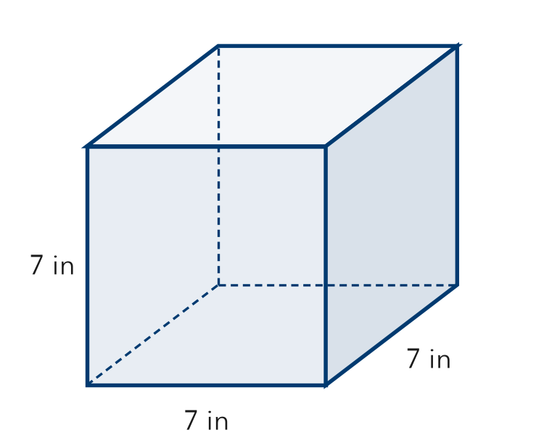
  Show your work.

5. Compare. Select the two powers that have the same value.
□ A 2⁶ | □ B 6² | □ C 4³ | □ D 3⁴

TEST PRACTICE choose the best answer
6. What is the value of 4³?
A 7 | B 12 | C 64 | D 81

7. Which expression has a value of 1,000?
A 10³ | B 3¹⁰ | C 10 × 3 | D 100³

CHECK YOURSELF | □ I can do this on my own | □ I need a little help | □ I have a question about #
AT HOME Ask someone at home to guess which is greater, 2⁵ or 5². Then find both values together.

Name Date Period
Lesson 6-4 · Homework Packet · Sheet 1 of 2
Writing Numerical Expressions
Maryland Standard 6.EE.A.2 · Learning target — I can write a numerical expression that matches a situation.

REMEMBER  • A numerical expression uses numbers and operations. It has no equals sign.  • Sum (+), difference (−), product (×), quotient (÷). Less than flips the order: 5 less than 12 is 12 − 5.  • Use parentheses for a part done first: the sum of 4 and 6, tripled, is 3 × (4 + 6). | WORKED EXAMPLE  Kayla buys 3 notebooks at $4 each and a backpack for $15. Write an expression for the total cost. Then evaluate it.  Step 1 Notebooks: 3 × 4. Backpack: 15  Step 2 Join them: 3 × 4 + 15  Step 3 Evaluate: 12 + 15 = 27  Answer 3 × 4 + 15 = $27
PRACTICE show your work · label units
1. Write a numerical expression for each phrase. Do not evaluate.
a. the product of 7 and 8, minus 10 | b. 12 less than 50
c. the quotient of 36 and 9, plus 2 | d. the difference of 15 and 6, doubled
e. 9 more than the product of 3 and 5 | f. the quotient of 42 and 7, tripled

2. Field Day. A class buys 5 packs of water at $6 each and 4 bags of oranges at $3 each. Write one expression for the total cost. Then evaluate it.

Show your work.
Expression and cost

3. Bake Sale. Nia sells 12 muffins at $2 each and 8 loaves of bread at $5 each. She spent $15 on supplies. Write one expression for the money she has left after paying for supplies. Then evaluate it.

Show your work.
Expression and amount

4. Which expression matches “the sum of 8 and 2, times 5”?
□ 8 + 2 × 5 | □ (8 + 2) × 5 | □ 8 × 5 + 2

5. Write a Story. Write a short story that matches 4 × (6 + 3). Then evaluate the expression.

CHECK YOURSELF | □ I can do this on my own | □ I need a little help | □ I have a question about #
AT HOME Find two prices at home or in an ad. Write one expression for buying some of each.
Name Date Period
Lesson 6-4 · Homework Packet · Sheet 2 of 2
Order of Operations with Powers
Maryland Standard 6.EE.A.2c · Learning target — I can evaluate an expression that contains grouping symbols and powers using the order of operations.

REMEMBER  • Order: 1. grouping ( ) 2. powers 3. × and ÷ left to right 4. + and − left to right.  • × and ÷ are partners: do whichever comes first from the left. So are + and −.  • A power applies only to the number just before it: 2 × 3² = 2 × 9 = 18. | WORKED EXAMPLE  Evaluate 20 − (2 + 1)² × 2.  Step 1 Grouping, then power: 20 − 3² × 2 = 20 − 9 × 2  Step 2 Multiply, then subtract: 20 − 18 = 2  Answer 2
PRACTICE show your work · label units
1. Evaluate each expression.
a. 6 + 4 × 5 = | b. (6 + 4) × 5 = | c. 3² + 2 × 4 =
d. 48 ÷ (2 + 6) = | e. 5² − 10 ÷ 2 = | f. 36 ÷ 3 × 2 =

2. Add one pair of parentheses to make each statement true.
a. 2 + 3 × 4 = 20 | b. 24 ÷ 4 + 2 = 4

3. Tile Floor. A square floor is 8 tiles by 8 tiles. Mr. Ruiz replaces all but 4 tiles. Each new tile costs $3. Evaluate 3 × (8² − 4) to find the cost.

Show your work.
Answer dollars

4. Bead Kits. Ms. Lewis has 5 bags with 4² beads in each bag. Her class uses 30 beads. Evaluate 5 × 4² − 30 to find how many beads are left.
Answer beads

5. Who Is Right? For 18 − 6 + 2, Kim got 10 and Lou got 14. Who is correct?
□ Kim | □ Lou

TEST PRACTICE choose the best answer
6. What is the value of 5 + 3 × 2²?
A 17 | B 32 | C 41 | D 256

7. Which expression has a value of 14?
A (2 + 3) × 4 | B 2 + 3 × 4 | C 2³ + 4 | D 16 ÷ 2 × 4

CHECK YOURSELF | □ I can do this on my own | □ I need a little help | □ I have a question about #
AT HOME Show someone at home why 2 + 3 × 4 and (2 + 3) × 4 have different values.

Name Date Period
Lesson 6-5 · Homework Packet · Sheet 1 of 2
Writing Algebraic Expressions
Maryland Standard 6.EE.A.2a · Learning target — I can write an algebraic expression that uses a variable for an unknown amount.

REMEMBER  • A variable is a letter that stands for an unknown amount. 5n means 5 × n.  • In 5n + 12, 5 is the coefficient and 12 is the constant.  • Order matters: “4 less than x” is x − 4. An amount that repeats goes with the variable. | WORKED EXAMPLE  Bowling costs $5 per game plus $4 for shoes. Write an expression for the cost of g games.  Step 1 Part that repeats: $5 for each game, 5g  Step 2 One-time part: 4  Step 3 Join them: 5g + 4  Answer 5g + 4 dollars
PRACTICE show your work · label units
1. Write an algebraic expression for each phrase.
a. a number n increased by 9 | b. 8 less than y
c. the product of 6 and k | d. m divided by 5
e. 3 more than twice x | f. 7 times the sum of a and 2

2. Music Lessons. Guitar lessons cost $15 per lesson plus $20 for a book. Let L be the number of lessons. Write an expression for the total cost.
Expression

3. Write an expression for each situation.
a. 4 friends share p pretzels equally. Pretzels each friend gets: | b. Tyrell had 50 stickers and gave away s. Stickers left:

4. Pizza Party. Each pizza costs $11. The class orders p pizzas and pays a $5 delivery fee. Write an expression for the total cost. Then find the cost of 4 pizzas.

Show your work.
Expression and cost

5. Find the Error. Tickets cost $7 each, plus one $3 fee. Dmitri wrote 7 + 3n for the cost of n tickets. Explain his mistake. Write the correct expression.

CHECK YOURSELF | □ I can do this on my own | □ I need a little help | □ I have a question about #
AT HOME Tell someone at home what the variable, coefficient, and constant mean in 15L + 20.
Name Date Period
Lesson 6-5 · Homework Packet · Sheet 2 of 2
Evaluating Algebraic Expressions
Maryland Standard 6.EE.A.2c · Learning target — I can evaluate an algebraic expression by substituting a value for the variable.

REMEMBER  • To evaluate, substitute the value, then use the order of operations.  • 4x means 4 × x. When x = 3, 4x = 12, not 43.  • Powers come before multiplying: 2n² with n = 5 is 2 × 25 = 50. | WORKED EXAMPLE  Evaluate 3a² − 4 when a = 4.  Step 1 Substitute: 3 × 4² − 4  Step 2 Power, multiply, subtract: 3 × 16 − 4 = 48 − 4 = 44  Answer 44
PRACTICE show your work · label units
1. Evaluate each expression when x = 6.
a. 5x = | b. x + 17 = | c. 40 − 3x =
d. x² + 4 = | e. x ÷ 2 + 9 = | f. 2(x − 1) =

2. Evaluate each expression when a = 4 and b = 5.
a. 3a + 2b = | b. a² − b =

3. Kayak rental costs 8h + 5 dollars for h hours. Complete the table.
Hours, h | 1 | 3 | 6
Cost, 8h + 5 (dollars)

4. Phone Battery. The expression 100 − 6h gives the percent of battery left after h hours. Find the percent left after 5 hours.

Show your work.
Answer %

5. Find the Error. Sam says 20 − 3k = 68 when k = 4. What is the correct value?
□ 68 | □ 8 | □ 32

TEST PRACTICE choose the best answer
6. What is the value of 5n − 7 when n = 3?
A 46 | B 22 | C 8 | D 15

7. Tickets cost $9 each and parking costs $6. Which expression gives the total cost for t tickets?
A 6t + 9 | B 15t | C 9(t + 6) | D 9t + 6

CHECK YOURSELF | □ I can do this on my own | □ I need a little help | □ I have a question about #

Name Date Period
Lesson 6-6 · Homework Packet · Sheet 1 of 2
Simplifying to Show Equivalence
Maryland Standard 6.EE.A.3 · Learning target — I can simplify an expression by combining like terms to test whether two expressions are equivalent.

REMEMBER  • Like terms have the same variable part: 4x and 9x are like terms. 4x and 4 are not.  • Combine like terms by adding or subtracting coefficients: 4x + 9x = 13x. A lone x is 1x.  • Expressions are equivalent if they simplify to the same expression. | WORKED EXAMPLE  Are 5m + 8 + 2m − 3 and 7m + 5 equivalent?  Step 1 Combine the m terms: 5m + 2m = 7m  Step 2 Combine the constants: 8 − 3 = 5  Step 3 The first simplifies to 7m + 5, the same as the second.  Answer Yes, they are equivalent.
PRACTICE show your work · label units
1. Simplify each expression.
a. 6a + 3a = | b. 10y − 4y =
c. x + 5x + 2 = | d. 7 + 3n + 4 =
e. 8b + 6 − 3b + 1 = | f. 2p + 9q + 5p =
g. 4m + 2 + m + 9 = | h. 12z − z =

2. Perimeter. The side lengths of the triangle are in centimeters. Write and simplify an expression for its perimeter.  Answer cm | 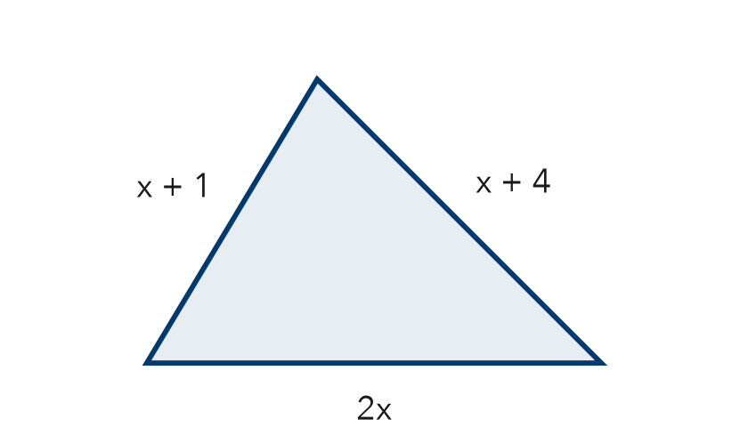
  Show your work.

3. Are 3w + 3w and 6w² equivalent?
□ Yes | □ No

4. Which expression is equivalent to 5x + 3 + 2x?
□ 10x | □ 7x + 3 | □ 5x + 5

5. Find the Error. Elena simplified 7x + 4 − 2x and wrote 9x. Explain her mistake. Then simplify correctly.

CHECK YOURSELF | □ I can do this on my own | □ I need a little help | □ I have a question about #
AT HOME Explain to someone at home why 4x + 4 cannot be written as 8x.
Name Date Period
Lesson 6-6 · Homework Packet · Sheet 2 of 2
Testing and Justifying Equivalence
Maryland Standard 6.EE.A.4 · Learning target — I can test whether two expressions are equivalent by substituting values and by reasoning.

REMEMBER  • Equivalent expressions have the same value for every value of the variable.  • Test with the same value in both. One value that gives different results proves they are not equivalent.  • Matching values do not prove it. Justify with properties, like the distributive property. | WORKED EXAMPLE  Are 4(n + 3) and 4n + 3 equivalent?  Step 1 Test n = 2: 4(2 + 3) = 20 and 4 × 2 + 3 = 11  Step 2 20 ≠ 11. Distributing shows 4(n + 3) = 4n + 12.  Answer Not equivalent
PRACTICE show your work · label units
1. Evaluate each expression when x = 5. Which two might be equivalent?
a. 3(x + 4) = | b. 3x + 12 = | c. 3x + 4 =

2. Write E if the expressions are equivalent or N if they are not.
a. 2(a + 5) and 2a + 10 | b. 6b + 1 and 7b
c. c + c + c and c³ | d. 8 + 4m − m and 3m + 8

3. Counterexample. Nate says n² and 2n are equivalent because both equal 4 when n = 2. Find a value of n that shows he is wrong.

Show your work.
Value and results

4. Reason. 3x and x + 6 are both 9 when x = 3. Which value of x shows they are not equivalent?
□ x = 3 | □ x = 4

5. Which property shows that 5(m + 2) = 5m + 10?
□ Commutative | □ Associative | □ Distributive

TEST PRACTICE choose the best answer
6. Which expression is equivalent to 7(p + 3)?
A 7p + 3 | B 7p + 21 | C p + 21 | D 10p

7. Which expression is not equivalent to 4y + 8?
A 4(y + 2) | B 2(2y + 4) | C 8 + 4y | D 4(y + 8)

CHECK YOURSELF | □ I can do this on my own | □ I need a little help | □ I have a question about #
AT HOME Pick a number with someone at home. Do 2(x + 3) and 2x + 6 give the same value? Try another number.

Name Date Period
Lesson 6-7 · Homework Packet · Sheet 1 of 2
Factors and Greatest Common Factor
Maryland Standard 6.NS.B.4 · Learning target — I can list the factors of two numbers and find their greatest common factor.

REMEMBER  • A factor divides a number with no remainder. Find factors in pairs: 18 = 1 × 18 = 2 × 9 = 3 × 6.  • The greatest common factor (GCF) is the greatest factor that two numbers share.  • Use the GCF to make the greatest number of identical groups with nothing left over. | WORKED EXAMPLE  Find the GCF of 24 and 36.  Step 1 Factors of 24: 1, 2, 3, 4, 6, 8, 12, 24  Step 2 Factors of 36: 1, 2, 3, 4, 6, 9, 12, 18, 36  Step 3 Common factors: 1, 2, 3, 4, 6, 12. The greatest is 12.  Answer GCF = 12
PRACTICE show your work · label units
1. List all the factors of each number.
a. 30: | b. 28:
c. 45: | d. 17:
e. 48: | f. 42:

2. Find the GCF of each pair.
a. 12 and 20: | b. 18 and 27: | c. 16 and 40:
d. 14 and 25: | e. 36 and 48: | f. 30 and 45:

3. Write the prime factorization of each number. Use exponents.
a. 36 = | b. 50 = | c. 72 =

4. Snack Bags. Mr. Diaz has 36 granola bars and 54 juice boxes. He makes identical snack bags with nothing left over. What is the greatest number of bags he can make? What is in each bag?

Show your work.
Answer

5. Find the Error. Hana says the GCF of 15 and 28 is 0 because they share no factors. Explain her mistake and give the GCF.

CHECK YOURSELF | □ I can do this on my own | □ I need a little help | □ I have a question about #
AT HOME Ask someone at home to name two numbers. Find their GCF together.
Name Date Period
Lesson 6-7 · Homework Packet · Sheet 2 of 2
Multiples and Least Common Multiple
Maryland Standard 6.NS.B.4 · Learning target — I can list multiples of two numbers and find their least common multiple.

REMEMBER  • Multiples of a number come from skip-counting: 6, 12, 18, 24, …  • The least common multiple (LCM) is the least number that is a multiple of both.  • Use the LCM when events happen together again, or to buy packs for equal amounts. | WORKED EXAMPLE  Find the LCM of 8 and 12.  Step 1 Multiples of 12: 12, 24, 36, …  Step 2 12 is not a multiple of 8. 24 is (8 × 3 = 24).  Answer LCM = 24
PRACTICE show your work · label units
1. Find the LCM of each pair.
a. 3 and 7: | b. 4 and 10: | c. 6 and 8:
d. 5 and 15: | e. 9 and 12: | f. 10 and 25:

2. Cookout. Hot dogs come in packs of 8. Buns come in packs of 10. Malik wants the same number of hot dogs and buns. What is the fewest packs of each he can buy?

Show your work.
Answer

3. Blinking Lights. One light blinks every 6 seconds. Another blinks every 9 seconds. They just blinked together. In how many seconds will they blink together again?
Answer seconds

4. Two runners start together. One laps the track every 4 minutes, the other every 6 minutes. Which tells when they are next at the start together?
□ GCF of 4 and 6 | □ LCM of 4 and 6

5. Reason. Is the LCM of two numbers always their product? Use 4 and 5, and 4 and 6, to explain.

TEST PRACTICE choose the best answer
6. What is the LCM of 6 and 15?
A 3 | B 30 | C 90 | D 21

7. Which pair of numbers has an LCM of 24?
A 4 and 6 | B 6 and 8 | C 2 and 12 | D 24 and 48

CHECK YOURSELF | □ I can do this on my own | □ I need a little help | □ I have a question about #

Name Date Period
Lesson 6-8 · Homework Packet · Sheet 1 of 2
Using Properties to Rewrite Expressions
Maryland Standard 6.EE.A.3 · Learning target — I can use the distributive property and like terms to rewrite an expression in simplest form.

REMEMBER  • Distributive property: multiply the outside number by each term inside: 4(x + 5) = 4x + 20.  • Commutative: change the order. Associative: change the grouping.  • Simplest form: distribute, put like terms together, then combine them. | WORKED EXAMPLE  Write 3(k + 4) + 2k in simplest form.  Step 1 Distribute: 3k + 12 + 2k  Step 2 Reorder (commutative): 3k + 2k + 12  Step 3 Combine like terms: 5k + 12  Answer 5k + 12
PRACTICE show your work · label units
1. Use the distributive property to rewrite each expression.
a. 6(n + 2) = | b. 3(4x + 1) = | c. 5(2 + y) =
d. 7(a − 3) = | e. 2(3b + 5) = | f. 10(m − 1) =

2. Use the distributive property to find each product. Show the sum you used.
a. 6 × 34 = | b. 8 × 52 =

3. Write each expression in simplest form.
a. 4(c + 3) + 5c = | b. 2(x + 6) + x + 1 =
c. 3(m + 2) + 4(m + 1) = | d. 8 + 5(t + 2) =

4. Garden. A garden is 6 feet wide and (x + 4) feet long. Its area is 6(x + 4) square feet. Write the area without parentheses. Then find the area when x = 5.  Answer | 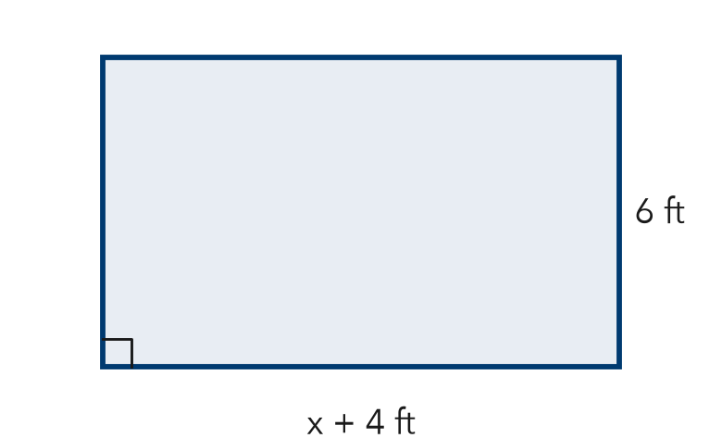
  Show your work.

5. Find the Error. Ana simplified 2(3x + 4) + x and got 7x + 4. Explain her mistake. Then simplify correctly.

CHECK YOURSELF | □ I can do this on my own | □ I need a little help | □ I have a question about #
AT HOME Show someone at home how 3(10 + 2) = 30 + 6 helps you find 3 × 12 in your head.
Name Date Period
Lesson 6-8 · Homework Packet · Sheet 2 of 2
Expanding and Factoring Expressions
Maryland Standard 6.EE.A.3 · Learning target — I can expand an expression and factor one using the greatest common factor.

REMEMBER  • Expand: distribute to remove parentheses: 5(2x + 3) = 10x + 15.  • Factor: put the GCF outside the parentheses; divide each term by it.  • Check a factored form by expanding it. | WORKED EXAMPLE  Factor 24y + 36.  Step 1 The GCF of 24 and 36 is 12. Divide: 24y ÷ 12 = 2y and 36 ÷ 12 = 3  Step 2 Write 12(2y + 3). Check: 12 × 2y + 12 × 3 = 24y + 36  Answer 12(2y + 3)
PRACTICE show your work · label units
1. Expand each expression.
a. 3(5x + 2) = | b. 8(y + 7) = | c. 4(3 + 2n) =

2. Factor each expression using the GCF.
a. 6x + 15 = | b. 20y + 32 = | c. 14a + 49 =
d. 36 + 27k = | e. 40m + 60 = | f. 11b + 33 =

3. Rectangle. A rectangle has an area of 8x + 56 square units. Its width is 8 units. Write an expression for its length.

Show your work.
Length

4. Stretch. Write two different factored forms of 12x + 24. Then write the form that uses the GCF.

5. Reason. Leon factored 30n + 45 as 5(6n + 9). Did he use the GCF?
□ Yes | □ No

TEST PRACTICE choose the best answer
6. Which is 16x + 40 factored using the GCF?
A 2(8x + 20) | B 8(2x + 5) | C 4(4x + 10) | D 8(2x + 40)

7. Which expression is equivalent to 6(3a + 2)?
A 18a + 2 | B 9a + 8 | C 18a + 12 | D 3a + 12

CHECK YOURSELF | □ I can do this on my own | □ I need a little help | □ I have a question about #
AT HOME Show someone at home how to factor 6x + 9 as 3(2x + 3). Then expand it to check.

