Name Date Period
Lesson 7-1 · Homework Packet · Sheet 1 of 2
Integers and Opposites
Maryland Standard 6.NS.C.5 · Learning target — I can write an integer for a real situation and name its opposite.

REMEMBER  • Integers: … −3, −2, −1, 0, 1, 2, 3 …  • Positive = above 0 (gain, up). Negative = below 0 (loss, down).  • Opposites are the same distance from 0 on different sides: 6 and −6. | WORKED EXAMPLE  A diver swims 18 feet below sea level. Write an integer for her depth and its opposite.  Step 1 Below sea level is less than 0: −18.  Step 2 The opposite is 18 units from 0 on the other side: 18.  Answer −18 feet; opposite 18
PRACTICE show your work · label units
1. Write an integer for each situation.
a. a loss of 12 yards | b. a deposit of $40
c. 9 floors below the street | d. 15 degrees above zero
e. a $25 withdrawal | f. a gain of 7 pounds

2. Plot −6 and its opposite on the number line. Label each point with its value.
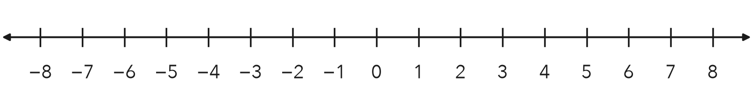
How far is each point from 0? units

3. Write the integer for each point. Then write its opposite.
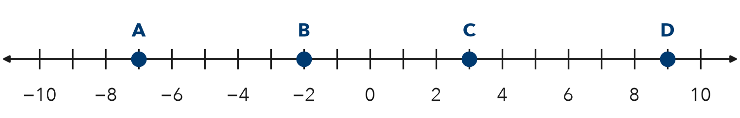
Point | A | B | C | D
Integer
Opposite

4. Find the Error. Keisha says the opposite of −15 is −15, because opposites keep the same number. Explain her mistake. Write the correct opposite.

CHECK YOURSELF | □ I can do this on my own | □ I need a little help | □ I have a question about #
AT HOME With someone at home, name a temperature on a weather report. Then name its opposite.
Name Date Period
Lesson 7-1 · Homework Packet · Sheet 2 of 2
Integers in Real Situations
Maryland Standard 6.NS.C.5 · Learning target — I can interpret integers in real situations and find the opposite of an opposite.

REMEMBER  • Positive: above, gain, deposit. Negative: below, loss, withdrawal.  • 0 is the start: sea level, a $0 balance.  • The opposite of the opposite is the number itself: −(−8) = 8. | WORKED EXAMPLE  Find the opposite of the opposite of 14.  Step 1 The opposite of 14 is −14.  Step 2 The opposite of −14 is 14.  Answer 14
PRACTICE show your work · label units
1. Write an integer for each situation.
a. a town 35 feet below sea level | b. earning $20 walking dogs
c. 4 degrees below zero | d. a loss of 8 yards

2. Find each value.
a. −(−9) = | b. −(15) = | c. −(−(−4)) =

3. Start at −3. Plot point A at −3, point B at the opposite of A, and point C at the opposite of B.
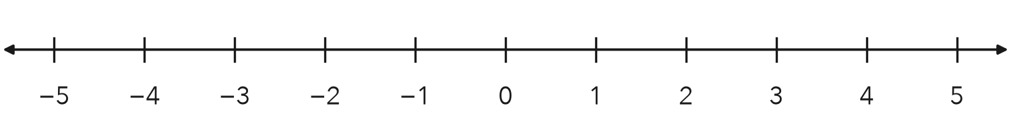
What do you notice about points A and C?

4. Weather. At noon it was 6 degrees above zero. At midnight it was 6 degrees below zero.
a. Write an integer for each temperature.
b. How are the two integers related?

5. Reasoning. Marcus says the opposite of a number is always negative. Is he right? Give an example.

TEST PRACTICE choose the best answer
6. Which integer describes a loss of 18 points in a game?
A 18 | B −18 | C −(−18) | D 0

7. Which equation is true?
A −(−11) = −11 | B −(−11) = 11 | C −(11) = 11 | D −(0) = 1

CHECK YOURSELF | □ I can do this on my own | □ I need a little help | □ I have a question about #
AT HOME Tell someone at home a money story with a negative number. Ask what 0 means in it.

Name Date Period
Lesson 7-2 · Homework Packet · Sheet 1 of 2
Rational Numbers on a Number Line
Maryland Standard 6.NS.C.6c · Learning target — I can plot a rational number and its opposite on a number line.

REMEMBER  • A rational number can be written as a fraction a/b of two integers (b ≠ 0). Examples: 3/4, −2.5, 7, −1 1/2.  • Between two integers, split the gap into equal parts (halves, fourths, tenths).  • Negative numbers sit left of 0. −2.5 is halfway between −3 and −2. | WORKED EXAMPLE  Plot −1.75 and its opposite on a number line.  Step 1 −1.75 is between −2 and −1. Split each unit into fourths; count 3 fourths left of −1.  Step 2 The opposite, 1.75, is 3 fourths right of 1.  Answer points at −1.75 and 1.75
PRACTICE show your work · label units
1. Write the number for each point as a decimal or a fraction.
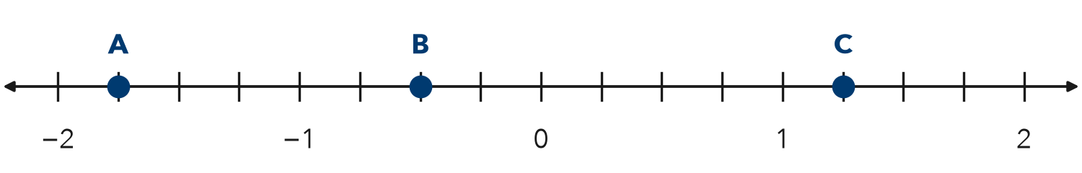
a. A = | b. B = | c. C =

2. Plot and label each number on the number line: −2.5, 1/2, −0.75, 1 1/4
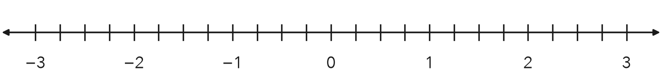

3. Name the two integers each number is between.
a. −4.6 is between | b. 7/2 is between
c. −0.3 is between | d. −9/4 is between

4. Write a rational number for each situation.
a. a loss of $3.50 | b. a gain of 2 1/2 ft | c. 4.5 degrees below 0

5. Pond. A frog sits 1.5 feet above a pond. A fish swims 2.25 feet below the surface (0).
a. Write a number for the frog and for the fish.
b. Which one is closer to the surface?

6. Find the Error. Tyrell plotted −1.5 between −1 and 0. Explain his mistake.

CHECK YOURSELF | □ I can do this on my own | □ I need a little help | □ I have a question about #
AT HOME Find a ruler or measuring cup at home. Show someone where 1/2, 1/4, and 3/4 are.
Name Date Period
Lesson 7-2 · Homework Packet · Sheet 2 of 2
Opposites of Rational Numbers
Maryland Standard 6.NS.C.6a · Learning target — I can find the opposite of a rational number and explain what taking the opposite twice does.

REMEMBER  • Opposites are the same distance from 0: 2.5 and −2.5.  • The opposite of a negative number is positive.  • Taking the opposite twice gives back the number you started with. | WORKED EXAMPLE  Start at 3/5. Find its opposite. Then find the opposite of that.  Step 1 Opposite of 3/5 is −3/5.  Step 2 Opposite of −3/5 is 3/5.  Answer −3/5, then 3/5
PRACTICE show your work · label units
1. Write the opposite of each number, or find the value.
a. 4.8 | b. −2/3 | c. −0.05
d. 0 | e. −(−1.6) = | f. −(−5/8) =

2. Point P is shown. Plot its opposite and label it Q.
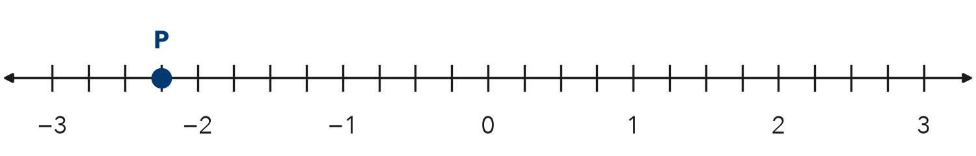
Q =

3. Game Score. Lena’s game score is −12.5 points. A bonus card changes her score to its opposite.
What is her new score? How far from 0 is it?

4. Stretch. Point M is 3.75 units from 0, to the left of 0. Point N is the opposite of M.
a. M =
b. N =

5. Find the Error. Kofi says −(−2/5) = −2/5. Explain his mistake. Give the correct value.

TEST PRACTICE choose the best answer
6. What is the opposite of −7/8?
A −7/8 | B 7/8 | C 8/7 | D −8/7

7. Point R is at 3.4. Where is the opposite of the opposite of R?
A −3.4 | B 0 | C 3.4 | D 4.3

CHECK YOURSELF | □ I can do this on my own | □ I need a little help | □ I have a question about #
AT HOME Explain to someone at home why −(−1.5) is a positive number.

Name Date Period
Lesson 7-3 · Homework Packet · Sheet 1 of 2
Absolute Value as Distance
Maryland Standard 6.NS.C.7c · Learning target — I can use absolute value to describe how far a number is from zero.

REMEMBER  • Absolute value is a number’s distance from 0. We write |−7| = 7.  • A number and its opposite have the same absolute value: |5| = |−5| = 5.  • Absolute value is never negative. A greater absolute value means farther from 0. | WORKED EXAMPLE  Which is farther from 0: −9 or 6?  Step 1 |−9| = 9 and |6| = 6.  Step 2 9 > 6, so −9 is farther from 0.  Answer −9
PRACTICE show your work · label units
1. Find each absolute value.
a. |−14| = | b. |8| = | c. |0| =
d. |−2.5| = | e. |3/4| = | f. |−1 1/2| =

2. Use the number line. Find the absolute value of each point.
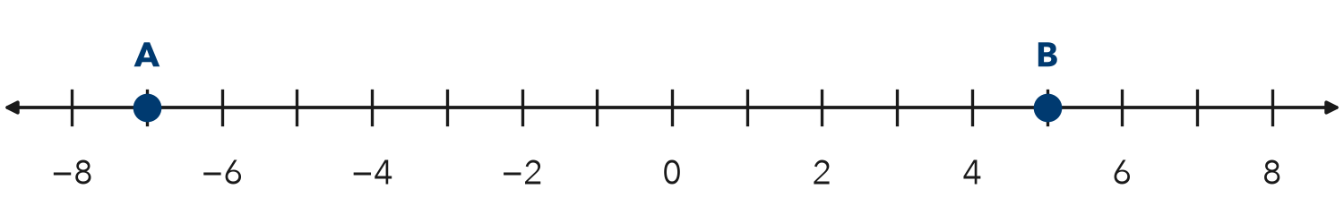
a. |A| = | b. |B| = | c. Farther from 0:

3. Compare. Write <, >, or = in each blank.
a. |−9| |7| | b. |−4| |4| | c. −10 |−3|
d. |−6.5| |6.5| | e. |−12| |−15| | f. 0 |−1|

4. Bank Balances. Rosa’s account balance is −$35 (she owes $35). Ben’s balance is $20.
a. Find the absolute value of each balance.
b. Whose balance is farther from $0?

5. Stretch. List all the integers with an absolute value less than 3.
Integers

6. Reasoning. Name two different numbers that have an absolute value of 4.5. Explain how you know.

CHECK YOURSELF | □ I can do this on my own | □ I need a little help | □ I have a question about #
AT HOME Ask someone at home: is it colder at −10 degrees or at 5 degrees? Which temperature is farther from 0?
Name Date Period
Lesson 7-3 · Homework Packet · Sheet 2 of 2
Absolute Value as Total Distance
Maryland Standard 6.NS.C.7c · Learning target — I can use absolute value to find the total distance between a negative and a positive reading.

REMEMBER  • Opposite sides of 0: add the absolute values.  • −3 to 5 is 3 + 5 = 8 units.  • Same side of 0: subtract the absolute values.  • −9 to −2 is 9 − 2 = 7 units. | WORKED EXAMPLE  A diver swims up from −24 feet to a boat deck at 6 feet. How far does she go?  Step 1 The numbers are on opposite sides of 0, so add.  Step 2 |−24| + |6| = 24 + 6 = 30  Answer 30 feet
PRACTICE show your work · label units
1. Use the number line. Find each distance.
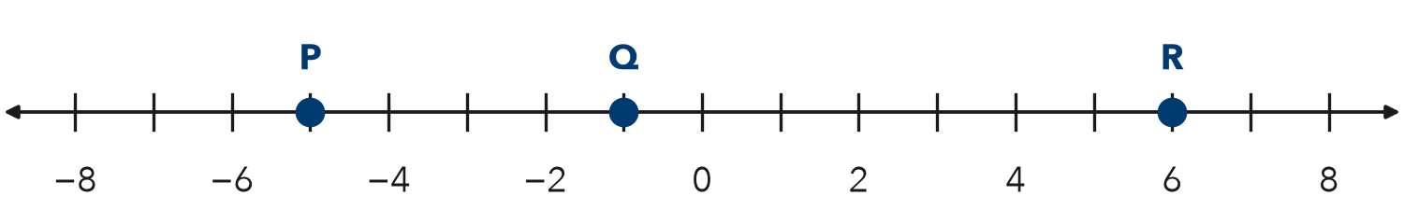
a. P to R: | b. Q to R: | c. P to Q:

2. Find the distance between each pair of numbers.
a. −7 and 3 | b. −12 and −4 | c. −2.5 and 4

3. Temperature Swing. It was −8 degrees at 6 a.m. and 15 degrees at 3 p.m. How much did it rise?
Answer degrees

4. Elevator. An elevator goes from parking level −3 up to floor 9. Street level is floor 0. How many floors does it travel?
Answer floors

5. Find the Error. To find the distance from −9 to 5, Omar wrote 9 − 5 = 4. Explain his mistake. Find the correct distance.

TEST PRACTICE choose the best answer
6. What is the distance between −13 and 6 on a number line?
A 7 | B 19 | C −19 | D −7

7. A cave floor is at −60 feet. A ledge is at −22 feet. How far apart are they?
A 82 feet | B 38 feet | C −38 feet | D 22 feet

CHECK YOURSELF | □ I can do this on my own | □ I need a little help | □ I have a question about #
AT HOME With someone at home, find how many degrees the temperature changed today.

Name Date Period
Lesson 7-4 · Homework Packet · Sheet 1 of 2
Comparing Numbers on a Number Line
Maryland Standard 6.NS.C.7a · Learning target — I can compare two rational numbers using their positions on a number line.

REMEMBER  • Numbers get greater to the right and less to the left.  • Any positive number is greater than any negative number.  • −2 > −8 because −2 is farther right. < means is less than; > means is greater than. | WORKED EXAMPLE  Compare −3.5 and −1.5. Use < or >.  Step 1 −1.5 is to the right of −3.5 on the number line.  Step 2 Right means greater.  Answer −1.5 > −3.5
PRACTICE show your work · label units
1. Use the number line. Write < or > in each blank.
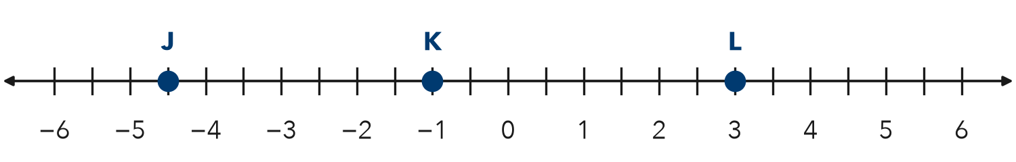
a. J K | b. L K | c. J L

2. Write < or > in each blank.
a. −8 −3 | b. 0 −6 | c. −2.5 −2.05
d. 4 −10 | e. −1/2 −3/4 | f. −7 −7.1

3. Plot −3.5 and −0.5 on the number line. Then write a true comparison using <.
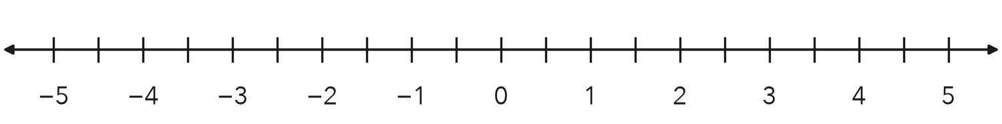

4. Golf. In golf, the lower score wins. Tanya scored −3. Malik scored −5.
a. Compare the scores using < or >.
b. Who won?

5. Cold Days. Monday’s low was −7 degrees. Tuesday’s low was −2 degrees. Which day was colder? Write a comparison using < or >.
Answer

6. Reasoning. Is −6 < |−6| true? Explain how you know.

CHECK YOURSELF | □ I can do this on my own | □ I need a little help | □ I have a question about #
AT HOME Ask someone at home: which is colder, −4 degrees or −9 degrees? Why?
Name Date Period
Lesson 7-4 · Homework Packet · Sheet 2 of 2
Ordering Integers and Rational Numbers
Maryland Standard 6.NS.C.7b · Learning target — I can order integers and rational numbers from least to greatest.

REMEMBER  • Place the numbers on a number line. Least is farthest left; greatest is farthest right.  • Change fractions to decimals to compare: −3/4 = −0.75.  • For negative numbers, the one farther from 0 is less. | WORKED EXAMPLE  Order −1.2, 0.5, −2, and −1/2 from least to greatest.  Step 1 Write −1/2 as −0.5.  Step 2 Read the number line from left to right.  Answer −2, −1.2, −1/2, 0.5
PRACTICE show your work · label units
1. Plot each number. Then write them in order from least to greatest: 1.5, −2.5, −3/4, 2 1/4, −3.25
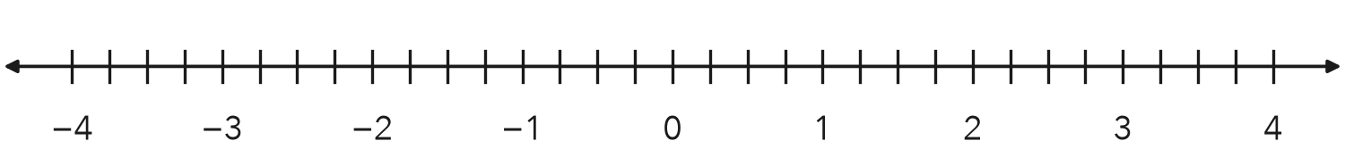
Order

2. Order each set from least to greatest.
a. −6, 4, −9, 0
b. −0.3, −3, −0.03

3. Circle the greatest number in each set.
a. −5, −2, −8 | b. −1.4, −1.04, −1.44
c. −2/3, −1/2, −3/4 | d. 0, −0.1, −10

4. Ocean Animals. A shark swims at −45.5 m, a turtle at −12 m, a dolphin at −30.25 m, and a jellyfish at −8.75 m. List the animals from deepest to closest to the surface.
Answer

5. Find the Error. Leo ordered −1/2, −0.4, and −0.6 from least to greatest as −0.4, −1/2, −0.6. Explain his mistake and write the correct order.

TEST PRACTICE choose the best answer
6. Which list is ordered from least to greatest?
A −5, −8, 0, 3 | B −8, −5, 0, 3 | C 0, −5, −8, 3 | D 3, 0, −5, −8

7. Which number is greatest?
A −2.7 | B −2.07 | C −2.77 | D −2.2

CHECK YOURSELF | □ I can do this on my own | □ I need a little help | □ I have a question about #
AT HOME List the low temperatures for three cold days with someone at home. Order them from coldest to warmest.

Name Date Period
Lesson 7-5 · Homework Packet · Sheet 1 of 2
Plotting Points on the Coordinate Plane
Maryland Standard 6.NS.C.6c · Learning target — I can plot a point with rational coordinates and name the quadrant it lies in.

REMEMBER  • Start at the origin (0, 0). Move x units right or left, then y units up or down.  • Quadrant signs: I (+, +), II (−, +), III (−, −), IV (+, −).  • A point with a 0 coordinate is on an axis, not in a quadrant. | WORKED EXAMPLE  Plot (−3.5, 2) and name its quadrant.  Step 1 Start at the origin. Move left 3.5 units.  Step 2 Move up 2 units. Left and up is Quadrant II.  Answer Quadrant II
PRACTICE show your work · label units

1. Write the ordered pair for each point. Name its quadrant. | 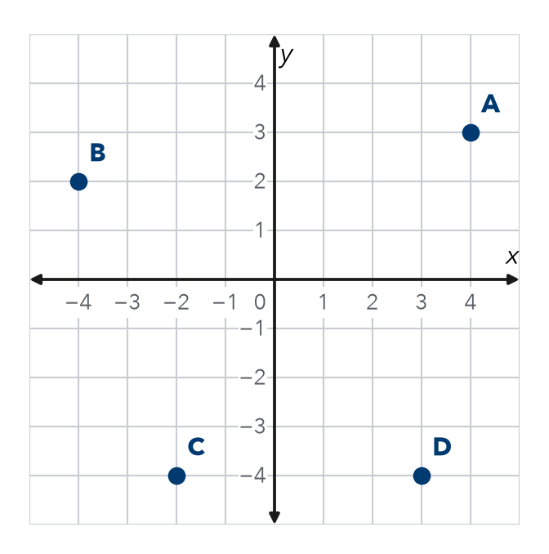
  Point | Ordered pair | Quadrant
  A
  B
  C
  D

2. Town Map. The library is at the origin. Plot and label each place: Park P(2, 4), Pool Q(−4, −1), School S(−3.5, 3), Garden G(4, −2.5).  Which place is in Quadrant III? Quadrant IV? | 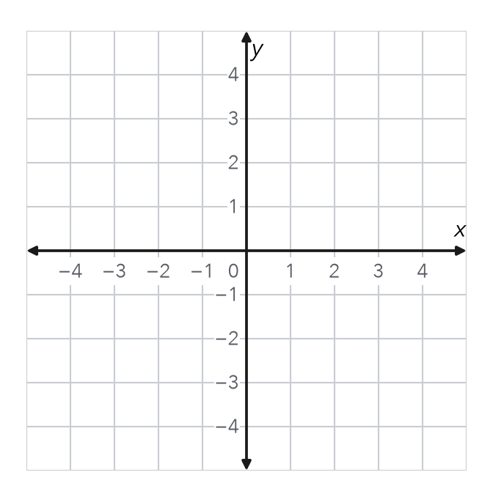

3. Name the quadrant or axis for each point.
a. (−7, −2) | b. (8, −1) | c. (0, 6)
d. (−1.5, 4) | e. (−9, 0) | f. (2.5, −6)

4. Reasoning. Malia says (−3, 5) and (5, −3) name the same point. Is she right? Explain.

CHECK YOURSELF | □ I can do this on my own | □ I need a little help | □ I have a question about #
AT HOME With someone at home, name a quadrant. Take turns saying an ordered pair that lands in it.
Name Date Period
Lesson 7-5 · Homework Packet · Sheet 2 of 2
Reflecting Points Across Axes
Maryland Standard 6.NS.C.6b · Learning target — I can reflect a point across the x-axis or the y-axis and name the new coordinates.

REMEMBER  • x-axis reflection: flip the sign of y. (3, 4) becomes (3, −4).  • y-axis reflection: flip the sign of x. (3, 4) becomes (−3, 4).  • Across both axes, both signs flip. | WORKED EXAMPLE  Reflect (−2, 5) across the x-axis.  Step 1 Keep x = −2.  Step 2 Change the sign of y: 5 becomes −5.  Answer (−2, −5)
PRACTICE show your work · label units

1. Point A is at (−4, 3). Plot point B, the reflection of A across the x-axis. Plot point C, the reflection of A across the y-axis.  a. B =  b. C = | 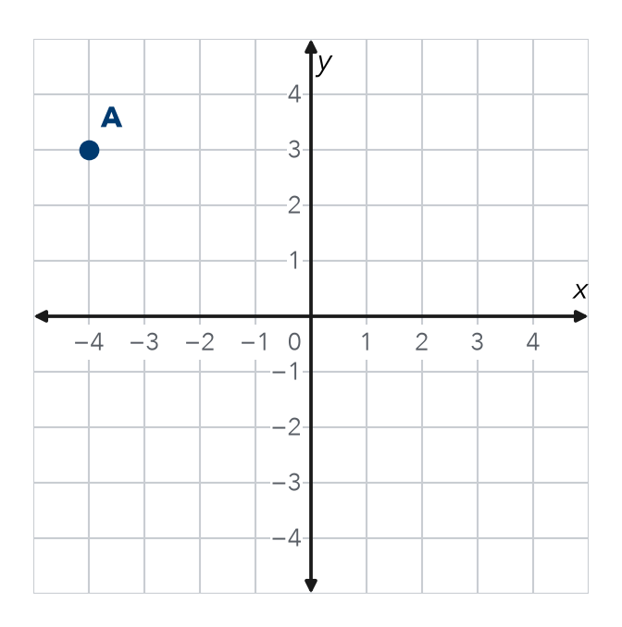

2. Write the new point after each reflection.
a. (−6, −2) across the y-axis | b. (−4, 7) across both axes

3. Park Map. A bench is the reflection of a bus stop at (7, −2.5) across the x-axis. Where is the bench?
Answer

4. Stretch. Point K was reflected across the x-axis. The new point is (−6, −5). Where was point K?
K

5. Find the Error. Sam reflected (−3, −8) across the y-axis and got (−3, 8). Explain his mistake. Fix it.

TEST PRACTICE choose the best answer
6. Point M(−5, 2) is reflected across the y-axis. What is the new point?
A (−5, −2) | B (5, 2) | C (5, −2) | D (2, −5)

7. The points (6, −1) and (6, 1) are reflections of each other across —
A the x-axis | B the y-axis | C both axes | D neither axis

CHECK YOURSELF | □ I can do this on my own | □ I need a little help | □ I have a question about #

Name Date Period
Lesson 7-6 · Homework Packet · Sheet 1 of 2
Distance Between Points on a Grid
Maryland Standard 6.NS.C.8 · Learning target — I can find the distance between two points that share a coordinate.

REMEMBER  • Same x-coordinate: the points are on a vertical line. Use the y-coordinates.  • Same y-coordinate: the points are on a horizontal line. Use the x-coordinates.  • Opposite signs: add the absolute values. Same signs: subtract them. | WORKED EXAMPLE  Find the distance from (3, −4) to (3, 5).  Step 1 Same x, so use the y-coordinates −4 and 5.  Step 2 Opposite signs, so add: 4 + 5 = 9.  Answer 9 units
PRACTICE show your work · label units

1. Use the grid. Find each distance.  a. A to B units  b. B to C units  c. A to D units | 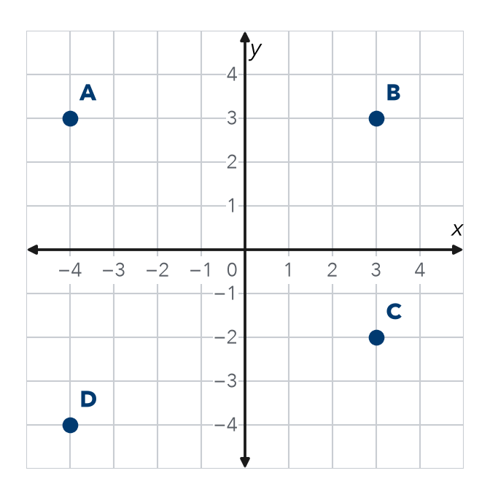

2. Find the distance between each pair of points.
a. (5, 6) and (5, −2) | b. (−7, 1) and (−2, 1)
c. (−3, −4) and (6, −4) | d. (0, −8) and (0, 3)
e. (−9, −2) and (−9, −7) | f. (2.5, 3) and (−4, 3)
g. (−1, −6) and (−1, 4) | h. (−8, 5) and (−3.5, 5)

3. City Blocks. Kim walks straight from (−6, −3) to (−6, 5). Each unit is 1 block. How far does she walk?
Answer blocks

4. Missing Point. Point P is at (2, −3). Point Q is 6 units to the left of P. Name point Q.
Answer

5. Find the Error. Eli says the distance from (1, −6) to (1, −2) is 8 because 6 + 2 = 8. Explain his mistake and find the correct distance.

CHECK YOURSELF | □ I can do this on my own | □ I need a little help | □ I have a question about #
AT HOME With someone at home, count the blocks between two places on one street.
Name Date Period
Lesson 7-6 · Homework Packet · Sheet 2 of 2
Comparing Distances on the Plane
Maryland Standard 6.NS.C.8 · Learning target — I can decide whether to add or subtract to find a distance, then compare two distances.

REMEMBER  • Find each distance first. Then compare.  • Different signs: add. Same sign: subtract.  • A distance is never negative. | WORKED EXAMPLE  Which is longer: (−2, 4) to (5, 4), or (1, −3) to (1, 5)?  Step 1 First: same y, use x: 2 + 5 = 7 units.  Step 2 Second: same x, use y: 3 + 5 = 8 units. 8 > 7.  Answer the second one
PRACTICE show your work · label units

1. Neighborhood. Each unit is 1 block. Which is closer to Home: the Library or the Park?  a. H to L blocks  b. H to P blocks  c. Which is closer? By how many blocks? | 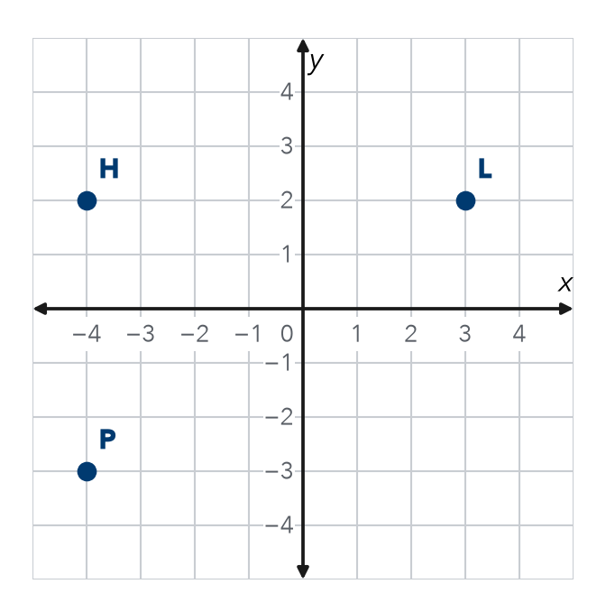

2. Find each distance.
a. (−8, 1) to (−3, 1) | b. (4, −6) to (4, 7)
c. (−6, −7) to (−6, −1) | d. (−2.5, 3) to (4.5, 3)

3. Runners. Ana runs from (−5, −1) to (6, −1). Jay runs from (2, 4) to (2, −6). Who runs farther, and by how many units?
Answer

4. Reasoning. For (−3, 7) to (−3, −2), do you add or subtract? Explain, then find the distance.

TEST PRACTICE choose the best answer
5. Segment JK runs from (−4, 2) to (6, 2). Segment MN runs from (1, −3) to (1, 5). Which is longer?
A JK, by 2 units | B MN, by 2 units | C neither | D JK, by 8 units

6. Point A is at (−2, −5). Point B is at (−2, 3). What is the distance from A to B?
A 2 units | B 3 units | C 8 units | D −8 units

CHECK YOURSELF | □ I can do this on my own | □ I need a little help | □ I have a question about #
AT HOME With someone at home, pick two places on one street. Which is closer to your home? By how many blocks?

Name Date Period
Lesson 7-7 · Homework Packet · Sheet 1 of 2
Polygons and Perimeter on the Plane
Maryland Standard 6.G.A.3 · Learning target — I can find the perimeter and area of a polygon drawn on the coordinate plane.

REMEMBER  • Plot the vertices in order. Connect them to draw the polygon.  • Find each horizontal or vertical side from the coordinates.  • Perimeter = sum of all sides. Area of a rectangle = length × width. | WORKED EXAMPLE  Find the perimeter and area of the rectangle with vertices (−3, 2), (4, 2), (4, −1), (−3, −1).  Step 1 Top: 3 + 4 = 7 units. Side: 2 + 1 = 3 units.  Step 2 P = 7 + 3 + 7 + 3 = 20 units. A = 7 × 3 = 21 square units.  Answer P = 20 units, A = 21 square units
PRACTICE show your work · label units

1. Use the rectangle on the grid.  a. Length of AB units  b. Length of BC units  c. Perimeter units  d. Area sq. units | 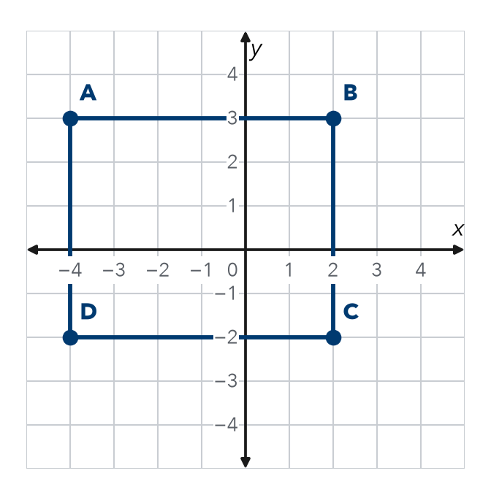

2. Plot A(−3, −2), B(4, −2), and C(−3, 4). Connect them to make a right triangle.
a. Base AB units
b. Height AC units
c. Area sq. units

3. Garden Fence. A garden has corners at (−5, 3), (6, 3), (6, −4), and (−5, −4). Each unit is 1 meter. How much fence goes around it?
Answer m

4. Square. A square has vertices (−3, 1), (2, 1), (2, −4), and (−3, −4). Find its perimeter.
Answer units

5. Reasoning. Three corners of a rectangle are (−2, 5), (3, 5), and (3, −1). Name the fourth corner.
Answer

CHECK YOURSELF | □ I can do this on my own | □ I need a little help | □ I have a question about #
Name Date Period
Lesson 7-7 · Homework Packet · Sheet 2 of 2
Designing Polygons with Scale
Maryland Standard 6.G.A.3 · Learning target — I can use a scale to find a missing dimension of a figure on the coordinate plane.

REMEMBER  • A scale tells what 1 grid unit stands for, like 1 unit = 5 ft.  • Real length = grid units × scale.  • Missing side = area ÷ known side. | WORKED EXAMPLE  1 unit = 5 ft. A rectangle’s sides run from (−2, 3) to (4, 3) and from (4, 3) to (4, −1). Find its real size.  Step 1 Top: 2 + 4 = 6 units. 6 × 5 = 30 ft.  Step 2 Side: 3 + 1 = 4 units. 4 × 5 = 20 ft.  Answer 30 ft by 20 ft
PRACTICE show your work · label units

1. Court Plan. On this plan, 1 unit = 5 ft. Side AB of a court is drawn. The court must cover 1,200 ft².  a. AB in grid units units  b. AB in feet ft  c. Other side in feet ft  d. Other side in grid units units | 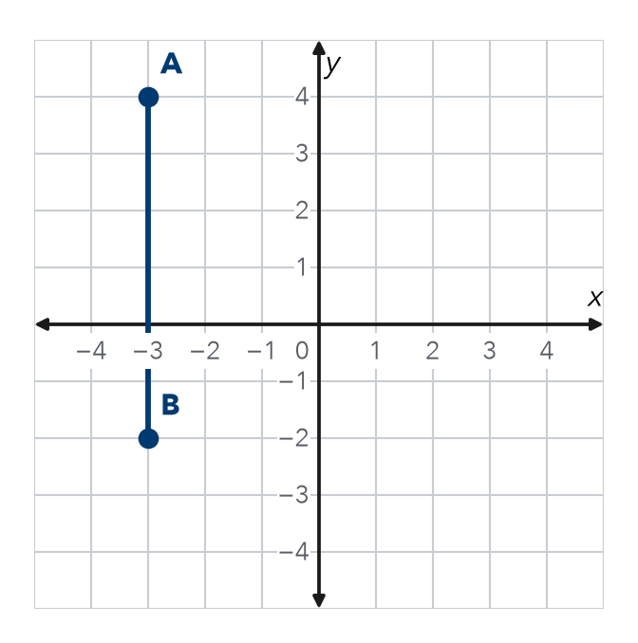

2. On a map, 1 grid unit = 4 meters.
a. 7 units = m | b. 36 m = units

3. Patio. A patio on a plan is 7 units by 5 units. 1 unit = 2 ft. Find the real area.
Answer ft²

4. Bedroom. On a plan, 1 unit = 3 ft. A room has corners at (−2, 4), (2, 4), (2, −1), and (−2, −1). Find its real perimeter.
Answer ft

5. Find the Error. If 1 unit = 3 ft, Lily says (−4, 1) to (5, 1) is 3 ft. Explain her error. Fix it.

TEST PRACTICE choose the best answer
6. A plan uses 1 unit = 6 m. A side is 5 units long. How long is the real side?
A 11 m | B 30 m | C 1 m | D 56 m

7. A rectangle has an area of 480 ft². One side is 24 ft. How long is the other side?
A 20 ft | B 456 ft | C 40 ft | D 504 ft

CHECK YOURSELF | □ I can do this on my own | □ I need a little help | □ I have a question about #

