Name Date Period
Lesson 8-1 · Homework Packet · Sheet 1 of 2
Equations and Solutions
Maryland Standard 6.EE.B.5 · Learning target — I can check whether a value is a solution of an equation by substituting it.

REMEMBER  • A solution is a value of the variable that makes an equation true.  • To check a value, substitute it for the variable. Then compare the two sides.  • If the two sides are not equal, the value is not a solution. | WORKED EXAMPLE  Is n = 14 a solution of n + 9 = 23?  Step 1 Replace n with 14: 14 + 9 = 23  Step 2 Compare: 23 = 23. Both sides match.  Answer Yes, n = 14 is a solution.
PRACTICE show your work · label units
1. Substitute the value. Write T for true or F for false.
a. y + 8 = 20 (y = 12) | b. 5m = 35 (m = 6) | c. k − 9 = 16 (k = 25)
d. h ÷ 4 = 7 (h = 32) | e. 13 + w = 30 (w = 17) | f. 6p = 54 (p = 9)
g. q − 11 = 4 (q = 15) | h. 9r = 63 (r = 8)

2. The tape diagram shows x + 16 = 41. Which value is the solution: 15, 25, or 35? Substitute each value to check.
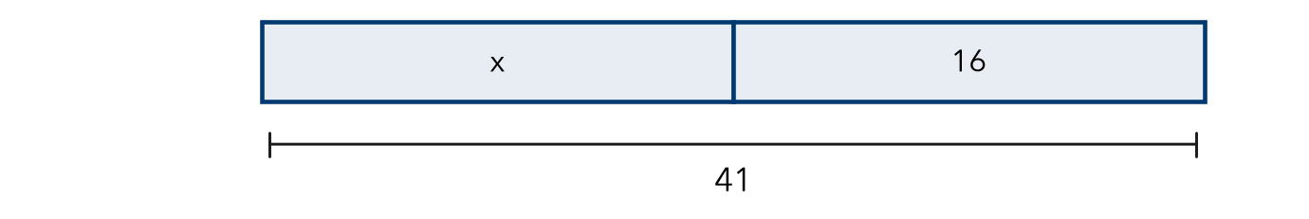
Solution

3. Bike Rack. A bike rack held b bikes. After 7 bikes left, 18 bikes were still there. Kendra writes b − 7 = 18. Is b = 11 a solution? Is b = 25 a solution? Show both checks.

Show your work.
Solution

4. Find the Error. Andre says p = 8 is a solution of 4p = 12 because 4 + 8 = 12. Explain his mistake. Then find the real solution.

5. Stretch. Malik paid $42 for t movie tickets that cost $6 each, so 6t = 42. Is t = 36 a solution? Is t = 7? Explain which value makes sense.
Solution

CHECK YOURSELF | □ I can do this on my own | □ I need a little help | □ I have a question about #
AT HOME Make up an equation for someone at home. Check their guess together by substituting.
Name Date Period
Lesson 8-1 · Homework Packet · Sheet 2 of 2
Writing Equations
Maryland Standard 6.EE.B.6 · Learning target — I can write an equation for a situation and test a proposed answer.

REMEMBER  • Use a variable for the unknown amount.  • “7 less than n” is n − 7, not 7 − n.  • Test an answer by substituting it. | WORKED EXAMPLE  b books plus 15 more is 52 books. Test b = 37.  Step 1 Equation: b + 15 = 52  Step 2 Test: 37 + 15 = 52, so it checks.  Answer b + 15 = 52; b = 37
PRACTICE show your work · label units
1. Write an equation for each sentence. Use n for the number.
a. A number increased by 9 is 31. | b. 7 times a number is 63.
c. 12 less than a number is 20. | d. A number divided by 5 is 8.

2. Stickers. Rosa gave away 14 stickers and has 29 left. Write an equation for s. Test s = 43.
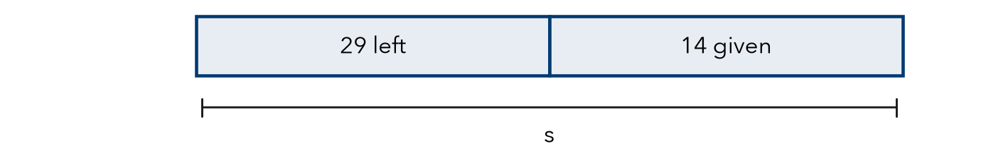
Equation and test

3. Field Trip. 56 students ride equally in 4 vans. Write an equation for v, the students per van. Test v = 12 and v = 14.

Show your work.
Equation and solution

4. Reading Log. Luis reads the same number of pages, p, each day for 5 days. He reads 85 pages in all. Write an equation. Test p = 17.
Equation and test

5. Find the Error. Tia is 13. She is 4 years older than her brother. Omar writes b − 4 = 13 for his age. Explain the mistake. Find b.

TEST PRACTICE choose the best answer
6. Jada saved $9 a week for w weeks. She saved $72. Which equation fits?
A w + 9 = 72 | B 9w = 72 | C w ÷ 9 = 72 | D 72w = 9

7. Which value of n is the solution of n − 15 = 27?
A n = 12 | B n = 27 | C n = 42 | D n = 405

CHECK YOURSELF | □ I can do this on my own | □ I need a little help | □ I have a question about #

Name Date Period
Lesson 8-2 · Homework Packet · Sheet 1 of 2
Addition Equations
Maryland Standard 6.EE.B.7 · Learning target — I can solve an addition equation by subtracting the same amount from both sides.

REMEMBER  • Addition and subtraction are inverse operations. They undo each other.  • To solve x + a = b, subtract a from both sides to keep the equation balanced.  • Check by substituting your solution into the original equation. | WORKED EXAMPLE  Solve x + 23 = 61.  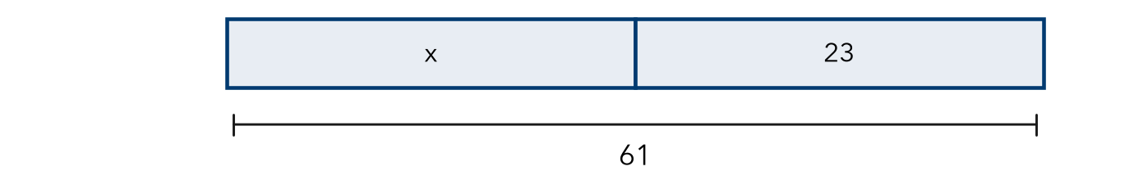  Step 1 Subtract 23 from both sides: x = 61 − 23 = 38  Step 2 Check: 38 + 23 = 61, so it checks.  Answer x = 38
PRACTICE show your work · label units
1. Solve each equation.
a. x + 9 = 17 | b. n + 14 = 32 | c. 25 + y = 60
d. m + 38 = 75 | e. 4.5 + k = 10 | f. w + 1.75 = 6

2. Write an addition equation for the tape diagram. Then solve it.
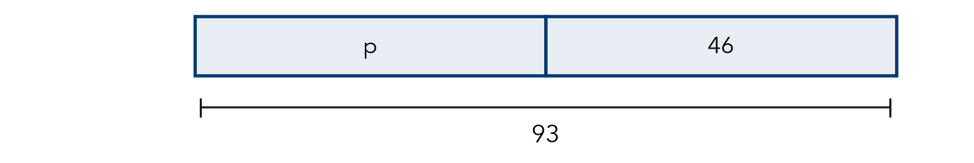
Equation and solution

3. Book Cart. A book cart held b books. A volunteer added 27 more books. Now the cart holds 64 books. Write an addition equation and solve it. Check your answer.

Show your work.
Answer books

4. Jacket. Amir has $38.50. A jacket costs $52. Write and solve an addition equation for m, the money he still needs.
Answer dollars

5. Check the Check. Dante solved n + 18 = 50 and got n = 32. To check, he wrote 32 − 18 = 14, so he says his answer is wrong. Is he right? Explain how he should check.

CHECK YOURSELF | □ I can do this on my own | □ I need a little help | □ I have a question about #
AT HOME Hide some coins in one hand and show the rest. Tell someone the total and have them write and solve an addition equation for the hidden coins.
Name Date Period
Lesson 8-2 · Homework Packet · Sheet 2 of 2
Subtraction Equations
Maryland Standard 6.EE.B.7 · Learning target — I can solve a subtraction equation by adding the same amount to both sides.

REMEMBER  • To solve x − a = b, add a to both sides.  • The solution is greater than b.  • Check by substituting into the equation. | WORKED EXAMPLE  Solve m − 36 = 47.  Step 1 Add 36 to both sides: m = 47 + 36 = 83  Step 2 Check: 83 − 36 = 47, so it checks.  Answer m = 83
PRACTICE show your work · label units
1. Solve each equation.
a. n − 19 = 26 | b. k − 27 = 58 | c. p − 3.5 = 6

2. The tape diagram shows a whole, t, and two parts. Write a subtraction equation. Then solve it.
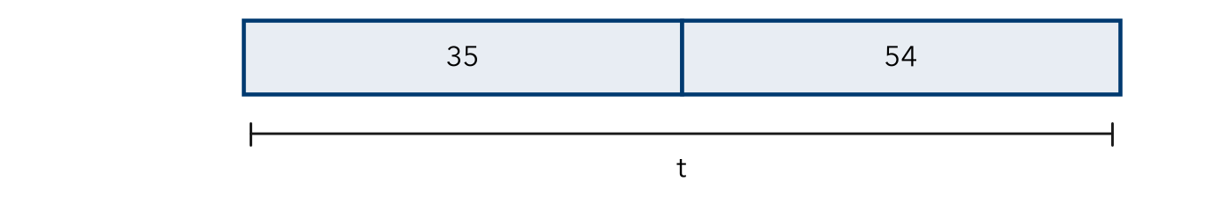
Equation and solution

3. Gift Card. Destiny had g dollars on a gift card. She spent $18.25 on a book. She has $31.75 left. Write a subtraction equation and solve it.

Show your work.
Answer dollars

4. Parking Lot. Some cars were in a lot. Then 26 cars left, and 59 cars were still there. Write and solve a subtraction equation for c, the cars at first.
Answer cars

5. Who Is Right? Mia and Leo solve n − 24 = 60. Mia says n = 36. Leo says n = 84. Who is correct? Use substitution to explain.

TEST PRACTICE choose the best answer
6. Solve p − 29 = 45.
A p = 16 | B p = 29 | C p = 74 | D p = 1,305

7. A baker sold 48 muffins and had 37 left. Which equation finds m, the muffins at the start?
A m + 48 = 37 | B m − 48 = 37 | C 48 − m = 37 | D 37m = 48

CHECK YOURSELF | □ I can do this on my own | □ I need a little help | □ I have a question about #

Name Date Period
Lesson 8-3 · Homework Packet · Sheet 1 of 2
Multiplication Equations
Maryland Standard 6.EE.B.7 · Learning target — I can solve a multiplication equation by dividing both sides by the same number.

REMEMBER  • In 6x, the coefficient 6 means 6 × x.  • To solve ax = b, divide both sides by a. Division undoes multiplication.  • Check: the coefficient times your solution should equal the right side. | WORKED EXAMPLE  Solve 8p = 96.  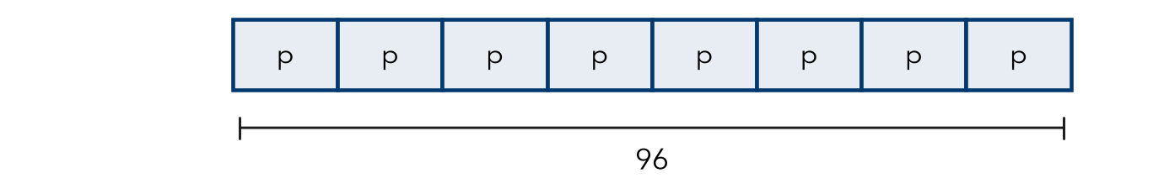  Step 1 Divide both sides by 8: p = 96 ÷ 8 = 12  Step 2 Check: 8 × 12 = 96, so it checks.  Answer p = 12
PRACTICE show your work · label units
1. Solve each equation.
a. 4x = 36 | b. 7n = 56 | c. 9y = 108
d. 12k = 84 | e. 5m = 85 | f. 3w = 4.5

2. Write a multiplication equation for the tape diagram. Then solve it.
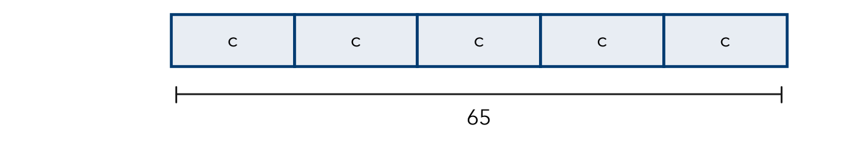
Equation and solution

3. Bus Fare. A family pays $11.25 for 5 bus fares. Each fare costs the same. Write and solve an equation for the cost of one fare, f. Check your answer.

Show your work.
Answer dollars

4. Garden Rows. Ms. Bell plants 84 seedlings in 6 equal rows. Write and solve a multiplication equation for s, the seedlings in each row.
Answer seedlings

5. Compare. Without solving, tell which equation has the greater solution: 4n = 80 or 5n = 80. Explain. Then solve both to check.

CHECK YOURSELF | □ I can do this on my own | □ I need a little help | □ I have a question about #
AT HOME Find a package with equal parts (eggs, juice boxes, crayons). Write a multiplication equation for it and solve for one part.
Name Date Period
Lesson 8-3 · Homework Packet · Sheet 2 of 2
Division Equations
Maryland Standard 6.EE.B.7 · Learning target — I can solve a division equation by multiplying both sides by the same number.

REMEMBER  • To solve x ÷ a = b, multiply both sides by a.  • The solution is the whole, so it is greater than b.  • Check: divide your solution by a. | WORKED EXAMPLE  Solve n ÷ 4 = 15.  Step 1 Multiply both sides by 4: n = 15 × 4 = 60  Step 2 Check: 60 ÷ 4 = 15, so it checks.  Answer n = 60
PRACTICE show your work · label units
1. Solve each equation.
a. n ÷ 7 = 6 | b. y ÷ 5 = 13 | c. k ÷ 10 = 4.5

2. Write a division equation for the tape diagram. Then solve it.
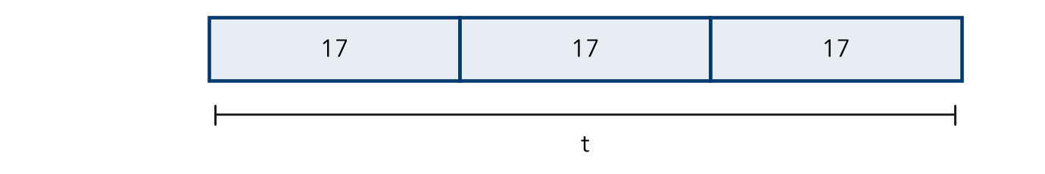
Equation and solution

3. Jump Rope. A rope is cut into 8 equal pieces, each 2.5 meters long. Write and solve a division equation for r, the whole rope.

Show your work.
Answer meters

4. Pizza Party. A pizza is cut into equal slices. 6 friends share it, and each gets 2 slices. Write and solve a division equation for z, the slices in the pizza.
Answer slices

5. Find the Error. Kayla and 3 friends share cards equally. Each gets 9 cards. Kayla writes c ÷ 3 = 9. Explain her mistake. Write and solve a correct equation.

TEST PRACTICE choose the best answer
6. Solve y ÷ 6 = 9.
A y = 1.5 | B y = 3 | C y = 15 | D y = 54

7. 12 students share p pretzels equally. Each gets 5. Which equation fits?
A p ÷ 12 = 5 | B 12 ÷ p = 5 | C 5p = 12 | D p − 12 = 5

CHECK YOURSELF | □ I can do this on my own | □ I need a little help | □ I have a question about #

Name Date Period
Lesson 8-4 · Homework Packet · Sheet 1 of 2
Writing Inequalities
Maryland Standard 6.EE.B.8 · Learning target — I can write an inequality that describes a constraint in a real situation.

REMEMBER  • An inequality compares amounts using <, >, ≤, or ≥.  • more than: > less than, fewer than: <  • at least: ≥ at most, no more than: ≤  • “At least” and “at most” include the boundary. | WORKED EXAMPLE  A food pantry needs at least 40 volunteers on Saturday. Write an inequality for v, the number of volunteers.  Step 1 “At least 40” means 40 or more, so 40 is included.  Step 2 Use ≥ : v ≥ 40. Test: 40 and 52 work; 38 does not.  Answer v ≥ 40
PRACTICE show your work · label units
1. Write an inequality for each phrase. Use x.
a. more than 12 | b. at most 30 | c. fewer than 8
d. at least 15 | e. no more than 6 | f. greater than −3
g. below 0 | h. a maximum of 100

2. Write an inequality for each sign. Use the variable given.
Sign | Inequality
Riders must be at least 54 inches tall. (h)
Speed limit: 35 miles per hour. (s)
Buy more than 10 items to get a discount. (n)
Fewer than 120 people may be in this room. (p)

3. City Bus. A city bus can carry no more than 48 riders. Write an inequality for r, the number of riders. Can the bus carry 48 riders? Can it carry 50 riders? Explain.
Inequality

4. Reverse It. Write a real-world situation for t < 60. Name two solutions.
Situation and solutions

5. Same or Different? Jordan says “x is at most 10” and “x is less than 10” mean the same thing. Is he right? Use the number 10 to explain.

CHECK YOURSELF | □ I can do this on my own | □ I need a little help | □ I have a question about #
AT HOME Look for a sign with a limit (speed limit, height rule, room capacity). Write an inequality for it and tell someone at home what it means.
Name Date Period
Lesson 8-4 · Homework Packet · Sheet 2 of 2
Representing Inequalities
Maryland Standard 6.EE.B.8 · Learning target — I can represent an inequality with a set of solutions and describe them.

REMEMBER  • Open dot: boundary not included (< or >).  • Closed dot: boundary is included (≤ or ≥).  • Arrow: left for < and ≤, right for > and ≥. | WORKED EXAMPLE  Graph x ≤ 3.  Step 1 ≤ includes 3, so draw a closed dot at 3.  Step 2 Shade left: the solutions are 3 and less.  Answer Closed dot at 3, arrow left
PRACTICE use the number lines · show your work
1. Write the inequality shown on the number line. Use x.
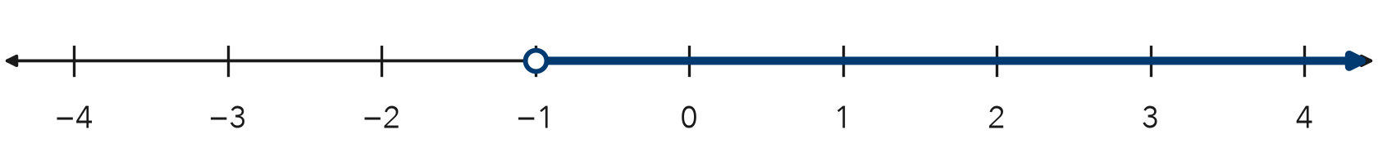
Inequality

2. Graph x ≥ 2 on the number line. Then name two solutions.
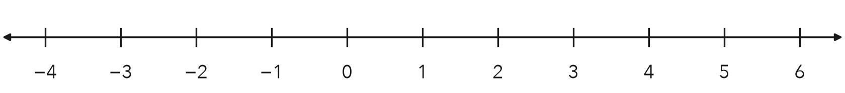
Two solutions

3. Each graph is described in words. Write the inequality for each graph. Use x.
a. open dot at 3, arrow right | b. closed dot at −2, arrow left

4. Water Bottle. A bottle holds at most 24 ounces of water. Write an inequality for w, the ounces of water. Graph it.
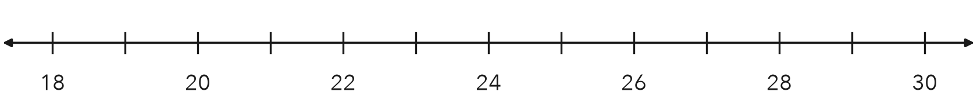
Inequality

5. Find the Error. Keon graphed n > 5 with a closed dot at 5 and an arrow to the right. Explain his mistake. Is 5 a solution?

TEST PRACTICE choose the best answer
6. Which inequality is shown on the number line?
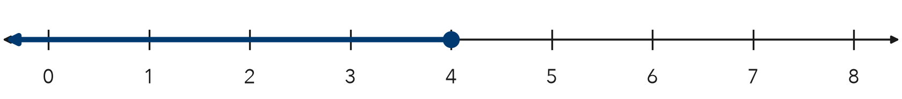
A x < 4 | B x ≤ 4 | C x > 4 | D x ≥ 4

7. Which number is a solution of n > −3?
A −5 | B −4 | C −3 | D 0

CHECK YOURSELF | □ I can do this on my own | □ I need a little help | □ I have a question about #

Name Date Period
Lesson 8-5 · Homework Packet · Sheet 1 of 2
Graphing Inequalities
Maryland Standard 6.EE.B.8 · Learning target — I can graph an inequality on a number line using an open or a closed dot.

REMEMBER  • Use an open dot for < or >. Use a closed dot for ≤ or ≥.  • Draw the arrow toward the solutions. The dot depends on the symbol, not on the sign of the number.  • Test a number under your arrow. It should make the inequality true. | WORKED EXAMPLE  Graph y > −2.  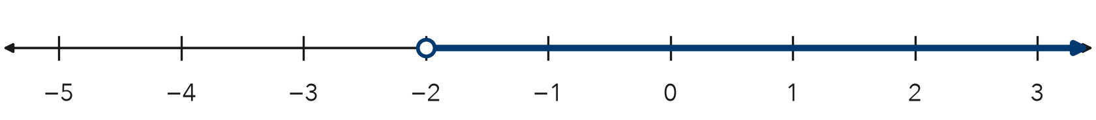  Step 1 > does not include −2, so draw an open dot at −2.  Step 2 Solutions are greater, so the arrow points right.  Answer Open dot at −2, arrow right
PRACTICE use the number lines · show your work
1. For each graph, tell the dot (open or closed) and the arrow direction (left or right).
a. x ≥ 9 | b. n < −4
c. p ≤ 0 | d. k > 2.5
e. w ≥ −6 | f. r < 7
g. b > −1.5 | h. c ≤ 12

2. Graph a ≤ −1 on the number line. Then name one solution.
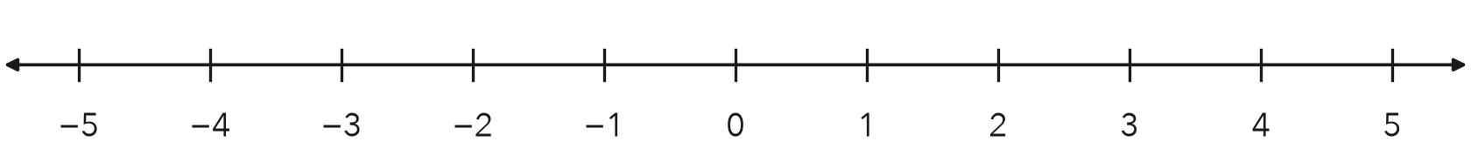
One solution

3. Hiking Trail. A trail is open to hikers who are at least 10 years old. Write an inequality for a, a hiker’s age. Then graph it.
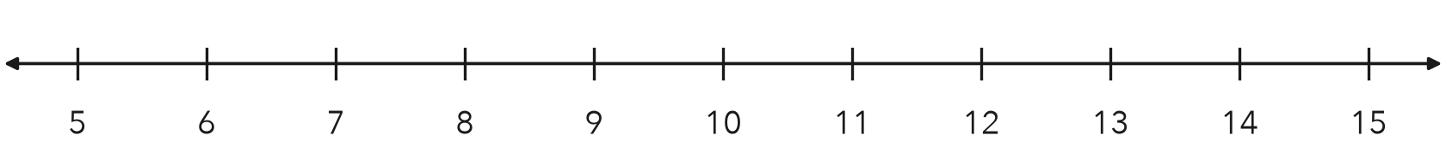
Inequality

4. Read the Graph. Write the inequality shown, using m. Then describe a real situation it could show.
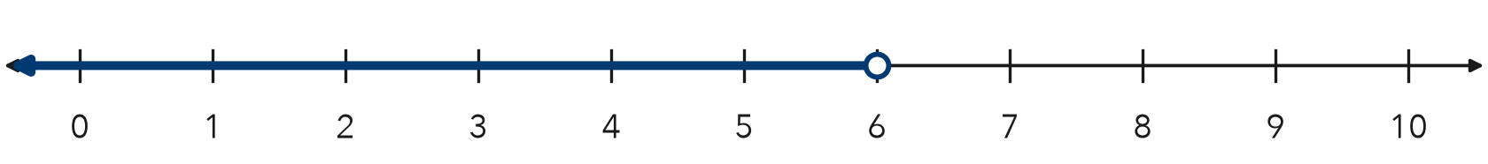

CHECK YOURSELF | □ I can do this on my own | □ I need a little help | □ I have a question about #
AT HOME Ask someone at home for a rule with a limit (bedtime, screen time, a speed limit). Write it as an inequality and graph it.
Name Date Period
Lesson 8-5 · Homework Packet · Sheet 2 of 2
Testing Solutions to Inequalities
Maryland Standard 6.EE.B.8 · Learning target — I can test values against an inequality and graph the solution set.

REMEMBER  • Substitute the value. A true statement means it is a solution.  • An inequality usually has many solutions.  • The boundary is a solution for ≤ and ≥ only. | WORKED EXAMPLE  Which of 6, 8, and 11 are solutions of x ≥ 8?  Step 1 Test 6: 6 ≥ 8 is false. Test 8: 8 ≥ 8 is true.  Step 2 Test 11: 11 ≥ 8 is true.  Answer 8 and 11 are solutions; 6 is not.
PRACTICE show your work · label units
1. Substitute each value. Write yes if it is a solution or no if it is not.
Inequality | x = 4 | x = 7 | x = 10
x > 7
x ≤ 7
x ≥ 4

2. Is the value a solution? Write yes or no.
a. x < 9; x = 9 | b. m ≥ −1; m = 0 | c. t ≤ 2.5; t = 3

3. Bowling. A bowling team wins a trophy for scoring more than 450 points. Write an inequality for the score, s. Test 450, 445, and 472.
Inequality and winning scores

4. Test −3, 0, and 2 in y ≤ −1. Then graph y ≤ −1 on the number line.
Solutions from the list

5. Find the Error. Bianca says n < 12 has 12 solutions: 11, 10, 9, and so on down to 0. Explain what she is missing.

TEST PRACTICE choose the best answer
6. Which value is not a solution of k ≥ −2?
A −3 | B −2 | C 0 | D 5

7. Which value is a solution of n > 15?
A 12 | B 14.9 | C 15 | D 15.5

CHECK YOURSELF | □ I can do this on my own | □ I need a little help | □ I have a question about #

