Name Date Period
Lesson 9-1 · Homework Packet · Sheet 1 of 2
Independent and Dependent Variables
Maryland Standard 6.EE.C.9 · Learning target — I can name the independent and dependent variables in a relationship.

REMEMBER  • The independent variable is the input you choose or control.  • The dependent variable is the output. It depends on the input.  • On a graph: independent on the x-axis, dependent on the y-axis. | WORKED EXAMPLE  The more cars Andre washes, the more money he earns. Name the variables.  Step 1 Andre controls how many cars he washes.  Step 2 Test: “Money earned depends on cars washed.” It makes sense.  Answer Independent: cars washed · Dependent: money earned
PRACTICE show your work · label units
1. For each pair of quantities, write I under the independent variable and D under the dependent variable.
 | Quantity | I or D | Quantity | I or D
a. | minutes biking |  | miles traveled
b. | total cost |  | tickets bought
c. | guests at a party |  | cups of juice needed

2. Bus Ride. The longer Imani rides the bus, the farther she gets from home. Write a sentence about these two quantities that uses “depends on.”
Sentence

3. Dog Walking. Rosa earns $6 per dog she walks. Name both variables.
Independent / Dependent

4. Sunflower. Kenji graphs the height of his sunflower each week.  a. Name the independent variable.  b. Name the dependent variable.  c. What does the point (4, 20) mean? | 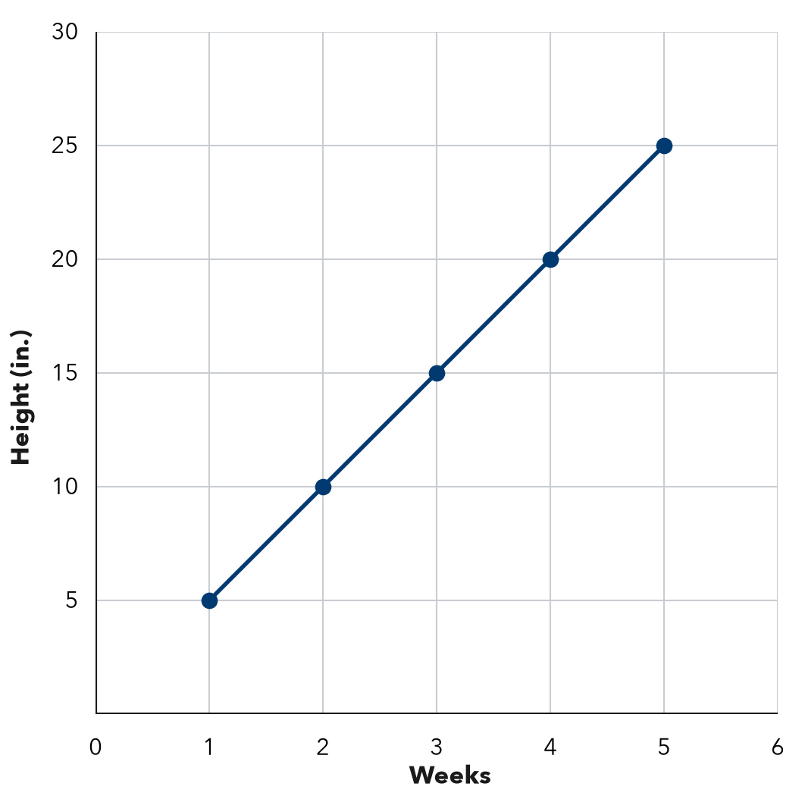

5. Find the Error. The number of people at a picnic changes how many sandwiches are needed. Leah says the sandwiches are independent because that is the bigger number. Explain her mistake.

CHECK YOURSELF | □ I can do this on my own | □ I need a little help | □ I have a question about #
AT HOME Name two things at home that change together. Which one depends on the other?
Name Date Period
Lesson 9-1 · Homework Packet · Sheet 2 of 2
Tables of Values
Maryland Standard 6.EE.C.9 · Learning target — I can build a table of values for a relationship between two variables.

REMEMBER  • A table of values pairs each input (x) with its output (y).  • Use the rule on every input. With a fee, multiply first, then add. | WORKED EXAMPLE  A copier prints 20 pages each minute. Make a table for 1, 2, and 4 minutes.  Step 1 Minutes is x. Pages is y. The rule is y = 20x.  Step 2 20 × 1 = 20, 20 × 2 = 40, 20 × 4 = 80  Answer 20, 40, and 80 pages
PRACTICE show your work · label units
1. Use the rule y = x + 8 to complete the table.
x | 0 | 2 | 4 | 7
y

2. Skate Rental. A rink charges $5 to get in plus $3 for each hour of skating. Complete the table.
Hours (x) | 1 | 2 | 3 | 6
Cost in $ (y)

3. Marker Boxes. The table shows markers in boxes. Describe the rule. Then fill in the missing values.
Boxes (x) | 1 | 2 | 3 | 4 | 8
Markers (y) | 8 | 16 | 24
Rule

4. Find the Error. Marcus made a table for y = 2x + 1. He wrote x: 1, 2, 3, 4 and y: 3, 5, 7, 8. Which y value is wrong? What should it be?
Answer

5. Stretch. A taxi charges $4 plus $2 for each mile. Complete the table. How many miles cost $20?
Miles (x) | 1 | 3 | 5
Cost in $ (y) |  |  |  | 20

TEST PRACTICE choose the best answer
6. A rule is “multiply by 4, then add 5.” What is y when x = 6?
A 24 | B 44 | C 29 | D 15

7. A table has x-values 1, 2, and 3. Which y-values match the rule y = x + 6?
A 6, 12, 18 | B 7, 8, 9 | C 7, 14, 21 | D 6, 7, 8

CHECK YOURSELF | □ I can do this on my own | □ I need a little help | □ I have a question about #

Name Date Period
Lesson 9-2 · Homework Packet · Sheet 1 of 2
From Table to Graph
Maryland Standard 6.EE.C.9 · Learning target — I can turn a table of values into points and plot them on a graph.

REMEMBER  • Each row of a table becomes an ordered pair (x, y).  • To plot (x, y), start at (0, 0). Move right x, then up y.  • Points from a constant rate line up in a straight line. | WORKED EXAMPLE  Movie tickets cost $8 each. Write ordered pairs for 1, 2, and 3 tickets.  Step 1 Tickets is x. Cost is y. Multiply each x by 8.  Step 2 8 × 1 = 8, 8 × 2 = 16, 8 × 3 = 24  Answer (1, 8), (2, 16), (3, 24)
PRACTICE show your work · label units
1. Write each table row as an ordered pair (x, y).
a. x = 4, y = 12 | b. x = 0, y = 0
c. x = 6, y = 30 | d. x = 9, y = 2

2. Smoothies. Smoothies cost $4 each. Complete the table. Then plot the points on the grid and connect them. | 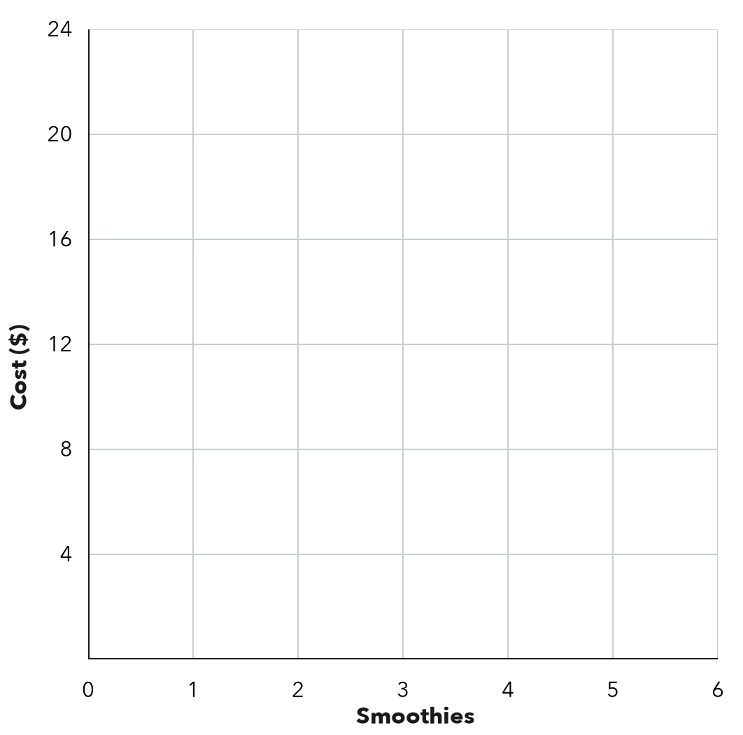
  Smoothies (x) | 1 | 2 | 3 | 5
  Cost in $ (y)

3. Hiking. The graph shows how far Kofi hikes.  a. Write the ordered pair for 5 hours.  b. What does (3, 6) mean?  c. Miles per hour: | 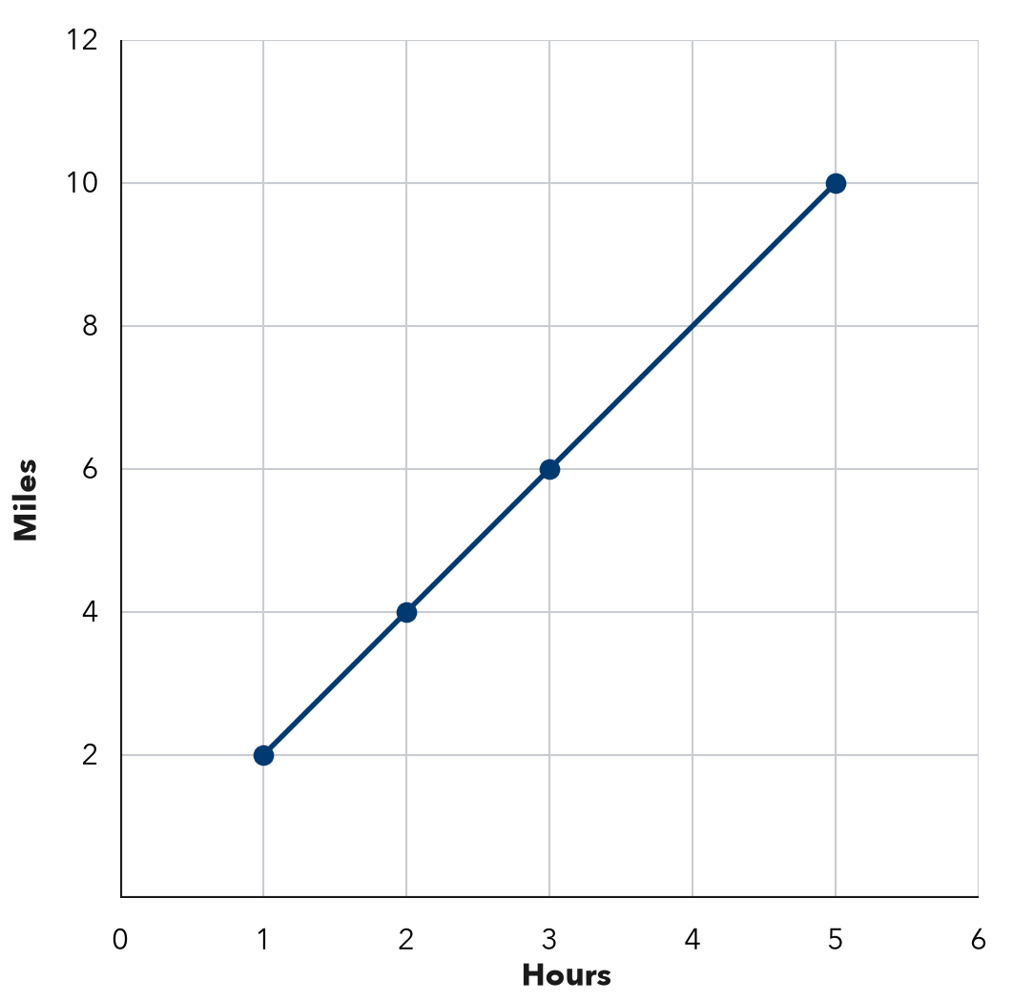

4. Bike Rental. A bike rents for $6 per hour. Write the ordered pairs (hours, cost) for renting 1, 3, and 4 hours. Then tell what (0, 0) means.
Ordered pairs

5. Find the Error. Teo’s table shows x (hours): 2, 4 and y (dollars): 10, 20. He plotted (10, 2) and (20, 4). Explain his mistake. Which points should he plot?

CHECK YOURSELF | □ I can do this on my own | □ I need a little help | □ I have a question about #
AT HOME Show someone at home how to plot (3, 5): right 3, then up 5.
Name Date Period
Lesson 9-2 · Homework Packet · Sheet 2 of 2
Analyzing a Graph
Maryland Standard 6.EE.C.9 · Learning target — I can read a relationship off a graph and describe the rate it shows.

REMEMBER  • For a line through (0, 0), the unit rate is y ÷ x. The point (3, 12) means 3 of x go with 12 of y.  • With the same scales, a steeper line has a greater rate. | WORKED EXAMPLE  A line through (0, 0) passes through (2, 10). Find the unit rate and y when x = 7.  Step 1 Unit rate: 10 ÷ 2 = 5  Step 2 y = 5 × 7 = 35  Answer 5 per unit; y = 35
PRACTICE show your work · label units

1. Filling a Pool. The graph shows the water in a pool.  a. What does (4, 60) mean?  b. Gallons per minute:  c. Gallons after 9 minutes: | 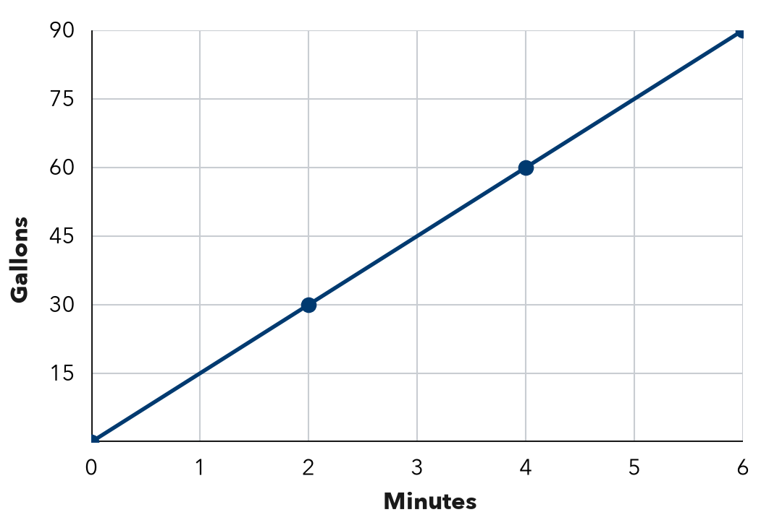

2. Each line passes through (0, 0) and the given point. Find the unit rate.
a. (3, 21) | b. (5, 40) | c. (8, 96)

3. Reading. A line through (0, 0) shows that Ana reads 18 pages in 3 hours. Find her unit rate. How many pages does she read in 7 hours?
Answer

4. Two Jobs. The graph shows pay for two jobs. Find each pay rate. Which line is steeper, and what does it mean?  Answer | 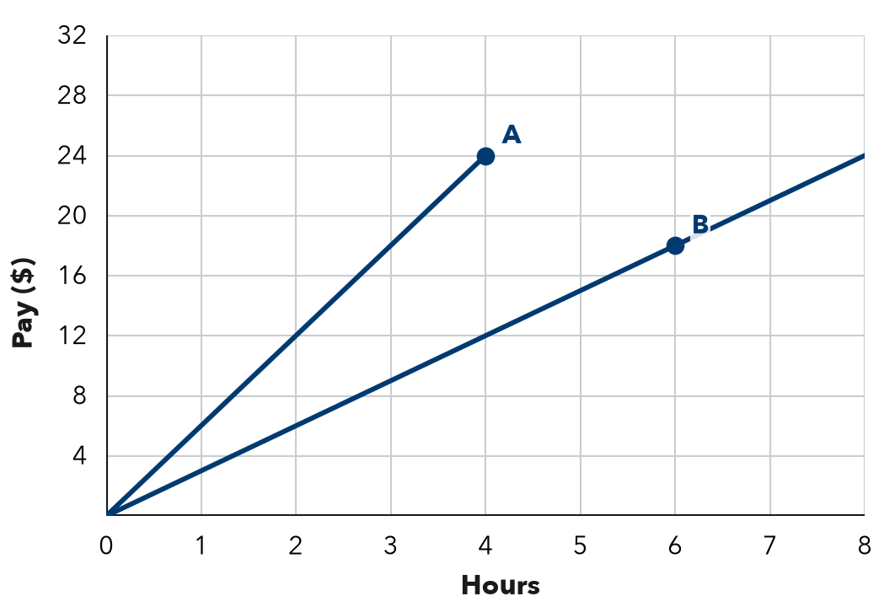

5. Savings. Jada’s savings graph passes through (0, 10), (1, 15), and (2, 20). She says it is proportional. Is she right? What does (0, 10) mean?

TEST PRACTICE choose the best answer
6. A line through the origin passes through (5, 35). What is the unit rate?
A 5 | B 30 | C 7 | D 175

7. Line P passes through (1, 4). Line Q passes through (1, 9). Both start at (0, 0). Which is true?
A P is steeper. | B Q is steeper; greater rate.
C They have the same rate. | D Q is steeper; smaller rate.

CHECK YOURSELF | □ I can do this on my own | □ I need a little help | □ I have a question about #

Name Date Period
Lesson 9-3 · Homework Packet · Sheet 1 of 2
Equations from Tables
Maryland Standard 6.EE.C.9 · Learning target — I can write an equation that matches a table of values.

REMEMBER  • An equation like y = 5x is a rule that works for every row.  • Same y ÷ x in every row: y = (that number) × x. Same y − x: y = x + (that number).  • Check your equation with two rows. | WORKED EXAMPLE  Write an equation for x: 2, 3, 5 and y: 12, 18, 30.  Step 1 12 ÷ 2 = 6, 18 ÷ 3 = 6, 30 ÷ 5 = 6  Step 2 Check: 6 × 5 = 30  Answer y = 6x
PRACTICE show your work · label units
1. Write an equation for each table.
a. x: 1, 2, 3 y: 7, 14, 21 y = | b. x: 1, 2, 3 y: 10, 11, 12 y =
c. x: 2, 4, 6 y: 10, 20, 30 y = | d. x: 5, 6, 7 y: 2, 3, 4 y =
e. x: 0, 4, 8 y: 6, 10, 14 y = | f. x: 1, 3, 5 y: 9, 27, 45 y =
g. x: 2, 3, 4 y: 16, 24, 32 y = | h. x: 10, 12, 14 y: 5, 7, 9 y =

2. Write the equation. Then complete the table.
x | 2 | 3 | 4 | 6 | 9
y | 22 | 33 | 44
Equation

3. Stretch. A table shows x: 2, 5, 9 and y: 0, 3, 7. Write an equation. Then find y when x = 20.
Answer

4. Tickets. The graph shows the cost of fair tickets. Write an equation for the graph. Then find the cost of 10 tickets.  Answer | 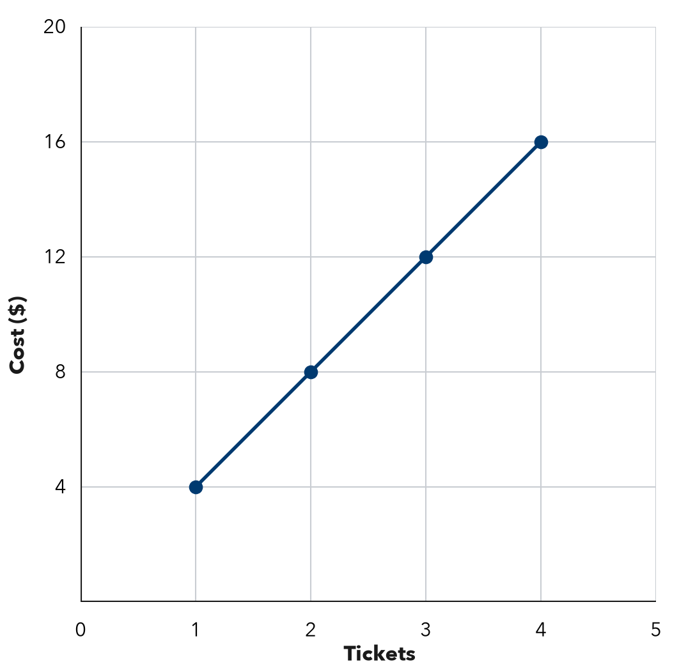

5. Find the Error. For x: 2, 4, 6 and y: 6, 8, 10, Owen wrote y = 3x because 3 × 2 = 6. Explain his mistake and write the correct equation.

CHECK YOURSELF | □ I can do this on my own | □ I need a little help | □ I have a question about #
AT HOME Make a 3-row table for a rule. Ask someone at home to find your equation.
Name Date Period
Lesson 9-3 · Homework Packet · Sheet 2 of 2
Equations from Situations
Maryland Standard 6.EE.C.9 · Learning target — I can write an equation from a described situation and identify its variables.

REMEMBER  • A rate (“each,” “per”) multiplies x. A starting amount or fee is added once.  • y = (rate) × x + (starting amount). Check it with one value from the story. | WORKED EXAMPLE  A gym charges $10 to enter plus $7 per hour. Write an equation for the cost y of x hours.  Step 1 Rate: 7 per hour, so 7x. Fee: add 10.  Step 2 Check 3 hours: 7 × 3 + 10 = 31  Answer y = 7x + 10
PRACTICE show your work · label units
1. Write an equation for each situation.
a. Each pack holds 12 pencils. Pencils y in x packs. y =
b. Jamal is 3 years older than his sister. Jamal’s age y when she is x. y =
c. A club costs $20 to join plus $15 a month. Cost y for x months. y =

2. Bowling. Shoes cost $4, plus $5 per game. Write an equation for the cost y of x games. Find the cost of 4 games.
Answer

3. Taxi. A taxi charges $3 to start plus $2 per mile. Write an equation for the cost y of x miles. Find the cost of 7 miles.
Answer

4. Car Wash. A class has $30 and earns $8 per car washed. Complete the table. Write an equation.
Cars (x) | 0 | 1 | 2 | 5
Total $ (y)
Equation

5. Find the Error. For “a $25 fee plus $10 an hour,” Nia wrote y = 35x. Explain her mistake and fix it.

TEST PRACTICE choose the best answer
6. A plumber charges a $40 fee plus $25 per hour. Which equation gives the cost c for h hours?
A c = 40h + 25 | B c = 25h + 40 | C c = 65h | D c = 25h

7. Which situation matches y = 3x + 12?
A 3 cans per box, 12 boxes | B Start with $3, earn $12 per hour
C Start with 12 gal, add 3 gal per min | D $12 for 3 people

CHECK YOURSELF | □ I can do this on my own | □ I need a little help | □ I have a question about #

Name Date Period
Lesson 9-4 · Homework Packet · Sheet 1 of 2
Substitute and Solve
Maryland Standard 6.EE.C.9 · Learning target — I can substitute a value into an equation to find the matching output.

REMEMBER  • To find the output, substitute the input for x.  • Then use order of operations: multiply first, then add or subtract. | WORKED EXAMPLE  Use y = 6x + 4 to find y when x = 5.  Step 1 Substitute: y = 6 × 5 + 4  Step 2 Multiply, then add: 30 + 4 = 34  Answer y = 34, so (5, 34)
PRACTICE show your work · label units
1. Substitute to find y.
a. y = 4x + 7, x = 3 | b. y = 9x, x = 8
c. y = 3x − 2, x = 10 | d. y = x + 15, x = 27

2. Complete the table for y = 2x + 3. Then plot the points and connect them. | 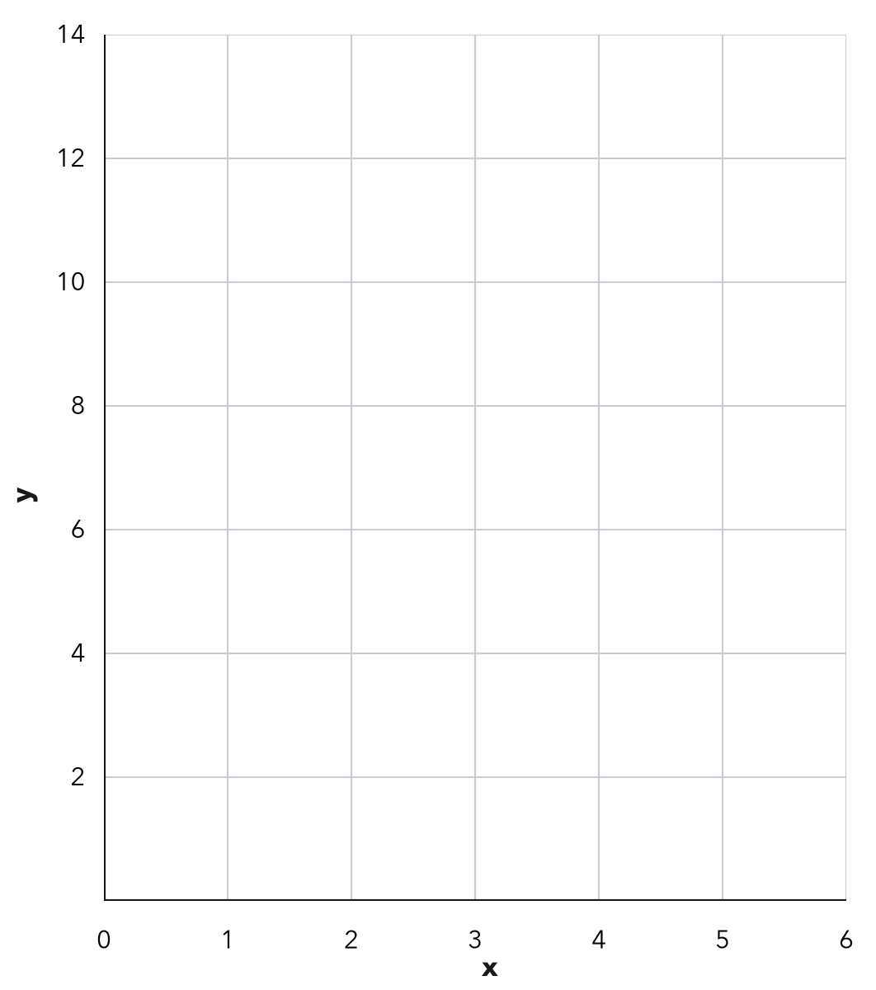
  x | 0 | 1 | 2 | 4 | 5
  y

3. Water Tank. A tank has 20 gallons. It fills at 15 gallons each minute, so g = 15m + 20.
a. Gallons after 6 minutes: gal
b. Gallons after 10 minutes: gal

4. Bike Rental. A bike rental costs c = 7h + 5 dollars for h hours. Find the cost of renting for 3 hours. Then find the cost for 8 hours.
Costs

5. On the Line? Substitute x to decide whether each point is on the graph of y = 5x + 2.
a. (4, 22): 5 × 4 + 2 = On the line? □ Yes □ No
b. (6, 30): 5 × 6 + 2 = On the line? □ Yes □ No

6. Find the Error. For y = 4x + 3 with x = 5, Dev added first: 4 + 3 = 7, and 7 × 5 = 35. Explain his mistake and find y.

CHECK YOURSELF | □ I can do this on my own | □ I need a little help | □ I have a question about #
AT HOME Pick a rule like y = 2x + 1. Ask someone at home for an input and find the output together.
Name Date Period
Lesson 9-4 · Homework Packet · Sheet 2 of 2
Working Backward to a Goal
Maryland Standard 6.EE.C.9 · Learning target — I can work backward from a goal to find the input an equation needs.

REMEMBER  • Know the goal (y)? Substitute it, then solve for x.  • Undo in reverse order: subtract the fee first, then divide by the rate.  • In a counting problem, a decimal answer may need to be rounded up. | WORKED EXAMPLE  A rental costs y = 4x + 10 for x hours. How many hours cost $46?  Step 1 Subtract 10: 46 − 10 = 36  Step 2 Divide by 4: 36 ÷ 4 = 9  Answer 9 hours
PRACTICE show your work · label units
1. Solve for x.
a. 7x = 63 | b. 8x = 104
c. 3x + 5 = 32 | d. 6x + 12 = 60

2. Trip Fund. A class has $45 and earns $15 a week: y = 15x + 45. How many weeks until it has $210?
Answer weeks

3. Gift Fund. A club has $30 in its gift fund. Members add $12 each week, so y = 12x + 30. How many weeks until the fund has $150?
Answer weeks

4. Plant Growth. A plant is 6 cm tall and grows 3 cm a week: h = 3w + 6.  a. Use the graph. When is it 18 cm?  b. Use the equation. When is it 33 cm? | 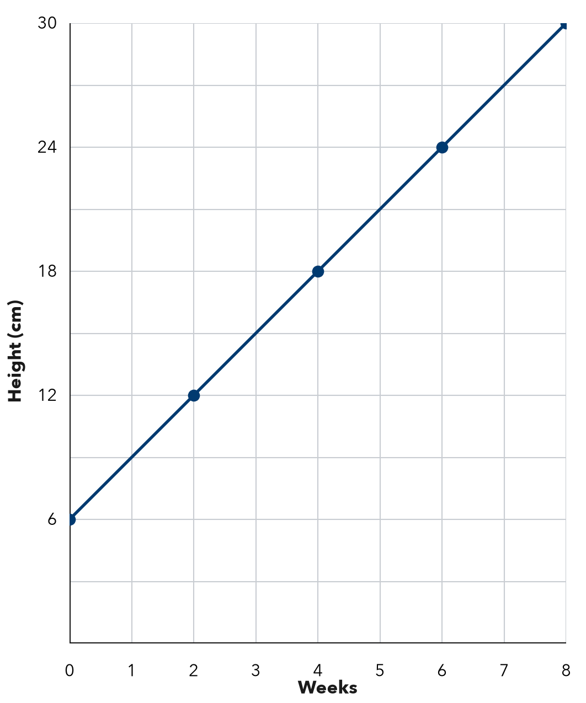

5. Round Up. A box holds 12 cookies. Ana needs 150 cookies, so she says 12.5 boxes. How many boxes should she buy? Explain.

TEST PRACTICE choose the best answer
6. A rental costs y = 8x + 12 dollars for x hours. Max has $60. How many hours can he rent?
A 5 hours | B 6 hours | C 7.5 hours | D 9 hours

7. Mia solved 5x + 20 = 85 by dividing 85 by 5 first. What is the correct value of x?
A x = 17 | B x = 21 | C x = 13 | D x = 65

CHECK YOURSELF | □ I can do this on my own | □ I need a little help | □ I have a question about #

