A
Project Work Report
On
“Full Stack Hospital Management System using React and Java with Spring boot”
Submitted to
SRI VENKATESWARA COLLEGE OF ENGINEERING AND TECHNOLOGY (AUTOMOMOUS)
Affiliated to JNTUA, Anathapuramu
In partial fulfillment of the requirements for the award of the degree of
BACHELOR OF TECHNOLOGY
IN
INFORMATION TECHNOLOGY ( IT )
during the academic year 2025-2026
Submitted by
B. JAGADESHWAR REDDY 22781A1204 B. DONA PRAJWALIKA 22781A1205
C. SANDHYA 22781A1214
L. DIVYA SREE 22781A1257
M. SAI KISHORE 22781A1260

Under the esteemed guidance of
P.Nanda kumar , M.E,Phd Assisstant Professor
Department of Information Technology

SRI VENKATESWARA COLLEGE OF ENGINEERING AND TECHNOLOGY(AUTONOMOUS)
Affiliated to JNTUA, Anathapuramu-515002(A.P) & Approved by AICTE, New Delhi
Accredited by NAAC, Bengaluru & NBA, New Delhi
An ISO 9001:2000 Certified Institution
R.V.S. Nagar, Chittoor-517127(A.P), India
www.svcetedu.org

SRI VENKATESWARA COLLEGE OF ENGINEERING AND TECHNOLOGY
(AUTONOMOUS)
Affiliated to JNTUA, Anathapuramu-515002(A.P) & Approved by AICTE, New Delhi
Accredited by NAAC, Bengaluru & NBA, New Delhi
An ISO 9001:2000 Certified Institution
R.V.S. Nagar, Chittoor-517127(A.P), India
www.svcetedu.org

CERTIFICATE


This is to certify that, the project entitled, “Full Stack Hospital management System using React and Java with Spring boot ” is a bonafide work carried by the following students
B. JAGADESHWAR REDDY 22781A1204 B. DONA PRAJWALIKA 22781A1205
C.SANDHYA 22781A1214
L.DIVYA SREE 22781A1257
M.SAI KISHORE 22781A1260

in partial fulfillment of the requirement for the award of the degree BACHELOR OF TECHNOLOGY in INFORMATION TECHNOLOGY during the academic year 2025-2026

SIGNATURE OF THE GUIDE SIGNATURE OF THE HOD
Mr.P.Nanda kumar, M.E, Ph.D. Dr.J.Velmurgan, Ph.D.
Assistant Professor HOD & Professor
Department of Information Technogoly. Department of Information Technology.
SVCET(AUTONOMOUS) SVCET(AUTONOMOUS)

INTERNAL EXAMINER EXTERNAL EXAMINIER

Viva-Voce Conducted on

SRI VENKATESWARA COLLEGE OF ENGINEERING AND TECHNOLOGY
(AUTONOMOUS)
Affiliated to JNTUA, Anathapuramu-515002(A.P) & Approved by AICTE, New Delhi
Accredited by NAAC, Bengaluru & NBA, New Delhi
An ISO 9001:2000 Certified Institution
R.V.S. Nagar, Chittoor-517127(A.P), India
www.svcetedu.org

Department of Information Technology

DECLARATION

We
B.JAGADESHWAR REDDY 22781A1204 B.DONA PRAJWALIKA 22781A1205
C.SANDHYA 22781A1214
L.DIVYA SREE 22781A1257
M.SAI KISHORE 22781A1260

hereby declare that the Project Report entitled " Full Stack Hospital Management System using React and Java with Spring boot" under the guidance of Mr.P.Nanda Kumar, M.E,Ph.d, Sri Venkateswara College of Engineering & Technology (Autonomous), Chittoor is submitted in partial fulfillment of the requirements for the award of the degree of BACHELOR OF TECHNOLOGY in INFORMATION TECHNOLOGY.
This is a record of bonafied work carried out by us and the results embodied in this project have not been reproduced or copied from any source. The results embodied in this project report have not been submitted to any other university or institution for the award of any other degree or diploma.

ACKNOWLEDGEMENT

A Grateful thanks to Dr.R.Venkataswamy, Chairman, Sri Venkateswara College of Engineering and Technology for providing education in their esteemed institution.
We, wish to record our deep sense of gratitude and profound thanks to our beloved Vice Chairman, Sri. R.V. Srinivas for his valuable support throughout the course.

We, express our sincere thanks to Dr. M. Mohan Babu, our beloved principal for his encouragement and suggestions during the course of study.

We, wish to convey our gratitude and express our sincere thanks to our Mr.P.Nanda Kumar, M.E, Ph.D, Assisstant Professor, IT , for giving us his inspiring guidance in undertaking our project report.

We express our sincere thanks to the Project Guide Dr.J.Velmurugan, Ph.D, Professor & Head of the Department, IT, for his keen interest, stimulating guidance, encouragement with our work during all stages, to bring this project into fruition.

We, wish to convey our gratitude and express our sincere thanks to all Project Review Committee members for their support and cooperation rendered for successful submission of our project work. Finally, we would like to express our sincere thanks to all teaching, non-teaching faculty members, our parents, and friends and for all those who have supported us to complete the project work successfully.

B.JAGADESHWAR REDDY 22781A1204 B.DONA PRAJWALIKA 22781A1205
C.SANDHYA 22781A1214
L.DIVYA SREE 22781A1257
M.SAI KISHORE 22781A1260


SRI VENKATESWARA COLLEGE OF ENGINEERING AND TECHNOLOGY
(AUTONOMOUS)
R.V.S. NAGAR, CHITTOOR-517 127, ANDHRA PRADESH
DEPARTMENT OF INFORMATION TECHNOLOGY

Vision and Mission of the Department under R20 Regulations

VISION

To provide leading Technologies in Information Technology & Computer Science fields to our

graduates to be globally recognized as innovative computing professionals.

MISSION
- The Department of Information Technology is dedicated to produce Software Engineers with basic knowledge in math develop problem solving skills necessary for the career advancement in Computer Science / IT & allied disciplines, and practice.
- Produce engineers with a strong practical and theoretical exposure in the relevant disciplines, who are able to contribute to society through innovation enterprise and leadership.
- Nurture engineer with a global outlook and to provide technological leadership through necessary technical tools.
- Produce engineers with teamwork, communication and interpersonal skill.

SRI VENKATESWARA COLLEGE OF ENGINEERING AND TECHNOLOGY
(AUTONOMOUS)
R.V.S. NAGAR, CHITTOOR-517 127, ANDHRA PRADESH DEPARTMENT OF INFORMATION TECHNOLOGY

Program Educational Objectives (PEOs) under R20 Regulations

Program Educational Objectives (PEOs):
PEO1: To Educate and train students in professional career by acquiring knowledge in scientific,mathematics and computing and engineering principles.

PEO2: Apply, Analysis, Design, Optimization and Implementation skills in order to formulate and solve Computer Science,Engineering and Multidisciplinary problems.
PEO3: Use their skills in ethical & professional manner to raise the satisfaction level of stakeholders and to take up higher studies, research & development and other creative efforts in science & technology.

SRI VENKATESWARA COLLEGE OF ENGINEERING AND TECHNOLOGY
(AUTONOMOUS)
R.V.S. NAGAR, CHITTOOR-517 127, ANDHRA PRADESH
DEPARTMENT OF INFORMATION TECHNOLOGY

Program Specific Outcomes (PSOs) under R20 Regulations

Program Specific Outcomes (PSOs):
PSO1: Analyze and recommend the appropriate IT infrastructure required for the implementation of a project.
PSO2: Design, develop and test the software system for world-wide network of computers to provide solutions to real word problems.

SRI VENKATESWARA COLLEGE OF ENGINEERING AND TECHNOLOGY
(AUTONOMOUS)
R.V.S. NAGAR, CHITTOOR-517 127, ANDHRA PRADESH
DEPARTMENT OF INFORMATION TECHNOLOGY
PROGRAM OUTCOMES

On successful completion of the Program, the graduates of B. Tech. IT Program will be able to:
1. Engineering knowledge: Apply the knowledge of mathematics, science, engineering fundamentals, and an engineering specialization to the solution of complex engineering problems.
2. Problem analysis: Identify, formulate, review research literature, and analyze complex engineering problems reaching substantiated conclusions using first principles of mathematics, natural sciences, and engineering sciences
3. Design / Development of solutions: Design solutions for complex engineering problems and design system components or processes that meet the specified needs with appropriate consideration for the public health and safety, and the cultural, societal, and environmental considerations.
4. Conduct investigations of complex problems: Use research-based knowledge and research methods including design of experiments, analysis and interpretation of data, and synthesis of the information to provide valid conclusions..
5. Conduct investigations of complex problems: Use research-based knowledge and research methods including design of experiments, analysis and interpretation of data, and synthesis of the information to provide valid conclusions.
6. The engineer and society: Apply reasoning informed by the contextual knowledge to assess societal, health, safety, legal and cultural issues and the consequent responsibilities relevant to the professional engineering practice.
7. Environment and sustainability: Understand the impact of the professional engineering solutions in societal and environmental contexts, and demonstrate the knowledge of, and need for sustainable development.
8. Ethics: Apply ethical principles and commit to professional ethics and responsibilities and norms of the engineering practice.
9. Individual and team work: Function effectively as an individual, and as a member or leader in diverse teams, and in multidisciplinary settings.
10. Communication: Communicate effectively on complex engineering activities with the engineering community and with society at large, such as, being able to comprehend and write effective reports and design documentation, make effective presentations, and give and receive clear instructions.
11. Project management and finance: Demonstrate knowledge and understanding of the engineering and management principles and apply these to one’s own work, as a member and leader in a team, to manage projects and in multidisciplinary environments.
12. Life-long learning: Recognize the need for, and have the preparation and ability to.

SRI VENKATESWARA COLLEGE OF ENGINEERING AND TECHNOLOGY

(Autonomous)

IV B.Tech II Semester IT

20AIT33: PROJECT WORK, SEMINAR AND INTERNSHIP IN INDUSTRY
 |  |  |  |  |  | L | T | P | C
 |  |  |  |  |  | - | - | - | 12
COURSE OUTCOMES:

After successful completion of this course, the students will be able to:

1. Analyze the functional requirements of a Hospital Management System and identify key modules such as patient management, appointment scheduling, billing, and staff management.
2. Design an efficient and user-friendly system architecture using appropriate software engineering principles and database design techniques..
3. Perform individually or in a team besides communicating effectively in written, oral and graphical forms on computer engineering systems or processes.
4. Develop a full-stack Hospital Management System using modern technologies (such as Java, React, databases, and APIs) to automate hospital operations.
5. Demonstrate teamwork, documentation skills, and problem-solving abilities by completing the project following industry-standard practices.

ABSTRACT

The Hospital Management System (HMS) is a web-based software application designed to automate and streamline the day-to-day administrative and clinical operations of hospitals and healthcare institutions. In traditional hospital environments, processes such as patient registration, appointment scheduling, medical record maintenance, billing, and staff coordination are often handled manually or through fragmented systems. These conventional approaches lead to data redundancy, increased chances of human error, delayed service delivery, inefficient resource utilization, and challenges in maintaining accurate and up-to-date patient records. The proposed Hospital Management System addresses these issues by providing a centralized, integrated, and user-friendly digital platform.
This project focuses on the design and development of a robust Hospital Management System that manages core hospital activities through well-structured and well-defined modules. The system includes modules for patient management, doctor and staff management, appointment scheduling, billing management, and administrative control. Each module is responsible for specific functionalities while ensuring seamless data sharing across the system. Patient-related information such as personal details, medical history, consultation records, and treatment details is securely stored in a centralized database, enabling fast access and reliable data retrieval. This centralized approach improves continuity of care, reduces duplication of records, and minimizes the risk of data inconsistency or loss.
The Hospital Management System is implemented using modern full-stack web technologies to support both frontend and backend operations. The frontend is developed using React, providing an intuitive, responsive, and interactive user interface for different users such as administrators, doctors, and hospital staff. The backend is developed using Java Spring Boot, which handles business logic, data processing, and secure communication through RESTful APIs. Role-based access control is implemented to ensure that users can access only the functionalities relevant to their roles, thereby maintaining data confidentiality, system security, and controlled access to sensitive hospital information.
A key functionality of the system is appointment management, which allows staff to schedule and manage patient appointments efficiently based on doctor availability. This reduces waiting time, avoids scheduling conflicts, and improves overall patient service quality. Doctors can view their assigned appointments, access patient details, and update consultation records through the system. The billing module automates bill generation and payment record management, reducing manual workload and minimizing accounting errors. Administrative users can manage system users, monitor hospital operations, and generate reports to support effective decision-making. Overall, the Hospital Management System demonstrates a practical application of full-stack development technologies to solve real-world healthcare management challenges in small to medium-scale hospital environments.

TABLE OF CONTENT:

SL.NO | CONTENT | PAGE NO
 | ABSTRACT | 11
1 | INTRODUCTION  1.1 PROBLEM STATEMENT | 13
2 | LITERATURE SURVEY | 16
3 | DATA COLLECTION | 19
4 | SYSTEM STUDY  4.1 EXISTING SYSTEM  4.2 PROPOSED SYSTEM | 21
5 | METHODOLOGY  5.1 ENHANCEMENTS | 25
6 | IMPLEMENTATION  6.1 DATA FLOW | 28
7 | SYSTEM SPECIFICATIONS  7.1 HARDWARE REQUIRMENTS  7.2 SOFTWARE REQUIRMENTS  7.3 EXECUTION OF FRONT-END | 37
8 | EXPERIMENTAL SETUP & RESULTS  8.1 EXPERIMENTAL SETUP  8.2 RESULTS | 43
9 | CODING  9.1 MODEL TRAINING CODE | 45
10 | EXECUTION SCREENSHOTS | 54
11 | LIMITATIONS | 57
12 | FUTURE SCOPE | 58
13 | APPLICATION | 59
14 | SYSTEM TESTING | 61
15 | CONCLUSION | 64
 | REFERENCES | 65

- INTRODUCTION

The rapid growth of the healthcare sector has significantly increased the need for efficient and reliable management of hospital operations and medical information. Hospitals are required to handle large volumes of data related to patients, doctors, staff members, appointments, treatments, and billing activities on a daily basis. In many healthcare institutions, these operations are still performed using manual methods or partially computerized systems, which often leads to inefficiencies, data inconsistency, and delays in service delivery. Such traditional approaches make it difficult to manage hospital workflows effectively and respond to the increasing demand for quality healthcare services. Therefore, there is a strong need for an integrated digital solution that can manage hospital activities in a systematic, accurate, and secure manner.
A Hospital Management System (HMS) is a software-based application designed to automate and coordinate the core administrative and clinical functions of a hospital. The primary objective of the system is to improve operational efficiency by reducing manual effort, minimizing errors, and ensuring timely access to accurate information. By centralizing hospital data within a single platform, the system enables smooth communication and coordination among various departments such as reception, consultation, billing, and administration. This centralized approach supports better data organization, faster information retrieval, and improved decision-making, ultimately contributing to enhanced patient care.
Traditional hospital management processes rely heavily on physical records, handwritten documents, and manual appointment scheduling. These methods are time-consuming and make it difficult to maintain complete patient histories, track doctor availability, and generate accurate operational reports. Manual record keeping also increases the risk of data duplication, loss of information, and unauthorized access to sensitive records. In contrast, a computerized Hospital Management System stores hospital data in a structured and secure database, allowing authorized users to access and update information efficiently. This digital approach improves data reliability, transparency, and accountability across hospital operations.
With advancements in information technology, modern Hospital Management Systems are developed using full-stack architectures that support scalability, security, and user-friendly interfaces. The proposed system is designed using React for the frontend and Java Spring Boot for the backend, enabling seamless interaction between users and system components through RESTful services. Role-based access control ensures that different users such as administrators, doctors, and hospital staff can access only the features relevant to their responsibilities. This controlled access improves system security while maintaining ease of use for daily hospital activities.
Another significant advantage of implementing a Hospital Management System is the improvement in service quality and operational organization. Automated appointment scheduling helps reduce waiting time and avoids scheduling conflicts. Digital patient records ensure continuity of care by allowing doctors to review patient histories and update consultation details efficiently. Automated billing processes simplify financial record management and reduce calculation errors. These features collectively contribute to a more organized, efficient, and reliable hospital environment.
Security and data privacy are critical concerns in healthcare applications. The Hospital Management System addresses these concerns by implementing authentication mechanisms, authorization controls, and secure data handling practices. User validation, role-based permissions, and controlled access to sensitive information help protect patient data and maintain confidentiality. Additionally, the modular design of the system allows future enhancements and scalability, making it adaptable to evolving healthcare management requirements.
In summary, the Hospital Management System represents an important step toward the digital transformation of hospital administration. By automating routine hospital operations and providing accurate, real-time access to information, the system reduces operational complexity, enhances efficiency, and supports better healthcare service delivery. This project demonstrates the practical application of software engineering and full-stack development concepts in solving real-world problems related to hospital management.

1.1 PROBLEM STATEMENT
- Hospitals are complex organizations that require effective coordination among multiple departments, resources, and personnel to deliver quality healthcare services. In many healthcare institutions, critical operations such as patient registration, appointment scheduling, medical record maintenance, billing, and staff management are still carried out using manual processes or disconnected software systems. These traditional methods make it difficult to manage hospital workflows efficiently and fail to meet the growing expectations of patients and healthcare professionals.
- One of the major challenges faced by hospitals is the inefficient handling of patient information. Manual record keeping often leads to incomplete, inconsistent, or duplicated data, which makes it difficult for doctors and staff to access accurate patient details when required. The absence of a centralized digital record system increases delays during consultations and affects the overall quality of care. Furthermore, paper-based records are vulnerable to loss, physical damage, and unauthorized access, raising serious concerns regarding data security and patient confidentiality.
- Appointment management is another critical issue in traditional hospital environments. Manual scheduling methods do not provide real-time visibility of doctor availability, leading to scheduling conflicts, long waiting times, and inefficient use of medical resources. Overcrowding and delays place additional pressure on hospital staff and reduce patient satisfaction. Without an automated scheduling system, it becomes difficult to manage appointments systematically and ensure balanced workloads for doctors.
- Billing and financial management also present significant challenges when handled manually. The process of generating bills, tracking payments, and maintaining financial records is time-consuming and prone to calculation errors. Such inaccuracies can lead to financial losses for hospitals and confusion for patients. Additionally, the lack of integrated reporting tools limits the ability of administrators to monitor hospital performance and make informed financial decisions.
- Another major problem is the lack of coordination and data integration among different hospital departments. When patient records, appointment details, and billing information are maintained separately, it results in delays in information flow and increased chances of miscommunication. This fragmented approach reduces overall operational efficiency and affects service quality. Therefore, there is a need for a centralized Hospital Management System that integrates all major hospital functions into a single, secure, and efficient digital platform.

2. LITERATURE REVIEW

The literature review presents an analysis of existing research and studies related to Hospital Management Systems and healthcare information systems. It examines various approaches proposed by researchers to automate hospital operations, manage medical data efficiently, and improve coordination between hospital departments. Studying previous work helps in understanding commonly used system architectures, identifying limitations of traditional solutions, and justifying the need for a modern, role-based, web-enabled Hospital Management System as proposed in this project.

a) AUTHORS:
R. Kumar, S. Verma, and P. Singh
ABSTRACT:
The authors proposed a computerized Hospital Management System focused on reducing manual workload in hospital administration. Their system automates key functions such as patient registration, appointment scheduling, and medical record maintenance using centralized data storage. The study highlights that traditional paper-based systems are inefficient and error-prone, particularly in hospitals with high patient volume. By digitizing records, the system improves data accuracy and retrieval speed for medical staff. However, the authors provide limited discussion on role-based access control, system security, and integration with modern web technologies, which are essential for scalable healthcare applications.

b) AUTHORS:
A. Sharma and M. Gupta
ABSTRACT:
This research presents a web-based Hospital Management System aimed at improving communication between patients, doctors, and administrative staff. The system emphasizes online appointment scheduling, doctor availability management, and automated billing processes through a client-server architecture. The study demonstrates that web-based access significantly reduces patient waiting time and improves service efficiency. While the proposed system enhances operational coordination, the authors identify challenges related to data privacy, authentication, and secure access control, highlighting the need for stronger security mechanisms in healthcare applications.

c) AUTHORS:
L. Wang, Y. Chen, and H. Liu
ABSTRACT:
The authors explored database-driven Hospital Management Systems with a focus on structured data storage and reporting capabilities. Their study emphasizes efficient database design for managing patient records, laboratory reports, and financial transactions. The research demonstrates that centralized databases improve data integrity, reduce redundancy, and support accurate report generation for hospital administrators. The authors also stress the importance of backup and recovery mechanisms. However, the system lacks modern user interfaces and does not fully address frontend usability or real-time interaction requirements in web-based hospital systems.

d) AUTHORS:
S. Patel and N. Desai
ABSTRACT:
This paper focuses on the implementation of role-based access control in Hospital Management Systems to ensure secure and authorized data access. The authors propose a model where different users such as patients, doctors, nurses, and administrators are granted access based on defined roles and responsibilities. The study highlights that improper access control can lead to data breaches and privacy violations. While the security model improves confidentiality and system reliability, the authors mention that further enhancements are required to support scalability and integration with additional hospital services.

e) AUTHORS:
J. Rao and K. Mehta
ABSTRACT:
The authors proposed a modular Hospital Management System designed for flexibility, maintainability, and future expansion. Their research emphasizes dividing the system into independent modules such as patient management, appointment management, billing, and reporting. This modular architecture simplifies system maintenance and allows easy integration of new features. The study highlights the use of software engineering best practices to improve system performance and reliability. The authors suggest that combining modular design with modern web technologies can further enhance scalability and real-time system interaction.

- DATA COLLECTION

Data collection is a critical phase in the development of the Hospital Management System, as the effectiveness and reliability of the system depend heavily on the accuracy and relevance of the data gathered. The objective of data collection in this project is to identify and organize the essential information required to support hospital operations and to understand how data flows between different functional modules of the system. A well-structured data collection process ensures that the system meets functional requirements, supports smooth system interaction, and enables efficient decision-making.
The primary data collected for the Hospital Management System includes patient-related information such as personal details, contact information, age, gender, and unique identification data. In addition, medical-related data such as appointment details, consultation history, treatment information, and billing records are collected and maintained digitally. Collecting structured patient data enables accurate identification and ensures continuity of care by allowing doctors to review previous interactions and treatment records efficiently.
Doctor and administrative staff data form another important component of the data collection process. This includes details such as doctor identification information, specialization, availability schedules, and assigned roles within the system. Administrative staff data includes login credentials and access privileges required to manage hospital operations. Collecting this information supports effective appointment scheduling, role-based access control, and smooth coordination between different hospital functions.
Appointment-related data is collected to manage patient visits in an organized manner. This includes appointment dates, time slots, assigned doctors, and appointment status. Accurate appointment data helps in minimizing scheduling conflicts, reducing patient waiting time, and improving hospital workflow. The system also considers follow-up appointments to ensure proper continuity of treatment.
Billing and financial data is collected to support hospital revenue management and financial transparency. This includes consultation fees, treatment charges, test fees, and payment details. Proper organization of billing data helps automate invoice generation, track payments, and generate financial reports, reducing manual errors and improving accountability.
The data required for this project is collected through analysis of hospital workflows, interaction with domain requirements, review of existing hospital management solutions, and evaluation of system requirements based on real-world healthcare scenarios. This approach ensures that the collected data aligns with the actual operational needs of a hospital.
In conclusion, effective data collection forms the foundation of the Hospital Management System. By identifying and organizing patient, doctor, appointment, and billing data in a structured manner, the system ensures accurate information handling, improved operational efficiency, and reliable healthcare service delivery.

SYSTEM STUDY

Existing System

The existing system in many hospitals primarily relies on manual procedures and partially computerized methods to manage daily operations. Activities such as patient registration, appointment scheduling, medical record maintenance, billing, and report generation are often handled using paper-based files or isolated software tools. These systems operate independently without proper integration, making hospital management inefficient and time-consuming, particularly in hospitals with a large patient population.

In the current system, patient details are typically recorded manually in registers or stored in basic digital files. Medical histories, prescriptions, and diagnostic reports are maintained separately, making it difficult to retrieve complete patient information during consultations. This fragmented approach increases the risk of data duplication, inconsistency, and loss of important records. Doctors and staff often spend additional time locating patient information, which affects service quality and delays treatment.

Appointment scheduling is usually managed manually at the hospital reception. This method does not provide real-time information about doctor availability, resulting in scheduling conflicts, overcrowding, and long waiting times. Emergency cases are also difficult to handle efficiently due to the absence of automated scheduling and prioritization mechanisms, leading to inconvenience for both patients and healthcare staff.

Billing and financial management in the existing system are largely manual, requiring staff to calculate charges, prepare bills, and maintain financial records by hand. These processes are prone to errors and inconsistencies, making financial tracking and auditing difficult. The lack of centralized data storage and automation reduces overall hospital efficiency and increases administrative workload.

4.1.1 Disadvantages of Existing System
- The existing system relies heavily on manual and paper-based processes, which are time-consuming and inefficient.
- Patient records are not stored in a centralized manner, leading to data duplication and inconsistency.
- Retrieving patient history and medical records takes more time, especially during emergency situations.
- Manual appointment scheduling causes long waiting times and frequent scheduling conflicts.
- There is no real-time visibility of doctor availability, resulting in poor workload management.
- Billing and payment processes are prone to calculation errors due to manual handling.
- Financial data is not properly synchronized with patient treatment records, making auditing difficult.
- Sensitive patient information lacks adequate security and is vulnerable to unauthorized access.
- There are no reliable data backup and recovery mechanisms, increasing the risk of permanent data loss.
- Communication between departments such as laboratory, pharmacy, and administration is slow and inefficient.
- Staff management and duty scheduling are difficult to track and manage effectively.
- The system does not support scalability, making it unsuitable for hospitals with growing patient volumes.

Proposed System

The proposed system is a fully computerized and integrated Hospital Management System designed to eliminate the limitations of traditional manual and fragmented hospital processes. The system provides a centralized digital platform to manage patient information, appointments, medical records, billing operations, and administrative activities efficiently. By integrating all hospital functions into a single web-based application, the proposed system improves accuracy, accessibility, and overall operational efficiency.
In the proposed system, all hospital data is stored in a centralized database and accessed through secure backend services. Patient information such as registration details, appointment records, treatment history, and billing data is maintained digitally and can be retrieved quickly by authorized users. This centralized data management reduces redundancy, improves consistency, and supports accurate record keeping.
The system includes an automated appointment management module that allows patients to book appointments based on doctor availability. Doctors can view scheduled appointments, access patient details, and update treatment information. Administrative users can manage system data and monitor hospital activities effectively.
Billing and financial operations are automated in the proposed system. Bills are generated based on services provided, and payment details are stored securely. This reduces calculation errors, improves transparency, and enables efficient financial reporting.
Role-based access control ensures that system features are accessible only to authorized users based on their roles, such as patient, doctor, or administrator. Authentication mechanisms and secure data handling techniques protect sensitive medical information and ensure system reliability.

4.2.1 Advantages
- The proposed system provides centralized storage of hospital data, ensuring consistency and easy access to information.
- Automated patient registration and record management reduce manual effort and save time.
- Real-time appointment scheduling minimizes waiting time and avoids scheduling conflicts.
- Doctors can access complete patient medical histories instantly, improving diagnosis accuracy.
- Automated billing and payment processing reduce calculation errors and improve financial transparency.
- Role-based access control ensures that sensitive data is accessed only by authorized users.
- The system improves coordination between departments such as laboratory, pharmacy, and administration.
- Digital records reduce the risk of data loss and eliminate dependency on paper-based files.
- Built-in reporting features support hospital management in monitoring operations and performance.
- The system enhances data security through authentication, authorization, and regular backups.
- Modular system design allows easy maintenance and future expansion.
- Overall hospital efficiency and patient satisfaction are significantly improved.

METHODOLOGY

The methodology describes the systematic and structured approach followed in the design and development of the Hospital Management System. This project adopts a modular and phased development methodology to ensure system reliability, scalability, security, and ease of maintenance. Each phase of development is carefully planned and executed to meet functional and non-functional requirements while addressing real-world hospital management challenges.
The first phase of the methodology is requirement analysis. In this phase, detailed system requirements are identified by studying hospital workflows, reviewing existing documentation, and analyzing user needs. Functional requirements such as patient registration, appointment scheduling, doctor management, medical record handling, billing, and administrative control are clearly defined. Non-functional requirements including system security, performance, usability, and data integrity are also considered to ensure the system meets healthcare industry expectations.
The next phase is system design, where the overall architecture of the Hospital Management System is planned. A layered architecture is adopted to separate the frontend user interface, backend business logic, and database layers. This separation improves system maintainability and scalability. Database design is carried out by identifying entities, attributes, and relationships required to support structured data storage. User interface design focuses on simplicity and usability to ensure that patients, doctors, and administrators can interact with the system efficiently.
The development phase involves the implementation of system modules using full-stack web technologies. Each module is developed independently following standard coding practices and later integrated into the complete system. The backend is responsible for handling business logic, role-based authentication, authorization, and database interaction. The frontend provides a responsive and interactive user interface for different users. Role-based access control is implemented to ensure that users can access only the features relevant to their roles.
Testing is an essential phase of the methodology to ensure system correctness and reliability. Unit testing is performed on individual modules to detect and resolve errors at an early stage. Integration testing ensures that different modules communicate correctly, while system testing validates overall functionality and performance. Special attention is given to testing data accuracy, security controls, and user access permissions.
After successful testing, the system is deployed in a controlled environment. Deployment includes configuring application servers, backend services, and the database. User guidance and documentation are provided to support smooth system usage. Feedback collected during deployment is used to refine and improve system functionality.
In summary, the adopted methodology provides a disciplined and organized approach to developing the Hospital Management System. By following clearly defined phases from requirement analysis to deployment, the project delivers a secure, efficient, and reliable healthcare management solution.

5.1 Enhancements
The Hospital Management System is designed with flexibility to support future enhancements and technological improvements. While the current system effectively automates core hospital operations, several additional features can be incorporated to further enhance usability, scalability, and healthcare service quality. These enhancements aim to extend system capabilities and adapt it to evolving healthcare requirements.
One possible enhancement is the development of mobile applications for patients and doctors. A mobile interface would allow patients to book appointments, receive notifications, and access medical information through smartphones. Doctors could use mobile access to review patient records and manage appointments remotely, improving responsiveness and continuity of care.
Advanced analytics and reporting features can also be introduced in future versions of the system. By analyzing historical patient and appointment data, the system could generate insights related to patient trends, resource utilization, and hospital performance. These reports would assist hospital administrators in strategic planning and decision-making.
Integration of pharmacy and inventory management modules is another potential enhancement. This feature would allow real-time tracking of medicine stock levels, automated alerts for low inventory, and improved coordination between doctors and pharmacy staff. Such integration would reduce medication delays and ensure timely availability of medicines.
Cloud-based deployment can further enhance system scalability and availability. Hosting the system on cloud platforms would support easier system maintenance, automated backups, and improved disaster recovery. Cloud integration would also enable secure access to the system from different locations.
Security can be strengthened by implementing advanced authentication techniques such as multi-factor authentication and data encryption. Regular security audits and compliance with healthcare data standards would further improve patient data confidentiality.
In conclusion, these enhancements provide a roadmap for future development of the Hospital Management System. Incorporating mobile access, analytics, cloud services, and enhanced security would allow the system to evolve into a more robust and adaptable healthcare management platform.

IMPLEMENTATION

The implementation phase focuses on developing a functional Hospital Management System by transforming system design into executable software modules. The system is implemented using a modular approach to ensure reliability, maintainability, and ease of use for hospital staff and patients.

Module-Based-Development
The Hospital Management System is divided into independent modules such as Patient Management, Appointment Scheduling, Doctor Management, Billing Management, and Administrative Control. Each module is developed separately and later integrated to function as a unified system.

Patient Registration and Record Management
The patient management module is implemented to capture and maintain patient personal details and appointment information. Each patient is uniquely identified within the system to avoid duplication. Patient records can be accessed and updated by authorized users, ensuring data consistency and continuity of care.
Appointment Scheduling System
The appointment scheduling module manages patient bookings based on doctor availability. Patients can select available time slots, and doctors can view scheduled appointments. This module helps reduce scheduling conflicts and improves workflow efficiency.
Doctor and Staff Management
Doctor details such as specialization and availability are maintained in the system. Role-based access control ensures that users can access only the functionalities relevant to their responsibilities, improving security and accountability.
Billing and Payment Processing
The billing module generates bills based on consultations and services provided. Billing records are stored digitally, enabling accurate tracking of payments and reducing manual calculation errors.
Laboratory and Pharmacy Integration
Laboratory test requests are recorded and tracked through the system. Test results are uploaded and linked to patient records. The pharmacy module manages medicine inventory, prescriptions, and stock updates to ensure availability of required drugs.

Database Implementation
A centralized database is implemented to store patient records, appointments, doctor details, and billing information. Data integrity constraints and structured storage ensure reliable data management. Regular backups are maintained to prevent data loss.
System Integration and Testing
All modules are integrated to function as a complete system. Unit testing and integration testing are performed to validate module functionality and data flow. Errors are identified and corrected before deployment.
Deployment and Operational Use
The system is deployed in an operational environment with configured user roles. Basic training and guidance are provided to ensure effective system usage. The implemented system reduces paperwork, improves operational efficiency, and enhances healthcare service delivery.

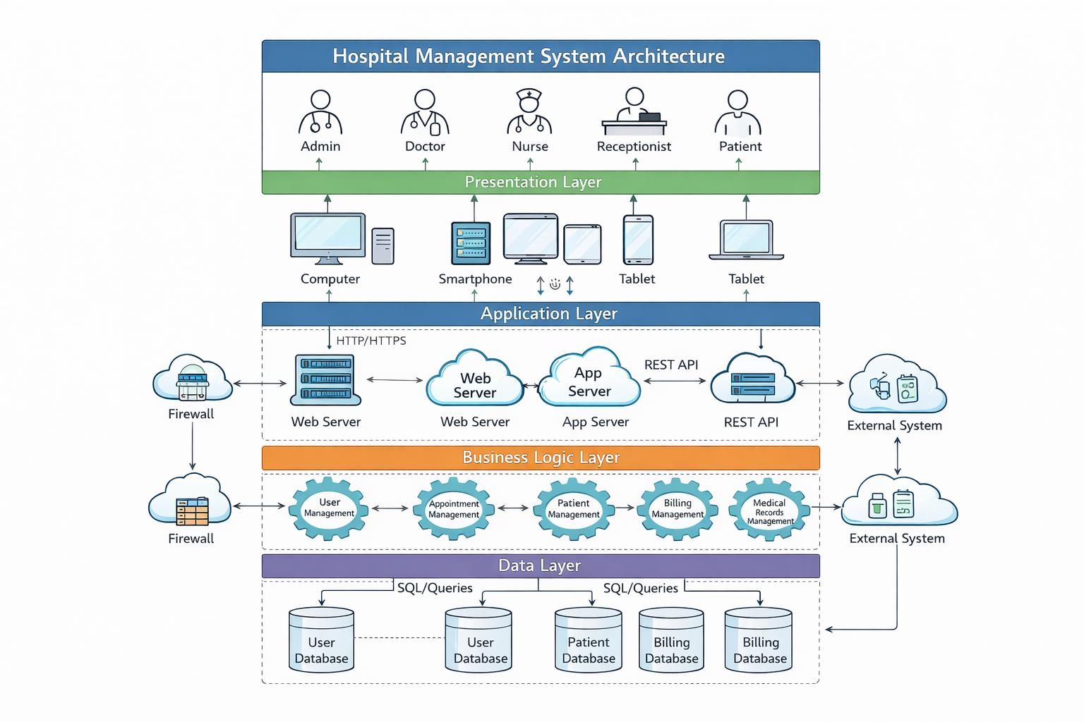
Fig 6.1: Hospital Management System Architecture

6.1 Data flow diagram

- The DFD is also called as bubble chart. It is a simple graphical formalism that can be used to represent a system in terms of input data to the system, various processing carried out on this data, and the output data is generated by this system.
- The data flow diagram (DFD) is one of the most important modeling tools. It is used to model the system components. These components are the system process, the data used by the process, an external entity that interacts with the system and the information flows in the system.
- DFD shows how the information moves through the system and how it is modified by a series of transformations. It is a graphical technique that depicts information flow and the transformations that are applied as data moves from input to output.
- DFD is also known as bubble chart. A DFD may be used to represent a system at any level of abstraction. DFD may be partitioned into levels that represent increasing information flow and functional detail.

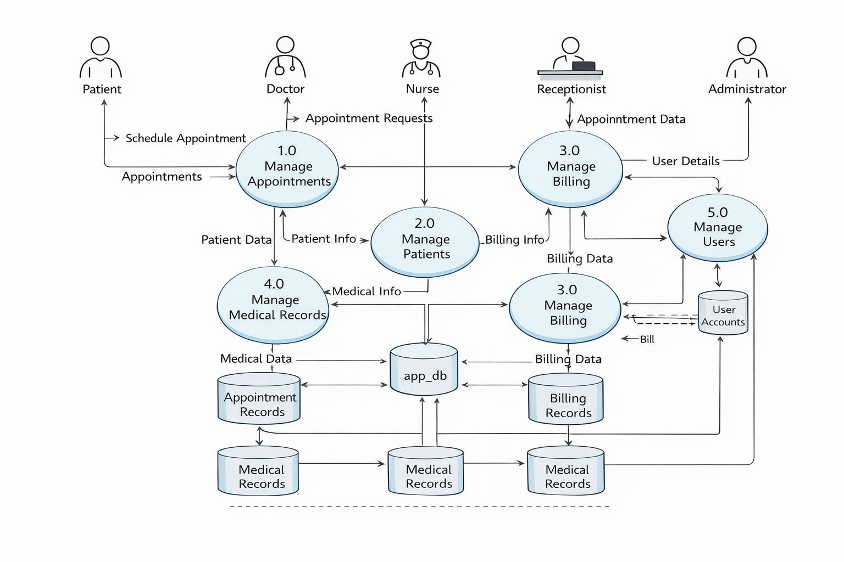
Fig 6.2: Data Flow diagram for the System

- UML diagrams

UML stands for Unified Modeling Language. UML is a standardized general-purpose modeling language in the field of object-oriented software engineering. The standard is managed, and was created by, the Object Management Group. The goal is for UML to become a common language for creating models of object oriented computer software. In its current form UML is comprised of two major components: a Meta-model and a notation. In the future, some form of method or process may also be added to; or associated with, UML.
The Unified Modeling Language is a standard language for specifying, Visualization, Constructing and documenting the artifacts of software system, as well as for business modeling and other non-software systems. The UML represents a collection of best engineering practices that have proven successful in the modeling of large and complex systems. The UML is a very important part of developing objects oriented software and the software development process. The UML uses mostly graphical notations to express the design of software projects.

- Goals

The Primary goals in the design of the UML are as follows:

- Provide users a ready-to-use, expressive visual modeling Language so that they can develop and exchange meaningful models.
- Provide extendibility and specialization mechanisms to extend the core concepts.
- Be independent of particular programming languages and development process.
- Provide a formal basis for understanding the modeling language.
- Encourage the growth of OO tools market.
- Support higher level development concepts such as collaborations, frameworks, patterns and components.
- Integrate best practices.

- Use case diagram

A Use Case Diagram represents the functional requirements of the Hospital Management System by identifying the different actors such as patient, doctor, admin, and staff. It shows how each actor interacts with the system through specific use cases like patient registration, appointment booking, consultation management, and billing. The diagram clearly defines the system boundaries and illustrates the relationships between actors and system functions. It helps in understanding user roles and responsibilities and ensures that all required functionalities of the system are properly identified and implemented.
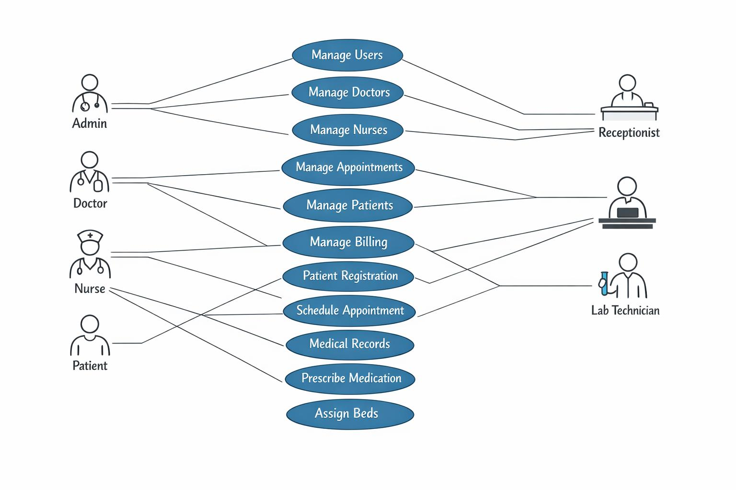

Fig 6.3: Use case Diagram

- Class diagram

A Class Diagram represents the static structure of the Hospital Management System by showing the main classes involved and their relationships. It includes classes such as Patient, Doctor, Appointment, Billing, and Admin, each containing attributes for data storage and methods for defining system behavior. The diagram illustrates how classes are connected through associations and dependencies, for example, a patient having multiple appointments or a doctor managing consultation schedules. It also defines access modifiers to ensure data security and proper control within the system. Overall, the class diagram acts as a blueprint for system development and helps developers understand the organization and structure of the application.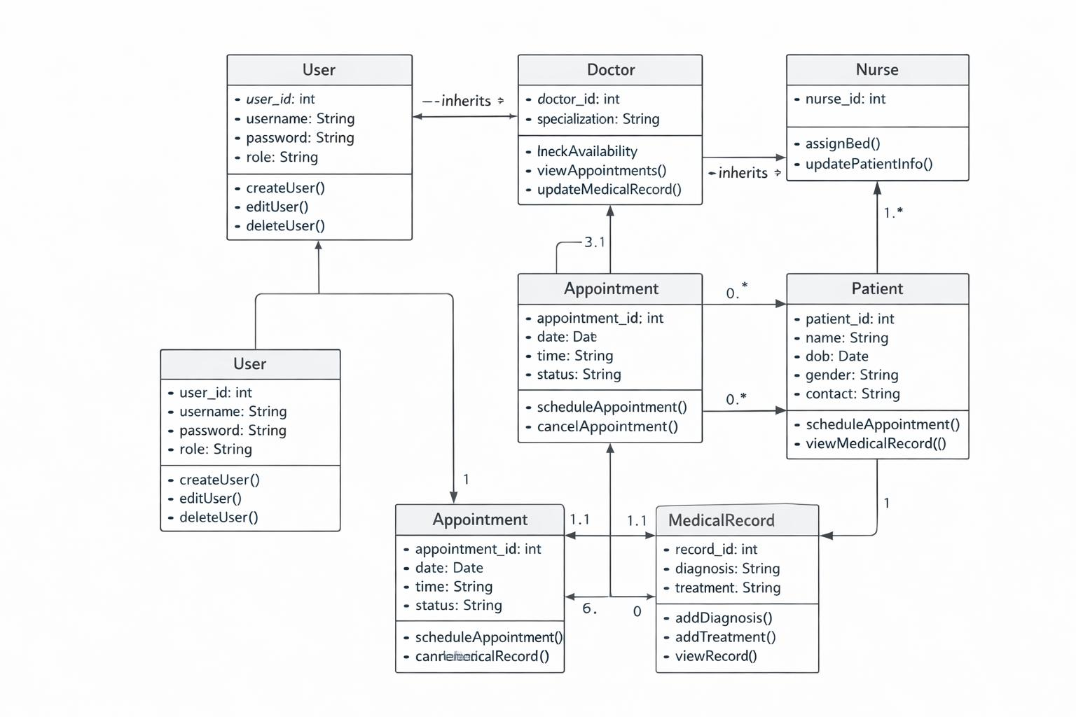
Fig 6.4: Class diagram

- Sequence diagram

The diagram follows a top-to-bottom flow, representing the sequence in which actions occur.
It begins with the patient initiating a request, such as appointment booking or registration.
The system processes the request and communicates with the database to store or retrieve information.
The doctor accesses patient details and updates medical records after consultation.
Billing details are generated based on services provided.
Confirmation messages are sent back to the user.
This diagram helps understand system behavior during execution.It ensures proper coordination among system components.

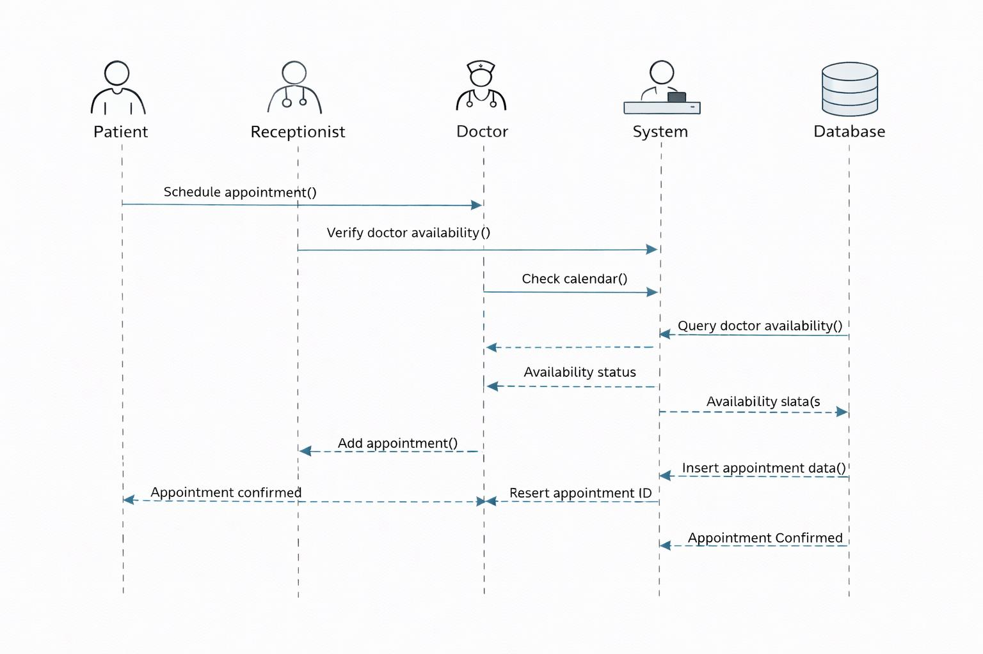
Fig 6.5: Sequence diagram

- Activity diagram
An Activity Diagram illustrates the workflow of activities involved in the Hospital Management System from start to end. It focuses on the sequence of actions performed and the decision points that control the flow of the system.
In the Hospital Management System, the activity diagram begins with patient entry into the system, followed by activities such as registration, appointment scheduling, consultation, and billing. Each activity represents a specific operation carried out by the system or hospital staff.
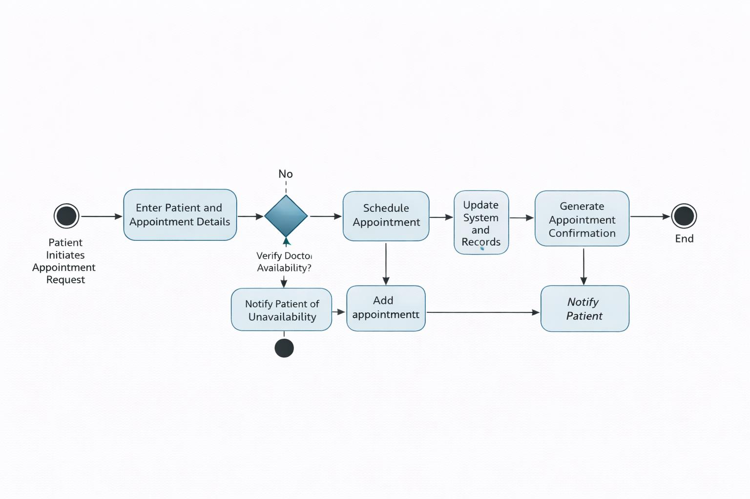
Fig 6.6: Activity Diagram

- Collaboration diagram
A Collaboration Diagram represents the structural organization of objects that participate in a specific interaction within the Hospital Management System. It emphasizes how objects are connected and how they work together to accomplish a particular functionality.
In this diagram, objects such as Patient, Reception, Doctor, Billing System, and Database are shown along with the links between them. The communication between these objects is represented using numbered messages, which indicate the order in which interactions occur.

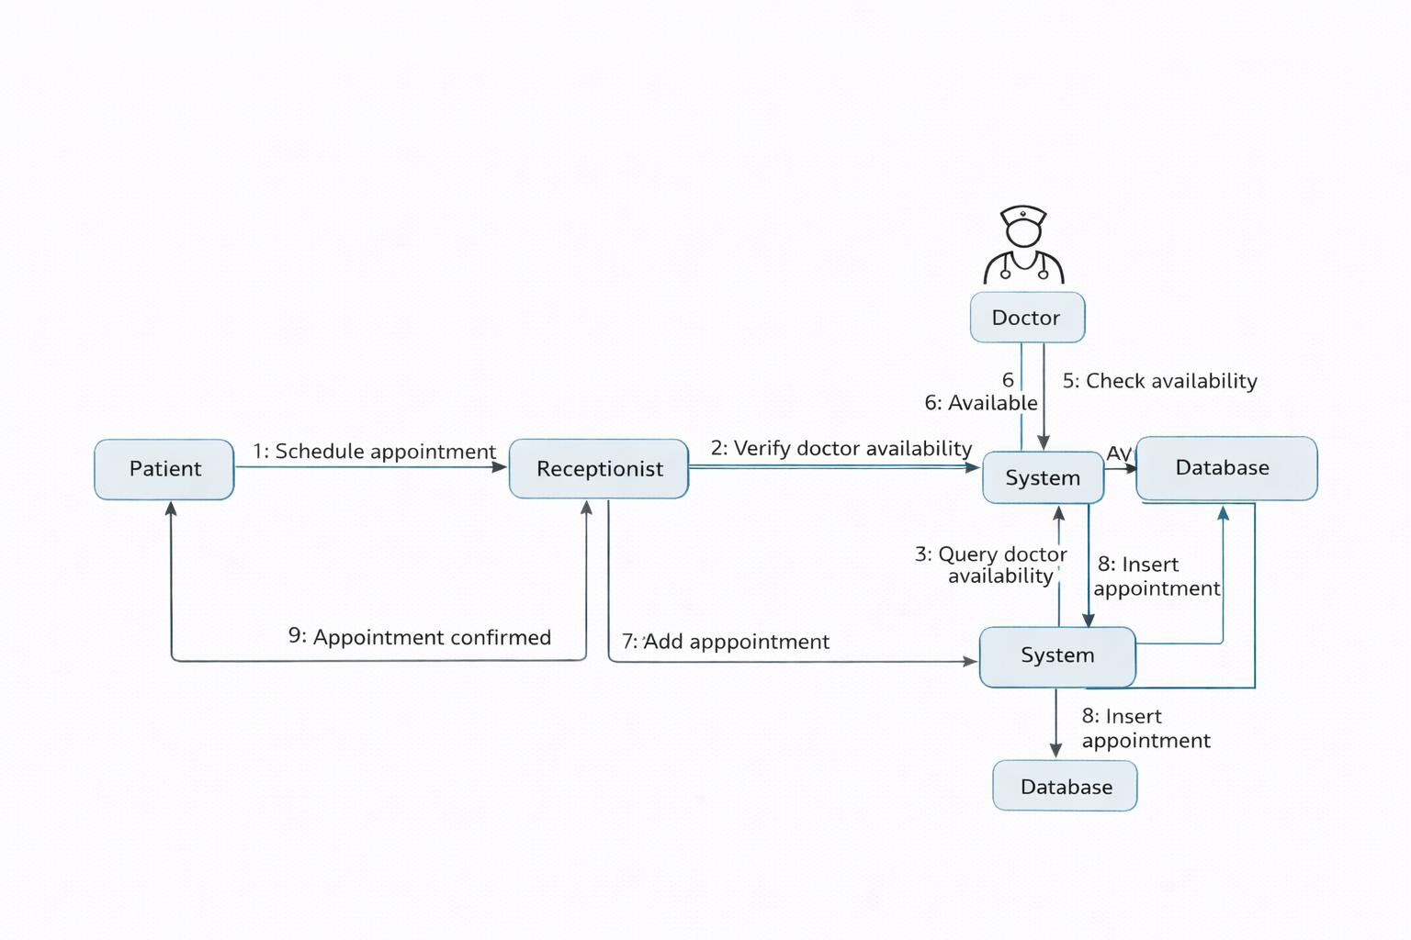

Fig 6.7: Collaboration diagram.

SYSTEM SPECIFICATION

System specification defines the hardware, software, and execution environment required to develop and run the Hospital Management System efficiently. The system is designed to operate on standard computing hardware and commonly used software platforms, making it suitable for deployment in small to medium-scale healthcare institutions.

7.1 Hardware requirements

The Hospital Management System does not require high-end hardware and can function efficiently on standard computer systems.
- Processor: Intel Core i3 or above
- RAM: Minimum 4 GB (8 GB recommended for better performance)
- Hard Disk: At least 20 GB free storage
- Display: 14-inch monitor or higher resolution
- Input Devices: Keyboard and Mouse
- Internet Connection: Required for accessing the web-based system and API communication

7.2 Software requirements

The following software tools and platforms are required for development and execution of the system:
- Operating System: Windows 10 / Linux / macOS
- Frontend Technology: React.js
- Backend Technology: Java with Spring Boot
- Database: MySQL
- IDE / Editor: Visual Studio Code / IntelliJ IDEA
- Web Browser: Google Chrome / Microsoft Edge
- Package Manager: Node.js and npm
- API Testing Tool: Postman (optional)

7.3 EXECUTION FOR FRONT-END

The frontend of the Hospital Management System is developed using React.js, which provides a component-based architecture for building dynamic and responsive user interfaces. React enables efficient state management and seamless interaction with backend REST APIs.

Front-End Execution Process:

- Install Node.js and npm on the system.
- Create the React application using the create-react-app tool.
- Develop frontend components for patient registration, appointment scheduling, billing, and dashboards.
- Integrate frontend components with backend REST APIs.
- Run the application using the React development server.

- Sample Front-End Execution Commands
npx create-react-app hospital-management
cd hospital-management
npm start

- Sample React Code (Patient Registration Component)
import React, { useState } from "react";
function PatientRegistration() {
const [patient, setPatient] = useState({
name: "",
age: "",
contact: ""
});

const handleChange = (e) => {
setPatient({ ...patient, [e.target.name]: e.target.value });
};

const handleSubmit = (e) => {
e.preventDefault();
alert("Patient Registered Successfully");
};

return (
<div>
<h2>Patient Registration</h2>
<form onSubmit={handleSubmit}>
<input
type="text"
name="name"
placeholder="Patient Name"
onChange={handleChange}
required
/>
<input
type="number"
name="age"
placeholder="Age"
onChange={handleChange}
required
/>
<input
type="text"
name="contact"
placeholder="Contact Number"
onChange={handleChange}
required
/>
<button type="submit">Register</button>
</form>
</div>
);
}
export default PatientRegistration;

- Front-End Execution Result

After successful execution, the application runs on the local server (default: http://localhost:3000).
Users can access different modules such as patient registration, appointment scheduling, and billing through a responsive user interface.

8 EXPERIMENTAL SETUP AND RESULTS

8.1 Experimental Setup

The experimental setup defines the environment used to evaluate the correctness and performance of the Hospital Management System.
- The system was executed on a personal computer with the required hardware and software configuration.
- The frontend was developed and executed using React.js in a local development environment.
- The backend services were implemented using Java Spring Boot with RESTful APIs.
- MySQL database was used to store patient, appointment, billing, and staff data.
- Frontend and backend communication was achieved through HTTP-based API calls.
- Different user roles such as patient, doctor, and administrator were created to test role-based access control.
- Sample data was inserted to simulate real hospital operations.

8.2 Experimental Procedure

The system was tested by performing the following operations:
- Registering new patients and storing their details
- Booking appointments based on doctor availability
- Updating medical records after consultation
- Generating bills for services provided
- Processing payments and updating payment status
- Managing doctors and system data through the admin module
Each operation was verified for correct input validation, data storage, and output display.

8.3 Results and Observations

- Patient registration was completed successfully with unique identification
- Appointment scheduling prevented overlapping time slots
- Medical records were stored and retrieved accurately
- Bills were generated automatically based on services
- Payment status updates were reflected correctly
- Role-based access ensured secure handling of sensitive data

8.4 Performance Evaluation

- The application performed efficiently under normal usage
- Database operations were fast and reliable
- The frontend interface remained responsive
- Error handling worked correctly for invalid inputs

8.5 Result Summary

The results confirm that the Hospital Management System functions as expected. The system improves operational efficiency, reduces manual effort, and ensures secure and reliable data management.

CODING

This section presents selected backend implementation components of the Hospital Management System. The code demonstrates the use of Spring Boot for building RESTful services, JPA for database interaction, and a layered architecture consisting of controller, service, repository, and entity layers. Only representative code snippets are included for clarity.

9.1 backend code

package com.hms;

import org.springframework.boot.SpringApplication;

import org.springframework.boot.autoconfigure.SpringBootApplication;

9.2 main Application Class

@SpringBootApplication

public class HospitalManagementApplication {

public static void main(String[] args) {

SpringApplication.run(HospitalManagementApplication.class, args);

}

}

9.3 Entity Classes (Model Layer)

package com.hms.model;

import jakarta.persistence.*;

@Entity

public class Patient {

@Id

@GeneratedValue(strategy = GenerationType.IDENTITY)

private Long patientId;

private String name;

private int age;

private String gender;

private String contact;

// Getters and Setters

}

9.4 Doctor.java

package com.hms.model;

import jakarta.persistence.*;

@Entity

public class Doctor {

@Id

@GeneratedValue(strategy = GenerationType.IDENTITY)

private Long doctorId;

private String name;

private String specialization;

private String availability;

// Getters and Setters

}

9.5 Appointment.java

package com.hms.model;

import jakarta.persistence.*;

@Entity

public class Appointment {

@Id

@GeneratedValue(strategy = GenerationType.IDENTITY)

private Long appointmentId;

private String appointmentDate;

private String status;

@ManyToOne

private Patient patient;

@ManyToOne

private Doctor doctor;

// Getters and Setters

}

9.6 Repository Layer (Database Access)

package com.hms.repository;

import org.springframework.data.jpa.repository.JpaRepository;

import com.hms.model.Patient;

public interface PatientRepository extends JpaRepository<Patient, Long> {

}

9.7 DoctorRepository.java

package com.hms.repository;

import org.springframework.data.jpa.repository.JpaRepository;
import com.hms.model.Doctor;

public interface DoctorRepository extends JpaRepository<Doctor, Long> {
}
9.8 AppointmentRepository.java

package com.hms.repository;

import org.springframework.data.jpa.repository.JpaRepository;
import com.hms.model.Appointment;

public interface AppointmentRepository extends JpaRepository<Appointment, Long> {
}
Service Layer (Business Logic)
9.9 PatientService.java

package com.hms.service;

import java.util.List;
import org.springframework.beans.factory.annotation.Autowired;
import org.springframework.stereotype.Service;
import com.hms.model.Patient;
import com.hms.repository.PatientRepository;

@Service
public class PatientService {

@Autowired
private PatientRepository repository;

public Patient savePatient(Patient patient) {
return repository.save(patient);
}

public List<Patient> getAllPatients() {
return repository.findAll();
}
}
Controller Layer (REST APIs)
9.10 PatientController.java
package com.hms.controller;

import java.util.List;
import org.springframework.beans.factory.annotation.Autowired;
import org.springframework.web.bind.annotation.*;
import com.hms.model.Patient;
import com.hms.service.PatientService;

@RestController
@RequestMapping("/api/patients")
@CrossOrigin(origins = "http://localhost:3000")
public class PatientController {

@Autowired
private PatientService service;

@PostMapping
public Patient addPatient(@RequestBody Patient patient) {
return service.savePatient(patient);
}

@GetMapping
public List<Patient> getPatients() {
return service.getAllPatients();
}
}
application.properties
spring.datasource.url=jdbc:mysql://localhost:3306/hospital_db
spring.datasource.username=root
spring.datasource.password=yourpassword

spring.jpa.hibernate.ddl-auto=update
spring.jpa.show-sql=true
spring.jpa.properties.hibernate.dialect=org.hibernate.dialect.MySQLDialect

server.port=8080

MySQL Database Code

9.11 Create Database

CREATE DATABASE hospital_db;
USE hospital_db;

9.12 Patient Table

CREATE TABLE patient (
patient_id BIGINT AUTO_INCREMENT PRIMARY KEY,
name VARCHAR(100) NOT NULL,
age INT NOT NULL,
gender VARCHAR(10),
contact VARCHAR(15),
created_at TIMESTAMP DEFAULT CURRENT_TIMESTAMP
);

9.13 Doctor Table

CREATE TABLE doctor (
doctor_id BIGINT AUTO_INCREMENT PRIMARY KEY,
name VARCHAR(100) NOT NULL,
specialization VARCHAR(100),
availability VARCHAR(50)
);

9.14 Appointment Table

CREATE TABLE appointment (
appointment_id BIGINT AUTO_INCREMENT PRIMARY KEY,
appointment_date DATE NOT NULL,
status VARCHAR(30),

patient_id BIGINT,
doctor_id BIGINT,

CONSTRAINT fk_patient
FOREIGN KEY (patient_id)
REFERENCES patient(patient_id)
ON DELETE CASCADE,

CONSTRAINT fk_doctor
FOREIGN KEY (doctor_id)
REFERENCES doctor(doctor_id)
ON DELETE CASCADE
);

9.15 Billing Table

CREATE TABLE billing (
bill_id BIGINT AUTO_INCREMENT PRIMARY KEY,
patient_id BIGINT,
amount DECIMAL(10,2),
payment_status VARCHAR(30),
billing_date DATE,

CONSTRAINT fk_bill_patient
FOREIGN KEY (patient_id)
REFERENCES patient(patient_id)
ON DELETE CASCADE
);

9.16 Laboratory Table

CREATE TABLE laboratory (
lab_id BIGINT AUTO_INCREMENT PRIMARY KEY,
patient_id BIGINT,
test_name VARCHAR(100),
result VARCHAR(200),
test_date DATE,

CONSTRAINT fk_lab_patient
FOREIGN KEY (patient_id)
REFERENCES patient(patient_id)
ON DELETE CASCADE
);

9.17 Pharmacy Table

CREATE TABLE pharmacy (
medicine_id BIGINT AUTO_INCREMENT PRIMARY KEY,
medicine_name VARCHAR(100),
quantity INT,
price DECIMAL(10,2),
expiry_date DATE
);

9.18 Insert Sample Data (Optional)

INSERT INTO patient (name, age, gender, contact)
VALUES ('Ramesh Kumar', 35, 'Male', '9876543210');

INSERT INTO doctor (name, specialization, availability)
VALUES ('Dr. Anjali', 'Cardiology', 'Mon-Fri');

INSERT INTO appointment (appointment_date, status, patient_id, doctor_id)
VALUES ('2026-01-25', 'Confirmed', 1, 1);

9.19 Useful Queries for Demo

SELECT p.name AS Patient, d.name AS Doctor, a.appointment_date, a.status
FROM appointment a
JOIN patient p ON a.patient_id = p.patient_id
JOIN doctor d ON a.doctor_id = d.doctor_id;

9.20 Get Patient Bills

SELECT p.name, b.amount, b.payment_status
FROM billing b
JOIN patient p ON b.patient_id = p.patient_id;

- EXECUTION SCREENSHOTS

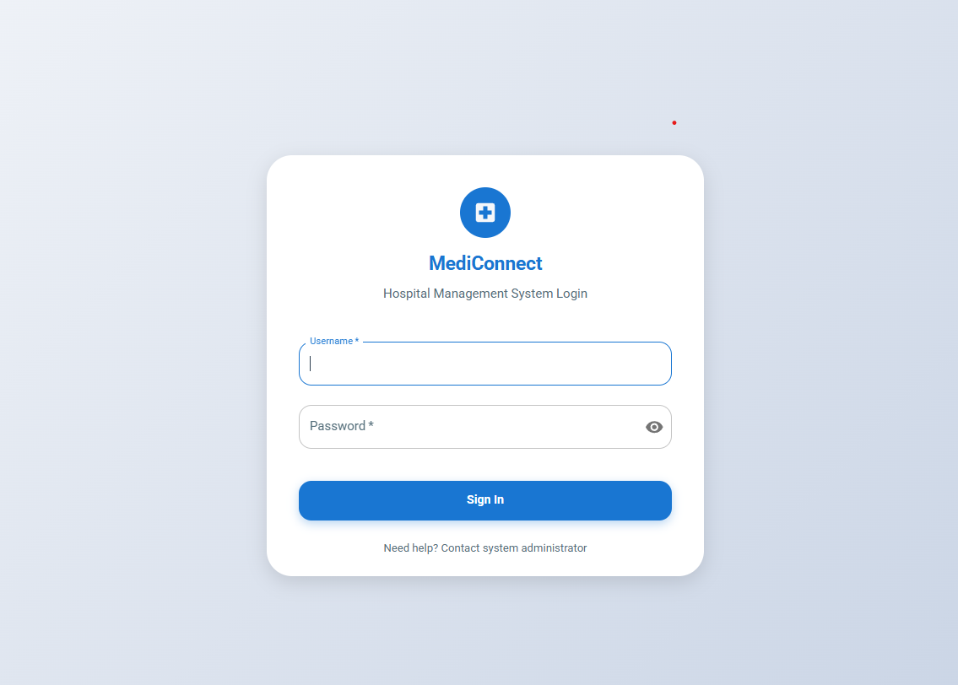

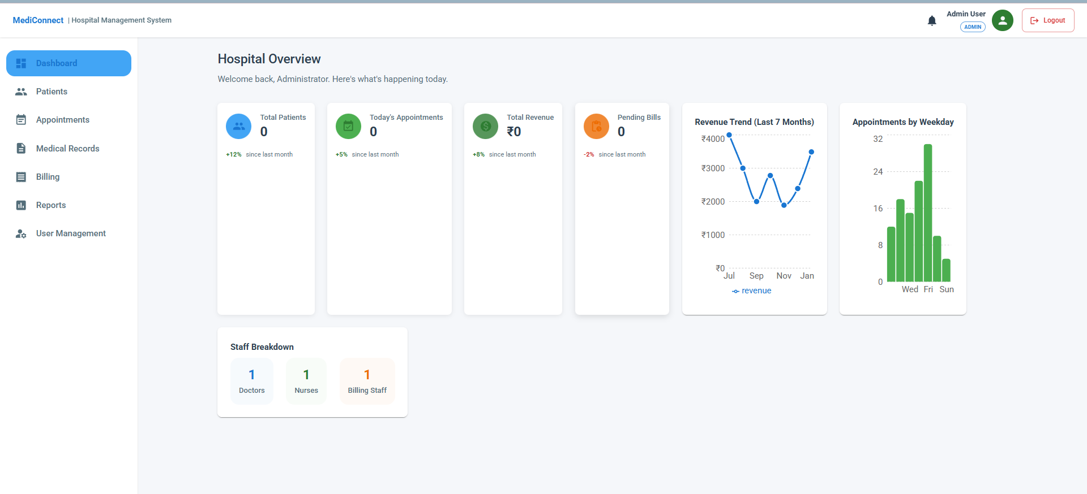

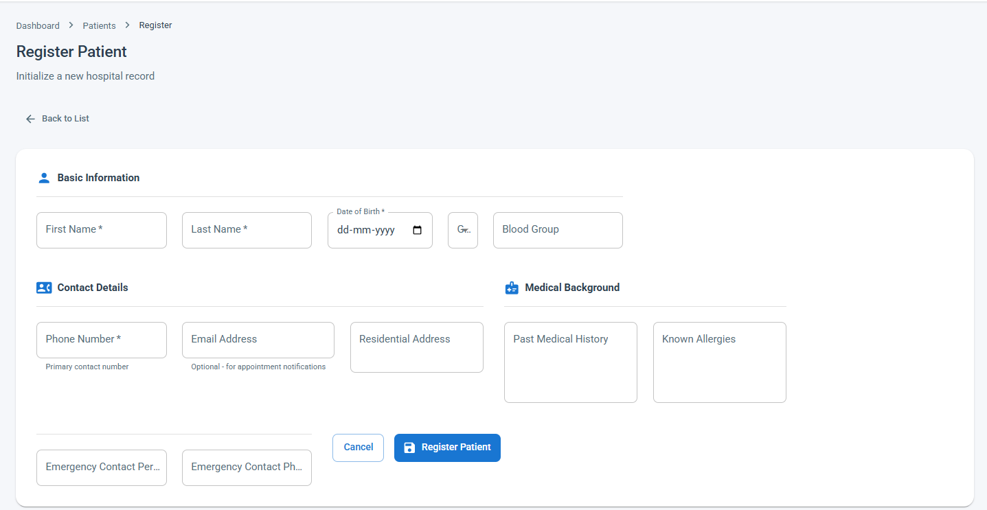

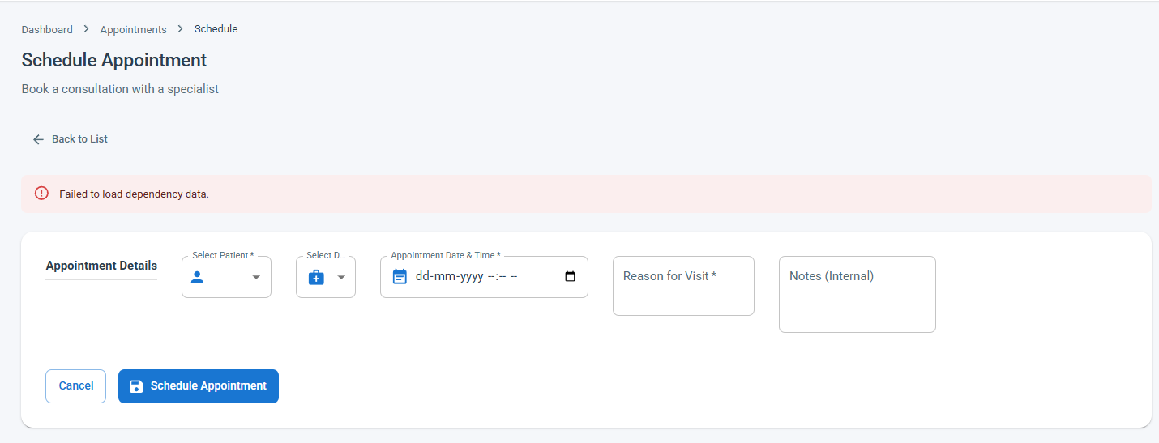

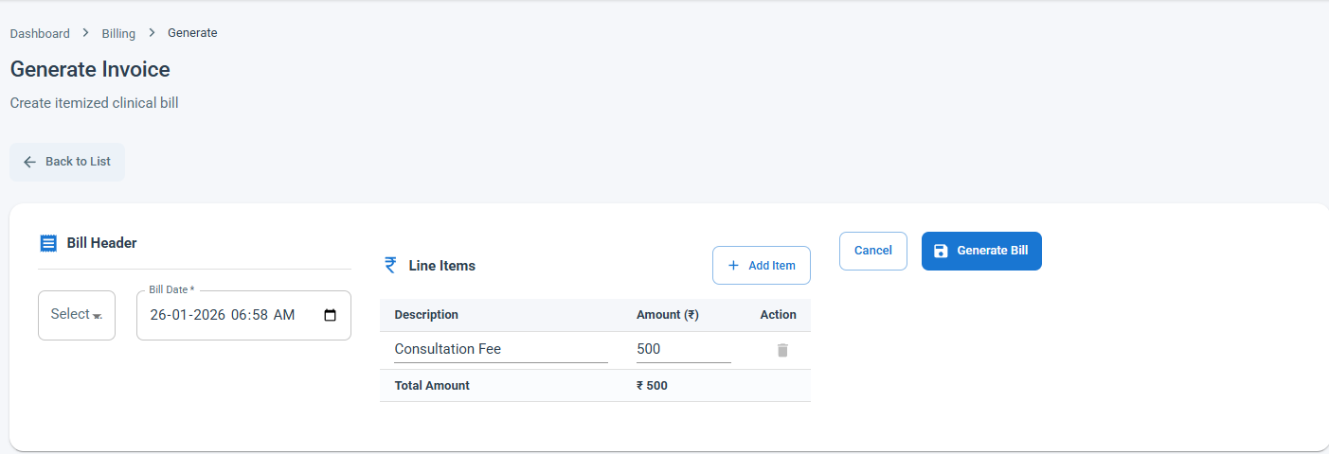

LIMITATIONS

Although the Hospital Management System improves hospital operations and data handling, it has certain limitations that should be considered.

- The system depends heavily on a stable internet connection; interruptions may affect real-time access and updates.
- Initial data entry requires manual effort, which may lead to errors if not properly verified.
- The system provides limited support for advanced medical decision-making and does not replace professional diagnosis.
- Integration with external systems such as insurance platforms and government health databases is restricted.
- Scalability may be limited when handling a very large number of users without additional infrastructure.
- Data security relies on proper configuration and user practices; misuse of credentials can compromise information.
- The system requires user training, and lack of technical familiarity may slow adoption among hospital staff.
These limitations highlight areas where future improvements and enhancements can be made.

FUTURE SCOPE

- The Hospital Management System has significant potential for expansion and improvement to support modern healthcare environments.
- Adoption of cloud-based deployment to improve system availability, scalability, and disaster recovery.
- Integration of electronic health record (EHR) standards to enable data sharing between different healthcare providers.
- Implementation of AI-powered chatbots to assist patients with appointment scheduling and basic inquiries.
- Development of decision-support systems to assist doctors with treatment planning and drug interaction alerts.
- Inclusion of automated resource management for beds, operation theaters, and medical equipment.
- Support for multi-language interfaces to improve accessibility for diverse users.
- Introduction of real-time reporting dashboards for hospital management to monitor performance metrics.
- These future enhancements will make the system more intelligent, scalable, and adaptable to evolving healthcare requirements.

- APPLICATIONS
The Hospital Management System (HMS) is widely used in real healthcare environments to streamline operations, improve patient care, and support administrative decision-making. Its applications extend across clinical, operational, and managerial domains, making it an essential component of modern hospitals and healthcare centers.

1. Patient Record Management in Hospitals
In real hospitals, maintaining physical patient files often leads to misplaced records and delayed treatments. The HMS replaces paper files with digital patient records. For example, in a multi-specialty hospital, a patient visiting different departments such as cardiology and orthopedics can have all medical history accessed instantly by doctors, enabling faster and more accurate diagnosis.

2. Appointment Scheduling in Outpatient Departments
Large hospitals face challenges in managing patient queues and doctor availability. The HMS appointment module allows patients to book appointments online and receive confirmation. For instance, in urban hospitals, patients can schedule consultations in advance, reducing overcrowding and waiting time at outpatient departments.

3. Clinical Workflow Support for Doctors and Nurses
Doctors and nursing staff use HMS to record consultations, update treatment plans, and monitor patient progress. In real-world usage, ward nurses update vital signs in the system, allowing doctors to review patient status remotely and make timely medical decisions.

4. Billing and Financial Operations
Hospitals handle complex billing involving consultations, diagnostics, pharmacy, and inpatient services. HMS automates billing by calculating charges based on services used. For example, during patient discharge, the system generates a consolidated bill, reducing disputes and improving payment accuracy.

5. Laboratory and Diagnostic Services
In diagnostic centers, test requests and result delivery must be fast and error-free. HMS allows doctors to order lab tests digitally and receive results directly in patient records. This reduces report delays and eliminates the risk of manual entry errors.

6. Pharmacy and Inventory Control
Real hospitals manage thousands of medicines daily. HMS tracks stock levels, expiry dates, and prescription dispensing. For example, hospital pharmacies use the system to get alerts when critical medicines are low, ensuring uninterrupted patient treatment.

7. Inpatient and Bed Management
Managing bed availability is critical in emergency and inpatient care. HMS provides real-time updates on bed occupancy. During high patient inflow situations, such as seasonal illness outbreaks, hospitals use HMS to allocate beds efficiently and avoid overcrowding.

8. Emergency Department Operations
In emergency units, time is crucial. HMS enables quick patient registration, immediate access to medical history, and fast coordination between departments. This helps emergency doctors provide rapid and informed treatment.

9. Administrative and Management Reporting
Hospital administrators use HMS-generated reports to analyze patient trends, revenue, and resource utilization. For example, management can identify peak admission times and adjust staffing accordingly, improving operational efficiency.

10. Data Security and Regulatory Compliance
Healthcare data is highly sensitive. HMS implements role-based access control and audit logs. In real-world scenarios, only authorized doctors can access patient records, ensuring privacy and compliance with healthcare regulations.

11. Multi-Department and Multi-Branch Coordination
Large healthcare groups operating multiple branches use HMS to centralize data across locations. For example, a patient visiting different branches of the same hospital chain can receive consistent care as their records are accessible system-wide.

Summary
In real healthcare environments, the Hospital Management System is applied as a centralized digital platform that enhances patient care, improves operational efficiency, reduces manual workload, and supports informed decision-making. Its wide range of applications makes it indispensable for hospitals, clinics, diagnostic centers, and healthcare networks.

14. SYSTEM TESTING

The purpose of testing is to discover errors. Testing is the process of trying to discover every conceivable fault or weakness in a work product. It provides a way to check the functionality of components, sub assemblies, assemblies and/or a finished product It is the process of exercising software with the intent of ensuring that the Software system meets its requirements and user expectations and does not fail in an unacceptable manner. There are various types of test. Each test type addresses a specific testing requirement.

13.1 TYPES OF TESTS
- Unit testing
Unit testing involves the design of test cases that validate that the internal program logic is functioning properly, and that program inputs produce valid outputs. All decision branches and internal code flow should be validated. It is the testing of individual software units of the application .it is done after the completion of an individual unit before integration. This is a structural testing, that relies on knowledge of its construction and is invasive. Unit tests perform basic tests at component level and test a specific business process, application, and/or system configuration. Unit tests ensure that each unique path of a business process performs accurately to the documented specifications and contains clearly defined inputs and expected results.
- Integration testing
Integration tests are designed to test integrated software components to determine if they actually run as one program. Testing is event driven and is more concerned with the basic outcome of screens or fields. Integration tests demonstrate that although the components were individually satisfaction, as shown by successfully unit testing, the combination of components is correct and consistent. Integration testing is specifically aimed at exposing the problems that arise from the combination of components.
- Functional test
Functional tests provide systematic demonstrations that functions tested are available as specified by the business and technical requirements, system documentation, and user manuals.
Functional testing is centered on the following items:
Valid Input : identified classes of valid input must be accepted.
Invalid Input : identified classes of invalid input must be rejected.
Functions : identified functions must be exercised.
Output : identified classes of application outputs must be exercised.
Systems/Procedures : interfacing systems or procedures must be invoked.
Organization and preparation of functional tests is focused on requirements, key functions, or special test cases. In addition, systematic coverage pertaining to identify Business process flows; data fields, predefined processes, and successive processes must be considered for testing. Before functional testing is complete, additional tests are identified and the effective value of current tests is determined.
4, System Test
System testing ensures that the entire integrated software system meets requirements. It tests a configuration to ensure known and predictable results. An example of system testing is the configuration oriented system integration test. System testing is based on process descriptions and flows, emphasizing pre-driven process links and integration points.
- White Box Testing
White Box Testing is a testing in which in which the software tester has knowledge of the inner workings, structure and language of the software, or at least its purpose. It is purpose. It is used to test areas that cannot be reached from a black box level.
- Black Box Testing
Black Box Testing is testing the software without any knowledge of the inner workings, structure or language of the module being tested. Black box tests, as most other kinds of tests, must be written from a definitive source document, such as specification or requirements document, such as specification or requirements document. It is a testing in which the software under test is treated, as a black box .you cannot “see” into it. The test provides inputs and responds to outputs without considering how the software works.
- Unit Testing
Unit testing is usually conducted as part of a combined code and unit test phase of the software lifecycle, although it is not uncommon for coding and unit testing to be conducted as two distinct phases.
Test strategy and approach Field testing will be performed manually and functional tests will be written in detail.
Test objectives
- All field entries must work properly.
- Pages must be activated from the identified link.
- The entry screen, messages and responses must not be delayed.
Features to be tested
- Verify that the entries are of the correct format
- No duplicate entries should be allowed
- All links should take the user to the correct page.

- Integration Testing
Software integration testing is the incremental integration testing of two or more integrated software components on a single platform to produce failures caused by interface defects.
The task of the integration test is to check that components or software applications, e.g. components in a software system or – one step up – software applications at the company level – interact without error.
Test Results: All the test cases mentioned above passed successfully. No defects encountered.
- Acceptance Testing
User Acceptance Testing is a critical phase of any project and requires significant participation by the end user. It also ensures that the system meets the functional requirements.
Test Results: All the test cases mentioned above passed successfully. No defects encountere

15 CONCLUSION
The Hospital Management System developed in this project provides a comprehensive and efficient solution for managing the complex operations of modern healthcare institutions. By integrating patient care processes with administrative and operational functions, the system successfully addresses the limitations of traditional manual record-keeping and fragmented hospital workflows.
The system enables accurate and centralized management of patient information, ensuring that medical records are securely stored and easily accessible whenever required. This improves continuity of care, supports timely clinical decisions, and reduces the risk of errors caused by missing or incomplete data. Digital record management also minimizes paperwork, saving time for healthcare professionals and allowing them to focus more on patient care.
Another major achievement of the system is the improvement in operational efficiency. Modules such as appointment scheduling, doctor management, billing, pharmacy, and laboratory services work together seamlessly. Automated scheduling reduces patient waiting times, while streamlined billing processes ensure transparency and faster financial transactions. These improvements contribute to better patient satisfaction and smoother hospital operations.
The Hospital Management System also enhances coordination among different departments. Real-time data sharing between doctors, nurses, laboratory staff, and administrative personnel ensures that all stakeholders have access to consistent and updated information. This level of integration supports effective teamwork and improves overall service quality within the hospital.
Security and data integrity are key strengths of the implemented system. Role-based access control restricts unauthorized access to sensitive patient information, ensuring confidentiality and compliance with healthcare data protection standards. The structured database design further ensures data accuracy, reliability, and long-term usability.
From a technological perspective, the system demonstrates the effective use of modern software development practices and tools. The combination of a user-friendly frontend, a robust backend, and a centralized database creates a scalable and maintainable architecture. The system is flexible enough to support future enhancements without major structural changes.
In conclusion, the Hospital Management System proves to be a reliable, practical, and valuable solution for healthcare organizations.

REFERENCES

• Pressman, R. S., Software Engineering: A Practitioner’s Approach, McGraw-Hill Education, 8th Edition.
• Sommerville, I., Software Engineering, Pearson Education, 10th Edition.
• Object Management Group (OMG), Unified Modeling Language (UML) Specification, OMG Publications.
• Oracle Corporation, Java Platform, Standard Edition Documentation, Oracle Docs.
• Pivotal Software, Spring Boot Reference Guide, Spring Official Documentation.
• Facebook Inc., React.js Official Documentation, https://react.dev
• Silberschatz, A., Korth, H. F., Sudarshan, S., Database System Concepts, McGraw-Hill, 6th Edition.
• MySQL AB, MySQL Reference Manual, Oracle Corporation.
• Fielding, R. T., Architectural Styles and the Design of Network-based Software Architectures, Doctoral Dissertation, University of California.
• ISO/IEC, Information Technology – Software Life Cycle Processes, ISO/IEC Standards.
• World Health Organization (WHO), Digital Health Systems and Hospital Information Systems, WHO Publications.
• IEEE Computer Society, IEEE Standards for Software Engineering Documentation, IEEE Press.
• Gamma, E., Helm, R., Johnson, R., Vlissides, J., Design Patterns: Elements of Reusable Object-Oriented Software, Addison-Wesley.
• Postman Inc., API Development and Testing Documentation, Postman Learning Center.
• National Institute of Standards and Technology (NIST), Guide to Data Security and Privacy in Healthcare Systems, NIST Publications.

IEEE FORMAT REFERENCES

- R. S. Pressman, Software Engineering: A Practitioner’s Approach, 8th ed. New York, USA: McGraw-Hill, 2015.
- I. Sommerville, Software Engineering, 10th ed. Boston, USA: Pearson, 2016.
- Object Management Group, Unified Modeling Language (UML) Specification, OMG, 2017.
- Oracle Corporation, Java Platform, Standard Edition Documentation. [Online]. Available: https://docs.oracle.com
- Pivotal Software, Spring Boot Reference Documentation. [Online]. Available: https://spring.io
- Meta Platforms Inc., React Documentation. [Online]. Available: https://react.dev
- A. Silberschatz, H. F. Korth, and S. Sudarshan, Database System Concepts, 6th ed. New York, USA: McGraw-Hill, 2011.
- Oracle Corporation, MySQL Reference Manual. [Online]. Available: https://dev.mysql.com
- R. T. Fielding, “Architectural styles and the design of network-based software architectures,” Ph.D. dissertation, Univ. of California, Irvine, 2000.
- IEEE Computer Society, IEEE Recommended Practice for Software Requirements Specifications, IEEE Std. 830.
- World Health Organization, Digital Health and Hospital Information Systems, WHO Press, 2020.
- National Institute of Standards and Technology, Security and Privacy Controls for Information Systems, NIST SP 800-53.
- E. Gamma et al., Design Patterns: Elements of Reusable Object-Oriented Software. Boston: Addison-Wesley, 1994.
- Postman Inc., API Development and Testing Guide. [Online]. Available: https://learning.postman.com
- ISO/IEC, Software Life Cycle Processes, ISO/IEC 12207

