End-to-End CI/CD Pipeline Documentation
(Java → Jenkins → SonarQube → Nexus → Docker → Tomcat Deployment)

1. Project Overview
This document explains a fully automated CI/CD workflow for building and deploying a Java web application.
The application is packaged as a WAR file using Maven and deployed into an Apache Tomcat server.
The pipeline includes code checkout, build, code quality analysis, storing artifacts in Nexus, Docker image creation, and deployment into Tomcat running on an EC2 instance.

2. Architecture Overview
Your deployment flow works like this:
Developer → GitHub → Jenkins Pipeline → Maven Build → SonarQube Analysis → Upload to Nexus → Build Docker Image →
Push to DockerHub → Deploy WAR into Tomcat → Application Accessible via Browser.

Insert Screenshot: Architecture Diagram

3. Tools & Technologies Used
- Java 11
- Maven
- Git & GitHub
- Jenkins (Pipeline)

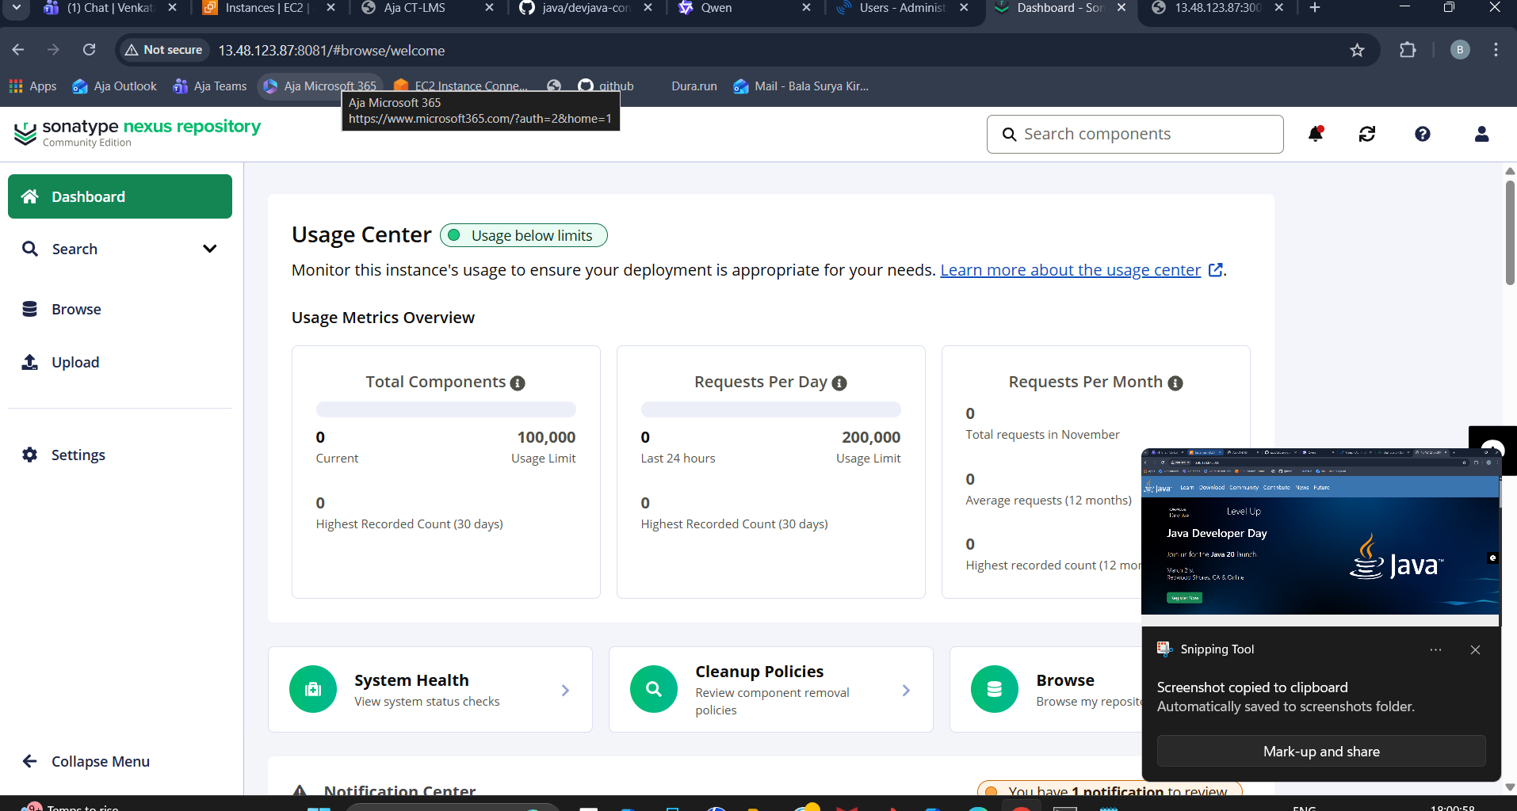

- SonarQube

- Nexus Repository Manager 3

- Docker & DockerHub
- Apache Tomcat
- EC2 Linux Instance

4. Complete Jenkins CI/CD Pipeline Flow
Your Jenkins pipeline includes the following stages:

1. **Checkout Code** – Pulls application source code from GitHub.
2. **Maven Build** – Executes `mvn clean package` to generate a WAR file.
3. **SonarQube Code Analysis** – Scans the source code for bugs, vulnerabilities, and code smells.
4. **Upload Artifact to Nexus** – Stores the WAR file securely as a versioned artifact.
5. **Build Docker Image** – Uses Dockerfile to create an image with Tomcat and your WAR.
6. **Push Docker Image to DockerHub** – Stores image in your registry.
7. **Deploy to Tomcat** – WAR file is deployed inside Tomcat running on EC2.

Insert Screenshot: Jenkins Pipeline Output

5. Dockerfile Used for Tomcat Deployment
Your Dockerfile deploys the generated WAR into Tomcat:

FROM tomcat:9-jdk11
COPY target/*.war /usr/local/tomcat/webapps/myapp.war
EXPOSE 8080
CMD ["catalina.sh", "run"]

Insert Screenshot: Docker Build and Container Logs

6. Jenkinsfile (Pipeline Script)
Your pipeline script includes environment variables, credentials, Maven build, SonarQube, Docker build/push, and deployment.
Insert Screenshot: Jenkinsfile View

7. Jenkins Credentials Configuration
You configured the following credentials inside Jenkins → Manage Credentials:
- **sonar-token** (Secret Text)
- **Sonar username/password**
- **Nexus credentials**
- **DockerHub credentials**

Insert Screenshot: Jenkins Credentials Page

8. Tomcat Deployment Details
You deployed the WAR file inside Tomcat using the Manager App and automated deployment.
Common URL pattern:
http://<EC2-IP>:8080/myapp

If Tomcat Manager gives 403 Forbidden, update the following configuration in `tomcat-users.xml`:

<role rolename="manager-gui"/>
<user username="admin" password="admin123" roles="manager-gui"/>

Insert Screenshot: Tomcat Deployment & Manager Page

9. Testing the Application
You tested the web application using endpoints, for example:
http://<EC2-IP>:8080/myapp/add?num1=10&num2=20

Insert Screenshot: Browser Output

10. Troubleshooting Notes
- **403 Tomcat Access Denied** → Add correct roles in `tomcat-users.xml`.
- **Sonar Token Errors** → Regenerate and update in Jenkins.
- **Docker Push Denied** → Login again using `docker login` inside Jenkins agent.
- **WAR not deploying?** → Check Tomcat logs inside container using `docker logs`.

11. Conclusion
You have successfully implemented a complete CI/CD workflow integrating multiple DevOps tools.
Your setup now supports automated building, testing, quality scanning, artifact storage, containerization, and deployment into Tomcat.

