🐳 Docker Advanced Concepts: Naming, Port Forwarding & Volumes

1. Docker Container Naming
When you run a container, you can specify a custom name or let Docker assign a random one.
- Run a container with a name:
docker run -d --name mynginx nginx
- List all running containers:
docker ps
- Inspect a container by name:
docker inspect mynginx
- Remove a container by name:
docker rm mynginx
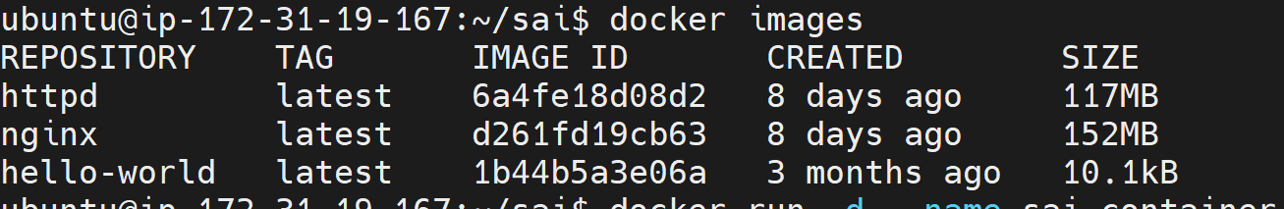
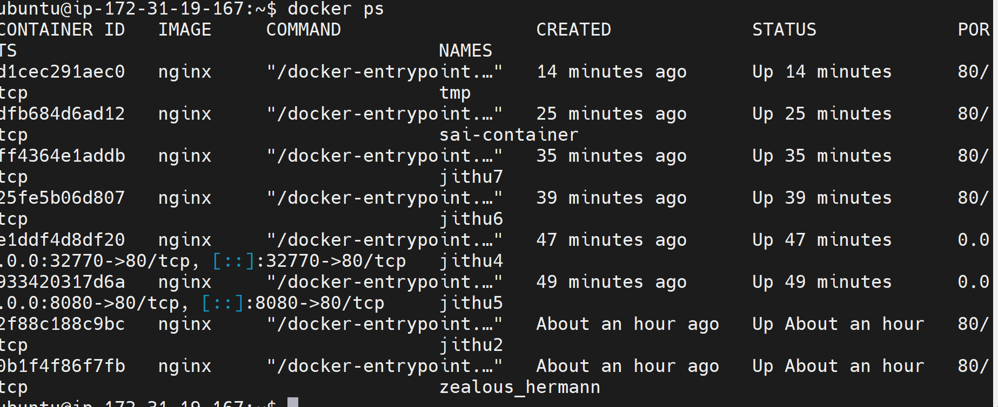
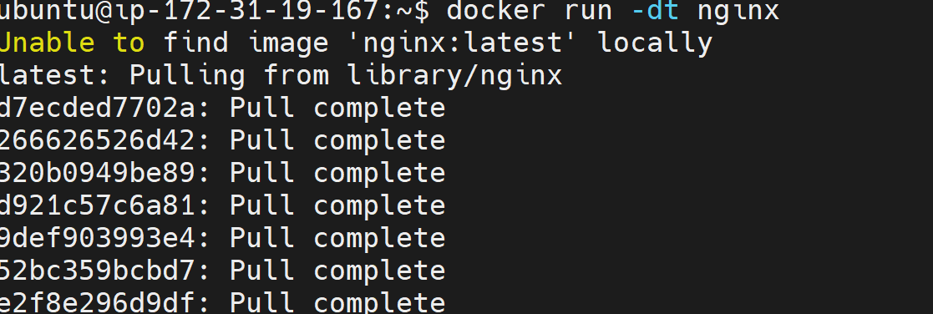

2. Docker Port Forwarding and Assignment
Docker allows you to map container ports to host machine ports for access from outside the container.
- Automatically assign random ports for exposed ports:
docker run -dt -P nginx
- Assign specific host port to container port:
docker run -dt -p 8080:80 nginx
- Map multiple ports:
docker run -dt -p 8080:80 -p 443:443 nginx
- Check port mappings:
docker ps
- Inspect detailed port information:
docker inspect <container_name> | grep Port
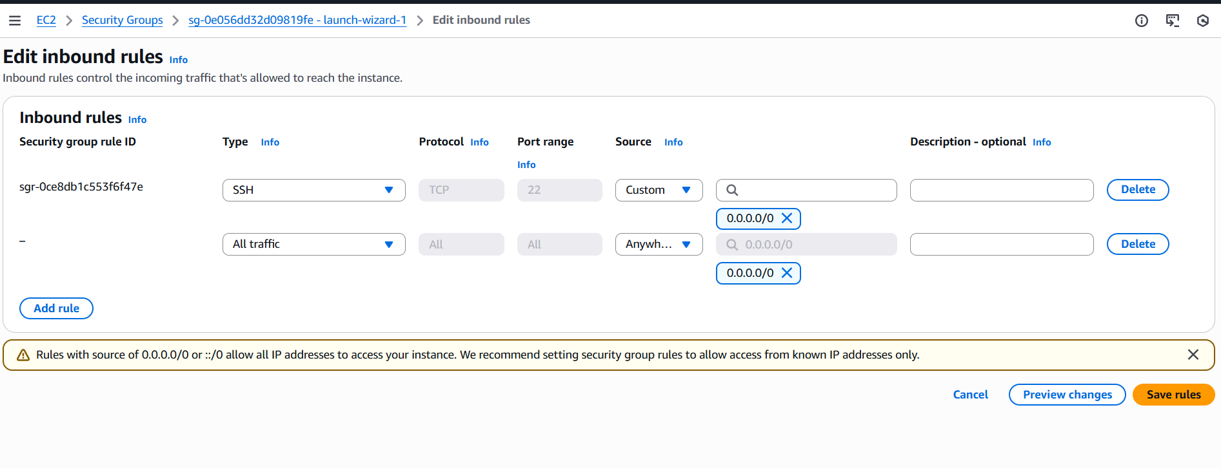
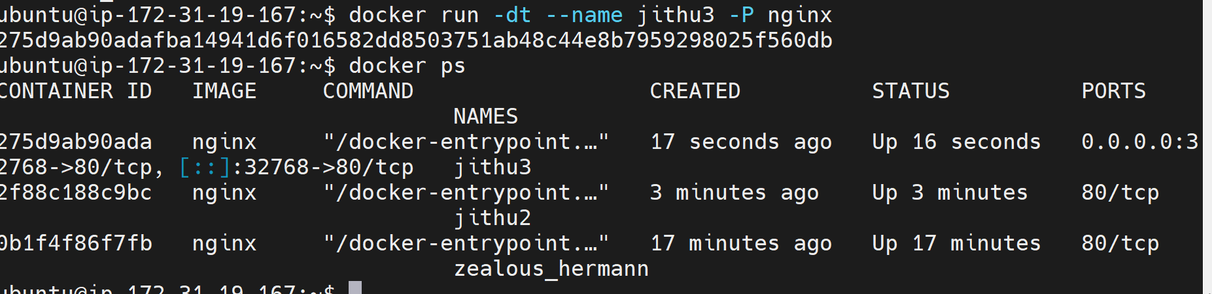
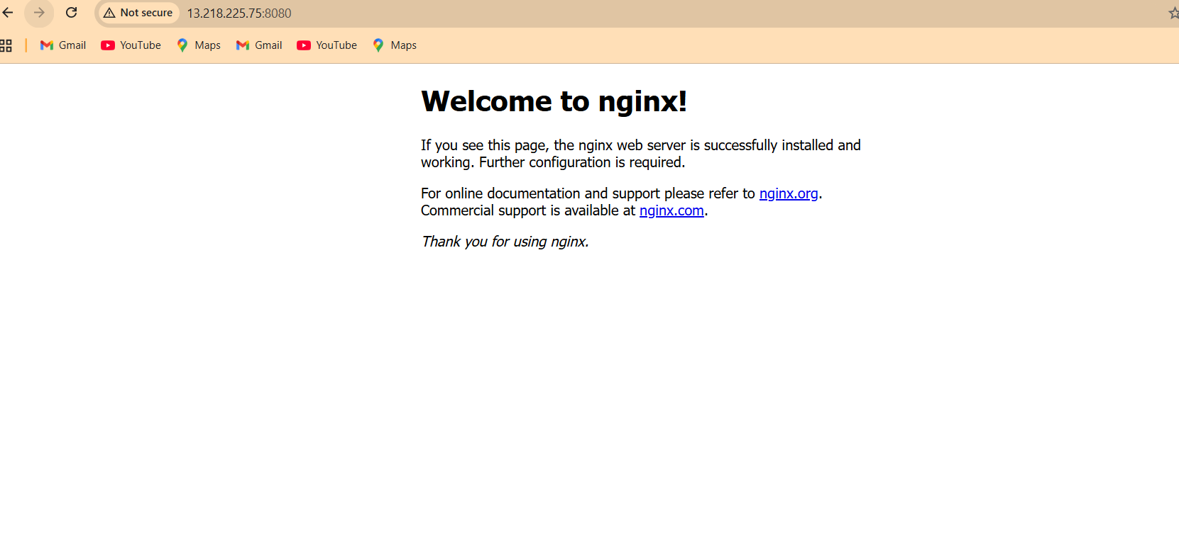

3. Docker Volumes Overview
Volumes are used to persist data beyond the container lifecycle. There are several types of volumes:

3.1 Named Volumes
- Create and attach a named volume:
docker run -d --name web1 -v mydata:/app/data nginx
- List volumes:
docker volume ls
- Inspect a specific volume:
docker volume inspect mydata
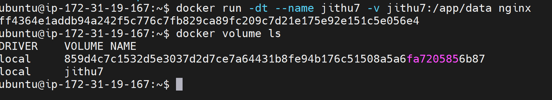
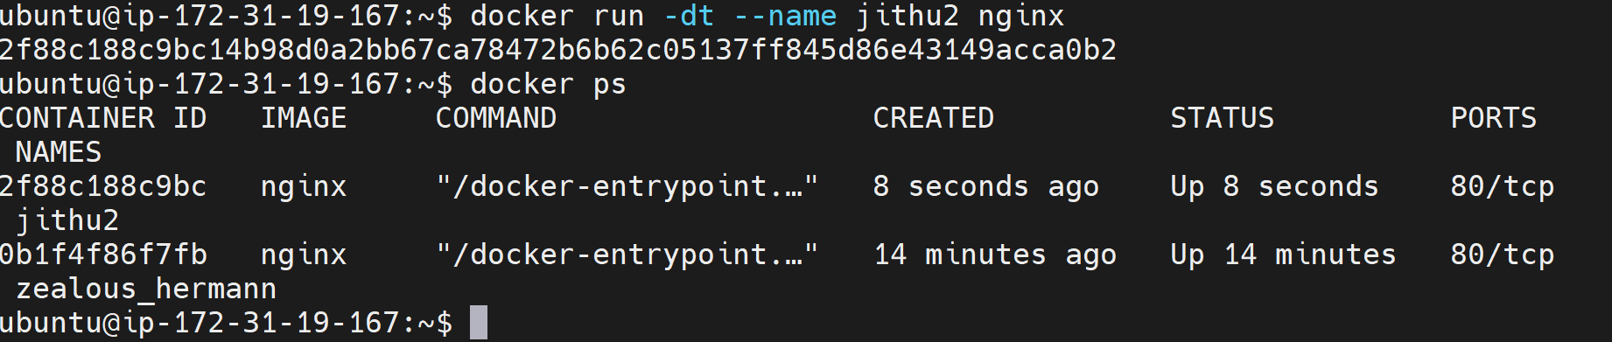

3.2 Anonymous (Unnamed) Volumes
- Run a container with an unnamed volume (Docker auto-generates name):
docker run -d -v /app/data nginx
- Check generated volume name:
docker volume ls
These are automatically deleted when the container is removed (unless you use --volumes-from or manually retain them).

3.3 Host / Bind Mount
Bind mounts allow you to use a specific directory from your host machine inside a container.
- Run a container with bind mount:
docker run -d --name sai-container -v /home/ubuntu/sai/:/app/data nginx
- Any change inside /home/ubuntu/sai on host reflects inside /app/data in the container.
- Verify mount inside container:
docker exec -it sai-container /bin/bash
cd /app/data
ls
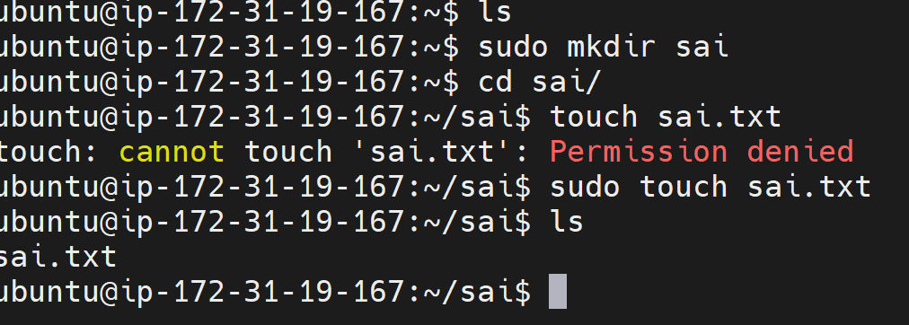
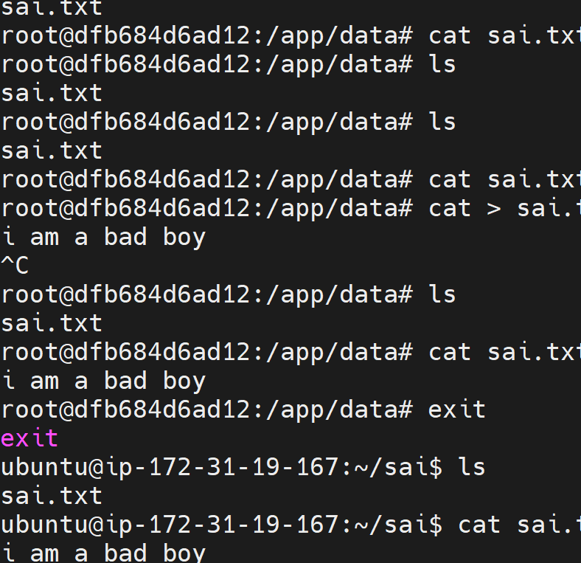
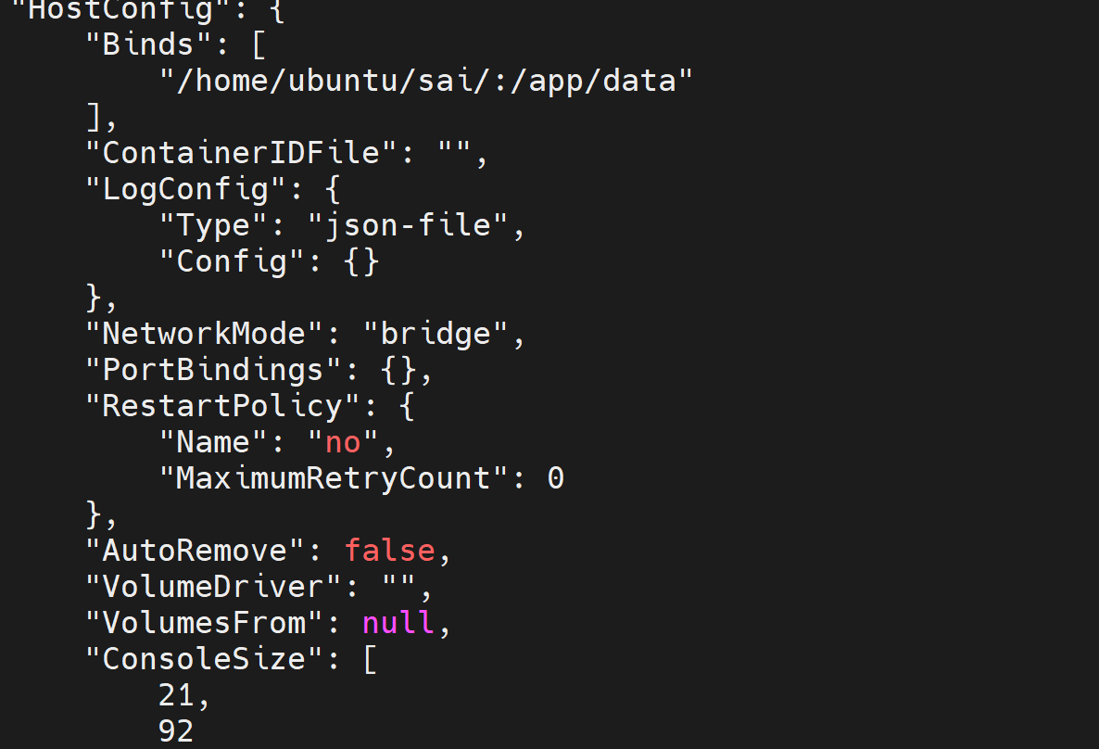

3.4 tmpfs Mounts
tmpfs mounts are in-memory storage locations that disappear when the container stops.
- Run a container with tmpfs mount:
docker run -dt --name tmp --mount type=tmpfs,target=/app/data,tmpfs-size=3m nginx
- Verify memory mount inside container:
docker exec tmp df -h /app/data
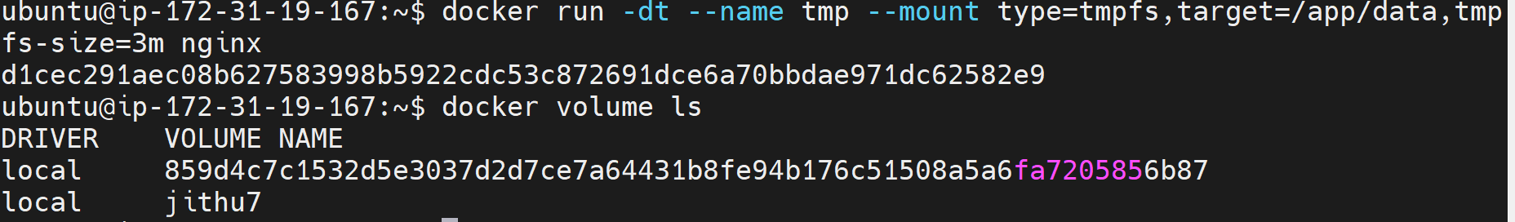
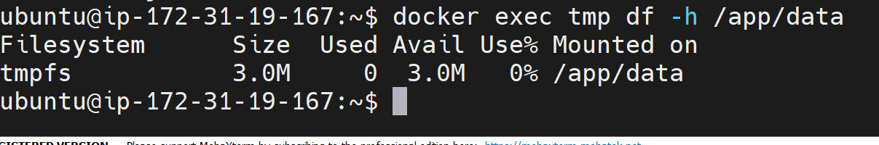

4. Summary Table of Commands
Concept | Example Command
Container Naming | docker run -d --name mynginx nginx
Auto Port Forwarding | docker run -dt -P nginx
Custom Port Mapping | docker run -dt -p 8080:80 nginx
Named Volume | docker run -v mydata:/app/data nginx
Anonymous Volume | docker run -v /app/data nginx
Bind Mount | docker run -v /home/user/data:/app nginx
tmpfs Volume | docker run --mount type=tmpfs,target=/app/data,tmpfs-size=64m nginx

