BITWISE RIGHT SHIFT OPERATOR IN JAVA

* **Right shift by 1 Divides the number by 2 in java**

Ex: let’s take a number 25 the output would be 12

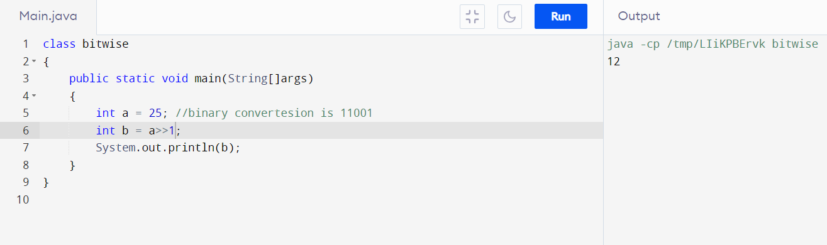

* **Right shift by 2 removes two bits from right side of a binary number**

Ex: 25 🡪binary conversion is 11001

🡪11001>>2 would be 110 therefore the value of binary number 110 is “6 ”.

**When we type x>>n, you tell the computer to move the bits x to the right n places.**

**When the value of a number is shifted to the right “n” places the right most “n” bits are lost.**

Syntax :

**Left_operand>>n**

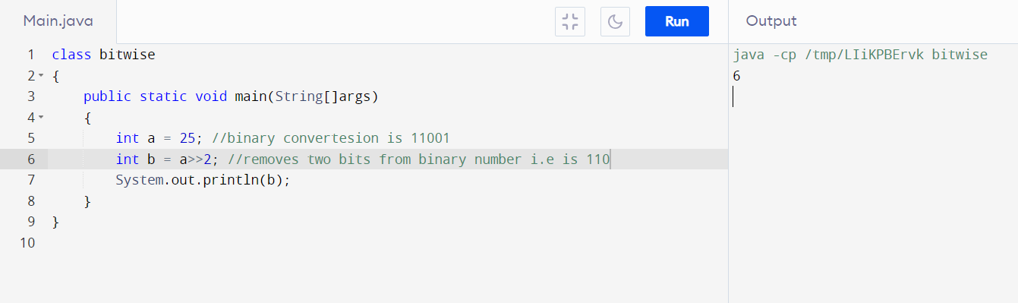

BITWISE LEFT SHIFT OPERATOR IN JAVA

* **Left shift by 1 Multiplies the number by 2 in java**

Ex: 25 number multiplied by two in left shift by 1 is 50

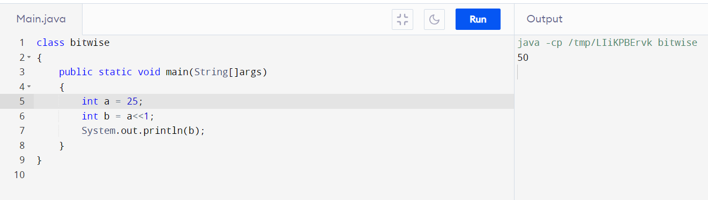

* **Left shift by 2 adds two zeroes two a binary number**

Ex: 25 binary conversion is 11001 after left shift by 2 it will become 1100100

The value is 100

