CS23532- COMPUTER NETWORKS



DEPARTMENT OF COMPUTER SCIENCE AND ENGINEERING

CS23532- COMPUTER NETWORKS LAB MANUAL

SECOND YEAR
THIRD SEMESTER
2026- 2027
ODD SEMESTER

NAME: Balumahendhiran B
REG NO: 251901507

Ex.No.1 | Study of various Network commands used in Linux and Windows: Hands-on practice of various network commands.
Date:
AIM: - To Study of various Network commands used in Linux and Windows

S.No | Command | Synopsis | Description | Sample Input | Sample Output
1 | arp -a | arp -a | Displays the ARP cache, showing the IP addresses and corresponding MAC  addresses of devices on the local network. | arp -a | Interface: 192.168.1.10 ---  0x7 Internet Address Physical Address Type 192.168.1.1 00-1a-  2b-3c-4d-5e dynamic
2 | hostname | hostname | Displays the hostname (computer name) of the local system. | hostname | DESKTOP-PC01
3 | ipconfig  /all | ipconfig /all | Displays complete TCP/IP  configuration, including IP address, subnet mask, gateway, DNS, DHCP,  and MAC address. | ipconfig /all | IPv4 Address : 192.168.1.10  Default Gateway : 192.168.1.1 DNS  Server : 8.8.8.8 DHCP Enabled : Yes
4 | nbtstat - a | nbtstat -a  <hostname> | Displays NetBIOS name table of a remote computer for troubleshooting NetBIOS over TCP/IP. | nbtstat -a DESKTOP-PC01 | NetBIOS Remote Machine Name Table Name Type Status DESKTOP-PC01 <00>  UNIQUE Registered
5 | netstat | netstat | Displays active TCP/IP  connections, listening ports, | netstat | Proto Local Address Foreign Address State TCP 192.168.1.10:49762

S.No | Command | Synopsis | Description | Sample Input | Sample Output
 |  |  | routing tables, and interface statistics. |  | 142.250.190.78:443  ESTABLISHED
6 | netstat - r | netstat -r | Displays the IP routing table of the local computer. | netstat -r | IPv4 Route Table Network Destination Netmask Gateway Interface
7 | nslookup | nslookup  <domain> | Queries the DNS server to obtain the IP address or DNS records of a domain. | nslookup www.google.com | Server: dns.google Address: 8.8.8.8 Name: www.google.com Address: 142.250.190.68
8 | pathping | pathping  <hostname/IP> | Combines the features of ping and tracert to trace the route and measure packet loss at each hop. | pathping www.google.com | Tracing route to www.google.com Computing statistics... Hop  1 192.168.1.1 Hop  2 10.0.0.1 Packet  Loss: 0%
9 | ping | ping  <hostname/IP> | Tests connectivity between the local computer and another host using ICMP Echo Request and Reply messages. | ping www.facebook.com | Pinging www.facebook.com [157.240.22.35]  with 32 bytes of data: Reply from 157.240.22.35:  bytes=32 time=25ms TTL=54
10 | route | route print | Displays or modifies the IP routing table. It is commonly used to view or configure static routes. | route print | IPv4 Route Table Active Routes: Network Destination Netmask Gateway Interface

Some important Linux networking commands

S.No | Command | Synopsis | Description | Sample Input | Sample Output
1 | ip | ip <OPTIONS>  <OBJECT> <COMMAND> | Displays and manages IP addresses, routing tables, and network interfaces. | ip address show | 2: eth0: <UP,BROADCAST,RUNNING>  inet 192.168.1.100/24 brd 192.168.1.255 scope global eth0
2 | ip address add | ip address add  <IP>/<Prefix> dev  <Interface> | Assigns an IP address to a network interface. | ip address add 192.168.1.254/24  dev eth0 | Assigned 192.168.1.254/24 to eth0 successfully.
3 | ip address del | ip address del  <IP>/<Prefix> dev  <Interface> | Removes an IP address from a network interface. | ip address del 192.168.1.254/24  dev eth0 | Deleted 192.168.1.254/24 from eth0.
4 | ip link set up | ip link set  <Interface> up | Brings the network interface online. | ip link set eth0 up | Interface eth0 is UP.
5 | ip link set down | ip link set  <Interface> down | Brings the network interface offline. | ip link set eth0 down | Interface eth0 is DOWN.
6 | ip link set promisc on | ip link set  <Interface> promisc on | Enables promiscuous mode on the interface. | ip link set eth0 promisc on | Promiscuous mode enabled on eth0.
7 | ip route add default | ip route add default via  <Gateway> dev  <Interface> | Adds the default gateway for all outgoing traffic. | ip route add default via 192.168.1.254  dev eth0 | Default route added successfully.
8 | ip route add | ip route add  <Network> via  <Gateway> | Adds a static route through a gateway. | ip route add 192.168.1.0/24  via 192.168.1.254 | Route added successfully.
9 | ip route add (Direct Route) | ip route add  <Network> dev  <Interface> | Adds a direct route through a network interface. | ip route add 192.168.1.0/24  dev eth0 | Route added via eth0.
10 | ip route delete | ip route delete  <Network> via  <Gateway> | Deletes a static route. | ip route delete 192.168.1.0/24 | Route deleted successfully.

S.No | Command | Synopsis | Description | Sample Input | Sample Output
 |  |  |  | via 192.168.1.254
11 | ip route get | ip route get  <Destination IP> | Displays the route used to reach a destination. | ip route get 10.10.1.4 | 10.10.1.4 via 192.168.1.254 dev  eth0 src 192.168.1.100
12 | ifconfig | ifconfig | Displays and configures network interface parameters (deprecated in modern Linux). | ifconfig | eth0: flags=4163<UP,BROADCAST,RUNNING>  inet 192.168.1.100 netmask  255.255.255.0
13 | mtr | mtr <hostname/IP> | Combines Ping and Traceroute to analyze network paths. | mtr google.com | HOST: localhost Loss% Snt Last Avg Best Wrst StDev
14 | mtr -g | mtr -g <hostname> | Displays numeric IP addresses instead of hostnames. | mtr -g google.com | 192.168.1.1 → 142.250.190.78
15 | mtr -b | mtr -b <hostname> | Displays both hostnames and IP addresses. | mtr -b google.com | router.local (192.168.1.1)  google.com (142.250.190.78)
16 | mtr -c | mtr -c <count>  <hostname> | Sends a specified number of probes. | mtr -c 10 google.com | 10 probes completed successfully.
17 | tcpdump - D | tcpdump -D | Lists all available network interfaces. | tcpdump -D | 1.eth0 2.lo 3.wlan0
18 | tcpdump | tcpdump -i  <Interface> | Captures packets on a network interface. | tcpdump -i eth0 | Listening on eth0...
19 | tcpdump - c | tcpdump -i  <Interface> -c  <count> | Captures a specified | tcpdump -i eth0  -c 10 | 10 packets captured.

S.No | Command | Synopsis | Description | Sample Input | Sample Output
 |  |  | number of packets.
20 | tcpdump host | tcpdump -i  <Interface> host  <IP> | Captures traffic to and from a specific host. | tcpdump -i eth0 host 8.8.8.8 | Captured packets to/from 8.8.8.8.
21 | tcpdump src host | tcpdump -i  <Interface> src host <IP> | Captures packets originating from a specific host. | tcpdump -i eth0 src host 8.8.8.8 | Source packets from 8.8.8.8 displayed.
22 | tcpdump dst host | tcpdump -i  <Interface> dst host <IP> | Captures packets destined for a specific host. | tcpdump -i eth0 dst host 8.8.8.8 | Destination packets to 8.8.8.8 displayed.
23 | tcpdump net | tcpdump -i  <Interface> net  <Network>/<Prefix> | Captures traffic from a specified network. | tcpdump -i eth0 net 10.1.0.0/24 | Packets from network 10.1.0.0/24 displayed.
24 | tcpdump port | tcpdump -i  <Interface> port  <Port> | Captures traffic on a specific port. | tcpdump -i eth0 port 53 | DNS packets captured.
25 | tcpdump host and port | tcpdump -i  <Interface> host  <IP> and port  <Port> | Captures traffic for a specific host and port. | tcpdump -i eth0 host 8.8.8.8 and  port 53 | DNS traffic with host 8.8.8.8 displayed.
26 | tcpdump port not | tcpdump -i  <Interface> port not <Port1> and not <Port2> | Captures all traffic except the specified ports. | tcpdump -i eth0 port not 53 and not 25 | Traffic excluding ports 53 and  25 captured.
27 | ping | ping <hostname/IP> | Tests network connectivity using ICMP Echo Requests and Echo Replies. | ping google.com | 64 bytes from google.com: icmp_seq=1 ttl=117 time=10.5 ms
28 | ping -c | ping -c <count>  <hostname> | Sends a specified number of | ping -c 10 google.com | 10 packets transmitted, 10 received, 0% packet loss.

S.No | Command | Synopsis | Description | Sample Input | Sample Output
 |  |  | ICMP Echo Requests.

Configuring an Ethernet connection by using nmcli:

Step No. | Task | Command | Expected Result
1 | List all Network Manager connection profiles | nmcli connection show | Displays all available network connection profiles with their Name, UUID, Type, and Device.
2 | Create a new Ethernet connection profile  It is specifically an nmcli connection management command.  - nmcli → NetworkManager Command Line Interface  - connection → Manages network connection profiles.  - add → Creates a new connection profile. | nmcli connection add con-name Internal-LAN ifname enp1s0 type ethernet | Creates a new Ethernet connection profile named Internal-LAN.
3 | Rename an existing connection profile (Optional) | nmcli connection modify "Wired connection 1" connection.id Internal-LAN | Renames the existing connection profile to Internal-LAN.
4 | Display the current settings of the connection profile | nmcli connection show "Internal-LAN" | Displays interface name, autoconnect status, IPv4 and IPv6 configuration details.
5 | Configure IPv4 using DHCP | nmcli connection modify "Internal-LAN" ipv4.method auto | Configures the interface to obtain the IPv4 address

Step No. | Task | Command | Expected Result
 |  |  | automatically using DHCP.
6 | Configure a static IPv4 address | nmcli connection modify "Internal-LAN" ipv4.method manual ipv4.addresses 192.0.2.1/24 ipv4.gateway 192.0.2.254 ipv4.dns  192.0.2.200 ipv4.dns-search example.com | Assigns a static IPv4 address, gateway, DNS server, and DNS search domain.
7 | Configure IPv6 using SLAAC | nmcli connection modify "Internal-LAN" ipv6.method auto | Enables automatic IPv6 configuration using Stateless Address Autoconfiguration (SLAAC).
8 | Configure a static IPv6 address | nmcli connection modify "Internal-LAN" ipv6.method manual ipv6.addresses 2001:db8:1::fffe/64 ipv6.gateway 2001:db8:1::ffee ipv6.dns 2001:db8:1::ffbb ipv6.dns-search example.com | Assigns a static IPv6 address, gateway, DNS server, and search domain.
9 | Activate the connection profile | nmcli connection up Internal-LAN | Activates the Internal-LAN network connection profile.
10 | Verify the IP address configuration | ip address show enp1s0 | Displays the assigned IPv4 and IPv6 addresses of the enp1s0 network interface.
11 | Verify the IPv4 default gateway | ip route show default | Displays the configured IPv4 default gateway.
12 | Verify the IPv6 default gateway | ip -6 route show default | Displays the configured IPv6 default gateway.
13 | Verify the DNS configuration | cat /etc/resolv.conf | Displays the configured DNS servers and DNS search domain.
14 | Test network connectivity | ping <host-name-or-IP-address> | Sends ICMP Echo Requests to verify connectivity with the specified host.

Sample Verification Outputs
Verification Command | Sample Output
ip address show enp1s0 | inet 192.0.2.1/24  inet6 2001:db8:1::fffe/64
ip route show default | default via 192.0.2.254 dev enp1s0 proto static
ip -6 route show default | default via 2001:db8:1::ffee dev enp1s0 proto static
cat /etc/resolv.conf | search example.com nameserver 192.0.2.200 nameserver 2001:db8:1::ffbb
ping google.com | 64 bytes from google.com: icmp_seq=1 ttl=117 time=11.2 ms

Output:
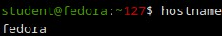
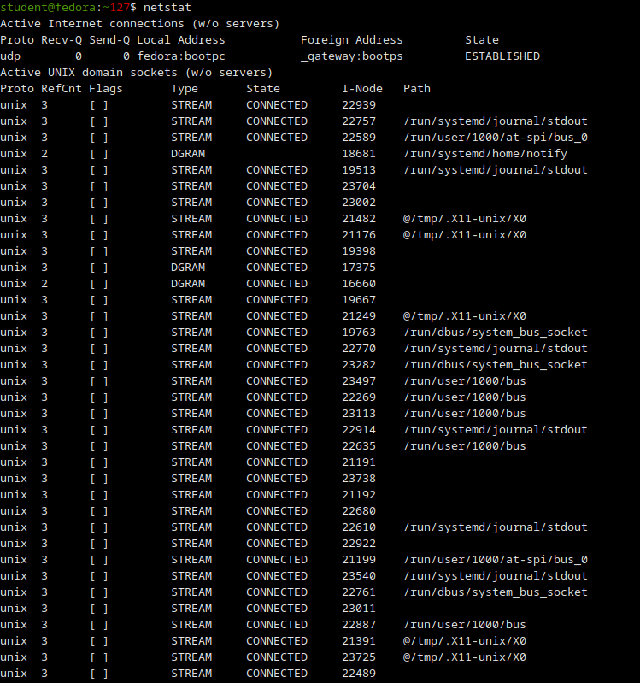
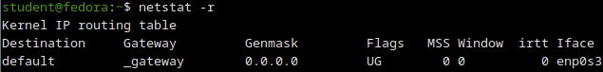
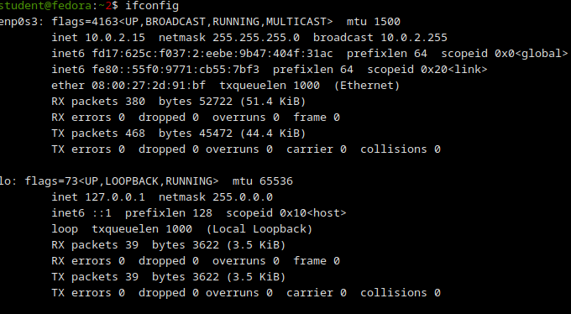
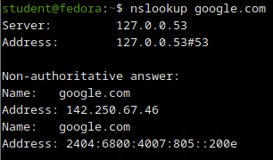
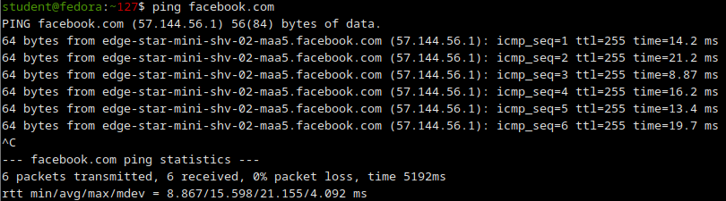
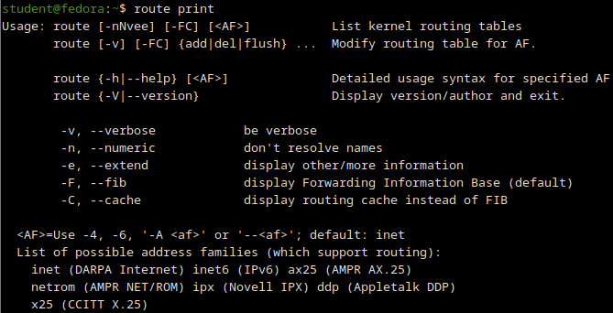
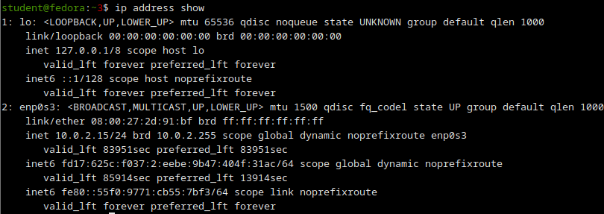
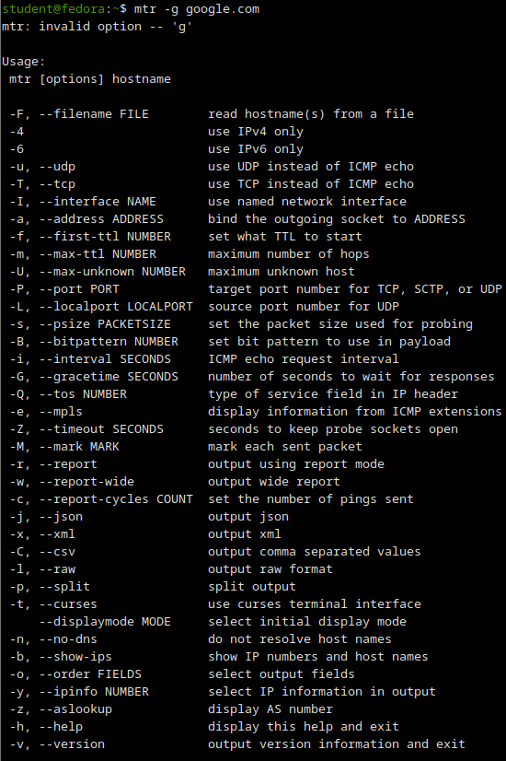

RESULT:
The various network commands in Linux and Windows were studied and executed successfully.

Ex.No.2 | Study of Network cables.  Understand different types of Network cables.  Make a cross-wired cable and straight through cable using clamping/crimping tool.
Date:
- Understand different types of network cable.
Different type of cables used in networking are:
  - Unshielded Twisted Pair (UTP) Cable
  - Shielded Twisted Pair (STP) Cable
  - Coaxial Cable
  - Fibre Optic Cable

Cable type | Category | Maximum Data Transmission | Advantages/ Disadvantages | Application/Use | Image
UTP | Category 3 | 10 bps | Advantages  - Cheaper in cost  - Easy to install as they have a smaller overall diameter.  Disadvantages  - More prone to (EMI)  Electromagnetic interference and noise | 10Base-T Ethernet | 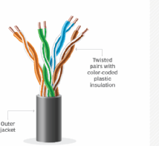
UTP | Category 5 | Up to 100 Mbps |  | Fast Ethernet, Gigabit Ethernet
UTP | Category 5e | 1Gbps |  | Fast Ethernet, Gigabit Ethernet
STP | Category6,6a | 10Gbps | Advantages  - Shielded.  - Faster than UTP.  - Less susceptible to noise and interference  Disadvantages  - Expensive  - Greater installation effort | Gigabit Ethernet, 10G Ethernet (55m)  Widely used in data centres | 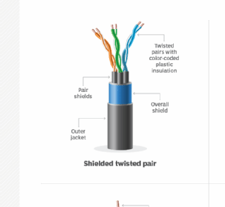  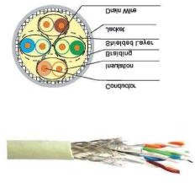
SSTP | Category 7 | 10Gbps |  | Gigabit Ethernet, 10G Ethernet (100m)

Coaxial cable | RG-6 RG-59 RG-11 | 10-100Mbps | - High bandwidth  - Immune to interference  - Low loss bandwidth  - Versatile  - Disadvantages  - Limited distance  - Cost  - Size is bulky | Speed of signal is 500m  Television network High speed internet connections | 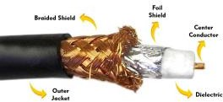
fibre optics cable | Single mode Multi mode | 100Gbps | Advantages  - High speed  - High bandwidth  - High security  - Long distance  Disadvantages  - Expensive  - Requires skilled installers | - Maximum distance of fibre optics cable is around 100meters | 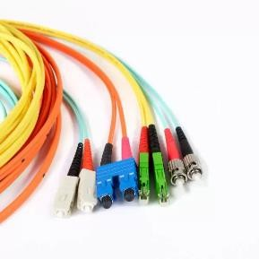

- Make Your Own Ethernet Cross-Over Cable/ Straight cable
Tools and parts needed:
- Ethernet cabling. CAT5e is certified for gigabit support, but CAT5 cabling works as well, just over shorter distances.
- A crimping tool. This is an all-in-one networking tool shaped to push down the pins in the plug and strip and cut the shielding off the cables.
- Two RJ45 plugs.
- Optional two plug shields.
• Ethernet Cable (CAT5e/CAT5)
- CAT5e is recommended because it supports Gigabit Ethernet (1000 Mbps).
- CAT5 also works but supports lower speeds and shorter distances.
• Crimping Tool
- A networking tool used to:
  - Strip the outer insulation of the cable.
  - Arrange and trim the wires.
  - Crimp (press) the RJ45 connector onto the cable.
• RJ45 Connectors (2)
- Plastic connectors fitted at both ends of the Ethernet cable.
- Used to connect the cable to computers, switches, routers, etc.
• Plug Shields (Optional)
- Protective covers placed over the RJ45 connectors.
- Prevent damage to the locking clip and reduce strain on the cable.

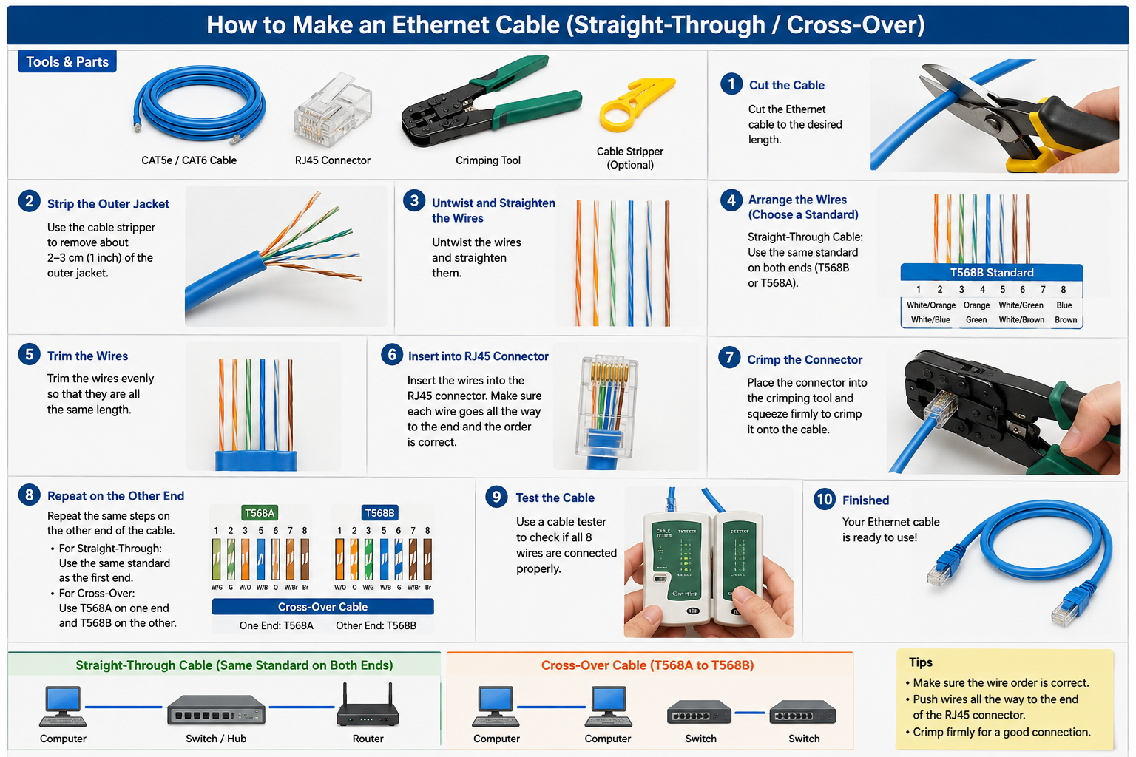

RESULT:

Ex.No.3 | Experiments on CISCO PACKET TRACER (Simulation Tool):  - To understand environment of CISCO PACKET TRACER to design simple network.  - Analyse the behaviour of network devices using CISCO PACKET TRACER simulator.  Design a simple network with multiple nodes and connect via networking devices available in library. Perform simulation and trace communication behaviour of specified network devices.  1: Use only HUB to design a small network having 4 to 6 hosts  2: Use only a Switch to design a small network with 4 to 6 hosts.  3: Use both the device (HUB and SWITCH) for a network and find out functioning difference between switch and hub.  Find out the network topology implemented in your college and draw and label that topology in your observation book.
Date:
AIM: To study the Packet tracer tool Installation and analyse the behaviour of network devices using CISCO PACKET TRACER
INSTALLING PACKET TRACER
Windows
Visit the Cisco Networking Academy website (www.netacad.com).
Log in using your Cisco NetAcad account.
Download the Packet Tracer installer for Windows.
Run the setup file, accept the license agreement, and complete the installation.
Linux
Download the appropriate Packet Tracer package for your Linux distribution.
Open the terminal and make the installer executable:
chmod +x PacketTracer601_i386_installer-rpm.bin
Run the installer:
./PacketTracer601_i386_installer-rpm.bin
Follow the on-screen instructions to complete the installation.

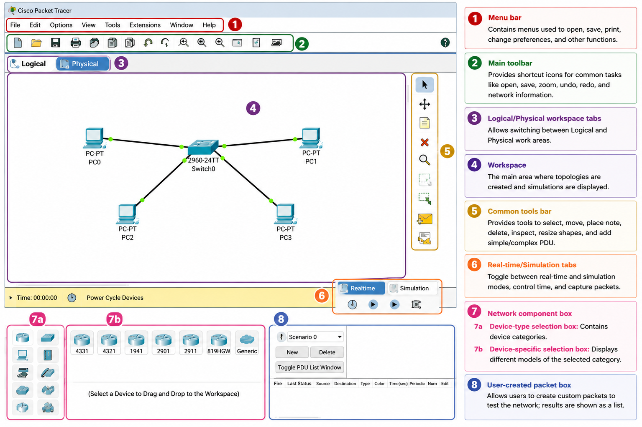
b) Analyse the behaviour of network devices using CISCO PACKET TRACER simulator.
Scenario 1: Network Using Only a Hub

Procedure

Step 1
Open Cisco Packet Tracer.

Step 2
From Network Devices, drag a Hub to the workspace.

Step 3
Drag 4 PCs (PC0, PC1, PC2, and PC3) from End Devices.

Step 4
Connect each PC to the Hub using Copper Straight-Through cables.

Step 5
Assign the following IP addresses.

Device | IP Address | Subnet Mask
PC0 | 192.168.1.1 | 255.255.255.0
PC1 | 192.168.1.2 | 255.255.255.0
PC2 | 192.168.1.3 | 255.255.255.0
PC3 | 192.168.1.4 | 255.255.255.0

Step 6
Switch to Simulation Mode.

Step 7
Click Add Simple PDU and send a packet from PC0 to PC2.

Step 8
Observe the packet movement.
Observation
- The Hub broadcasts the packet to all connected hosts.
- Every PC receives the packet.
- Only the destination PC accepts the packet.
- Network collisions may occur because all devices share the same communication channel.
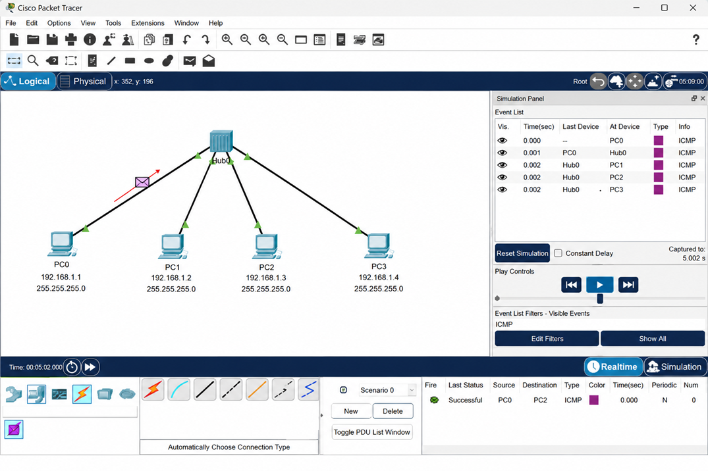

c) Scenario 2: Network Using Only a Switch

Aim
To design a simple network using a switch and observe the communication behaviour during simulation.

Network Topology
Switch0
/ | | \
PC0 PC1 PC2 PC3

Devices Required
Device | Quantity
Switch 2960 | 1
PC-PT | 4
Copper Straight-Through Cable | 4

Procedure
Step 1
Open Cisco Packet Tracer.
Step 2
From Network Devices → Switches, drag a 2960 Switch into the workspace.
Step 3
Drag four PCs (PC0, PC1, PC2, and PC3) from End Devices.
Step 4
Connect each PC to the switch using Copper Straight-Through cables.
Step 5
Assign the following IP addresses.
Device | IP Address | Subnet Mask
PC0 | 192.168.1.1 | 255.255.255.0
PC1 | 192.168.1.2 | 255.255.255.0
PC2 | 192.168.1.3 | 255.255.255.0
PC3 | 192.168.1.4 | 255.255.255.0
Step 6
Switch to Simulation Mode.
Step 7
Select Add Simple PDU.
Step 8
Click PC0 and then PC2.
Step 9
Observe the packet movement.
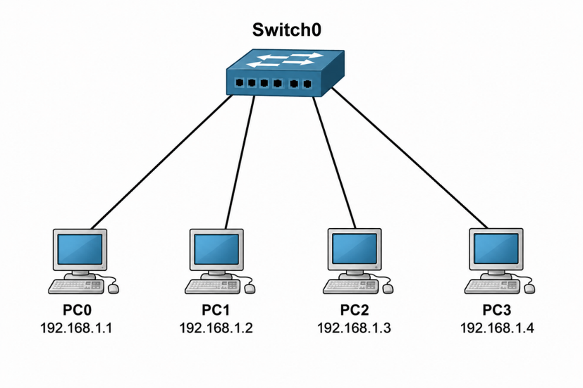
Observation
- The switch learns the MAC addresses of connected devices.
- Initially, the switch may flood the frame if the destination MAC address is unknown.
- Once the MAC address table is learned, the switch forwards packets only to the destination port.
- Other PCs do not receive the packet.
- No collisions occur because each switch port forms a separate collision domain.
Scenario 3: Network Using Both Hub and Switch

Aim
To design a network using both a hub and a switch and compare their communication behaviour.

Network Topology

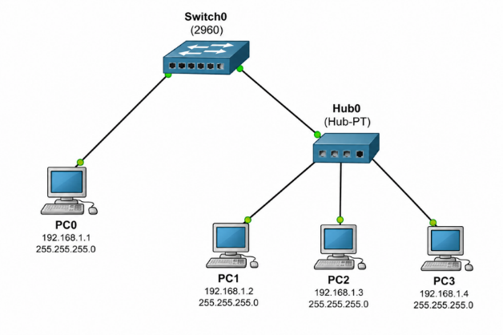
Devices Required
Device | Quantity
Switch 2960 | 1
Hub | 1
PC-PT | 4
Copper Straight-Through Cable | 5

Procedure
Step 1
Open Cisco Packet Tracer.
Step 2
Place one 2960 Switch and one Hub in the workspace.
Step 3
Add four PCs.
Step 4
Connect:
PC0 → Switch
Hub → Switch
PC1 → Hub
PC2 → Hub
PC3 → Hub

Step 5
Assign the following IP addresses.
Device | IP Address | Subnet Mask
PC0 | 192.168.1.1 | 255.255.255.0
PC1 | 192.168.1.2 | 255.255.255.0
PC2 | 192.168.1.3 | 255.255.255.0
PC3 | 192.168.1.4 | 255.255.255.0
Step 6
Switch to Simulation Mode.
Step 7
Send a Simple PDU from PC0 to PC2.
Step 8
Observe the packet movement.

Observation
- The switch forwards the frame only toward the hub.
- The hub broadcasts the frame to all devices connected to it.
- PC1 and PC3 receive the frame but discard it.
- PC2 accepts the packet because it is the intended destination.
- The switch limits unnecessary traffic, while the hub broadcasts within its segment.

OUTPUT:

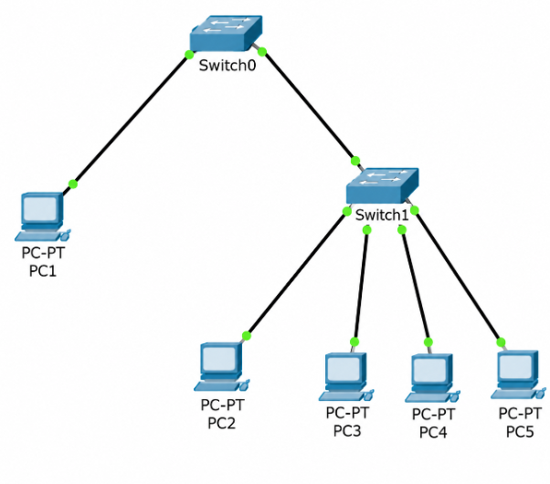

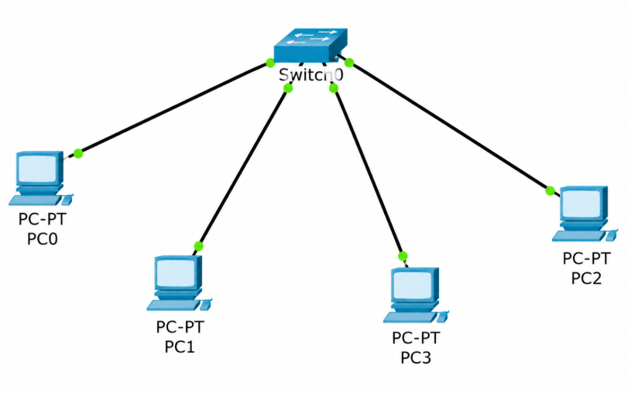
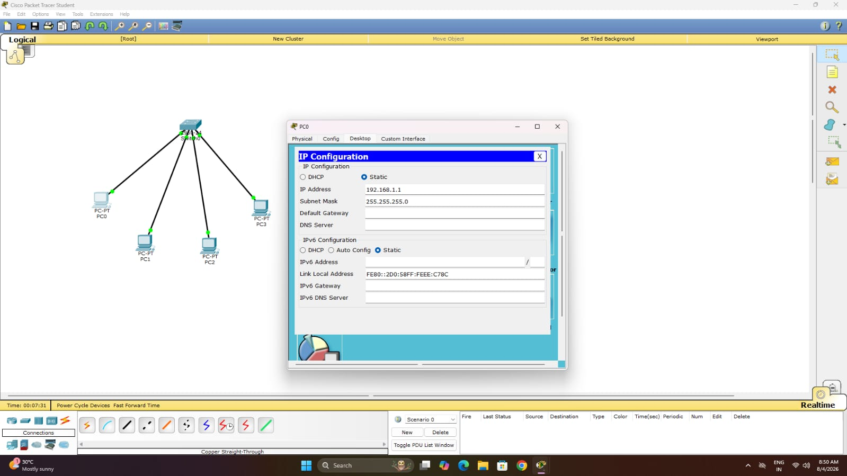

RESULT: Cisco Packet Tracer was successfully installed and studied.The behaviour and communication of various network devices were successfully analyzed using Cisco Packet Tracer.

Ex.No.4 | - Setup and configure a LAN (Local area network) using a Switch  and Ethernet cables in your lab.  - Connect 3-4 host machines to a switch.  - Assign ip addresses to each host machine.  - Check the connectivity between the machines by using ping command.  - Share and access files and folder across the machines of the LAN.
Date:

LAN:
A local area network (LAN) is a collection of devices connected together in one physical location, such as a building, office, or home. A LAN can be small or large, ranging from a home network with one user to an enterprise network with thousands of users and devices in an office or school.
Regardless of size, a LAN's single defining characteristic is that it connects devices that are in a single, limited area.

Set Up a LAN (Local Area Network) Directly

How to Set Up a LAN (Local Area Network)
Step 1: Plan the Network
Plan and design an appropriate network topology based on the network requirements and the physical location of the devices.

Step 2: Gather the Required Devices
Prepare the following hardware components:
- 4 Computers (PCs)
- 1 Network Switch (8-port, 16-port, or 24-port)
- 4 Ethernet (UTP) Cables
Step 3: Connect the Devices
Connect each computer to the network switch using Ethernet cables. Plug one end of the Ethernet cable into the Ethernet port of the computer and the other end into an available port on the switch. Ensure that the link LEDs on the switch and the computers are ON, indicating successful connections.

Step 4: Assign IP Addresses to the PCs
- Log in to each computer using an Administrator or Owner account.
- Open Control Panel → Network and Internet → Network and Sharing Center.
- Click Change Adapter Settings.
- Right-click Local Area Connection (or Ethernet) and select Properties.
- Select Internet Protocol Version 4 (TCP/IPv4) and click Properties.
- Select the Use the following IP address option.
- Enter the IP address and subnet mask for each computer as shown below:
Computer | IP Address | Subnet Mask
PC1 | 10.1.1.1 | 255.0.0.0
PC2 | 10.1.1.2 | 255.0.0.0
PC3 | 10.1.1.3 | 255.0.0.0
PC4 | 10.1.1.4 | 255.0.0.0
Click OK to save the configuration. Repeat the same procedure for all the PCs connected to the switch.
Step 5: Configure the Network Switch
- Connect a computer to the switch using an Ethernet cable.
- Open a web browser and enter the IP address of the switch in the address bar to access the switch's management interface.
- Log in using the appropriate username and password.
- Configure the basic settings of the switch.
- Assign the following management IP address to the switch:
Device | IP Address | Subnet Mask
Switch | 10.1.1.5 | 255.0.0.0
Save the configuration.

Step 6: Verify Network Connectivity
Open the Command Prompt on each computer and use the ping command to test connectivity with the other computers and the switch.
Example:
- ping 10.1.1.2
- ping 10.1.1.3
- ping 10.1.1.4
- ping 10.1.1.5
If replies are received without packet loss, the network has been configured successfully.

Step 7: Share a Folder
- Create or select a folder to be shared.
- Right-click the folder and select Properties.
- Open the Sharing tab.
- Click Share.
- Select Everyone from the list of users.
- Click Share and then Done.
The selected folder is now accessible to all computers on the same LAN.
Step 8: Access the Shared Folder
- Open File Explorer on another computer connected to the LAN.
- In the address bar, type the IP address or computer name of the shared computer. For example:
  - \\10.1.1.1
  - \\PC1
- Press Enter to view the shared folder.
- Open the folder and verify that files can be accessed successfully.
Procedure to Set Up a LAN Using Cisco Packet Tracer
Step 1: Design the Network Topology
- Open Cisco Packet Tracer.
- From the Network Devices section, select Switches and drag one 2960 Switch onto the workspace.
- From the End Devices section, drag four PCs onto the workspace.
- Rename the devices as PC0, PC1, PC2, and PC3.
Sample Design:
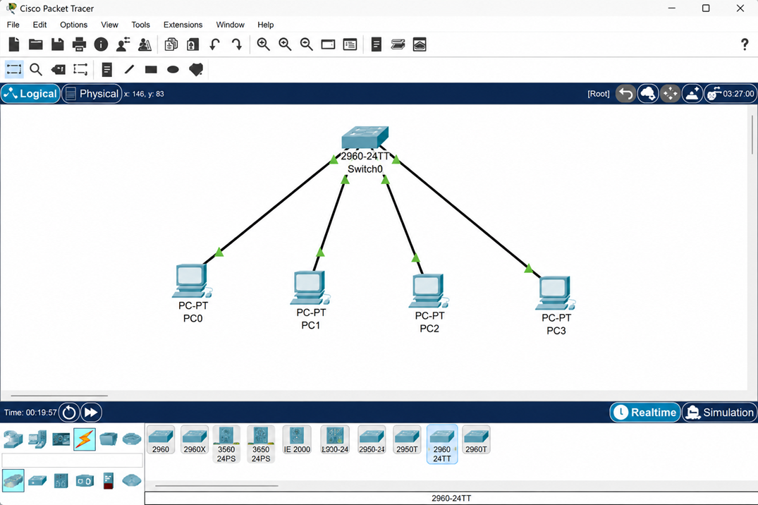
Step 2: Connect the Devices
- Click Connections (Lightning Bolt icon).
- Select Copper Straight-Through Cable.
- Connect the devices as follows:
Source Device | Interface | Destination Device | Interface
PC0 | FastEthernet0 | Switch0 | FastEthernet0/1
PC1 | FastEthernet0 | Switch0 | FastEthernet0/2
PC2 | FastEthernet0 | Switch0 | FastEthernet0/3
PC3 | FastEthernet0 | Switch0 | FastEthernet0/4
- Wait until the link LEDs turn green, indicating that the devices are successfully connected.
Step 3: Assign IP Addresses to the PCs
For each PC:
- Click the PC.
- Select the Desktop tab.
- Click IP Configuration.
- Enter the following IP addresses:
Device | IP Address | Subnet Mask
PC0 | 10.1.1.1 | 255.0.0.0
PC1 | 10.1.1.2 | 255.0.0.0
PC2 | 10.1.1.3 | 255.0.0.0
PC3 | 10.1.1.4 | 255.0.0.0
Leave the Default Gateway blank because no router is used in this LAN.
Step 4: Verify IP Configuration
On each PC:
- Open Desktop.
- Select Command Prompt.
- Execute the following command:
ipconfig
Verify that the configured IP address and subnet mask are displayed correctly.
Step 5: Test Network Connectivity
From PC0, open Command Prompt and execute:
ping 10.1.1.2
Similarly, test connectivity with the remaining PCs:
ping 10.1.1.3

ping 10.1.1.4
Repeat the ping test from each PC to ensure that all hosts can communicate successfully.
Step 6: Verify Packet Transmission Using Simulation Mode
- Click Simulation mode at the bottom-right corner of Packet Tracer.
- Select the Add Simple PDU tool (Envelope icon).
- Click PC0 as the source device.
- Click PC3 as the destination device.
- Click Auto Capture/Play.
Observe the ICMP Echo Request and Echo Reply packets travelling through the switch.
Step 7: Configure an FTP Server for File Sharing
Since Packet Tracer does not support Windows folder sharing, use an FTP server to simulate file sharing.
- Drag one Server from End Devices into the workspace.
- Connect the server to the switch using a Copper Straight-Through Cable.
- Configure the server with:
Device | IP Address | Subnet Mask
Server0 | 10.1.1.5 | 255.0.0.0
- Open Server0.
- Select Services → FTP.
- Turn the FTP service ON.
- Create a username and password (for example, student / student123).
Step 8: Access the FTP Server
On PC0:
- Open Desktop → Command Prompt.
- Connect to the FTP server using:
ftp 10.1.1.5
- Enter the configured username and password.
- Execute FTP commands such as:
dir
get sample.txt
put report.txt
Verify that files can be uploaded to and downloaded from the FTP server.
Step 9: Save the Project
- Click File → Save As.
- Save the Packet Tracer file with an appropriate name, for example:
LAN_Configuration.pkt
The LAN configuration is now complete.

OUTPUT:
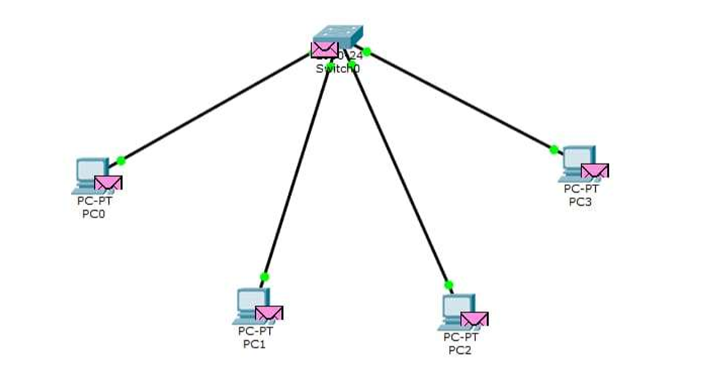
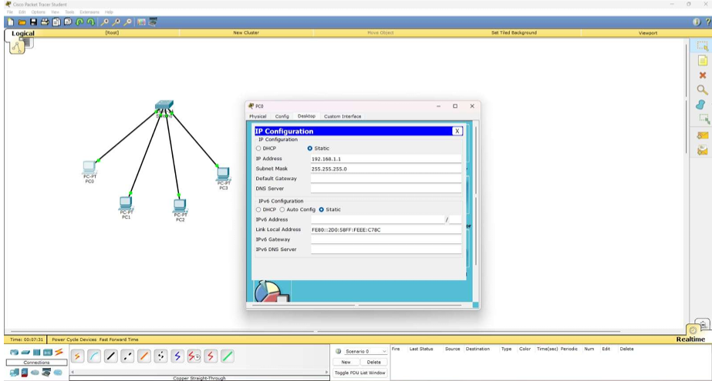

RESULT:

A LAN was successfully set up and configured using a switch and Ethernet cables.
The connected devices were successfully communicated and network connectivity was verified.

Ex.No.5 | Experiments on Packet capture tool: Wireshark
Date | Experiments on Packet capture tool: Wireshark

AIM:
To understand the features of wireshark as a packet capture tool and understand encapsulation of information at various layers of a Protocol stack.
WIRESHARK
Wireshark is a free, open-source network packet analyzer used for network troubleshooting, analysis, and security auditing. It lets you capture and interactively browse live data traffic passing through a network interface:
Workdone by Wireshark:
- Capture network traffic
- Decode packet protocols using dissectors
- Define filters – capture and display
- Watch smart statistics
- Analyze problems
- Interactively browse that traffic
Wireshark used for:
- Network administrators: troubleshoot network problems
- Network security engineers: examine security problems
- Developers: debug protocol implementations
- People: learn network protocol internals
Getting Wireshark
Wireshark can be downloaded for Windows or macOS from its official website. For Linux or another UNIX-like system, Wireshark will be found in its package repositories. For Ubuntu, Wireshark will be found in the Ubuntu Software Center.

Download Wireshark from the following link
https://www.wireshark.org/download.html
Procedure to Capture Packets Using Wireshark
Step 1: Download and install Wireshark on your computer.
Step 2: Open the Wireshark application.
Step 3: From the home screen, select the network interface (e.g., Wi-Fi or Ethernet) through which your computer is connected to the network.
Step 4: Click the Start Capturing Packets button (blue shark fin icon) or double-click the selected interface.
Step 5: Generate network traffic by opening a website, sending a ping, or browsing the Internet.
Step 6: Observe the captured packets appearing in real time in the Packet List pane.
Step 7: To view only specific packets, enter a display filter (e.g., http, tcp, udp, icmp, dns) in the filter bar and press Enter.
Step 8: Click on any packet to view its detailed information in the Packet Details pane.
Step 9: Expand the protocol layers (Ethernet, IP, TCP/UDP, etc.) to examine packet contents.
Step 10: Click the Stop button (red square) to stop packet capture.
Step 11: To save the captured packets, go to File → Save As, choose a location, and save the file in .pcapng (or .pcap) format.
Sample Capturing Packets from Wireshark: Sample output
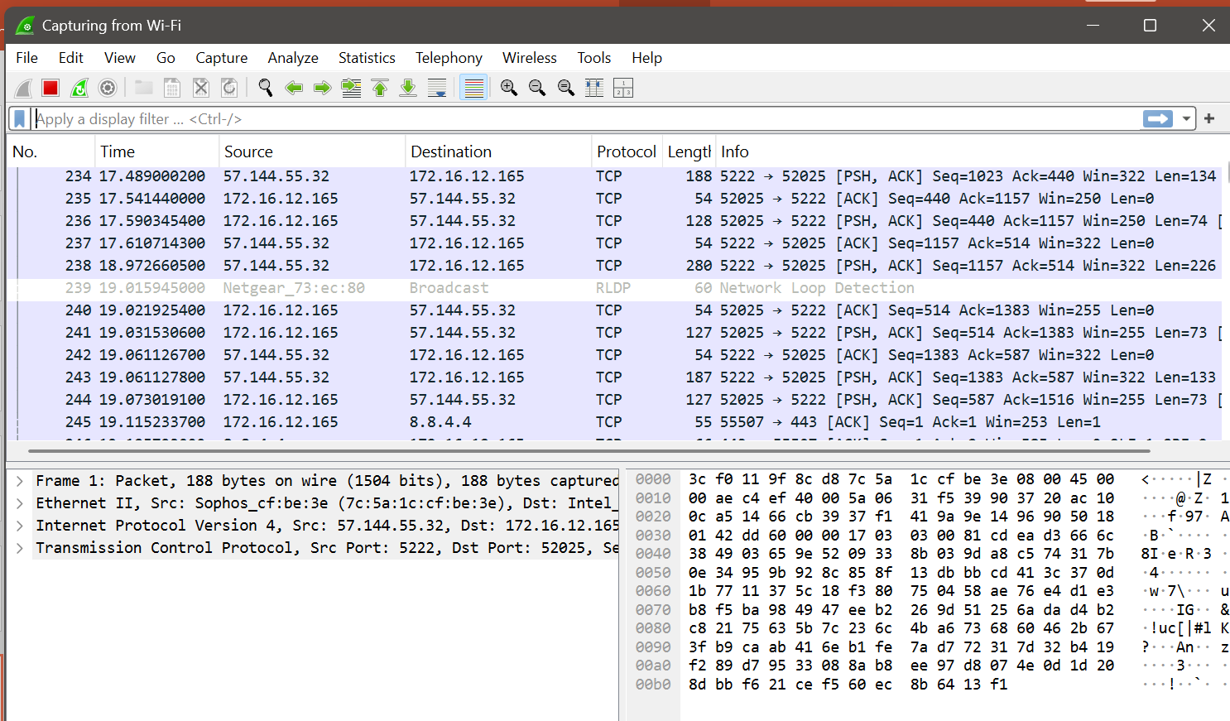

Different Panes in Wireshark:
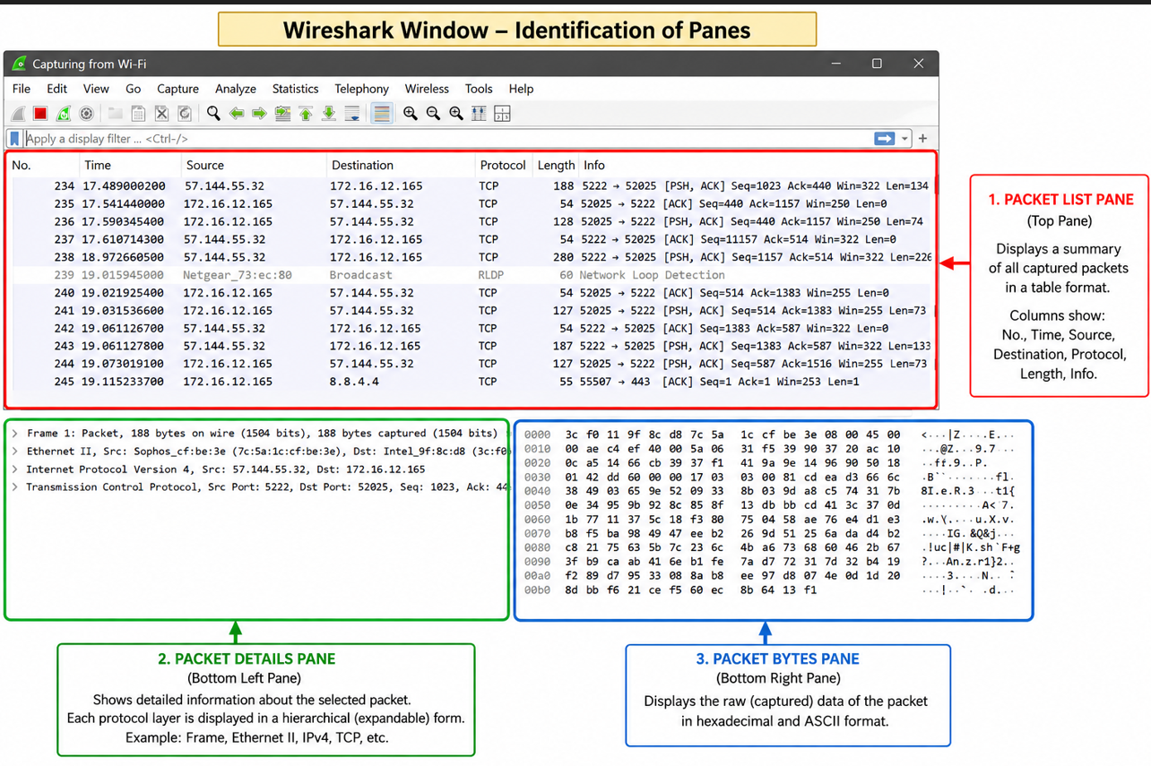

1. Packet List Pane (Top Pane)
- Displays a summary of all captured packets.
- Each row represents one captured packet.
- Shows details such as Packet Number, Time, Source, Destination, Protocol, Length, and Info.

2. Packet Details Pane (Middle Pane)
- Displays detailed information about the selected packet.
- Information is organized into protocol layers such as Frame, Ethernet, IP, TCP/UDP, etc.
- Each protocol layer can be expanded to view more details.

3. Packet Bytes Pane (Bottom Pane)
- Displays the raw data of the selected packet.
- Data is shown in hexadecimal format on the left.
- The corresponding ASCII representation is shown on the right.
Note: These three panes work together to help users analyze captured network packets efficiently in Wireshark.
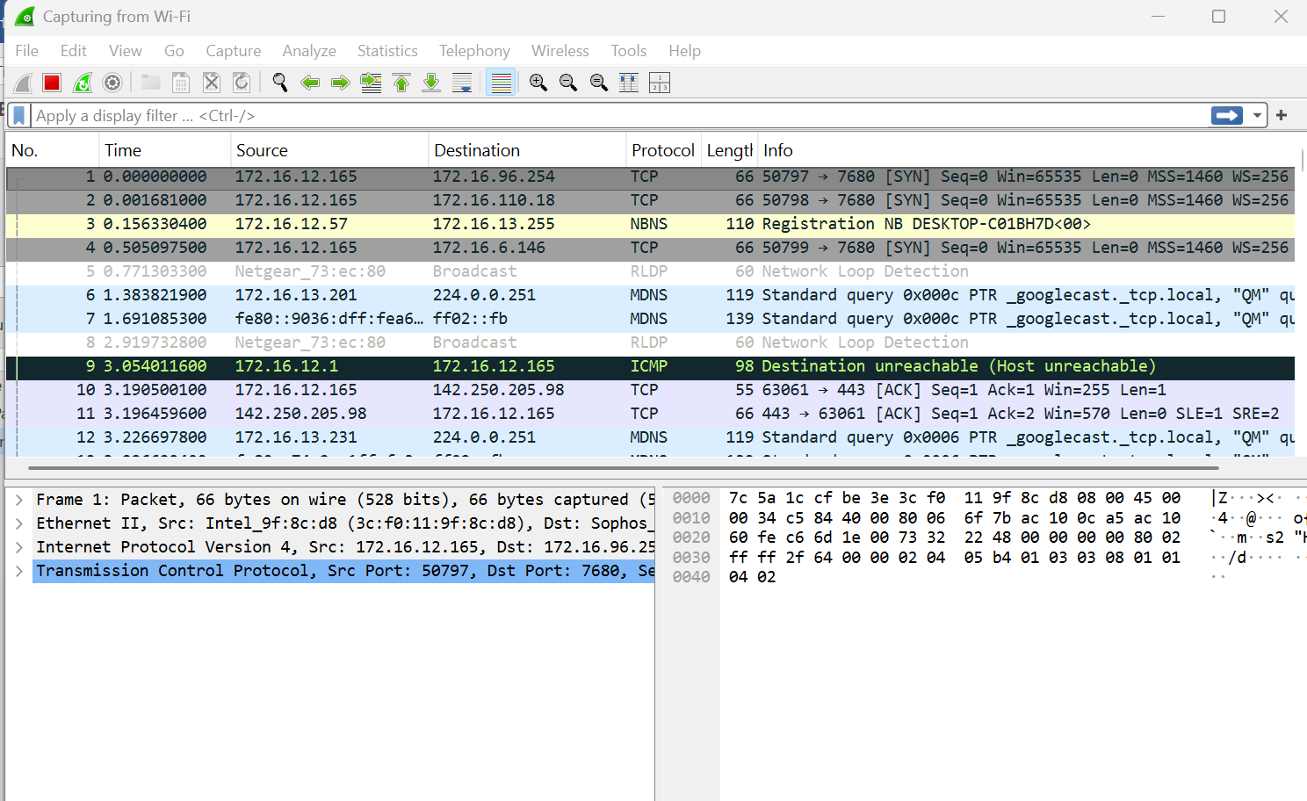
Color Coding:
In Wireshark, packet colors help you quickly identify different types of network traffic. Based on your screenshot, the colors indicate the following:
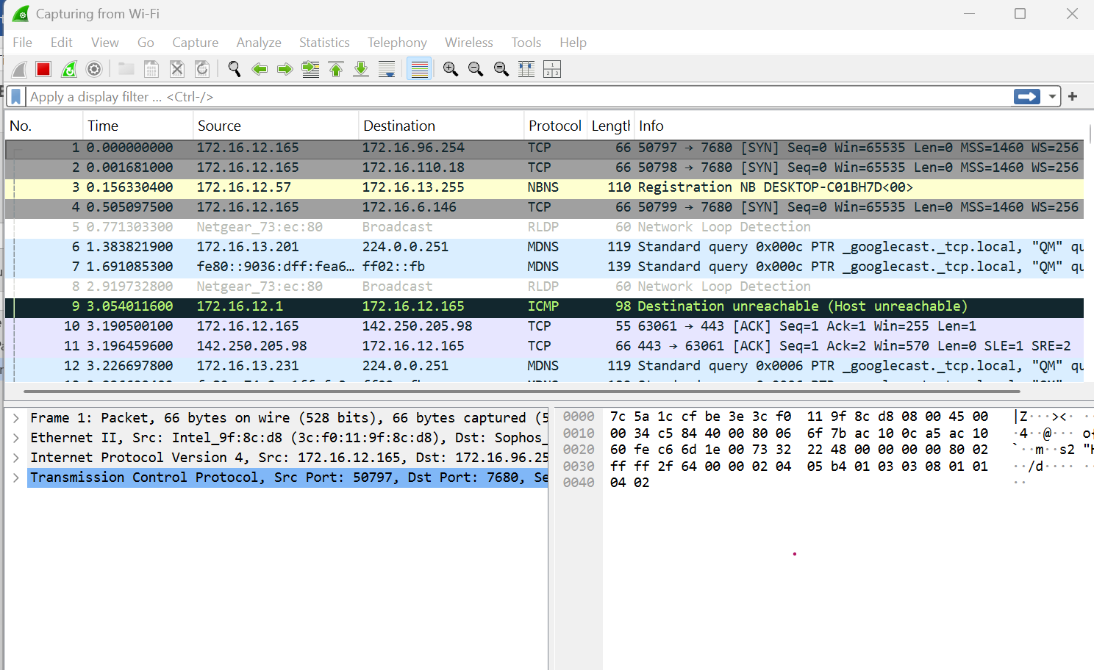
Color | Protocol/Traffic | Description
Light Gray | TCP | Indicates normal TCP packets such as SYN and ACK packets.
Light Yellow | NBNS (NetBIOS Name Service) | Used for NetBIOS name registration and name resolution on a local network.
White | RLDP (Network Loop Detection) | Represents Network Loop Detection Protocol packets used by network devices.
Light Blue | MDNS (Multicast DNS) | Used for local network service discovery (e.g., Chromecast, printers, Apple devices).
Dark Green / Black with Green Text | ICMP | Indicates Internet Control Message Protocol packets such as Destination Unreachable, Ping Request, or Ping Reply.
Light Purple / Lavender | TCP | Represents another category of TCP packets (e.g., ACK or established connection traffic) based on Wireshark's default coloring rules.

To view exactly what the color codes mean, click View > Coloring Rules. You can also customize and modify the coloring rules from here, if you like.
Sample Output:
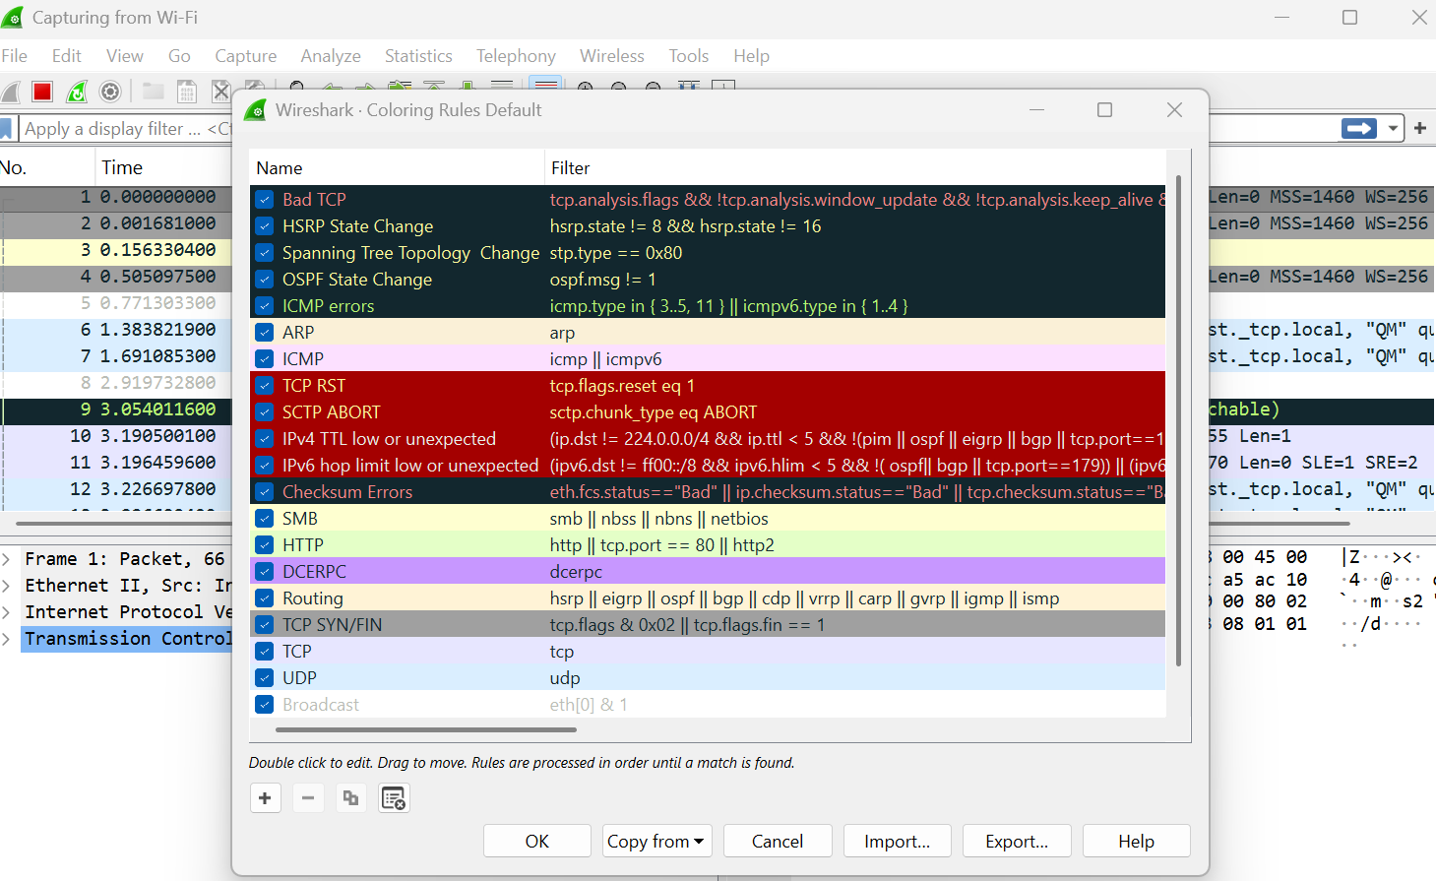

Sample Captures:
- If there is no interesting network traffic on your own network, you can use sample capture files.
- Download a sample capture file and open it by selecting File → Open in Wireshark.
- Browse to the downloaded file and click Open to analyze the captured packets.
- You can also save your own captured packets for future analysis by selecting File → Save.
- Wireshark saves capture files in .pcap or .pcapng format.
Simple Procedure:
- Download a sample capture file.
- Open Wireshark.
- Click File → Open.
- Select the sample capture file.
- Analyze the captured packets.
- To save your own capture, click File → Save.
You can also save your own captures in Wireshark and open them later. Click File > Save to save your captured packets

Filtering Packets:
• Close unnecessary applications before capturing packets.
• This reduces unwanted network traffic.
• Capture only the traffic related to the program you want to analyze.
• Without filters, thousands of packets may be captured.
• Filters help narrow down the packet list.
• This makes packet analysis faster and easier.
• Wireshark provides Capture Filters and Display Filters to simplify traffic analysis.
Sample filter applied for TCP:
Filtered Packet List
No. | Time | Source | Destination | Protocol | Length | Info
1 | 0.001 | 192.168.1.10 | 142.250.183.78 | TCP | 74 | 50234 → 443 [SYN]
2 | 0.005 | 142.250.183.78 | 192.168.1.10 | TCP | 74 | 443 → 50234 [SYN, ACK]
3 | 0.006 | 192.168.1.10 | 142.250.183.78 | TCP | 66 | 50234 → 443 [ACK]
4 | 0.020 | 192.168.1.10 | 142.250.183.78 | TCP | 1514 | HTTP GET Request
5 | 0.055 | 142.250.183.78 | 192.168.1.10 | TCP | 1514 | HTTP 200 OK

Display Filters in Wireshark:
• Click Analyze → Display Filters to open the list of available display filters.
• Choose a predefined filter from the default list.
• You can create your own custom filters.
• Save custom filters for future use.
• Display filters make it easier to find specific packets.
• For advanced filter syntax, refer to the official Wireshark Display Filter documentation.

Example: Create and Save a Custom Filter
Suppose you frequently analyze DNS packets.
- Click Analyze → Display Filters.
- Click the + (Add) button.
- Enter:
  - Filter Name: DNS Packets
  - Filter Expression: dns
- Click OK.

Follow TCP Stream in Wireshark
- Right-click on a TCP packet.
- Select Follow → TCP Stream.
- Wireshark displays the complete conversation between the client and the server.
- This helps you understand the data exchanged during the communication.
- You can also choose Follow → UDP Stream or other available protocol streams, if supported.
- This feature is useful for analyzing web requests, application data, and troubleshooting network communication.
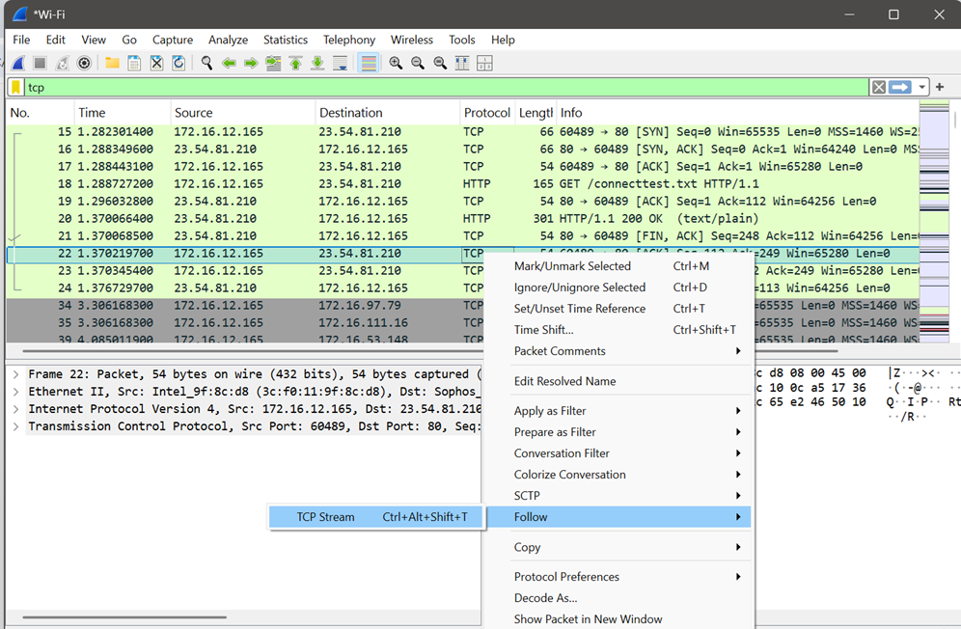

Sample Output:
No. | Source | Destination | Protocol | Info
35 | 192.168.1.10 | 93.184.216.34 | TCP | 50321 → 80 [SYN]
36 | 93.184.216.34 | 192.168.1.10 | TCP | 80 → 50321 [SYN, ACK]
37 | 192.168.1.10 | 93.184.216.34 | TCP | 50321 → 80 [ACK]
38 | 192.168.1.10 | 93.184.216.34 | HTTP | GET /index.html
39 | 93.184.216.34 | 192.168.1.10 | HTTP | HTTP/1.1 200 OK

Inspecting Packets:
• Click a packet in the Packet List pane.
• The packet details are displayed in the Packet Details pane.
• Expand each protocol layer (Ethernet, IP, TCP/UDP, etc.) to view more information.
• View the raw packet data in the Packet Bytes pane.
• Inspecting packets helps analyze source and destination addresses, protocol information, ports, and packet contents.

Sample Output:
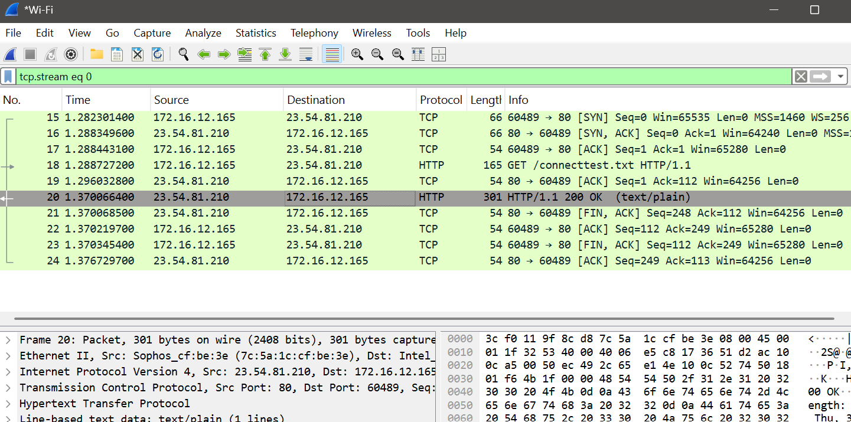

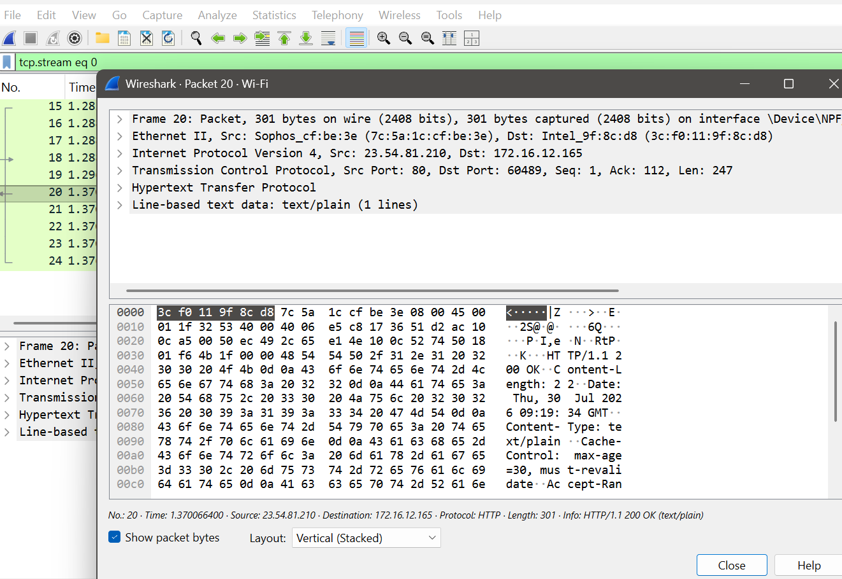

Flow Graph in Wireshark
Definition:
A Flow Graph visually represents the sequence of communication between different devices (hosts) in a network. It makes it easier to understand how packets are exchanged.

How to Open Flow Graph
- Open a packet capture (.pcap) file.
- Click Statistics → Flow Graph.
- A Flow Graph window appears showing the communication between hosts.

What the Graph Shows
- Vertical lines represent different network devices (hosts).
- Horizontal arrows represent packets sent between hosts.
- Time is shown from top to bottom.
- Each arrow is labeled with the protocol and packet information.
Example:
Yes. Below is a sample Flow Graph output similar to what you would see in Wireshark after selecting Statistics → Flow Graph.

Sample Output: Flow Graph
Time Client (192.168.1.10) Server (93.184.216.34)

0.000 |--------------------------->| DNS Query
0.015 |<---------------------------| DNS Response

0.030 |--------------------------->| TCP SYN
0.035 |<---------------------------| TCP SYN-ACK
0.040 |--------------------------->| TCP ACK

0.050 |--------------------------->| HTTP GET /index.html
0.120 |<---------------------------| HTTP/1.1 200 OK
0.125 |<---------------------------| HTML Page Data

0.150 |--------------------------->| TCP FIN
0.155 |<---------------------------| TCP ACK
0.160 |<---------------------------| TCP FIN
0.165 |--------------------------->| TCP ACK

Wireshark Capture Options:
  - Go to capture 🡪 option
  - Select stop capture automatically after 100 packets.
  - Then click Start capture.
Step 1: Select the Active Interface
In your screenshot, choose the interface that is currently connected to the network.
- If you are using Wi-Fi, click Wi-Fi.
- If you are using a LAN cable, click Ethernet.
Tip: The active interface usually shows a moving graph or increasing traffic. In your screenshot, Wi-Fi is likely the correct choice if you are connected wirelessly.
Step 2: Go to the Options Tab
Click the Options tab at the top.
You will see settings similar to this:
☑ Stop capture automatically after

Step 3: Set the Packet Limit
Check the option:
☑ Stop capture automatically after
Select:
100 Packets

Creating a Filter to display only DHCP packets and inspect the packets.

Procedure
- Open Wireshark.
- Select the Ethernet (Local Area Connection) or Wi-Fi interface.
- Click Capture → Options.
- Select Stop capture automatically after 100 packets.
- Click Start to begin packet capture.
- Generate DHCP traffic by disconnecting and reconnecting the network, or by running:
- ipconfig /release
ipconfig /renew
- After the capture stops, type the following in the Display Filter bar:
dhcp
(If dhcp does not work, use bootp.)
- Press Enter or click Apply to display only DHCP packets.
- Click any DHCP packet to inspect its details.
- Click File → Save As, enter a filename, and save the captured packets as a .pcapng file.
Create a Filter to display only IP/ICMP packets and inspect the packets. Procedure
Step 1: Check if ping is working
- Press Windows + R.
- Type cmd and press Enter.
- Type:
ping 8.8.8.8
- Press Enter.
What do you see?
- If you see:
Reply from 8.8.8.8...
then the ping is working.
- If you see:
Request timed out
or
Ping request could not find host...
tell me exactly what message appears.

Step 2: Check whether Wireshark is capturing
When you click Start Capture, do you see the packet count increasing continuously?
- Yes → Wireshark is capturing.
- No → The wrong network interface is selected.

Step 3: Verify the filter
After capturing packets, clear any existing filter and type:
icmp
If the filter bar turns green, the filter is valid.
If it stays green but shows 0 packets, then no ICMP packets were captured.

Step 4: Easier alternative
Instead of using ping, try this:
- Start Wireshark.
- Open Google Chrome.
- Visit www.google.com.
- Stop the capture.
- In the Display Filter, type:
dns
or
tcp
- Press Enter.
These filters almost always show packets because web browsing generates DNS and TCP traffic.
Sample Output (ICMP Filter)
Display Filter:
icmp
Packet List
No. | Time | Source | Destination | Protocol | Length | Info
15 | 2.345 | 192.168.1.10 | 8.8.8.8 | ICMP | 74 | Echo (ping) request
16 | 2.356 | 8.8.8.8 | 192.168.1.10 | ICMP | 74 | Echo (ping) reply
17 | 3.347 | 192.168.1.10 | 8.8.8.8 | ICMP | 74 | Echo (ping) request
18 | 3.359 | 8.8.8.8 | 192.168.1.10 | ICMP | 74 | Echo (ping) reply
19 | 4.351 | 192.168.1.10 | 8.8.8.8 | ICMP | 74 | Echo (ping) request
20 | 4.362 | 8.8.8.8 | 192.168.1.10 | ICMP | 74 | Echo (ping) repl

OUTPUT:

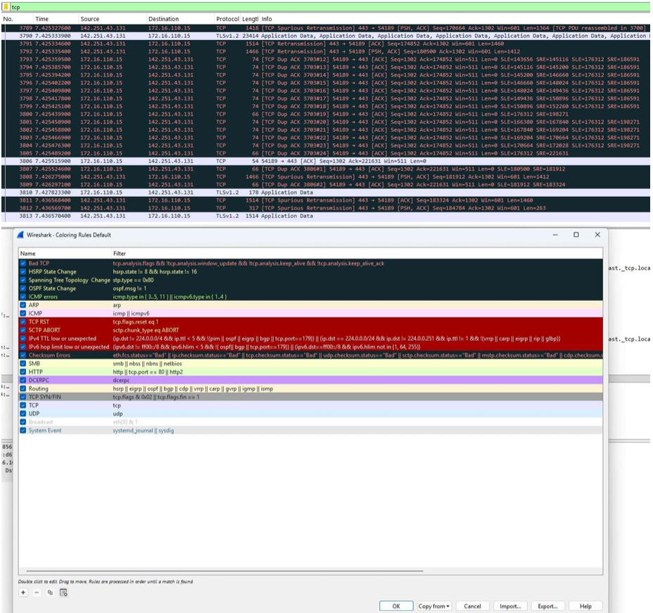
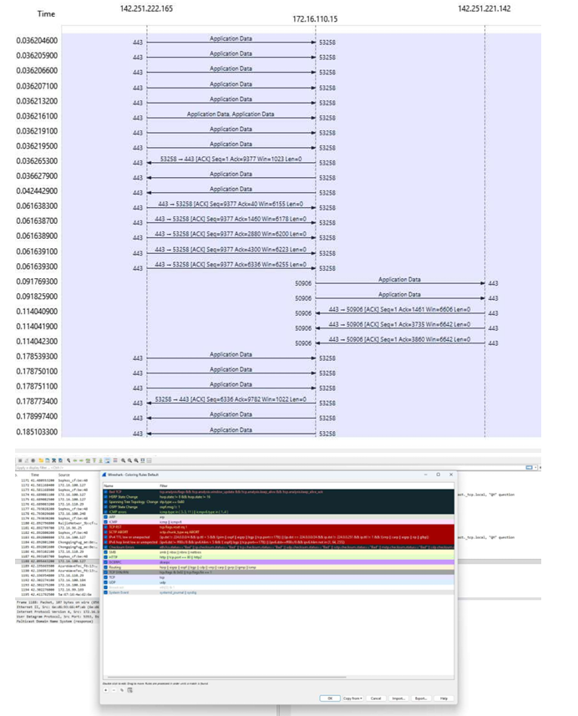

RESULT:
Wireshark was successfully used to capture and analyze network packets.
The captured packets were studied to understand different network protocols and communication behavior.

Ex.No.6 | Develop a customized ping command to test the server connectivity
DATE:

6.1 Customized ping command to test the server connectivity
Aim:
To develop a customized ping command to test the server connectivity.
Algorithm for Program1: Customized ping command to test the server connectivity:
- Start.
- Import the socket and time modules.
- Specify the server name, port number, and number of attempts.
- Create a TCP socket.
- Set the timeout period.
- Record the start time.
- Connect to the server.
- Record the end time.
- Calculate and display the response time.
- If the connection fails, display "Request timed out".
- Repeat Steps 4–10 for the specified number of attempts.
- Stop.

PROGRAM 1:
Customized ping command to test the server connectivity:
import socket
import time
host = "google.com"
port = 80
count = 4
for i in range(count):
try:
# Create a socket
s = socket.socket(socket.AF_INET, socket.SOCK_STREAM)
# Set timeout (optional)
s.settimeout(3)
# Record start time
start = time.time()
# Connect to the server
s.connect((host, port))
# Record end time
end = time.time()
# Close the socket
s.close()
print(f"Reply from {host}: time={(end - start) * 1000:.2f} ms")
except Exception:
print("Request timed out")

Sample Output:
Reply from google.com: time=18.52 ms
Reply from google.com: time=17.84 ms
Reply from google.com: time=19.03 ms
Reply from google.com: time=18.26 ms

OUTPUT:

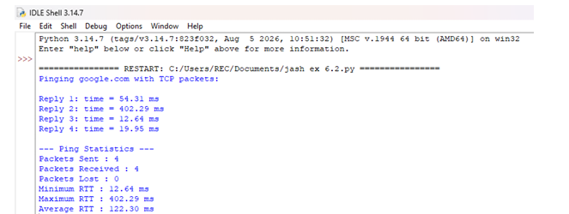

RESULT:
A customized ping command was successfully developed to test server connectivity.
The server’s reachability and response time were successfully verified.

6.2 Customized Ping Program to Measure Min, Max, and Average RTT
AIM:
To develop a Customized Ping Program to Measure Min, Max, and Average RTT ALGORITHM for Program 2:
• Start.
• Import the required modules.
• Initialize the server address, port number, and number of ping attempts.
• Create an empty list to store RTT values.
• Repeat the following for each ping attempt:
- Create a TCP socket.
- Set the timeout value.
- Record the start time.
- Connect to the server.
- Record the end time.
- Calculate the RTT and store it in the list.
- Display the RTT.
- If the connection fails, display "Request timed out".
• Calculate and display:
- Packets Sent
- Packets Received
- Packets Lost
- Minimum RTT
- Maximum RTT
- Average RTT
• Stop.

PROGRAM2: Customized Ping Program to Measure Min, Max, and Average RTT

import socket
import time
# Server details
host = "google.com"
port = 80
count = 4
# List to store RTT values
rtt_list = []
print(f"Pinging {host} with TCP packets:\n")
for i in range(count):
try:
# Create a TCP socket
s = socket.socket(socket.AF_INET, socket.SOCK_STREAM)
s.settimeout(3)
# Record start time
start = time.time()
# Connect to the server
s.connect((host, port))
# Record end time
end = time.time()
# Close the socket
s.close()
# Calculate RTT in milliseconds
rtt = (end - start) * 1000
rtt_list.append(rtt)
print(f"Reply {i+1}: time = {rtt:.2f} ms")
except Exception:
print(f"Reply {i+1}: Request timed out")
# Display statistics
if len(rtt_list) > 0:
print("\n--- Ping Statistics ---")
print(f"Packets Sent : {count}")
print(f"Packets Received : {len(rtt_list)}")
print(f"Packets Lost : {count - len(rtt_list)}")
print(f"Minimum RTT : {min(rtt_list):.2f} ms")
print(f"Maximum RTT : {max(rtt_list):.2f} ms")
print(f"Average RTT : {sum(rtt_list)/len(rtt_list):.2f} ms")
else:
print("\nNo response received from the server.")

SAMPLE OUTPUT:
Pinging google.com with TCP packets:

Reply 1: time = 18.24 ms
Reply 2: time = 17.81 ms
Reply 3: time = 19.15 ms
Reply 4: time = 18.56 ms

--- Ping Statistics ---
Packets Sent : 4
Packets Received : 4
Packets Lost : 0
Minimum RTT : 17.81 ms
Maximum RTT : 19.15 ms
Average RTT : 18.44 ms

OUTPUT:
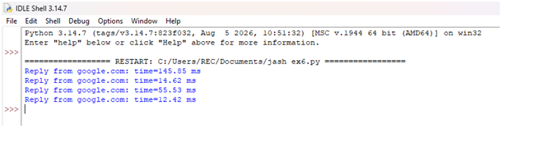

RESULT:
A customized ping command was successfully developed to test server connectivity.
The server’s reachability and response time were successfully verified.

Ex.No.7 | Write a code using RAW sockets to implement packet sniffing.
DATE: | Write a code using RAW sockets to implement packet sniffing.

AIM:
To develop a Python program using raw sockets that captures Ethernet frames and extracts the source and destination MAC addresses and protocol details for network analysis and troubleshooting.
Definition:
Packet sniffing is the technique of capturing and examining network packets transmitted over a network to monitor communication, troubleshoot network issues, and analyze network traffic.
Algorithm:

- Start.
- Import the required modules.
- Get the local host IP address.
- Create and bind a raw socket.
- Enable IP header inclusion and promiscuous mode.
- Set the packet count to 5.
- Receive one packet at a time.
- Extract and display:
Destination MAC address
Source MAC address
Protocol type
Packet length
- Repeat until 5 packets are captured.
- Disable promiscuous mode.
- Display the completion message.
- Stop.

PROGRAM:
import socket
import struct

def get_mac_addr(bytes_addr):
"""Convert MAC address from bytes to readable format."""
return ':'.join('{:02X}'.format(b) for b in bytes_addr)

def get_protocol(bytes_proto):
"""Convert protocol bytes to hexadecimal."""
return hex(struct.unpack('!H', bytes_proto)[0])

def ethernet_frame(data):
"""Extract Ethernet frame information."""
dest_mac, src_mac, proto = struct.unpack('!6s6s2s', data[:14])
return (
get_mac_addr(dest_mac),
get_mac_addr(src_mac),
get_protocol(proto),
data[14:]
)
def main():
host = socket.gethostbyname(socket.gethostname())
print("Listening on:", host)
try:
# Create raw socket
conn = socket.socket(socket.AF_INET,
socket.SOCK_RAW,
socket.IPPROTO_IP)

# Bind socket
conn.bind((host, 0))

# Include IP header
conn.setsockopt(socket.IPPROTO_IP,
socket.IP_HDRINCL,
1)

# Enable promiscuous mode
conn.ioctl(socket.SIO_RCVALL, socket.RCVALL_ON)

print("\nPacket Sniffer Started...\n")

# Capture only 5 packets
packet_count = 5

for i in range(packet_count):

raw_data, addr = conn.recvfrom(65536)

print(f"\nPacket {i+1}")
print("-" * 40)

if len(raw_data) >= 14:
dest_mac, src_mac, eth_proto, data = ethernet_frame(raw_data)

print("Destination MAC :", dest_mac)
print("Source MAC :", src_mac)
print("Protocol :", eth_proto)
print("Packet Length :", len(raw_data), "bytes")

# Disable promiscuous mode
conn.ioctl(socket.SIO_RCVALL, socket.RCVALL_OFF)

print("\nPacket Sniffer Stopped Successfully.")

except PermissionError:
print("Run this program as Administrator.")

except KeyboardInterrupt:
conn.ioctl(socket.SIO_RCVALL, socket.RCVALL_OFF)
print("\nPacket Sniffer Stopped by User.")

if __name__ == "__main__":
main()

SAMPLE OUTPUT:

Listening on: 192.168.1.10

Packet Sniffer Started...

Packet 1
----------------------------------------
Destination MAC : 45:00:00:3C:1C:46
Source MAC : 40:06:B1:E6:C0:A8
Protocol : 0x101
Packet Length : 60 bytes

Packet 2
----------------------------------------
Destination MAC : 45:00:00:34:2F:9A
Source MAC : 40:11:C3:D8:C0:A8
Protocol : 0x101
Packet Length : 52 bytes

Packet 3
----------------------------------------
Destination MAC : 45:00:00:54:3B:8F
Source MAC : 40:06:91:AB:C0:A8
Protocol : 0x101
Packet Length : 84 bytes

Packet 4
----------------------------------------
Destination MAC : 45:00:00:28:5D:71
Source MAC : 40:01:6F:12:C0:A8
Protocol : 0x101
Packet Length : 40 bytes

Packet 5
----------------------------------------
Destination MAC : 45:00:00:3C:7A:15
Source MAC : 40:06:5A:9F:C0:A8
Protocol : 0x101
Packet Length : 60 bytes

Packet Sniffer Stopped Successfully.

OUTPUT:
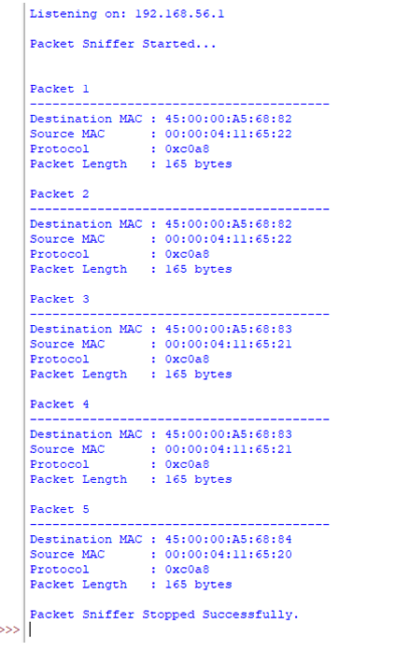

RESULT:
A RAW socket program was successfully implemented to capture and analyze network packets.The packet headers and basic network information were successfully examined using packet sniffing.

Ex.No.8 | Develop a simple calculator using XMLRPC
DATE | Develop a simple calculator using XMLRPC

AIM:
To develop a simple calculator using XMLRPC using Python.

Introduction: XML-RPC:
XML-RPC is a protocol that uses XML to encode remote procedure calls (RPC) and HTTP as a transport mechanism, allowing a client to call functions on a remote server over a network.

ALGORITHM:

CLIENT:
- Start the program.
- Import the xmlrpc.client module.
- Create a connection to the XML-RPC server using ServerProxy.
- Display the calculator menu:
  - Addition
  - Subtraction
  - Multiplication
  - Division
  - Exit
- Read the user's choice.
- If the user selects Exit, terminate the program.
- Otherwise, read two input numbers.
- Send the selected operation and the two numbers to the server.
- Receive the result from the server.
- Display the result.
- Repeat Steps 4–10 until the user chooses Exit.
- End the program.
SERVER:
- Start the program.
- Import the SimpleXMLRPCServer module.
- Define the calculator functions:
Addition
Subtraction
Multiplication
Division (check for division by zero).
- Create an XML-RPC server on localhost with port 8000.
- Register all the calculator functions with the server.
- Display the message "XML-RPC Server is Running on Port 8000...".
- Wait for client requests.
- When a client sends a request:
- Execute the requested arithmetic operation.
- Return the result to the client.
- Continue serving requests until the server is manually stopped.
- End the program.

PROGRAM CODE:

SERVER:

from xmlrpc.server import SimpleXMLRPCServer
# Calculator Functions
def add(a, b):
return a + b

def sub(a, b):
return a - b

def mul(a, b):
return a * b

def div(a, b):
if b == 0:
return "Error! Division by Zero"
return a / b

# Create XML-RPC Server
server = SimpleXMLRPCServer(("localhost", 8000))
print("XML-RPC Server is Running on Port 8000...")

# Register Functions
server.register_function(add, "add")
server.register_function(sub, "sub")
server.register_function(mul, "mul")
server.register_function(div, "div")

# Keep Server Running
server.serve_forever()

CLIENT:
import xmlrpc.client
# Connect to Server
proxy = xmlrpc.client.ServerProxy("http://localhost:8000/")
while True:
print("\n------ XML-RPC Calculator ------")
print("1. Addition")
print("2. Subtraction")
print("3. Multiplication")
print("4. Division")
print("5. Exit")

choice = int(input("Enter your Choice: "))

if choice == 5:
print("Calculator Closed.")
break

a = float(input("Enter First Number: "))
b = float(input("Enter Second Number: "))

if choice == 1:
print("Result =", proxy.add(a, b))

elif choice == 2:
print("Result =", proxy.sub(a, b))

elif choice == 3:
print("Result =", proxy.mul(a, b))

elif choice == 4:
print("Result =", proxy.div(a, b))

else:
print("Invalid Choice")

SAMPLE OUTPUT:
SERVER:
XML-RPC Server is Running on Port 8000...

127.0.0.1 - - [09/Jul/2026 11:05:10] "POST /RPC2 HTTP/1.1" 200 -
127.0.0.1 - - [09/Jul/2026 11:05:24] "POST /RPC2 HTTP/1.1" 200 -
127.0.0.1 - - [09/Jul/2026 11:05:38] "POST /RPC2 HTTP/1.1" 200 -
127.0.0.1 - - [09/Jul/2026 11:05:52] "POST /RPC2 HTTP/1.1" 200 -

CLIENT:
------ XML-RPC Calculator ------
1. Addition
2. Subtraction
3. Multiplication
4. Division
5. Exit

Enter your Choice: 1
Enter First Number: 15
Enter Second Number: 10
Result = 25.0

------ XML-RPC Calculator ------
1. Addition
2. Subtraction
3. Multiplication
4. Division
5. Exit
Enter your Choice: 2
Enter First Number: 15
Enter Second Number: 10
Result = 5.0

------ XML-RPC Calculator ------
1. Addition
2. Subtraction
3. Multiplication
4. Division
5. Exit

Enter your Choice: 3
Enter First Number: 15
Enter Second Number: 10
Result = 150.0

------ XML-RPC Calculator ------
1. Addition
2. Subtraction
3. Multiplication
4. Division
5. Exit

Enter your Choice: 4
Enter First Number: 15
Enter Second Number: 10
Result = 1.5

------ XML-RPC Calculator ------
1. Addition
2. Subtraction
3. Multiplication
4. Division
5. Exit

Enter your Choice: 4
Enter First Number: 15
Enter Second Number: 0
Result = Error! Division by Zero

------ XML-RPC Calculator ------
1. Addition
2. Subtraction
3. Multiplication
4. Division
5. Exit

Enter your Choice: 5
Calculator Closed.

OUTPUT:

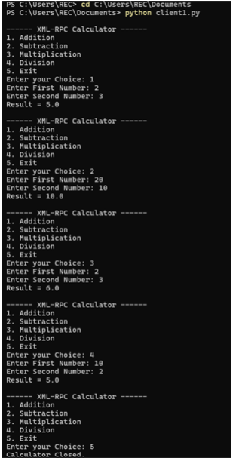

RESULT:
Thus a simple calculator was developed using xmlrpc in python.

Ex.No.9 | Develop a program to create reverse shell using TCP sockets
DATE: | Develop a program to create reverse shell using TCP sockets

AIM :
To write a program to create reverse shell using TCP sockets
ALGORITHM:

Server:
Algorithm: TCP Socket Server
- Start the program.
- Import the required modules.
- Create a TCP socket.
- Bind the socket to the host address and port number.
- Listen for incoming client connections.
- Accept the client connection.
- Receive the command from the client.
- Check the received command:
  - If hello, send a greeting message.
  - If time, send the current time.
  - If date, send the current date.
  - If exit, send a closing message and terminate the connection.
  - Otherwise, send "Invalid Command".
- Repeat Steps 7 and 8 until the client exits.
- Close the client connection and the server socket.
- Stop the program.
Client:

Algorithm: TCP Socket Client
- Start the program.
- Import the socket module.
- Define the HOST address and PORT number.
- Create a TCP socket.
- Connect to the server using the specified HOST and PORT.
- Display the list of available commands.
- Repeat the following steps until the user enters exit:
  - Read a command from the user.
  - Send the command to the server.
  - Receive the response from the server.
  - Display the server's response.
  - If the command is exit, terminate the loop.
- Close the client socket.
- Stop the program.

PROGRAM:
SERVER:
import socket
import datetime
HOST = "127.0.0.1"
PORT = 5000
server = socket.socket(socket.AF_INET, socket.SOCK_STREAM)
server.bind((HOST, PORT))
server.listen(1)
print("Server is listening on", HOST, PORT)
conn, addr = server.accept()
print("Connected by:", addr)
while True:
data = conn.recv(1024).decode()
if not data:
break
print("Client Command:", data)
if data.lower() == "hello":
response = "Hello from Server!"
elif data.lower() == "time":
response = datetime.datetime.now().strftime("%H:%M:%S")
elif data.lower() == "date":
response = datetime.datetime.now().strftime("%d-%m-%Y")
elif data.lower() == "exit":
response = "Connection Closed"
conn.send(response.encode())
break
else:
response = "Invalid Command"
conn.send(response.encode())
conn.close()
server.close()
CLIENT:
import socket
HOST = "127.0.0.1"
PORT = 5000
client = socket.socket(socket.AF_INET, socket.SOCK_STREAM)
client.connect((HOST, PORT))
print("Connected Successfully")
print("Available Commands")
print("1. hello")
print("2. time")
print("3. date")
print("4. exit")
while True:
command = input("\nEnter Command: ")
client.send(command.encode())
response = client.recv(1024).decode()
print("Server:", response)
if command.lower() == "exit":
break
client.close()

SAMPLE OUTPUT:
Connected Successfully

Available Commands
1. hello
2. time
3. date
4. exit

Enter Command: hello
Server: Hello from Server!

Enter Command: time
Server: 10:35:42

Enter Command: date
Server: 09-07-2026

Enter Command: test
Server: Invalid Command

Enter Command: exit
Server: Connection Closed

OUTPUT:

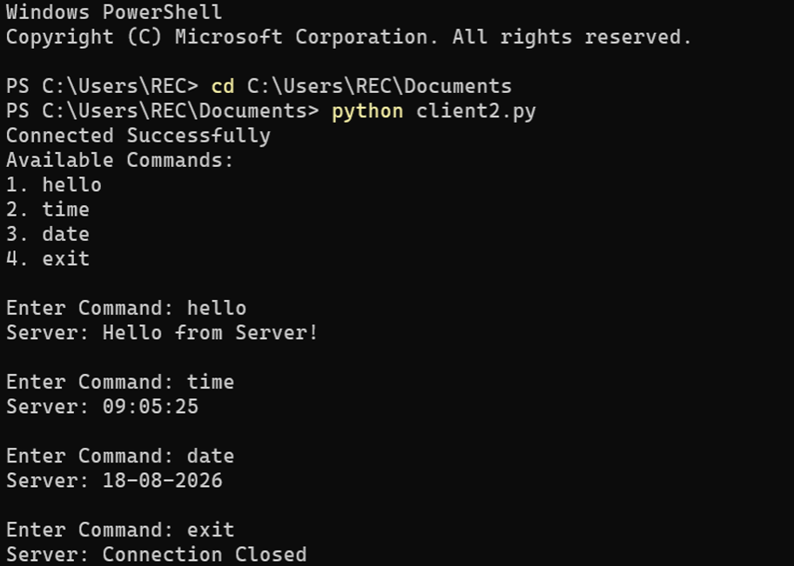

RESULT:
A TCP socket-based reverse shell program was successfully developed and tested in a controlled environment.The communication between the client and server was established successfully using TCP sockets.

Ex.No.10 | Design a simple topology and configure with one router, two switches and PCs using Cisco Packet Tracer
DATE:

AIM:
To design and configure a simple network topology with one router, two switches, and four PCs in Cisco Packet Tracer for successful inter-network communication.
PROCEDURE:

1. Topology
Router R1
┌────────────┐
│ │
G0/0 G0/1
│ │
│ │
Switch S1 Switch S2
┌────┴────┐ ┌────┴────┐
│ │ │ │
PC1 PC2 PC3 PC4

2. Devices to place
In Cisco Packet Tracer, place:
- 1 Router – Cisco 1941
- 2 Switches – Cisco 2960
- 4 PCs
Use Copper Straight-Through cables.

3. IP Addressing
Device | Interface | IP Address | Subnet Mask | Gateway
R1 | G0/0 | 192.168.1.1 | 255.255.255.0 | —
R1 | G0/1 | 192.168.2.1 | 255.255.255.0 | —
PC1 | NIC | 192.168.1.10 | 255.255.255.0 | 192.168.1.1
PC2 | NIC | 192.168.1.11 | 255.255.255.0 | 192.168.1.1
PC3 | NIC | 192.168.2.10 | 255.255.255.0 | 192.168.2.1
PC4 | NIC | 192.168.2.11 | 255.255.255.0 | 192.168.2.1
So we have two different networks:
Network 1: 192.168.1.0/24
PC1 ─┐
PC2 ─┤
S1 ─── R1 G0/0 = 192.168.1.1

Network 2: 192.168.2.0/24
PC3 ─┐
PC4 ─┤
S2 ─── R1 G0/1 = 192.168.2.1

4. Configure Router R1
Click R1 → CLI and enter:
enable
configure terminal

interface gigabitEthernet 0/0
ip address 192.168.1.1 255.255.255.0
no shutdown
exit

interface gigabitEthernet 0/1
ip address 192.168.2.1 255.255.255.0
no shutdown
exit

end
write memory
The important command is:
no shutdown
It activates the router interface.
Check the interfaces using:
show ip interface brief
You should see the interfaces as up/up.
SCREENSHOTS:( to be pasted)

5. Configure PC1
Go to:
PC1 → Desktop → IP Configuration
Enter:
IP Address: 192.168.1.10
Subnet Mask: 255.255.255.0
Default Gateway: 192.168.1.1

SCREENSHOTS:( to be pasted)

6. Configure PC2
IP Address: 192.168.1.11
Subnet Mask: 255.255.255.0
Default Gateway: 192.168.1.1

SCREENSHOTS:( to be pasted)

7. Configure PC3
IP Address: 192.168.2.10
Subnet Mask: 255.255.255.0
Default Gateway: 192.168.2.1

SCREENSHOTS:( to be pasted)

8. Configure PC4
IP Address: 192.168.2.11
Subnet Mask: 255.255.255.0
Default Gateway: 192.168.2.1
SCREENSHOTS:( to be pasted)

9. Test the network
From PC1 → Desktop → Command Prompt, type:
ping 192.168.1.11
This tests PC1 → PC2.
Then:
ping 192.168.2.10
This tests PC1 → Router → Switch 2 → PC3.
You should receive:
Reply from 192.168.2.10
Reply from 192.168.2.10
Reply from 192.168.2.10
Reply from 192.168.2.10

SCREENSHOTS:( to be pasted)

SAMPLE CONFIGURATION:
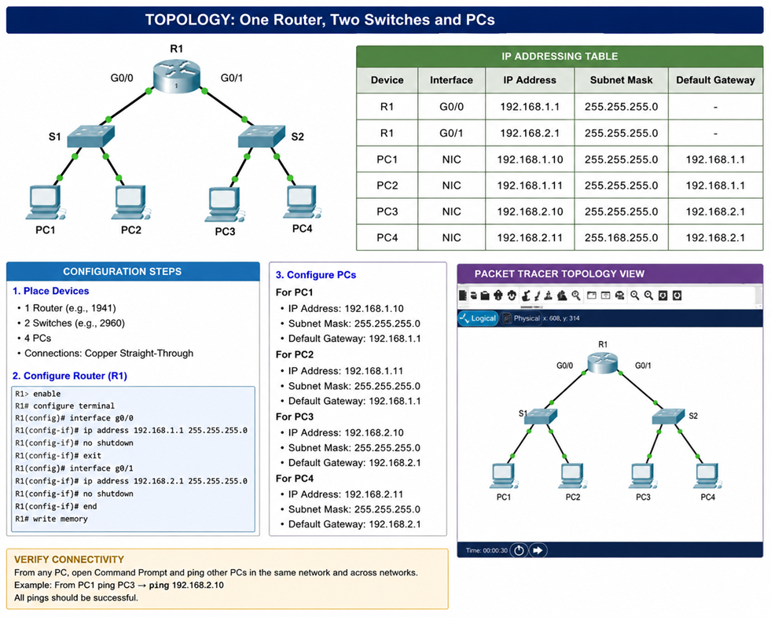

OUTPUT:
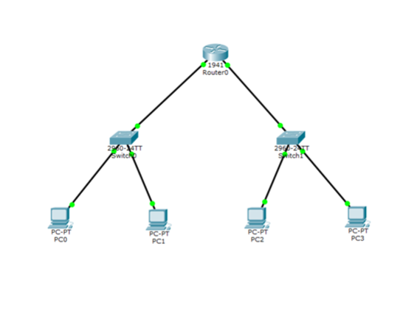
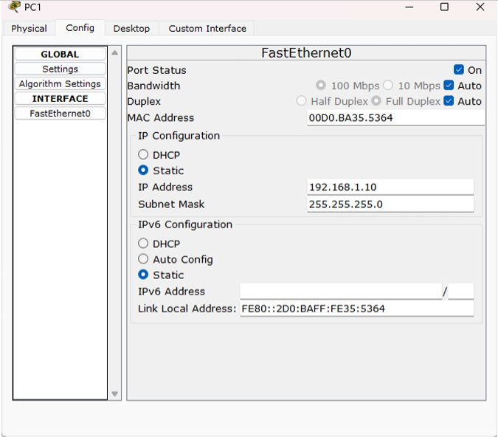
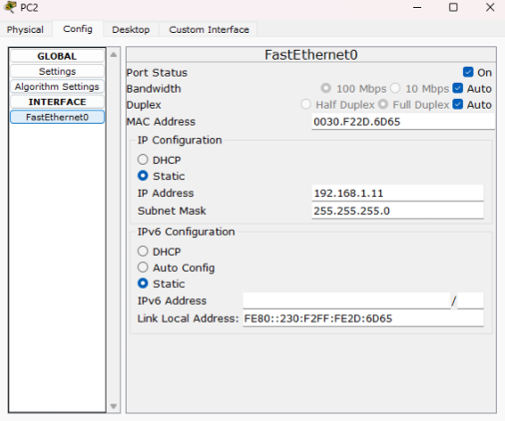
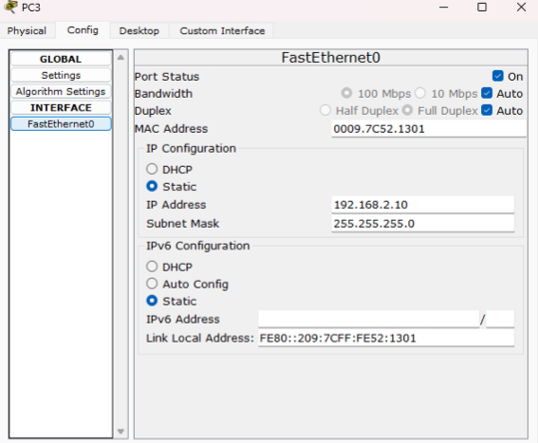
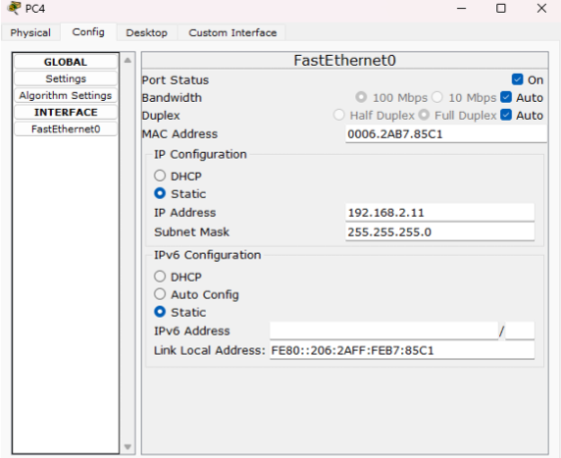
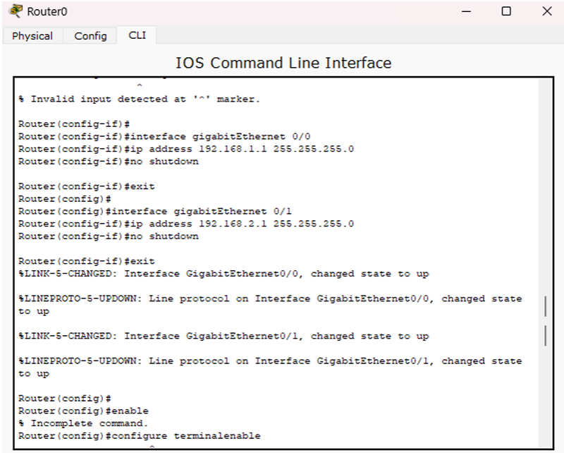

RESULT:
A simple network topology with one router, two switches, and PCs was successfully designed and configured using Cisco Packet Tracer.Connectivity between the network devices and PCs was successfully established and verified.
Ex.No.11 | STUDY OF SOCKET PROGAMMING IN PYTHON
Date: | STUDY OF SOCKET PROGAMMING IN PYTHON

Aim:
To study the concepts of socket programming in python.

STUDY OF SOCKET PROGAMMING IN PYTHON

A network socket is one endpoint of a two-way communication link between two programs running on a network. It is a software-based handle combining an IP address and a port number, allowing different processes to send and receive data across a device or the internet
Socket programming in python
- Python's core networking library is Socket Module.
- Python's socket module has both class-based and instances-based methods.
- Class-based method is an intuitive approach which doesn't need an instance of a
- socket object.
- For example, in order to print a machine's IP address, you don't need a socket
- object. Instead, just call the socket's class-based methods.
- In instance-based method, if some data needed to be sent to a server application,
- it is more intuitive to create a socket object to perform that explicit operation.
- This module has everything you need to build socket servers and clients.

Algorithm 1: TCP Server
Input: Client message
Output: Response message to the client
- Start
- Import the socket module.
- Create a TCP socket using socket().
- Bind the socket to the IP address localhost and port number 5000.
- Put the server socket into listening mode using listen().
- Wait for a client connection using accept().
- Receive the message from the client using recv().
- Decode the received message.
- Display the client's message.
- Create a response message.
- Encode and send the response to the client using send().
- Close the client connection.
- Close the server socket.
- Stop

TCP Client
Input: Message to be sent to the server
Output: Response received from the server
- Start
- Import the socket module.
- Create a TCP socket using socket().
- Connect to the server using connect() with localhost and port 5000.
- Create a message to send to the server.
- Encode the message.
- Send the message to the server using send().
- Wait for the server's response using recv().
- Decode the received response.
- Display the server's response.
- Close the client socket.
- Stop

PROGRAM(Server):
# TCP Server Program
import socket
# Create a socket
server_socket = socket.socket(socket.AF_INET, socket.SOCK_STREAM)
# Bind IP address and port
server_socket.bind(("localhost", 5000))
# Listen for client connection
server_socket.listen(1)
print("Server is waiting for connection...")
# Accept client connection
conn, address = server_socket.accept()
print("Client connected:", address)
# Receive message from client
message = conn.recv(1024).decode()
print("Message from client:", message)
# Send response to client
response = "Hello Client! Message received successfully."
conn.send(response.encode())
# Close connection
conn.close()
server_socket.close()

PROGRAM (CLIENT):
# TCP Client Program
import socket
# Create a socket
client_socket = socket.socket(socket.AF_INET, socket.SOCK_STREAM)
# Connect to server
client_socket.connect(("localhost", 5000))
# Send message to server
message = "Hello Server!"
client_socket.send(message.encode())
# Receive response from server
response = client_socket.recv(1024).decode()
print("Message from server:", response)
# Close connection
client_socket.close()

SAMPLE OUTPUT:
Server Output
C:\Python> python server.py

Server is waiting for connection...
Client connected: ('127.0.0.1', 54321)
Message from client: Hello Server!

Client Output
C:\Python> python client.py

Message from server: Hello Client! Message received successfully.

OUTPUT:

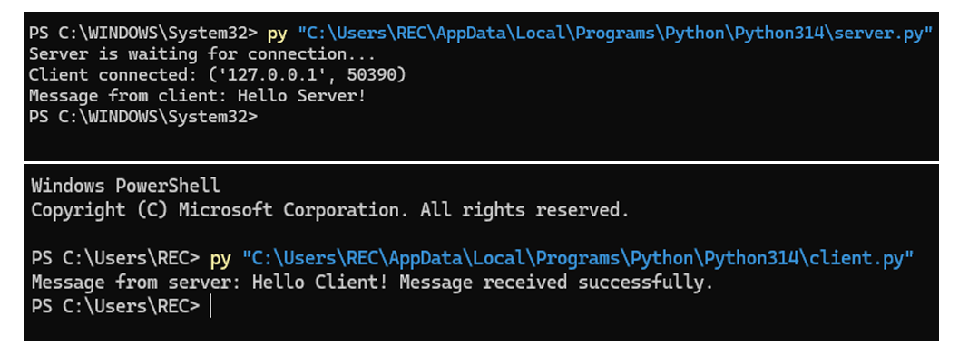

RESULT: Python socket programming was successfully studied and implemented.
Client-server communication was established successfully using TCP/IP sockets.

Ex.No.12 | Examine Network Address Translation (NAT) using Cisco Packet Tracer
Date:

AIM:
To configure and examine Network Address Translation (NAT) using Cisco Packet Tracer and verify communication between a private network and a public network.
Requirements
- Cisco Packet Tracer
- 1 Router (Cisco 1941)
- 2 Switches (Cisco 2960)
- 2 PCs
- Copper Straight-Through cables
Network Topology
Private Network Public Network

PC0 -------- Switch0 -------- Router -------- Switch1 -------- PC1
192.168.1.10 NAT Router 203.0.113.10
G0/0 Public PC
192.168.1.1
|
G0/1
203.0.113.1
IP Addressing
Device | Interface | IP Address | Subnet Mask
PC0 | FastEthernet0 | 192.168.1.10 | 255.255.255.0
Router | G0/0 | 192.168.1.1 | 255.255.255.0
Router | G0/1 | 203.0.113.1 | 255.255.255.0
PC1 | FastEthernet0 | 203.0.113.10 | 255.255.255.0
PROCEDURE
Step 1: Create the topology
- Open Cisco Packet Tracer.
- Place:
  - Two PCs.
  - Two 2960 switches.
  - One 1941 router.
- Connect:
  - PC0 → Switch0.
  - Switch0 → Router G0/0.
  - Router G0/1 → Switch1.
  - Switch1 → PC1.
- Use Copper Straight-Through cables.
Step 2: Configure PC0
Go to:
PC0 → Desktop → IP Configuration
Enter:
IP Address : 192.168.1.10
Subnet Mask : 255.255.255.0
Default Gateway : 192.168.1.1
Step 3: Configure PC1
Go to:
PC1 → Desktop → IP Configuration
Enter:
IP Address : 203.0.113.10
Subnet Mask : 255.255.255.0
Default Gateway : 203.0.113.1
Step 4: Configure the Router
Open:
Router → CLI
Configure the inside interface:
Router> enable
Router# configure terminal

Router(config)# interface gigabitEthernet 0/0
Router(config-if)# ip address 192.168.1.1 255.255.255.0
Router(config-if)# ip nat inside
Router(config-if)# no shutdown
Router(config-if)# exit
Configure the outside interface:
Router(config)# interface gigabitEthernet 0/1
Router(config-if)# ip address 203.0.113.1 255.255.255.0
Router(config-if)# ip nat outside
Router(config-if)# no shutdown
Router(config-if)# exit
Step 5: Configure NAT
Create an access list to identify the private network:
Router(config)# access-list 1 permit 192.168.1.0 0.0.0.255
Configure PAT (NAT Overload):
Router(config)# ip nat inside source list 1 interface gigabitEthernet 0/1 overload
This allows multiple private IP addresses to share the router's outside IP address.
Step 6: Verify the Router Configuration
Execute:
Router# show ip interface brief
Expected output:
Interface IP-Address Status
GigabitEthernet0/0 192.168.1.1 up
GigabitEthernet0/1 203.0.113.1 up
Step 7: Test Connectivity
From PC0, open:
Desktop → Command Prompt
Enter:
ping 192.168.1.1
Expected:
Reply from 192.168.1.1: bytes=32 time<1ms TTL=255
Now test the public-side PC:
ping 203.0.113.10
Expected:
Reply from 203.0.113.10: bytes=32 time<1ms TTL=127
Step 8: Verify NAT Translation
Generate traffic from PC0 by pinging PC1:
PC0> ping 203.0.113.10
Then, on the router, enter:
Router# show ip nat translations
Sample output:
Pro Inside global Inside local Outside local Outside global
icmp 203.0.113.1:1 192.168.1.10:1 203.0.113.10:1 203.0.113.10:1
This shows that the private IP address 192.168.1.10 has been translated to the router's public IP address 203.0.113.1.
Step 9: Verify NAT Statistics
Enter:
Router# show ip nat statistics
Sample output:
Total active translations: 1

Inside interfaces:
GigabitEthernet0/0

Outside interfaces:
GigabitEthernet0/1

Hits: 5
Misses: 0
The exact numbers may vary depending on the number of packets generated.

SAMPLE OUTPUT
PC0 pinging PC1:
PC> ping 203.0.113.10

Pinging 203.0.113.10 with 32 bytes of data:

Reply from 203.0.113.10: bytes=32 time<1ms TTL=127
Reply from 203.0.113.10: bytes=32 time<1ms TTL=127
Reply from 203.0.113.10: bytes=32 time<1ms TTL=127
Reply from 203.0.113.10: bytes=32 time<1ms TTL=127

Ping statistics:
Packets: Sent = 4, Received = 4, Lost = 0 (0% loss)
NAT Translation Table:
Router# show ip nat translations

Pro Inside global Inside local Outside local Outside global
icmp 203.0.113.1:1 192.168.1.10:1 203.0.113.10:1 203.0.113.10:1

OUTPUT:

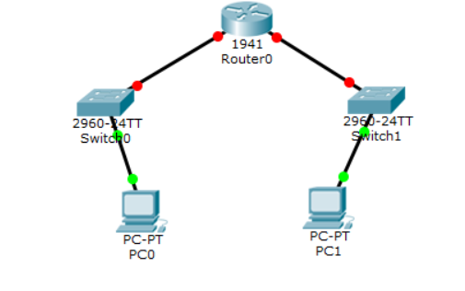
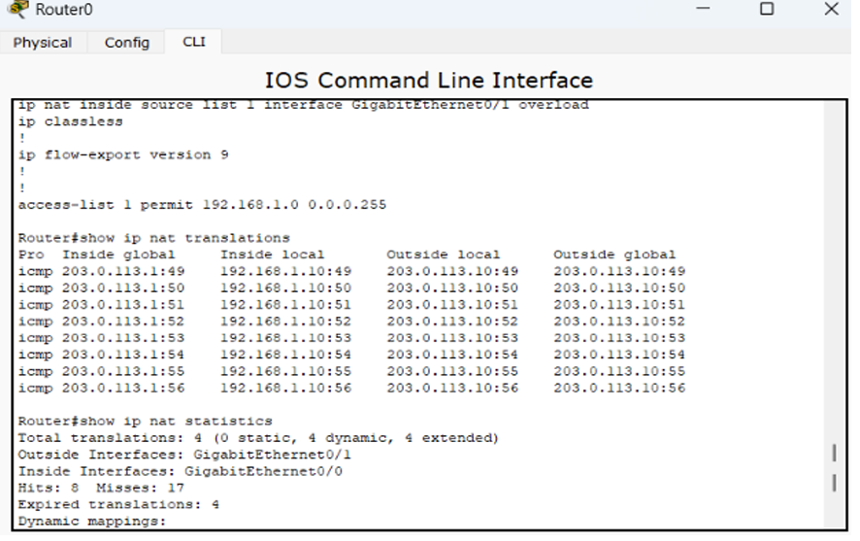

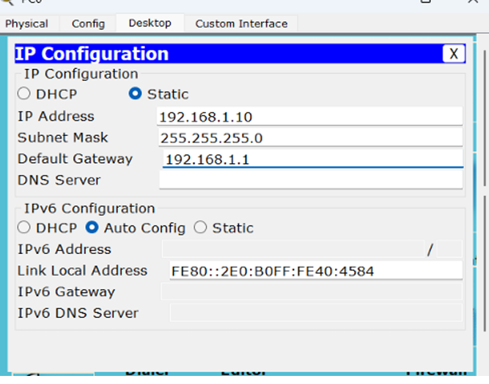

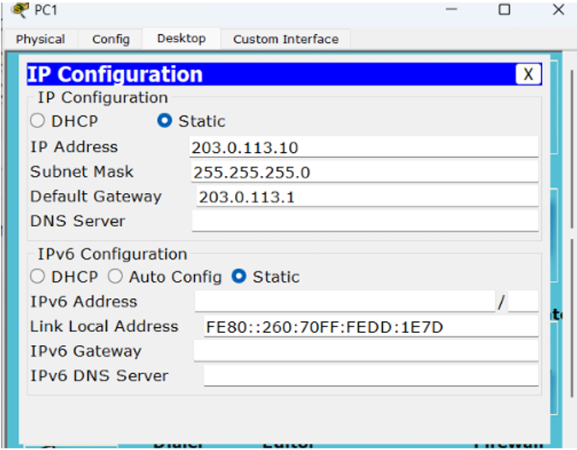

RESULT
Thus, Network Address Translation (NAT) was successfully configured and examined using Cisco Packet Tracer. The private IP address 192.168.1.10 was translated into the public IP address 203.0.113.1, and successful communication with the public network was verified.

Ex. No:13 | NETWORK FORENSICS USING PCAPXRAY TOOL
DATE: | NETWORK FORENSICS USING PCAPXRAY TOOL

PcapXray is a network forensics tool. Its main purpose is to take a captured network traffic file (.pcap or .pcapng) and help you understand what happened on the network
AIM:
To analyze a PCAP file using PcapXray and visualize network activity for basic network forensic investigation.
ALGORITHM: For Installing PCAP and Analyzing:
- Install PcapXray dependencies using: sudo pip3 install -r requirements.txt
- Launch the tool with: sudo python3 PcapXray.py
- Open the web interface and upload the given PCAP file.
- Click Analyze to process the packet data.
- View the generated network topology and communication graph.
- Examine hosts, protocols, and suspicious connections.
- Save the generated report and diagrams for documentation.
Working entirely in Chrome without installing:
https://wiki.wireshark.org/SampleCaptures
What to do
- Open the link above.
- Find ipv4frags.pcap.
- Download it to your Downloads folder.
- Open your online PCAP analyzer.
- Click Upload.
- Select:
ipv4frags.pcap
7.Click Analyze.
Working entirely in Chrome without installing:
Yes. Let me show you exactly what to click and what to look for in A-Packets. You can do this entirely in Chrome.
Step 1 — Open A-Packets
Open the official upload page:
A-Packets PCAP Upload
You should see “Choose a PCAP” / “Click or Drop to Select.” A-Packets currently accepts .pcap, .pcapng, and .cap files, with a 25 MB free limit.

Step 2 — Get a sample PCAP
For your first experiment, use a sample PCAP, not your personal network traffic.
You can download ipv4frags.pcap from the Wireshark sample captures collection:
Wireshark Sample Captures
Save the file in your Downloads folder.
Step 3 — Upload the file
On A-Packets:
Click/Drop to Select
Then:
Downloads → ipv4frags.pcap → Open
You should see the filename appear on the page.
Then click:
Upload PCAP and Analyze
A-Packets says the analysis normally takes only a short time, depending on the capture.
Step 4 — Examine the results
After processing, you'll get a results page.
Summary:
This gives you an overview of the PCAP, such as:
- Number of packets
- Capture duration
- Traffic information
- Hosts involved
The A-Packets documentation describes a summary and traffic analysis view


After Uploading PCAP View Report:
SAMPLE OUTPUTS:
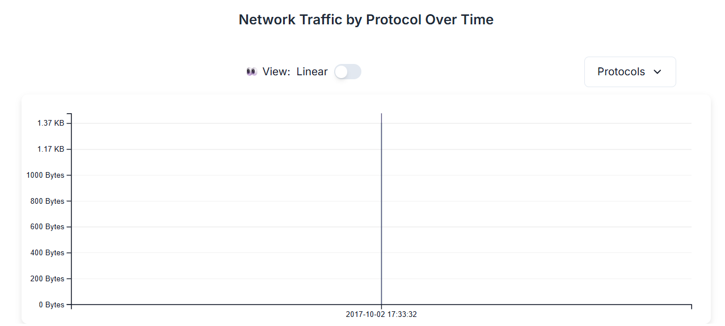
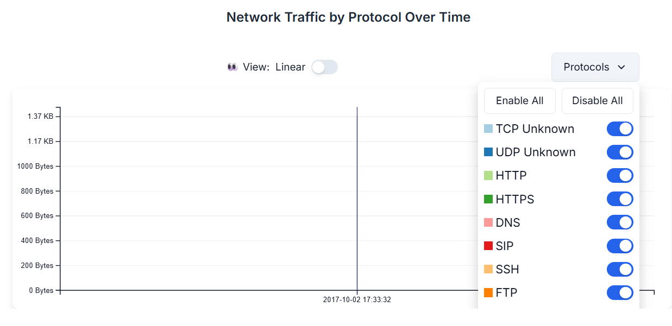
OUTPUT:

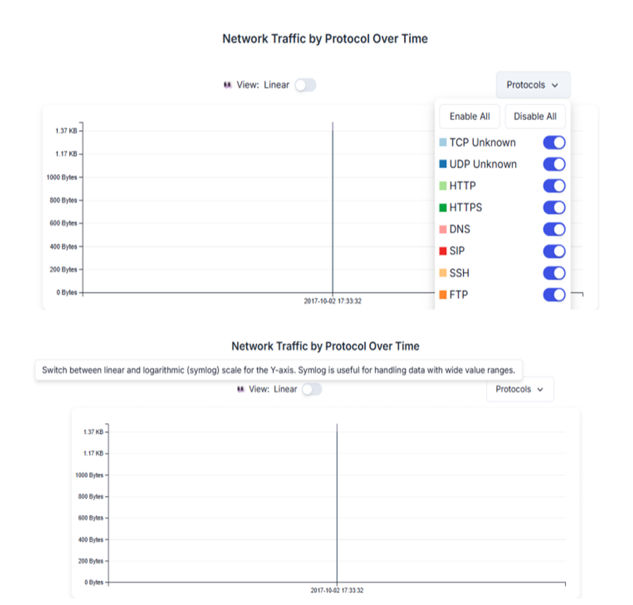

RESULT:
The PCAP file was successfully analyzed using PcapXray, and the network activities, communicating hosts, and protocols were identified and visualized.

Ex.No.14 | To Analyze the different types of servers using Webalizer tool
DATE:

Aim
To install, configure, and execute the Webalizer log analysis tool on a Windows operating system to analyze raw server logs and generate interactive HTML dashboards containing traffic graphs and usage statistics.

Apparatus Required
- Operating System: Windows 10 or Windows 11 (64-bit)
- Software Bundle: XAMPP for Windows (includes Apache Web Server and pre-configured Webalizer)
- Access Level: Windows Administrator privileges
- Web Browser: Microsoft Edge, Google Chrome, or Mozilla Firefox

Theory
Server log files record every user transaction, but they are difficult to read in their raw .log text formats. Webalizer solves this by converting text logs into structured HTML pages.
While Webalizer is natively a Linux tool, it is seamlessly integrated into Windows environments using XAMPP. XAMPP automatically pipes the Apache web server log (access.log) into the Webalizer engine. Webalizer then calculates key performance indicators:
- Hits: Total number of files requested (images, text, pages).
- Files: Total number of successful requests fulfilled by the server.
- Pages: Pure HTML or PHP document views (ignoring individual embedded images).
- Visits: Distinct user journeys tracked via unique IP addresses.

Step-by-Step Procedure
Step 1: Install the XAMPP Server Environment
- Download the XAMPP installer for Windows from the official website.
- Double-click the installer executable file.
- During the Select Components prompt, ensure that Apache and Webalizer are checked.
- Complete the wizard to install XAMPP into the default directory: C:\xampp\.

Step 2: Start the Web Server
- Open the Windows Start Menu, search for XAMPP Control Panel, and run it as an Administrator.
- Click the Start button next to the Apache module. The module background will turn green, indicating the web server is actively running and generating log files.

Step 3: Locate the Log and Configuration Files
Verify where Windows is storing your logs and how Webalizer is targeting them:
  - Raw Server Logs Location: C:\xampp\apache\logs\access.log
  - Webalizer Configuration File Location: C:\xampp\webalizer\webalizer.conf
(Optional Tuning): If you open webalizer.conf using Notepad, you will observe that XAMPP has pre-written the paths using forward-slash formatting compatible with the tool:
text
LogFile c:/xampp/apache/logs/access.log OutputDir c:/xampp/htdocs/webalizer Use code with caution.

Step 4: Execute Webalizer Manually via Windows Command Prompt
- Press Win + R, type cmd, and hit Enter to launch the Command Prompt.
- Change the directory to the XAMPP Webalizer folder: cmd
cd C:\xampp\webalizer Use code with caution.
- Run the executable tool to process the active Windows logs: cmd
webalizer.exe
Use code with caution.
The command prompt will flash an information line confirming how many lines of te/t data it successfully read and converted.

Step 5: View and Analyze the HTML Reports
- Launch your web browser.
- Type the following address into the URL bar and press enter: http://localhost/webalizer/
- Click on the current calendar month link to view the visual traffic analysis charts, total system bandwidth usage, and data tables tracking user visits.

Step 6: Automate the Log Analysis using Windows Task Scheduler
To avoid running the command prompt manually every day, set up a background Windows Task:
- Press the Windows key, search for Task Scheduler, and open it.
- In the right-hand Actions menu, select Create Basic Task.
- Name your task XAMPP Webalizer Update and select Daily as the frequency trigger.
- Set the Action to Start a program.
- Click Browse and target the executable path: C:\xampp\webalizer\webalizer.exe
- In the Start in (optional) textbox, type C:\xampp\webalizer to ensure the program finds its default configuration parameters. Click Finish.

Conclusion
The Webalizer analysis program was successfully deployed and executed on the Windows OS environment via XAMPP. Raw, unorganized data entries in access.log were converted into comprehensive, easy-to-read web graphs. The setup provides administrators with a highly visual framework to evaluate server stress, incoming traffic spikes, and user distribution patterns.

Ex.No.15 | Building anonymous FTP Scanner using ftplib module
DATE: | Building anonymous FTP Scanner using ftplib module

AIM:
To build an anonymous ftp scanner using ftplib module in python.

Introduction:
FTP Scanner:
A tool that automatically scans IPs/hosts for active FTP servers. It tests connectivity and credentials, reporting successful logins and vulnerabilities.
ftplib:
A built-in Python library for working with the File Transfer Protocol (FTP). It allows connecting to FTP servers, logging in, listing directories, and transferring files.

ALGORITHM:
- Start.
- Import the ftplib module.
- Specify the FTP server hostname.
- Connect to the FTP server.
- Log in using the username anonymous and password anonymous.
- If the login is successful:
- Display the login status.
- Display the server's welcome message.
- Display the directory listing.
- Close the FTP connection.
- If the login fails, display an error message.
- Stop.

PROGRAM:
import ftplib
def anonymous_login(hostname):
try:
# Connect to the FTP server
ftp = ftplib.FTP(hostname)
# Login using anonymous credentials
response = ftp.login('anonymous', 'anonymous')
print(response)
# Check whether anonymous login is successful
if "230" in response:
print("\n[*] FTP Anonymous Login Succeeded.")
print("Server:", hostname)
# Display welcome message
print("\nWelcome Message:")
print(ftp.getwelcome())
# Display directory listing
print("\nDirectory Listing:")
ftp.dir()
# Close the FTP connection
ftp.quit()
except Exception as e:
print("Error:", e)
print("\n[-] FTP Anonymous Login Failed.")
# Main Program
hostname = "ftp.be.debian.org"
anonymous_login(hostname)

SAMPLE OUTPUT:
230 Login successful.

[*] FTP Anonymous Login Succeeded.
Server: ftp.be.debian.org

Welcome Message:
220 FTP Server Ready

Directory Listing:
drwxr-xr-x 2 ftp ftp 4096 Jan 10 2026 debian
drwxr-xr-x 2 ftp ftp 4096 Jan 10 2026 cdimage
drwxr-xr-x 2 ftp ftp 4096 Jan 10 2026 project
-rw-r--r-- 1 ftp ftp 512 README.txt

221 Goodbye.

OUTPUT:
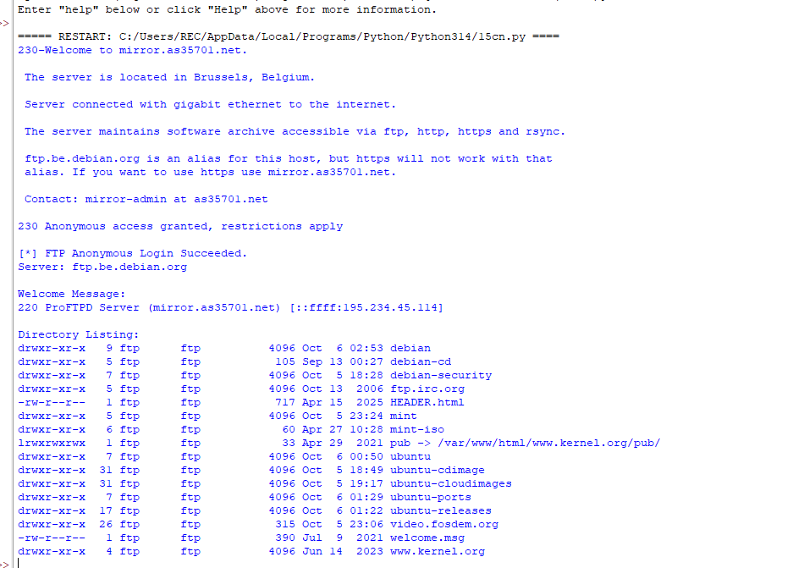

RESULT:
Thus an anonymous ftp scanner using ftplib module was built and executed successfully.

