**Name:** SUDHARSON.V

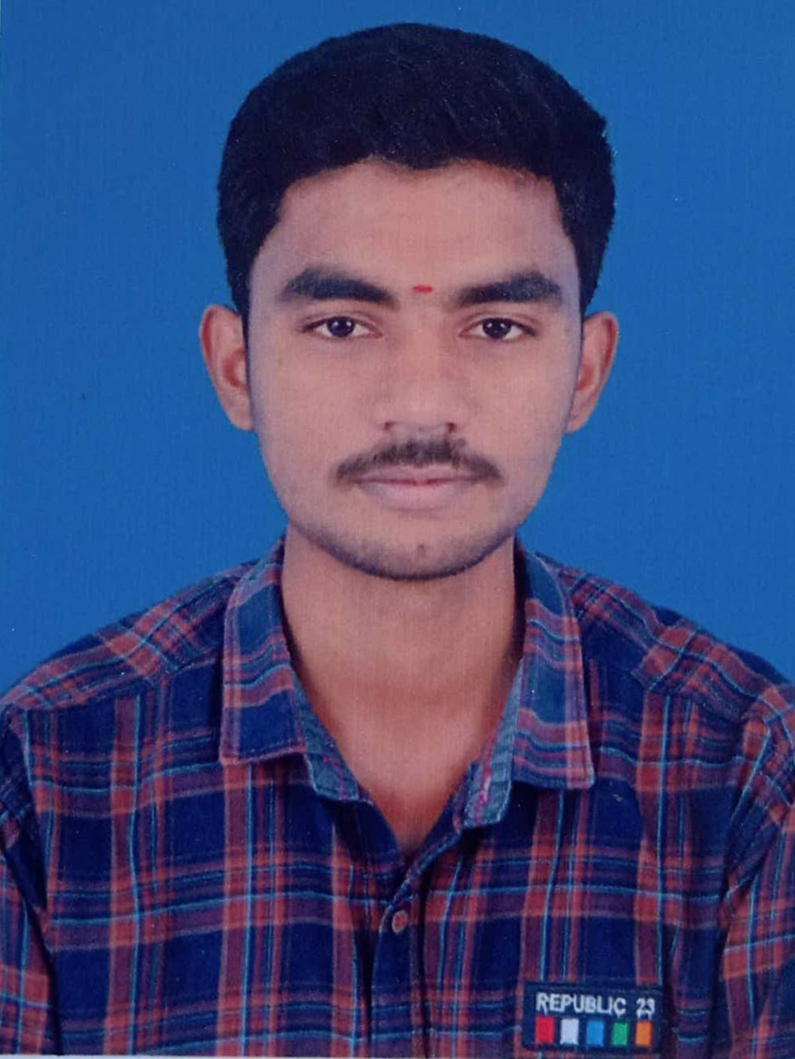

**Contact No:** 9361510166

**Email Id:**[vsudharsonsudharson@gmail.com](mailto:vsudharsonsudharson@gmail.com)

**________________________________________________________**

**Career Objectives:**

To enhance my professional skills, capabilities and knowledge in an organization which recognizes the value of hard work and trust me with responsibilities and challenges.

**Educational Information's:**

|  |  |  |  |  |
| --- | --- | --- | --- | --- |
| **Qualification** | **Institution** | **Board/ University** | **Year** | **Percentage of Marks** |
| **B.E**  **(EEE)** | **Mahendra Engineering College** | **Autonomous** | **2023** | **86.70%** |
| **HSC** | **St’Marys Hr. Sec. School** | **State Board** | **2019** | **60.67%** |
| **SSLC** | **St’Marys Hr. Sec. School** | **State Board** | **2017** | **80.8%** |

**Technical Skills:**

**Java**

* Good knowledge on Oops concepts.
* Good knowledge on Arrays and string.

**Python**

* Knowledge on string.
* Knowledge on functions.

**Oracle SQL**

* Having knowledge in writing SQL queries.
* Knowledge on DQL,DDL,DML.

**HTML**

* Basic.

**Certifications:**

* I have completed java and python for beginners courses in sololearn.

**Acadamic Project:**

* IOT based battery monitoring system.

**Personal Interest:**

* I have more interest in programming languages.

**Personal information's:**

**Date of Birth :**25-09-2000

**Language Known :**English, Telugu, Tamil.

**Present address :** 5/4111, Mettupatti Seshanchavadi(vali),

Vazhappaddy(TK),Salem - 636111

**Declaration:**

Hereby declare that all the information furnished above is true to the best of my knowledge and belief.

**Place :** Salem

Yours Faithfully

V.Sudharson

**Date :**