SLE-3: ARCHITECTURAL DESIGN (FULL C4 MODEL)
Course: 02AML204 – Introduction to Artificial Intelligence
PRN | ____________________
Name | ____________________
Division | A / B
Date | ____________________
1. System Title & Short Description
BFS/DFS Maze Search System. The system solves a maze-search problem using Breadth-First Search (BFS) and Depth-First Search (DFS). The user provides a maze with a start and goal position. The search engine explores possible paths and produces a search result or path. The architecture is divided into four C4 levels so the system can be understood from the overall user interaction down to the main functions.
2. Context Diagram — Level 1
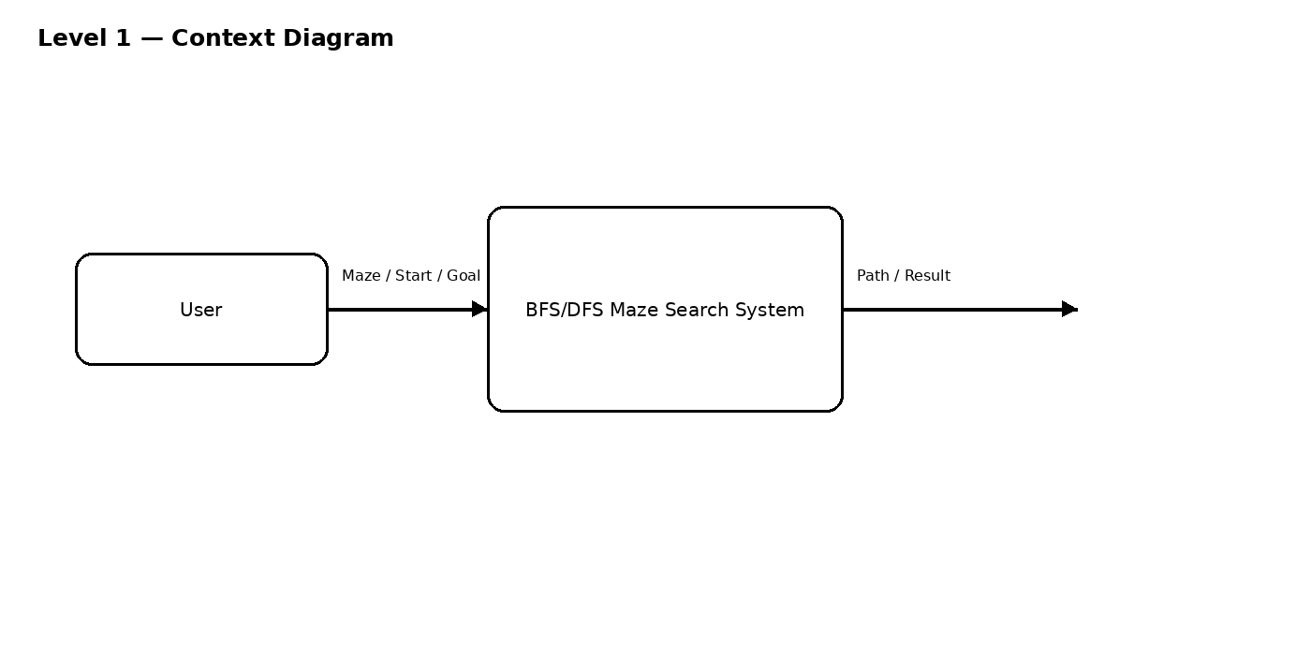
The user supplies the maze and search information to the Maze Search System. The system performs BFS or DFS and returns the search result or path to the user.
3. Container Diagram — Level 2
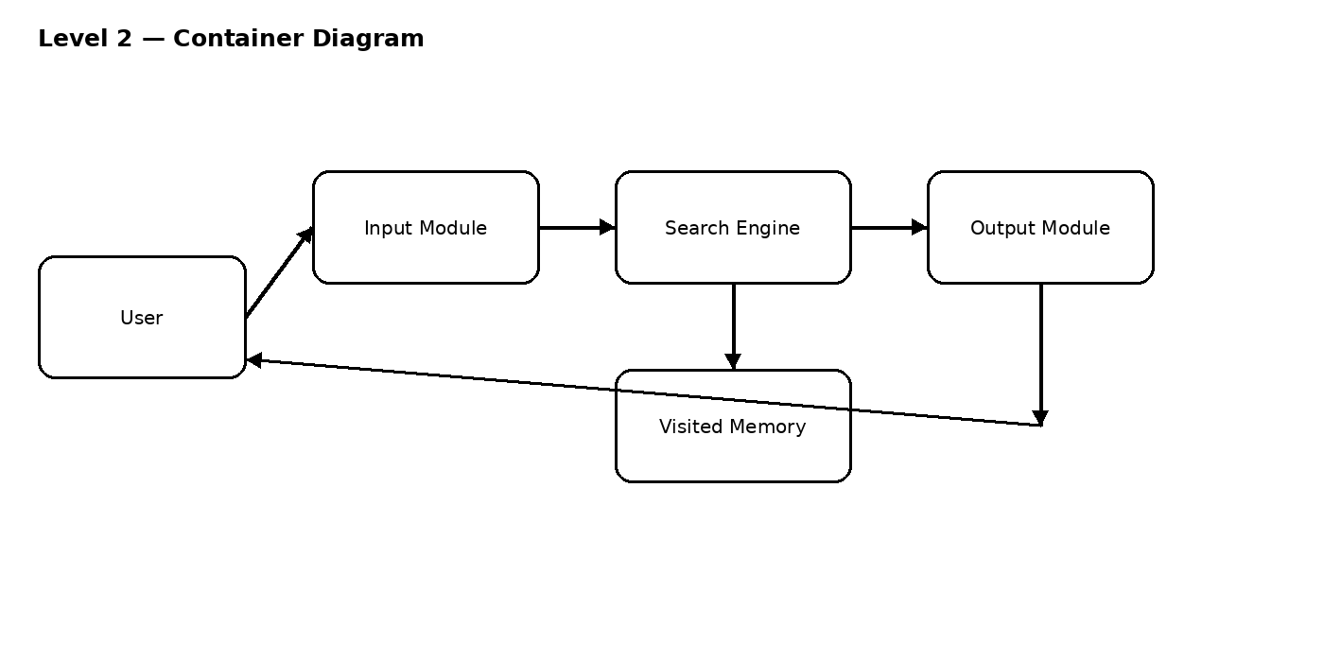
• Input Module: accepts the maze, start position, goal position and selected search method.
• Search Engine: runs the selected BFS or DFS algorithm.
• Visited Memory: stores explored positions to avoid repeated processing.
• Output Module: displays the path, result or failure to the user.

4. Component Diagram — Level 3
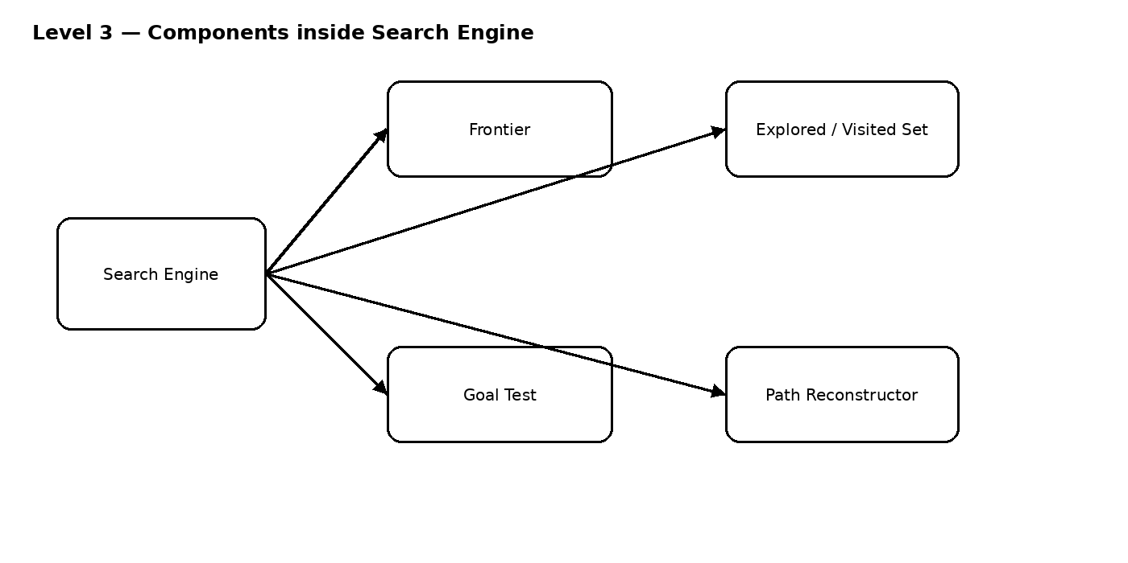
The Search Engine is the main container selected for component-level design. Frontier stores nodes waiting to be explored. The Explored/Visited Set records explored states. Goal Test checks whether the goal is reached. Path Reconstructor rebuilds the final path.
5. Code Level Overview — Level 4
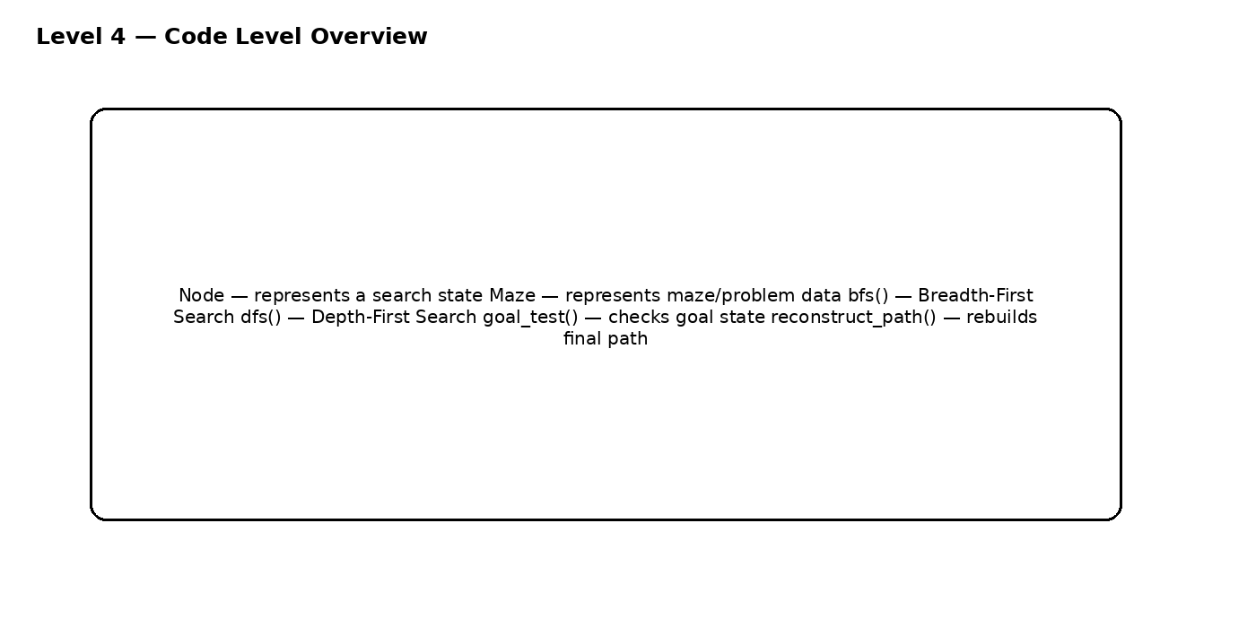
Only the main classes and functions are shown at this level; large source code is not required.
6. Design Decisions
The system is separated into input, search, memory and output responsibilities so each part has a clear purpose. BFS and DFS are kept inside the Search Engine because they are alternative search strategies for the same maze problem. Only the Search Engine is expanded into components to keep the C4 model simple and readable.
7. AI Contribution Note
AI tools used: ChatGPT, for learning C4 concepts, organizing the architecture and preparing explanations. AI helped with understanding the C4 levels, drafting diagram structure, simplifying explanations and preparing viva questions. I selected the BFS/DFS maze-search system, reviewed the architecture, understood the diagrams/functions, and will verify and explain the final submission.
8. Conclusion
This SLE-3 work helped me understand software architecture using the Full C4 Model. I learned how the same BFS/DFS maze-search system can be represented from a high-level context down to its main code functions. The architecture also makes the responsibilities of each part easier to understand and explain.

