High level design document

**1 Introduction**

This high-level design document describes about the scope and the problem statement related to the FDI (Foreign direct investment) on various sectors. This also describes the tools, data strategy used to drive a meaningful KPI to make use.

**1.2 Scope**

The HLD documentation presents the structure of the system, such as the database architecture, application architecture (layers), Application flow (Navigation), and technology architecture. The HLD uses non-technical to mildly-technical terms which should be understandable to the administrators of the system

**2 General Description**  
  
**2.1 Product Perspective & Problem Statement**  
  
FDI is an important reflection of the economy, and understanding the patterns of investments are of great interest for investors. In this project, we will explore the patterns of investments through the years of investment data and fields.  
  
The objective of the project is to perform data visualization techniques to understand the  
insight of the data. This project aims apply various Business Intelligence tools such as Tableau or Power BI to get a visual understanding of the data.

**2.2 Tools used**

* Power BI
* Power query Editor
* Excel for dataset

**3 Design Details**

**3.1 Functional Architecture**

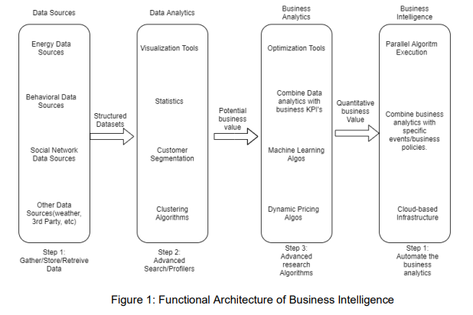

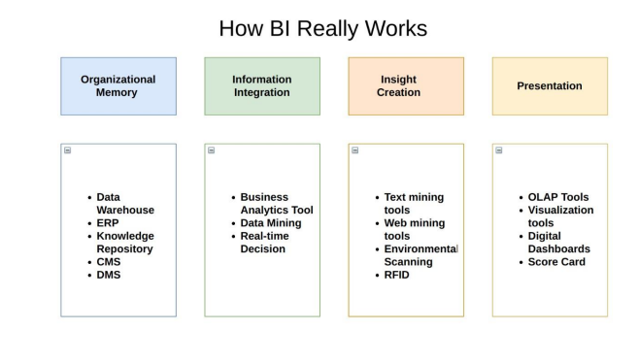

**3.2 Optimization**

**Data strategy**

**Minimize the number of fields**

The given data set contains only the required number of fields. So, there is no need to remove any fields.

**Minimize the number of records**

I could utilize all records of the dataset because it contained records that are valid and ready for consumption

**Optimize extracts to speed up future queries by materializing calculations, removing columns and the use of accelerated views**

1. The first row in the CSV file is a header. So, before using the dataset for processing in the BI, I configured the first row as the header in power query editor.
2. Every column data type has been changed to Decimal except first column which is in text data type.
3. Added a new column to represent the sum of every column in the row from 2001-01 to 2016-17 and also renamed column name as **Total-2001-2017**.
4. Added a new column to show the minimum amount of all columns in a given row from 2001-01 to 2016-17 in all Sectors and also renamed column name as **Minimum.**
5. Added a new column to show the maximum amount of all columns in a given row from 2001-01 to 2016-17 in all Sectors and also renamed column name as **Maximum**.
6. Added a new column to show the average amount of all columns in a given row from 2001-01 to 2016-17 in all Sectors and also renamed column name as **Average**.
7. In Power Query Editor Ribbon View menu bar, under column **quality, column distribution and column profile** have been checked for correctness
8. As a final step, closed and applied then loaded data into Power BI Report.

**4.   KPIs**

Dashboards will be implemented to display and indicate certain KPIs and relevant indicators for the disease

  As and when, the system starts to capture the historical/periodic data for a user, the dashboards will be included to display charts over time with progress on various indicators or factors

4 .1 KPIs (Key Performance Indicators)

**Key indicators displaying a summary of the FDI on with various sectors.**

**In which sector investment was consistently increased over the years? Justify with a graph.**

SERVICES SECTOR (Fin.,Banking,Insurance,Non Fin/Business,Outsourcing,R&D,Courier,Tech. Testing and Analysis, Other) - Service Sector has increase consistenly over year from 2013-2017, more investment coming from service sector.

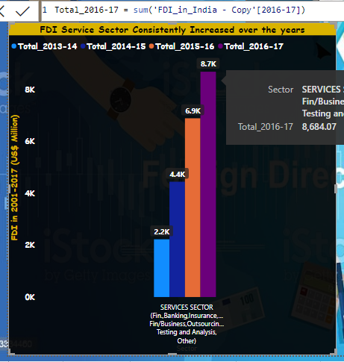

**Was there any decline of investments in any particular sector over the years? Justify with a graph**

PORTS Sector - Decline of investments year from 2011-12 to 2016-17.

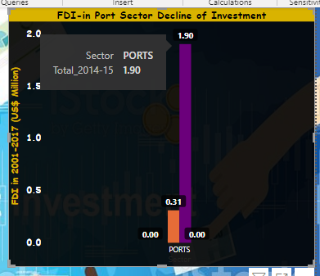

**In which sector investment is almost constant over the years? Justify with a graph**

Service Sector, automobile industry, Telecommunication and Computer Software investment is almost constant over the years

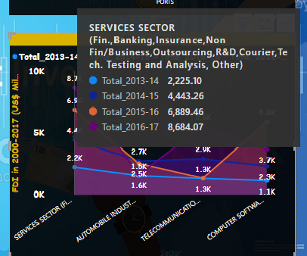

**Is there any particular year in which one or more investments were below the average? Justify with a graph**

5 Sectors are below average almost all the years:

COIR

Defence Industries

MATHEMATICAL,SURVEYING AND DRAWING INSTRUMENTS

Coal Production

PHOTOGRAPHIC RAW FILM AND PAPER

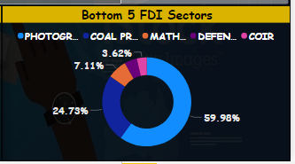

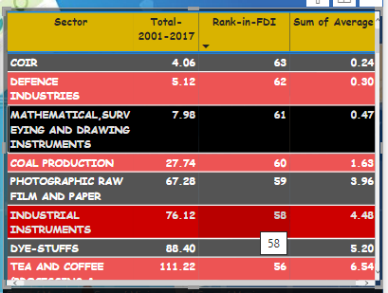

**Was there any sudden change(increase/decrease) in the investment during these years? Justify with a graph**

In the year 2011-12, increased investment all the sectors, expect Automoble industry and MISCELLANEOUS INDUSTRIES

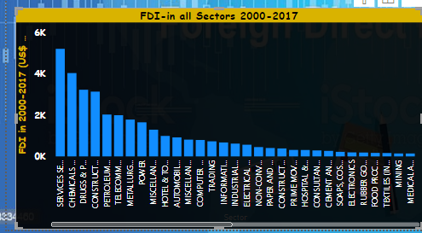

**Show me the top 5 sectors to invest in? Can you show the data to justify it?**

Services Sector

Computers Software & Hardware

Construction Development

Telecommunication

Automobile Industry

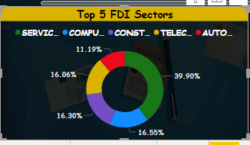

**5 Deployment**

I’m using the connectivity Type – Import for the FDI analysis. In case if there are any addition of sectors or more records available, we can export the data from the source system and import it into the power BI to see the expected result.

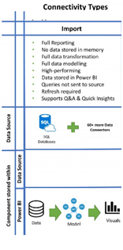

**Power BI Communication Flow**

