## Low Level Design

Project Title: **Foreign Direct** **Investment Analytics**

**Data Processing and reporting:**

Power BI is a business platform that includes several technologies to work together. It delivers outstanding business intelligence solutions. Power BI Architecture contains four steps.

Let us discuss these four steps giving insightful information about each one of them.

1. Data Integration
2. Data Transforming
3. Report & Publish
4. Creating and Dashboard

### **1. Data Integration:**

Data has been extracted from FDI data bases and shared as dataset in an excel sheet. The data was represented in the CSV format. I imported the file into the Power BI, it got placed into the staging area. Used the below tool for data processing

* Power BI premium

### **2. Data Transforming:**

Integrated data is not ready to visualize data because the data should be transformed. To transform the data, it should be cleaned or pre-processed. For example, I changed the data type from string to decimal. After data is pre-processed or cleaned, business rules are applied to transform the data. After processing the data, it is loaded into the power BI

|  |
| --- |
|  |

### **3. Report & Publish:**

After sourcing and cleaning the data, I created the reports. Reports are the visualization of the data in the form of slicers, graphs, and charts. Power BI offers a lot of custom visualization to create the reports. After creating reports, I published them to power bi services and also publish them to an on-premise power bi server.

### **4. Creating Dashboards:**

I have created dashboards after publishing reports to Power BI services, by holding the individual elements. The visual retains the filter when the report is holding the individual elements to save the report. Pinning the live report page allows the dashboard users to interact with the visual by selecting slicers and filters.

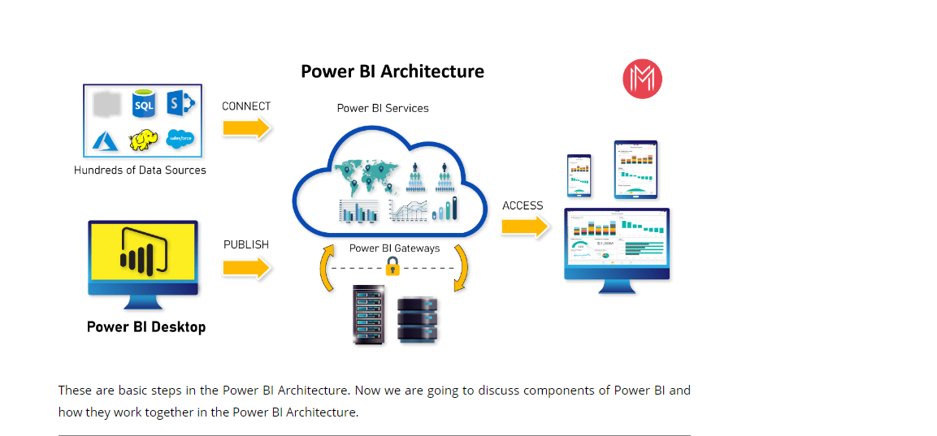

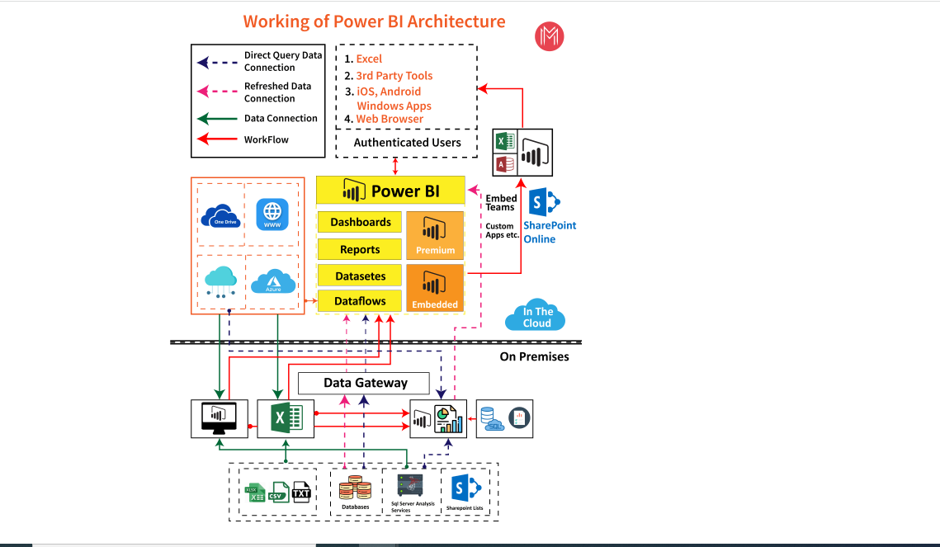

**Deployment.**

**Unit Test Cases**

**Test Case Description** **Expected Results**

FDI Sector in India slicer When clicked on the slicer, a dropdown list all the sectors, which describe the investment of year from 2001-2017.

Total FDI from 2001-2017 When clicked on the slicer, which describe column chart investment of all sectors.

Top 5 FDI Sectors When clicked on the slicer, which describe Donut chart top 5 investment of all sectors.

Min, Max & Avg. Investment This is an important visual in card which shows the investment of Max, Mini and Avg. investment across all sectors.

Rank-in-FDI This Table visual shows Rank of all sectors based on Investment from the year 2001-2017.