**Wireframe Documentation**

**Project Title: Investment Analytics**

**As per the problem statement, we have divided analysis into 5 pages: -**

1. **Home Page Design:**

**What is FDI?**

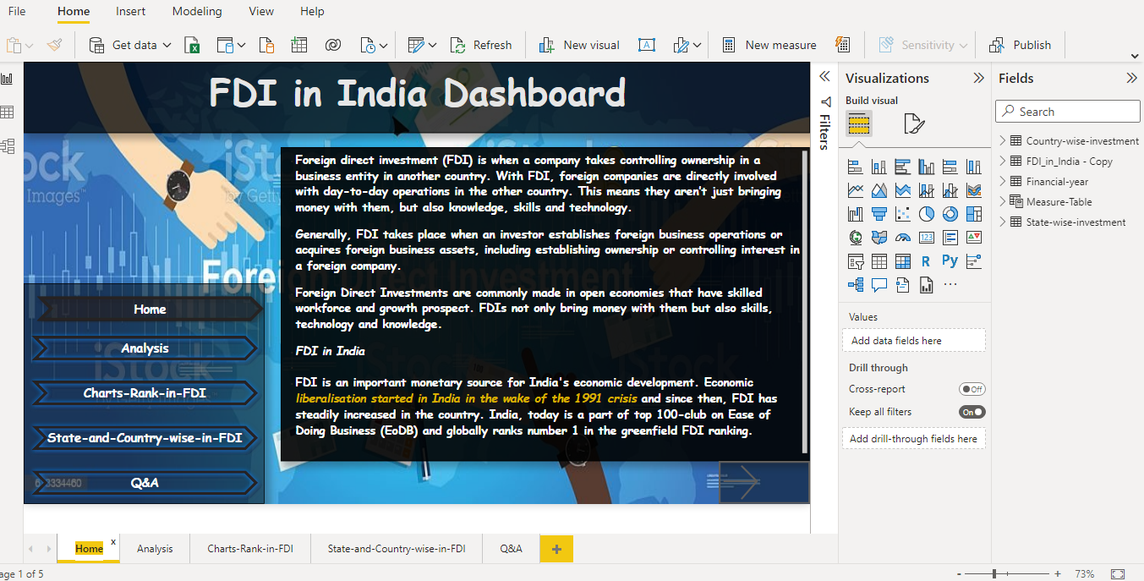

1. **Analysis Page Design:**

**Total FD Investment from 2001-2017 in all sectors**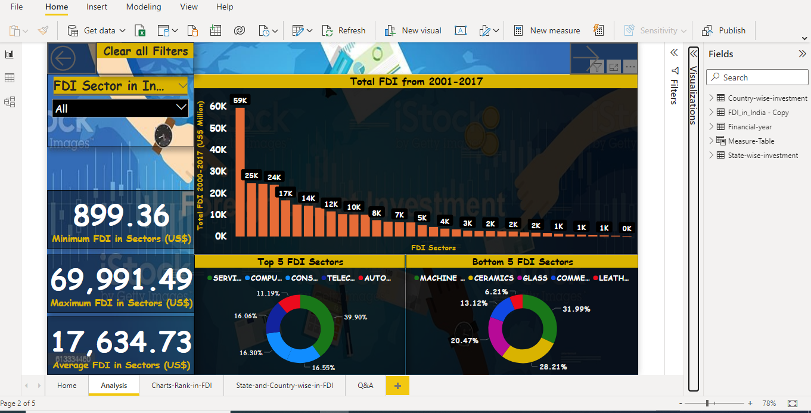

1. **Charts-Rank-in-FDI:**

**Total FD Investment every year from 2001-2017 in all sectors**

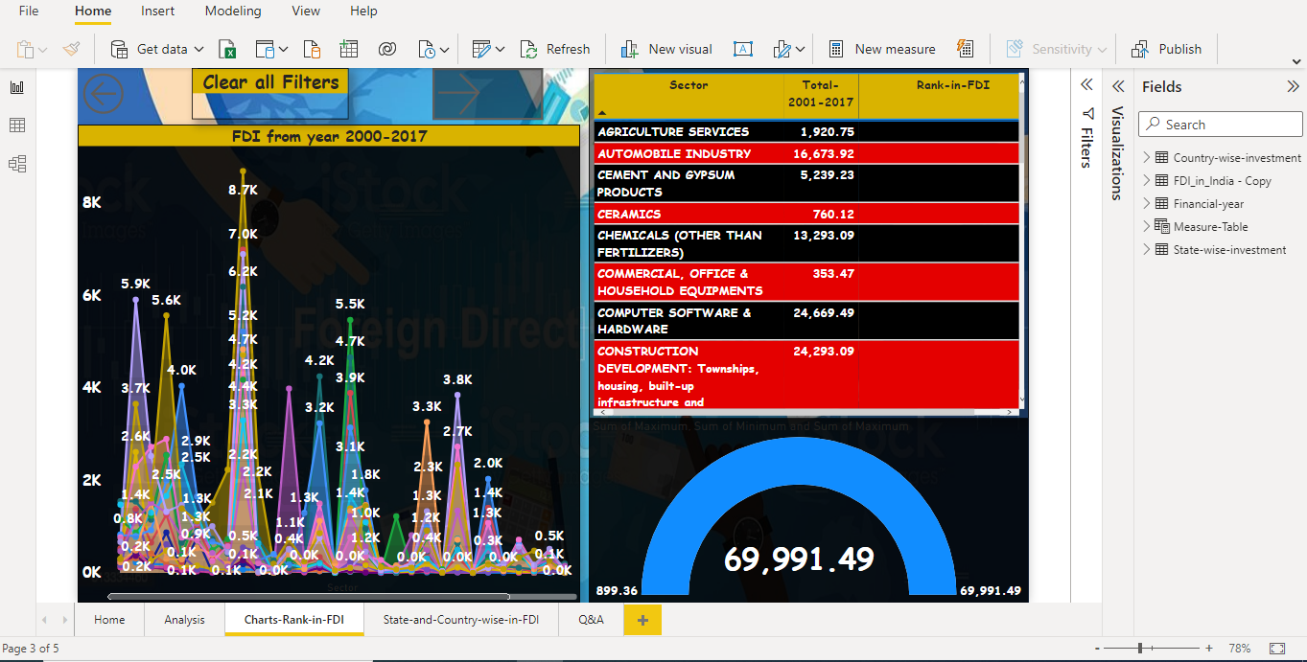

1. **State-and-Country-wise-in FDI:**

**Top 5 Country-wise Investment and Top 5 State-wise Investment**

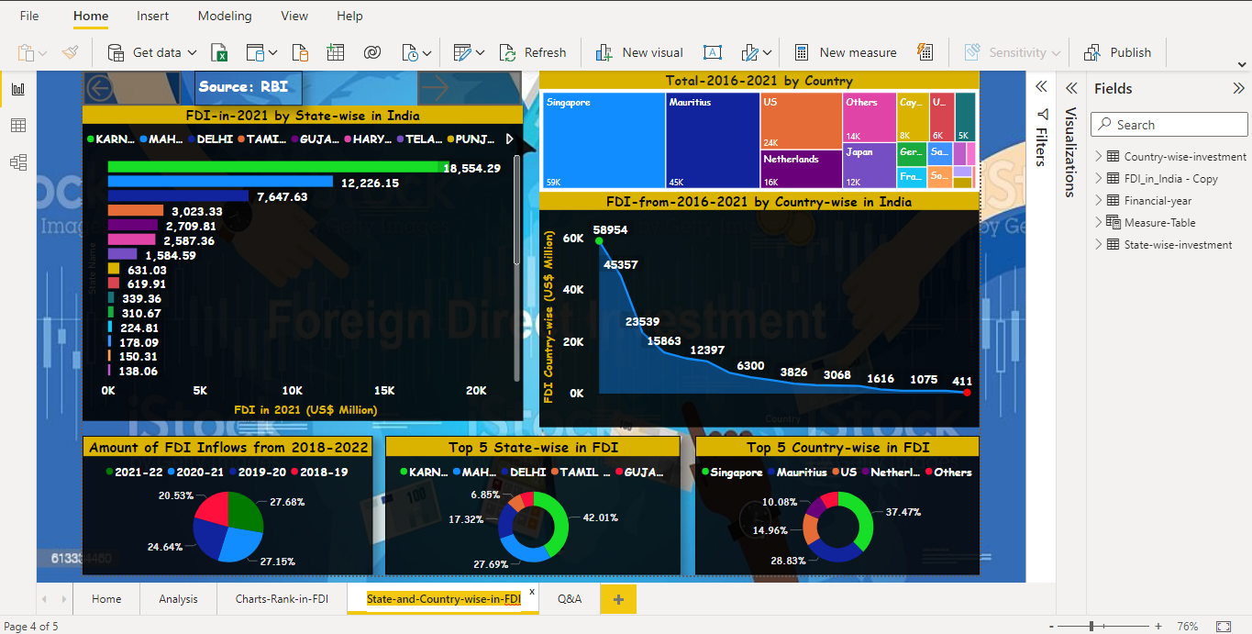

1. **QA Page:**

**Question and answer from our data analysis.**

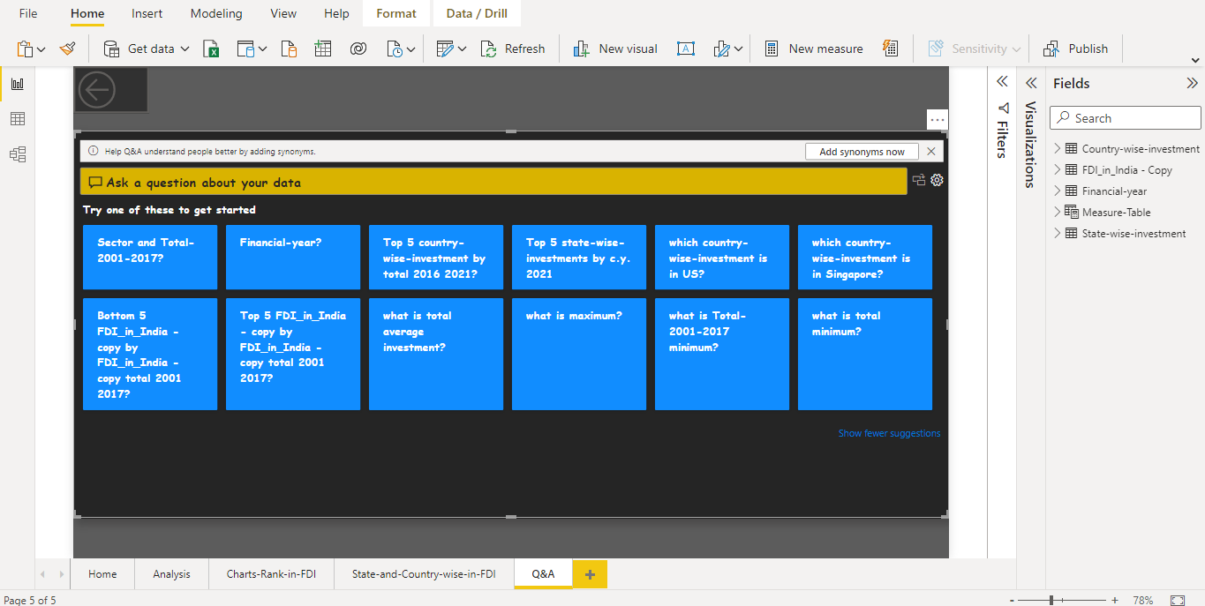

**Power Query Editor page:**

**FDI_in_India**

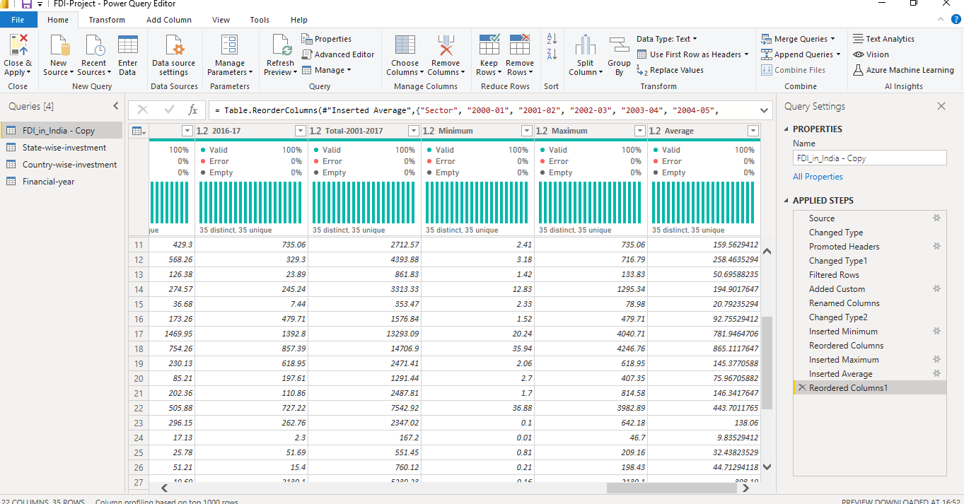

**State-wise-Investment:**

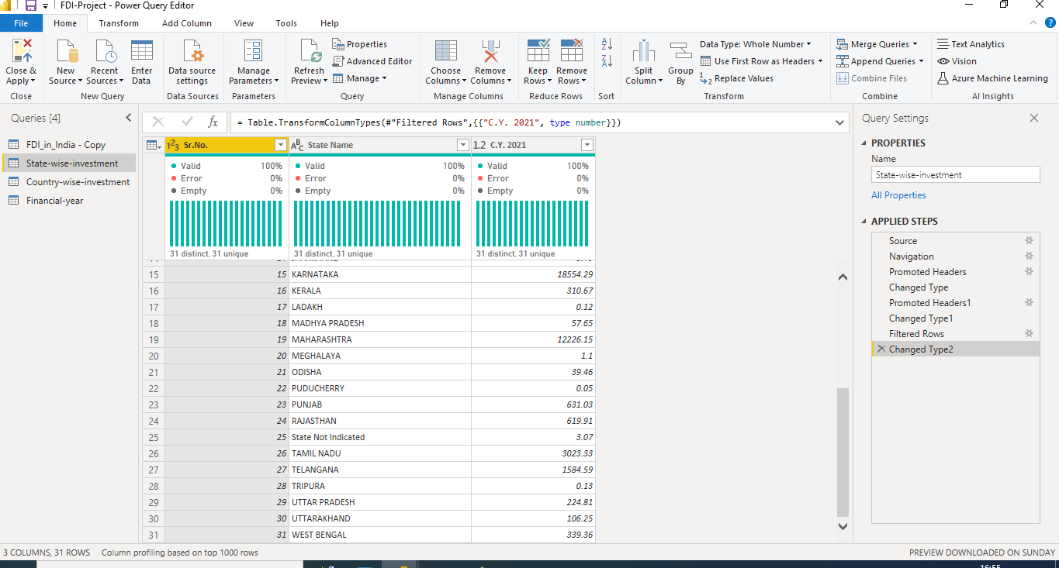

**Country-wise-Investment:**

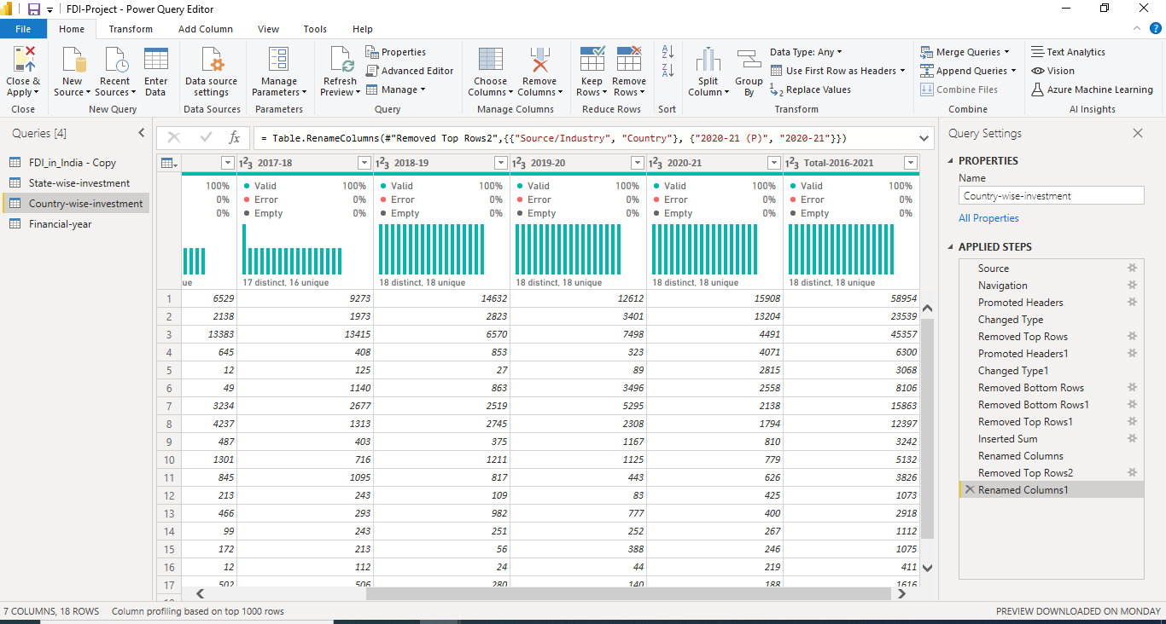

**Advance Editor Page in Power Query Editor:**

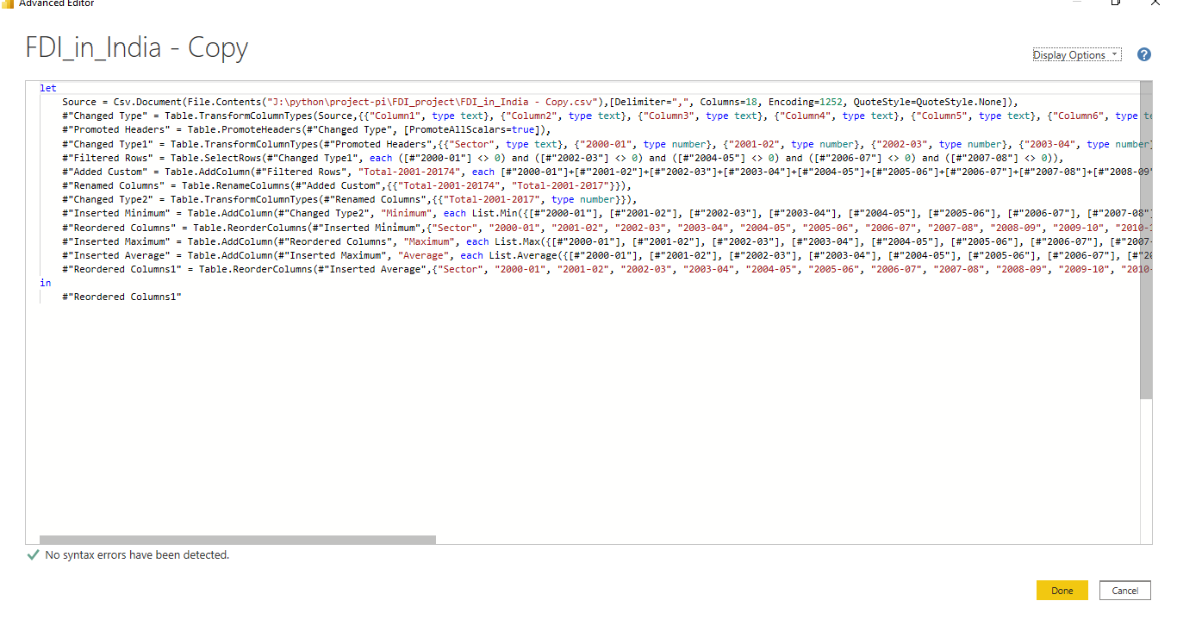

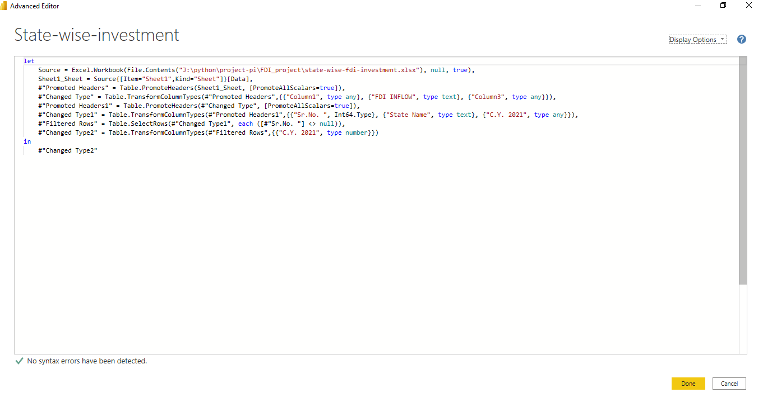

**New column added in Power BI Data: RankX, AverageX,MAXX and MINX**

