**Excel Assignment 6**

1. What are the various elements of the Excel interface? Describe how they're used.

* Quick Access Toolbar.
* File Tab.
* Title Bar.
* Control Buttons.
* Menu Bar.
* Ribbon/Toolbar.
* Dialog Box Launcher.
* Name Box.

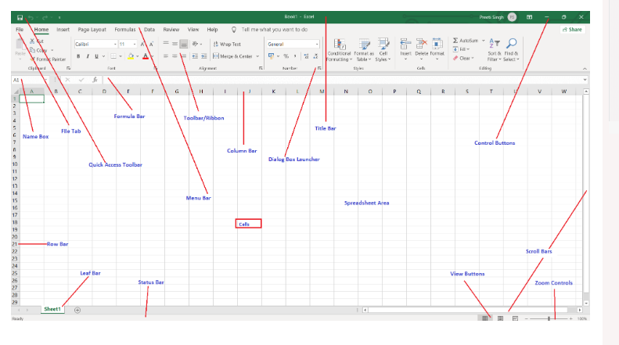

2. Write down the various applications of Excel in the industry.

The most common business uses of MS Excel are **business analysis, managing lists of people, operations management, and performance reporting**. The software is also handy for office administration, project management, and managing programs, contracts and accounts.

Microsoft Excel enables users to **identify trends and organize and sort data into meaningful categories**. Excel also performs Human Resources functions, such as sorting worked hours and organizing employee profiles and expenses, which help businesses better understand the structure and activities of their workforce.

3. On the ribbon, make a new tab. Add some different groups, insert commands in the groups and name them according to their commands added. Copy and paste the screenshot of the steps you followed.

**Select File > Options > Customize Ribbon.**

* To add a new tab to the ribbon, select New Tab.
* To add a custom group to a tab, select the tab we want to add a group to, and then select New Group. (Macros and All chart types)

[.](https://support.microsoft.com/en-us/office/video-customize-the-ribbon-9ce81e05-ecc1-4142-a3e3-1298b37a59c6)

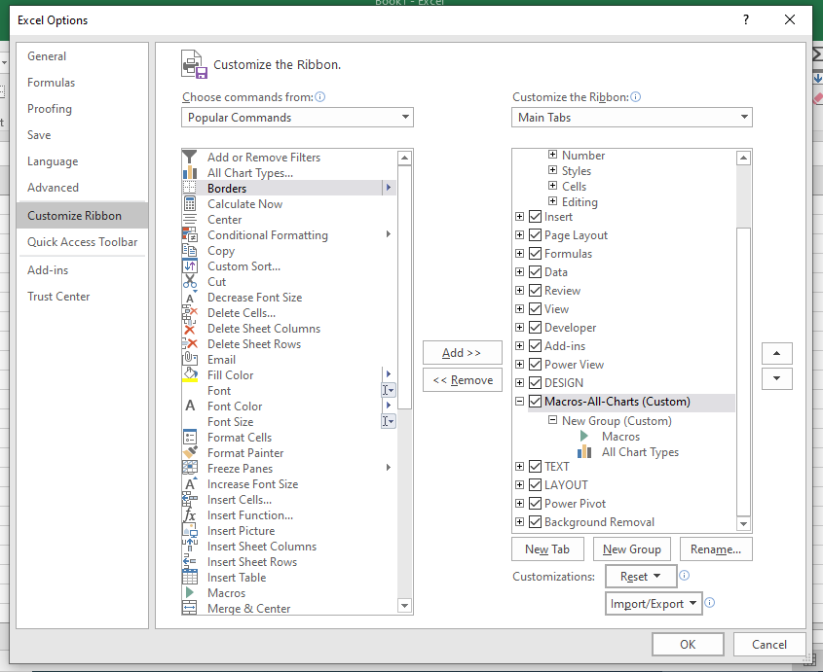

4. Make a list of different shortcut keys that are only connected to formatting with their functions.

Italicize text or remove italic formatting. Ctrl+I or Ctrl+3

Bold text or remove bold formatting. Ctrl+B or Ctrl+2

Underline text or remove underline. Ctrl+U or Ctrl+4

Apply or remove strikethrough formatting. Ctrl+5

5. What distinguishes Excel from other analytical tools?

Analyze Data in Excel **empowers you to understand your data through natural language queries that allow you to ask questions about your data without having to write complicated formulas**. In addition, Analyze Data provides high-level visual summaries, trends, and patterns.

Excel skills have been recognized as a valuable tool for data scientists and analysts because **it allows them to quickly manipulate, analyze, and visualize data without having to spend time learning complex programming languages such as Python or R**.

6. Create a table and add a custom header and footer to your table.

