**Excel Assignment – 7**

1. Using Insert Function, give examples of any function available in the different dropdowns present in the function library. For example AutoSum, Recently Used, Text, Date & Time, etc.

* Formulas tab, Insert Function.
* Pressing (Shift + F3)
* Clicking the Insert Function button "fx".
* Typing an equal sign directly into a cell. This method does not display the "Insert Function" dialog box.
* Using the Name Box on the left of the formula bar.

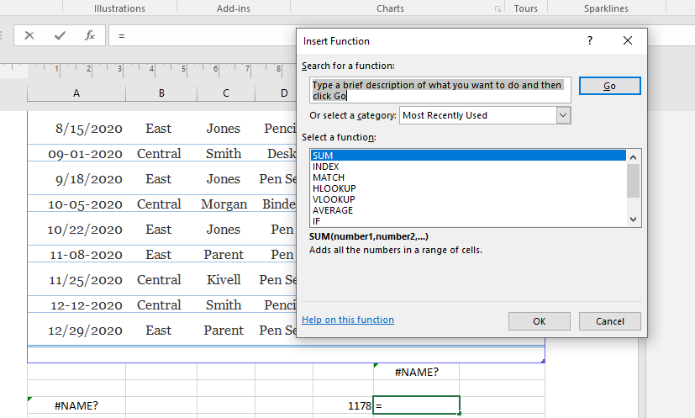

2. What are the different ways you can select columns and rows?

**Click on any cell in the column and then press Ctrl + Space**. Select the row number to select the entire row. Or click on any cell in the row and then press **Shift + Space**. To select non-adjacent rows or columns, hold Ctrl and select the row or column numbers.

3. What is AutoFit and why do we use it?

Excel's AutoFit feature is **designed to automatically resize cells in a worksheet to accommodate different sized data without having to manually change the column width and row height**. AutoFit Column Width - changes the column width to hold the largest value in the column

4. How can you insert new rows and columns into the existing table?

* Click where you want in your table to add a row or column and then click the Layout tab (this is the tab next to the Table Design tab on the ribbon).
* To add rows, click Insert Above or Insert Below and to add columns, click Insert Left or Insert Right.

5. How do you hide and unhide columns in excel?

On the Home tab, in the Cells group, click Format. Do one of the following: **Under Visibility, click Hide & Unhide, and then click Unhide Rows or Unhide Columns**.

6. Create an appropriate table within the worksheet and use different functions available in the AutoSum command.

The AutoSum button includes a menu that appears when you click the arrow next to the button. You can enter the **Average, Count, Max, or Min** function almost as easily as you can enter the Sum function all it takes is an extra click to select the function you want from the menu.