**Excel Assignment – 8**

1. What do you mean by AutoComplete feature in Excel and what are the benefits of using this feature?

AutoComplete **helps you quickly insert functions and arguments while minimizing typing and syntax errors**. The AutoComplete menu shows you available options based on context, and you choose what you want to insert into your formula.

1. Explain working with workbooks and working with cells.

**A workbook is a spreadsheet program file that you create in Excel**. A workbook contains one or more worksheets. A worksheet (also known as a spreadsheet) consists of cells in which you can enter and calculate data. The cells are organized into columns and rows.

1. What is fill handle in Excel and why do we use it?

'Fill Handle' is **a tool that you can use to autocomplete lists in Excel**. For example, if you have to enter numbers 1 to 20 in cell A1:A20, instead of manually entering each number, you can simply enter the first two numbers and use the fill handle to do the rest.

1. Describe flash fill and what the different ways to access the flash fill are.

Flash Fill **automatically fills your data when it senses a pattern**. For example, we can use Flash Fill to separate first and last names from a single column, or combine first and last names from two different columns. Note: Flash Fill is only available in Excel 2013 and later.

Select the cells, Go to Data-> Data Tools -> Flash Fill,

**Flash Fill shortcut key**

One of the reasons why Excel is popular among its users is because of its shortcut keys. Excel provides shortcut key keys for almost every operation. Those who quickly want to access Flash Fill without using a mouse can run it directly from the keyboard using the shortcut keys: Ctrl + E.

Flash Fill is used to extract any substring, numbers from string, zip codes, or even allows the user to split cells in Excel.

1. Extract first name and last name from the mail id and then from the address column, extract the city, state, and pin code using the flash fill. Given below is an example of the columns you have to create. Paste the screenshot of what you have created using the flash fill command.

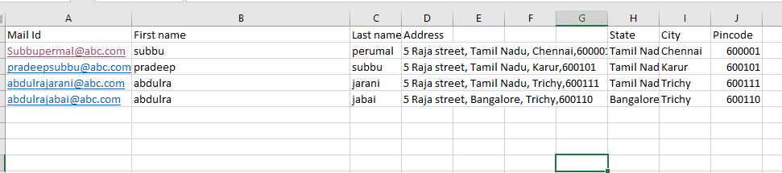

1. Give some examples of using the fill handle.

Add cell = A1+B1

Then press double click fill handle to do the rest.

|  |  |
| --- | --- |
|  |  |
|  |  |
|  |  |
|  |  |
|  |  |
|  |  |
|  |  |
|  |  |
|  |  |
|  |  |