

**SCHOOL OF SCIENCE, ENGINEERING AND TECHNOLOGY**

**COMP 222: RAPID APPLICATION DEVELOPMENT**

**PROJECT: INVENTORY MANAGEMENT SYSTEM**

**PRESENTED BY:**

**KEITANY ANTHONY: CS/MG/**

**FATMA HUSSEIN: CS/MG/**

**FELIX KIPROTICH:** **CS/MG/**

**KIPKORIR ENOCK: CS/MG/**

**OTIENO BILDAD MOSES OKOTH: CS/MG/1952/09/20**

Submitted to School of Science Engineering and Technology of Kabarak University in Partial Fulfillment of Award of Bachelor of Science in Computer Science

**MARCH 2023**

# TABLE OF CONTENTS

CHAPTER I 3

INTRODUCTION 3

1.1 Introduction to the system 3

1.2 Statement of the problem 3

1.3 Background of the study 3

1.4 Purpose of study 4

1.5 Objectives 5

1.7 Scope of the study 6

1.8 limitations of the study 6

1.9 Tools used 6

CHAPTER 2 7

ANALYSIS OF THE SYSTEM 7

2.1 System Requirement 7

2.2 System Overview 7

2.2.1 Centralized Architecture 7

2.2.2 Diverse Product Management 7

2.2.3 Multilocation Support 7

2.2.2 User Base and Roles 7

2.2.5 Procurement Lifecycle Management 7

2.2.6 Storage and Distribution 8

2.2.7 Real-Time Inventory Tracking 8

2.2.8 Order Processing 8

2.2.9 Integration with Point-of-Sale Systems 8

2.3 Context Diagram 8

2.4 Use Case Diagram 9

2.4 Sequence Diagram 10

2.5 Conclusion 11

CHAPTER 3 12

SYSTEM DESIGN 12

3.1 System Architecture 12

CHAPTER 4 13

SYSTEM IMPLEMENTATION 13

4.1 Introduction 13

4.2 Coding 13

4.3 Testing Strategies 13

4.3.1 Unit Testing 13

4.3.2 Integration Testing 13

4.3.3 Functional Testing 13

4.3.4 Performance Testing 13

4.3.5 Usability Testing 13

4.4 Execution Snapshots 14

4.5 Specific Adjustments 14

# CHAPTER I

# INTRODUCTION

## Introduction to the system

This chapter gives a brief introduction and background information on Inventory Management System software web application. Its further proceeds to research problems, the main objective, specific objectives, research questions and the significance of the study

## 1.2 Statement of the problem

The existing inventory management systems utilized by organizations, particularly small to medium-sized ones, face several challenges and shortcomings that hinder their effectiveness in efficiently managing stocks. These challenges include: Inefficiencies in Stock Recording and Transactions: Current systems may lack the capability to accurately record and track day-to-day stock transactions, leading to discrepancies and inaccuracies in inventory levels and financial record Limited Integration and Analytical Capabilities: The absence of integration with other organizational processes, such as accounting systems, and the lack of advanced analytical features inhibit organizations' ability to derive meaningful insights from their inventory data, hindering informed decision-making and strategic planning .Scalability Issues: As organizations grow, the capacity of existing systems to handle increasing transaction volumes and complex stock management requirements becomes strained, resulting in operational inefficiencies and potential disruptions in supply chain management.

## 1.3 Background of the study

Inventory management is a critical aspect of organizational operations across various industries. Efficient inventory management ensures that organizations maintain optimal stock levels, minimize carrying costs, and meet customer demand effectively. In light of this importance, the development and implementation of robust Inventory Management Systems (IMS) have become increasingly prevalent. The need for accurate and streamlined inventory management processes has led organizations to adopt IMS software solutions. These systems automate inventory tracking, facilitate stock replenishment, and provide insights into inventory performance through data analysis and reporting functionalities.

The study focuses on the development and evaluation of an Inventory Management System tailored to the specific needs of the organization. The system aims to address key challenges encountered in traditional inventory management practices, such as manual record-keeping, data discrepancies, and inefficient stock monitoring.

## 1.4 Purpose of study

Inventory Management System" software, which is designed to streamline the recording and tracking of stock transactions within an organization. It is able to achieve its functionality by Recording Transactions: The software is responsible for capturing the day-to-day transactions related to the organization's stocks. This includes recording purchases from suppliers and sales to customers. For purchases, it logs details such as product information, quantity, and credit/debit transactions with the supplier. Similarly, for sales, it records details such as product sold, quantity, and credit/debit transactions with the customer.

Stock Management: The system maintains accurate stock levels by updating the inventory whenever a product is purchased. This ensures that the inventory is always up to date and reflects the current state of available products. This functionality is crucial for efficient inventory management, as it allows the organization to monitor stock levels and make informed decisions regarding replenishment.

Sales Reporting: One of the key features of the software is its ability to generate sales reports. After a product is sold, the system compiles relevant information to create detailed sales reports. These reports may include metrics such as total sales revenue, quantity of products sold, and profitability analysis. Sales reports provide valuable insights into the organization's sales performance and help in strategic decision-making.

Transaction Traceability: The software ensures transparency and accountability by maintaining a record of who sold each product. By associating sales transactions with specific personnel, the system reduces the risk of misunderstandings or disputes in the future. This traceability feature enhances accountability and helps in resolving any discrepancies that may arise.

Overall, the "Inventory Management System" software addresses the need for efficient management of stock transactions within an organization. By recording transactions, managing stock levels, generating sales reports, and ensuring transaction traceability, the software plays a vital role in optimizing inventory operations and facilitating informed decision-making

## 1.5 Objectives

1. To explore methodologies for optimizing inventory management processes and enhancing overall efficiency in tracking stock levels.
2. To identify and prioritize essential features in the IMS that cater to diverse business requirements, considering factors such as industry type, business size, and inventory complexity.
3. To seamlessly integrate usability testing into the IMS development process, ensuring continuous alignment with evolving user requirements and maintaining a user-friendly interface.
4. To systematically test the performance of the IMS, with a specific focus on translation accuracy, responsiveness, and overall reliability in day-to-day inventory operations.
5. To devise effective strategies for assessing the IMS's impact on user awareness, incorporating user feedback mechanisms and performance testing to measure responsiveness and user satisfaction.

**1.5.2 Research Questions**

1. How can the IMS effectively optimize user interaction to streamline inventory management methods and enhance overall user experience?
2. What methods can be employed to identify and prioritize essential features in the IMS, considering the diversity of user needs across different industries and operational contexts?
3. How can usability testing be seamlessly integrated into the IMS development process to ensure continuous alignment with evolving user requirements and expectations?
4. How can the IMS's performance, specifically focusing on order processing, stock updates, and reporting, be systematically tested to guarantee reliability and responsiveness in daily inventory operations?
5. What strategies can be devised to assess the effectiveness of the IMS in enhancing user awareness, incorporating user feedback mechanisms and performance testing for a comprehensive evaluation?

## 1.7 Scope of the study

The project's main objective is to analyze, improve, and implement an inventory management system that leverages theoretical knowledge in a practical environment. By addressing the specific needs of small to medium-sized organizations and transitioning from traditional paper-based systems to digital solutions, the project aims to enhance organizational efficiency and prepare individuals for the challenges of real-world problem-solving.

## 1.8 limitations of the study

Lack of Accounting Features: One limitation is that the software does not include accounting features. While it effectively manages inventory-related tasks such as recording stock information, purchases, and sales, it does not extend to full-fledged accounting functionalities such as managing financial transactions, generating financial statements, or handling tax calculations. Inadequacy for Large Organizations: Another limitation is that the software may not be suitable for large organizations. Since the main focus was on functional requirements, the software may lack scalability and robustness needed to handle the complex inventory management needs of large-scale enterprises.

## 1.9 Tools used

For the development IMS system, a variety of tools and techniques are used. For the development of the system the user requirements have to be written in the understandable form. The use of different graphical representation of the system process has been implemented in development of system for non-technical users to understand the system working process. We used the mostly used Tools and techniques for system development as:

HTML, CSS, SCSS

JDK 1.7_3

MySQL server

MS Word (Documentation)

# CHAPTER 2

# ANALYSIS OF THE SYSTEM

## 2.1 System Requirement

The analysis of the Inventory Management System (IMS) serves as a critical component in the continuous improvement of business processes. This chapter delves into a thorough examination of the current state of the IMS, identifying strengths, weaknesses, and potential areas for enhancement. The aim is to ensure the system aligns seamlessly with business objectives, user needs, and industry standards.

## 2.2 System Overview

The current IMS is a centralized system managing a diverse range of products across multiple locations. It caters to a user base of over 100 employees, overseeing the procurement, storage, and distribution of products. Key functionalities include real-time inventory tracking, order processing, and integration with point-of-sale systems.

### 2.2.1 Centralized Architecture

The current IMS operates on a robust centralized architecture, serving as the nerve center for managing a wide array of products distributed across multiple locations. This centralized approach ensures a unified and synchronized view of the entire inventory ecosystem, promoting consistency and accuracy in data management.

### 2.2.2 Diverse Product Management

The system caters to a diverse range of products, encompassing various categories, sizes, and specifications. From perishable goods with expiration dates to durable items, the IMS efficiently handles the intricacies of each product type. This versatility is crucial for businesses dealing with a wide spectrum of inventory.

### 2.2.3 Multilocation Support

Acknowledging the diverse operational landscape, the IMS extends its capabilities across multiple locations. Whether it's regional warehouses, retail outlets, or distribution centers, the system seamlessly integrates data from various locations, providing a holistic view of the entire supply chain.

### 2.2.2 User Base and Roles

With a user base exceeding 100 employees, the IMS accommodates the needs of a sizable workforce involved in different aspects of the supply chain. The system incorporates role-based access control, ensuring that users have access only to the functionalities pertinent to their responsibilities. This not only enhances security but also streamlines workflows.

### 2.2.5 Procurement Lifecycle Management

The IMS plays a pivotal role in overseeing the end-to-end procurement lifecycle. From supplier negotiations to purchase order generation, the system facilitates efficient procurement processes. Integration with supplier databases ensures that product information and pricing remain up-to-date, fostering transparent and collaborative relationships with suppliers.

### 2.2.6 Storage and Distribution

Efficient storage and distribution are at the core of the IMS functionalities. The system optimizes warehouse management, employing best practices for inventory placement, retrieval, and overall logistics. Automation technologies, such as barcode and RFID systems, enhance accuracy in tracking and facilitate timely order fulfillment.

### 2.2.7 Real-Time Inventory Tracking

Real-time inventory tracking stands as a cornerstone feature of the IMS. This capability ensures that stakeholders have instant access to the latest information on stock levels, minimizing the risk of stockouts or overstock situations. Barcode and RFID technologies contribute to the accuracy and speed of inventory data updates.

### 2.2.8 Order Processing

The IMS streamlines order processing with automated workflows. From order creation to fulfilment, the system minimizes manual intervention, reducing the likelihood of errors and enhancing overall order accuracy. Integration with point-of-sale systems ensures that inventory levels are automatically updated with each transaction.

### 2.2.9 Integration with Point-of-Sale Systems

To maintain real-time synchronization between inventory data and sales transactions, the IMS seamlessly integrates with point-of-sale systems. This integration not only facilitates accurate inventory tracking but also enhances the overall customer experience by ensuring product availability and timely order fulfilment.

## 2.3 Context Diagram

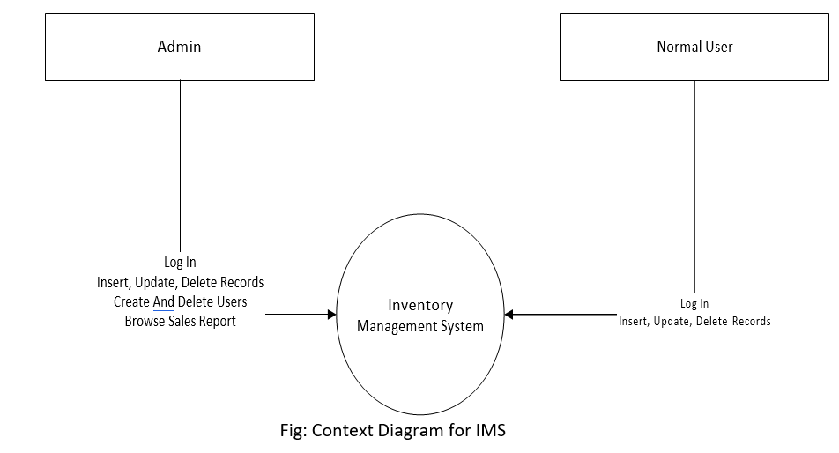

## 2.4 Use Case Diagram

Our use case diagram for the Inventory Management System illustrates how different actors, representing users or external systems, engage in various activities (use cases) within the application. This graphical representation facilitates a clearer understanding of the system's functionalities and user interactions, aiding in the communication of the system's behavior from a user's perspective.

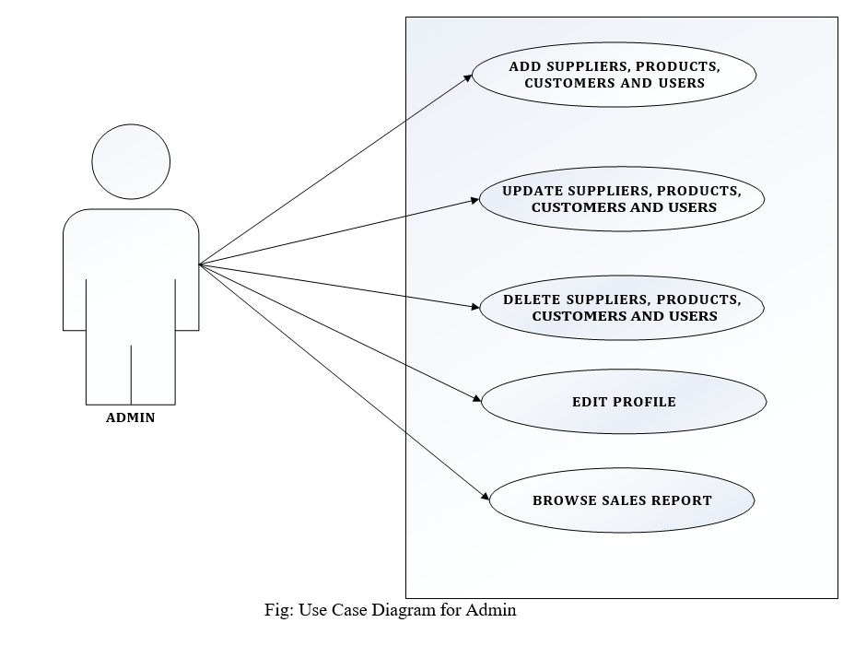

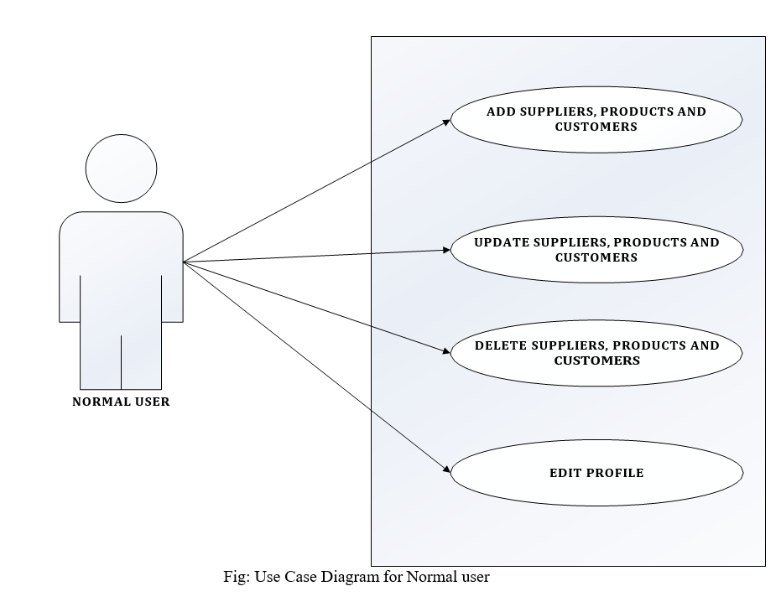

## 2.4 Sequence Diagram



Login Request

Check User Validation

Move To Dashboard

Insert Records

Update Records

Save To Database

Delete Records

Add User Delete User

Provide Privilege to User

View Sales Report View Records

Logout

Redirect To Login Page

Logout

**Database**

**Login Dialog**

**Admin**



**Normal User**

Login Request

Check User Validation

Move To Dashboard

Insert Records

Update Records

Save To Database

Delete Records

View Records

Logout

Redirect To Login Page

Login Page

**Login Dialog**

**Database**

## 2.5 Conclusion

In conclusion, the analysis of the IMS provides valuable insights into its current state. Addressing identified areas for improvement will not only optimize daily operations but also ensure the system remains adaptive to the evolving needs of the business and industry standards.

# CHAPTER 3

# SYSTEM DESIGN

## 3.1 System Architecture

The Inventory Management System (IMS) architecture is designed to provide a robust and efficient framework for handling various aspects of inventory management. At its core, the architecture comprises several key components, each serving a specific purpose to ensure the seamless operation of the system.

The system is structured around a centralized database that stores crucial information such as product details, stock levels, and transaction records. This database forms the backbone of the IMS, enabling real-time access to accurate and up-to-date inventory data.

The server-side logic is distributed across different modules, including order processing, inventory tracking, and reporting. These modules interact with the database to execute functions such as updating stock levels, processing sales orders,

# CHAPTER 4

# SYSTEM IMPLEMENTATION

## 4.1 Introduction

The implementation phase of the Inventory Management System (IMS) is a crucial step in bringing the system to life. It involves installing the new IMS and transitioning from the existing inventory management system to the redesigned one.

## 4.2 Coding

## 4.3 Testing Strategies

### 4.3.1 Unit Testing

Unit testing in the context of the IMS involves examining individual components or functionalities in isolation. For instance, it could focus on a specific feature like adding a new supplier. The aim is to ensure that this particular function works as intended, validating that the system accurately records new supplier information without causing unintended side effects on other components.

### 4.3.2 Integration Testing

Integration testing assesses how different modules or features of the IMS work together. In the case of the IMS, this might involve testing the interaction between adding a new supplier (previously tested in unit testing) and another feature, such as generating a sales report. The goal is to identify any issues that may arise when these functionalities are integrated, ensuring a seamless flow of data and operations.

### 4.3.3 Functional Testing

Functional testing evaluates specific functions or features of the IMS against predefined requirements. In the context of adding a new supplier or generating a sales report, functional testing ensures that these actions align with the specified functionalities. It verifies that the IMS performs the intended operations accurately, covering aspects like data accuracy, calculations, and system responses.

### 4.3.4 Performance Testing

Performance testing for the IMS involves assessing its responsiveness and efficiency, especially when handling tasks like adding a new supplier or generating sales reports. This strategy ensures that these operations perform optimally under different conditions, such as varying user loads or peak usage times. Performance testing helps identify potential bottlenecks and ensures the system's reliability.

### 4.3.5 Usability Testing

Usability testing evaluates the user experience within the IMS, specifically focusing on tasks like adding a new supplier or generating a sales report. It assesses how easily users can accomplish these tasks, considering factors like system navigation, clarity of instructions, and overall user satisfaction. Usability testing aims to enhance the system's user-friendliness, making it intuitive and efficient for users at various levels.

In a usability test for the IMS, users may be observed as they go through the process of adding a new supplier or generating a sales report. Feedback on the clarity of instructions, ease of navigation, and the overall user satisfaction provides valuable insights for improving the user interface and ensuring a positive user experience.

## 4.4 Execution Snapshots

## 4.5 Specific Adjustments

In the intricate landscape of organizational operations, the acknowledgment of unique workflows and operational nuances becomes the impetus for specific adjustments during the changeover process. This phase is not a one-size-fits-all approach but rather a meticulous tailoring of the Inventory Management System (IMS) to align seamlessly with the existing processes of each organization. The overarching aim is to minimize disruption to regular inventory operations and facilitate a smooth transition.