**SURFACE CRACK DETECTION**

TEAM – 4

**Architecture Diagram:**

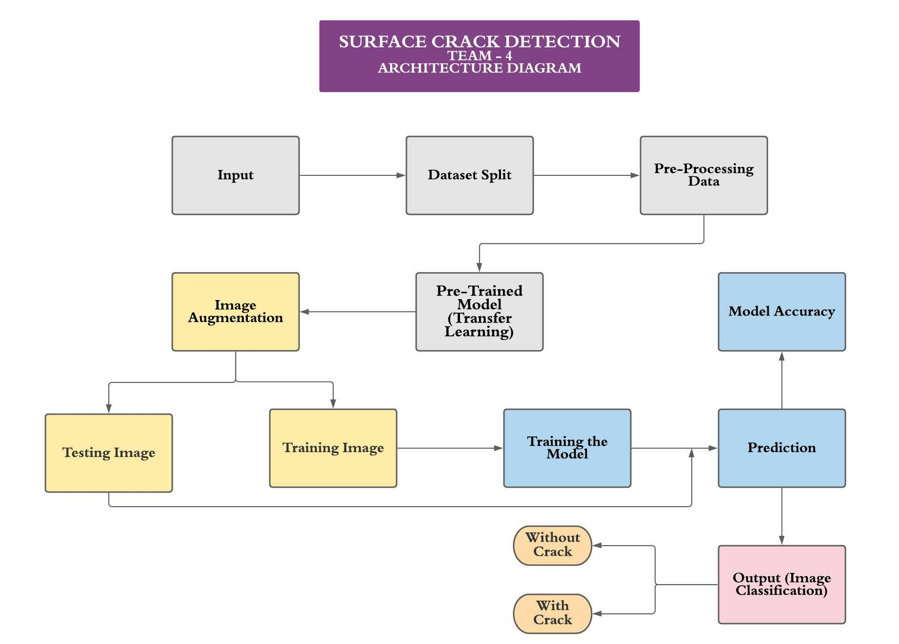

**Figure 1:** This architecture diagram was built using lucidchart. Check the diagram at the URL <https://lucid.app/lucidchart/ec02e1f0-c9dc-44e2-b054-066699b6f2fd/edit?viewport_loc=-129%2C240%2C2220%2C924%2C0_0&invitationId=inv_fdb46fbb-cf86-473a-96aa-5c8f32f61ba7>

**Hardware Requirements:**

* A minimum of 8GB RAM is sufficient but 16GB RAM and above is recommended.
* When it comes to CPU, a minimum of 7th generation (Intel Core i7 processor) is recommended.
* SSD is also required to enhance the speed and efficiency.

**Software Requirements:**

* Kaggle
* Anaconda – Jupyter Note Book
* Python 3
* Visual Studio Code

**Tools/Packages Required:**

* numpy
* tensorflow
* tensorflow.keras
* re
* os
* shutil
* matplotlib
* random
* pandas

**Datasets Identified:**

* *Kaggle dataset*:
  + - * The dataset contains concrete images of not having any cracks. Negative Folder has 20000 images with 227 x 227 pixels with RGB channels. No data augmentation in terms of random rotation or flipping is applied.
      * The dataset contains concrete images of having cracks. Positive Folder has 20000 images with 227 x 227 pixels with RGB channels. No data augmentation in terms of random rotation or flipping is applied

Link: <https://www.kaggle.com/arunrk7/surface-crack-detection>

**Software Engineering Model:**

*Agile Methodology*:

Agile software development refers to software development methodologies centered round the idea of iterative development, where requirements and solutions evolve through collaboration between self-organizing cross-functional teams. The ultimate value in Agile development is that it enables teams to deliver value faster, with greater quality and predictability, and greater aptitude to respond to change. Scrum and Kanban are two of the most widely used Agile methodologies.

**Modules:**

* ***Sandhya S*** - Data collection, importing dataset and data preprocessing
* ***Monisha V*** - Modifying the pre trained model and creating a model
* ***Sivani S*** - Performing image augmentation on Train and Test datasets.
* ***Balasubramanian KN*** - Training the model (using more than 1 pre trained architecture)
* ***Bhagya Narayanan R*** - Testing and Predicting the model and designing web UI.

**Team Members:**

1. Balasubramanian KN
2. Bhagya Narayanan R
3. Monisha V
4. Sandhya S
5. Sivani S