**Project 3 – Publishing Amazon SNS Messages Privately**

**Project**: Publishing Amazon SNS messages privately

**Industry**: Healthcare

**Problem Statement**: How to secure patient records online and send it privately to the intended party

**Topics**: In this project, you will be working on a hospital project to send reports online and develop a platform so the patients can access the reports via mobile and push notifications. You will publish the report to an Amazon SNS which keeping it secure and private. Your message will be hosted on an EC2 instance within your Amazon VPC. By publishing the messages privately, you can improve the message delivery and receipt through Amazon SNS.

**Highlights**:

• AWS CloudFormation to create a VPC

• Connect VPC with AWS SNS

• Publish message privately with SNS

**Solution:**

**B**efore proceeding forward and execute its steps, let’s check the steps we’re going to perform, you can directly jump to any topic for your reference if you want:

Step 1: Create a Key Pair

Step 2: Create Resources

Step 3: Check the Internet Connection for Your Instance

Step 4: Create an Endpoint

Step 5: Publish a Message

Step 6: Verify

Now let’s get started with its steps.

**Step 1: Create a Key Pai**r

1. In the navigation menu on the left, find the Network & Security section. Then, choose Key Pairs.

2. Choose Create Key Pair.

3. In the Create Key Pair window, for Key pair name, type VPCE-Tutorial-KeyPair. Then, choose Create



**Step 2: Create Resources**

Now we need to create VPC through Cloud Formation.

1. Choose Create Stack.
2. On the Select Template page, choose Upload a template to Amazon S3, select the file, and choose Next.

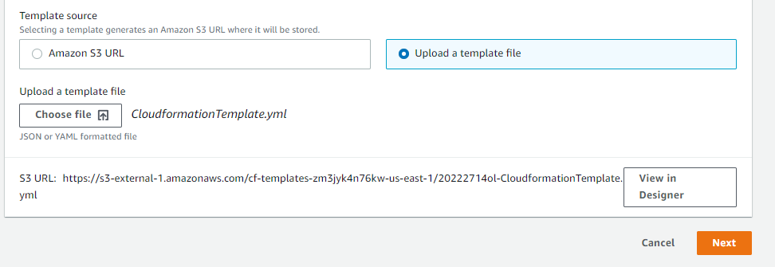

1. On the Specify Details page, specify stack and key names:
   1. For Stack name, type VPCE-Tutorial-Stack.
   2. For KeyName, choose VPCE-Tutorial-KeyPair.
   3. For SSHLocation, keep the default value of 0.0.0.0/0.
   4. Choose Next.

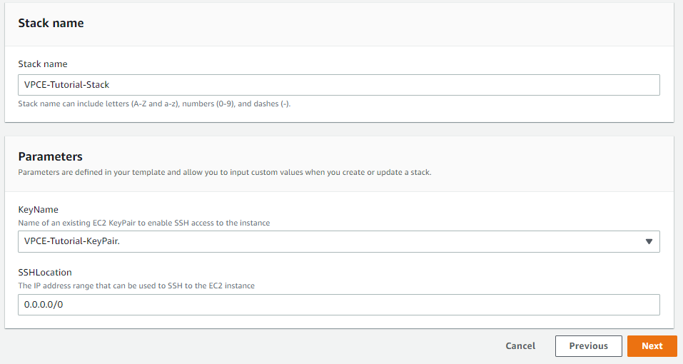

1. On the Options page, keep all of the default values, and choose next.
2. On the Review page, verify the stack details.

1. Under Capabilities, select the check box that acknowledges that AWS CloudFormation might create IAM resources with custom names.

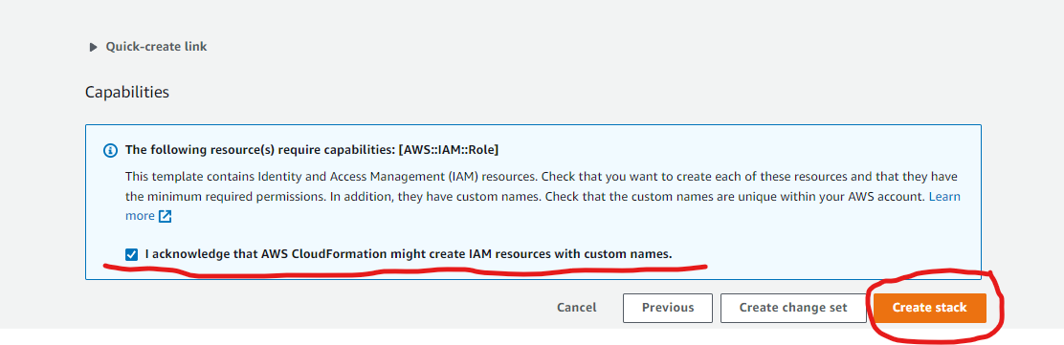

1. Choose Create

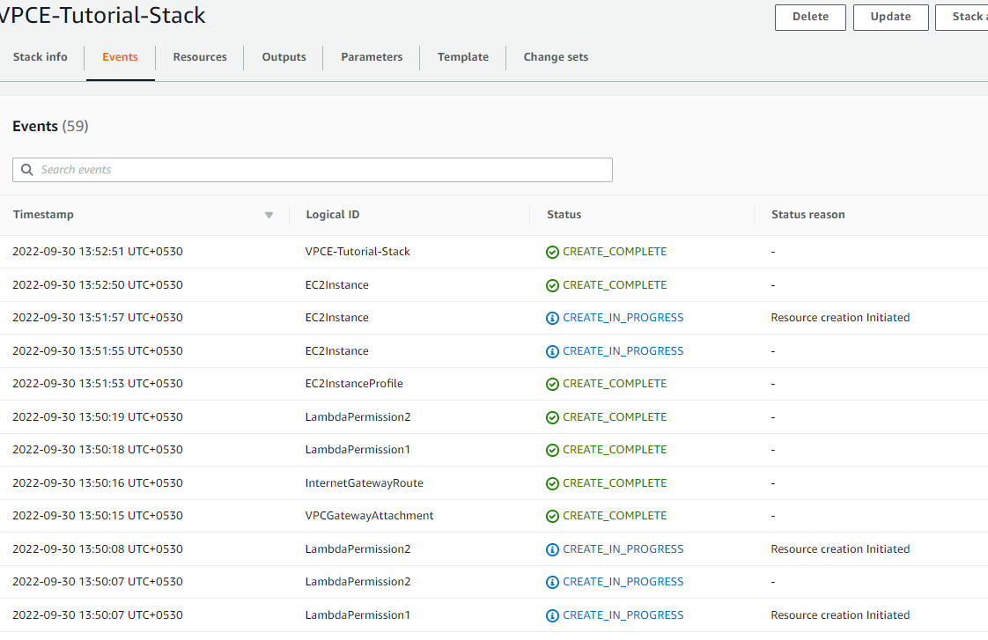

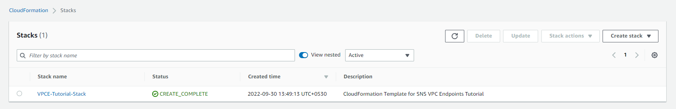

**Step 3: Check the Internet Connection for Your Instance**

Access EC2 Instance.

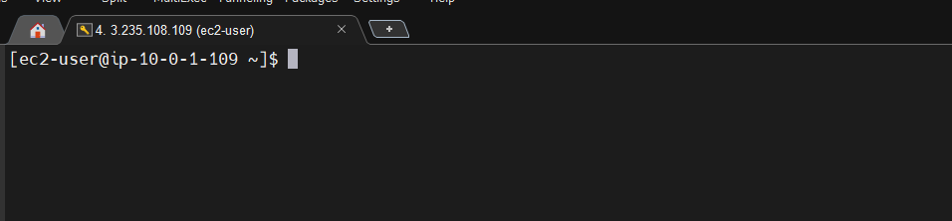

To verify that the instance lacks internet connectivity, Ping amazon.com, google.com and see if we are able to ping the websites.



To verify that the instance lacks connectivity to Amazon SNS.

1. In the navigation menu on the left, choose Topics.

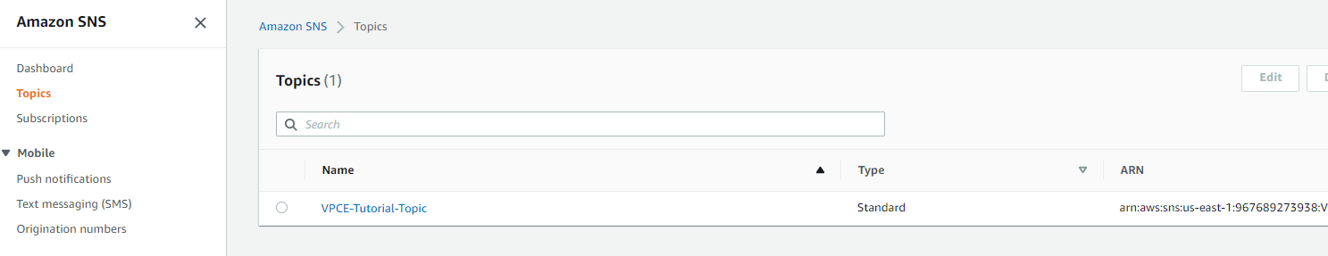

2. On the Topics page, copy the Amazon Resource Name (ARN) for the topic VPCE- Tutorial Topic.

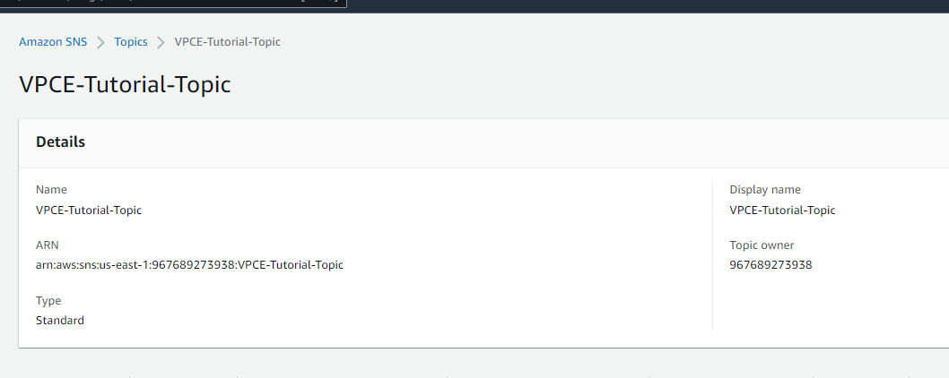

1. In EC2 terminal, attempt to publish a message to the topic: aws sns publish --region us-east-1 --topic-arn arn:aws:sns:us-east-1:967689273938:VPCE-Tutorial-Topic --message "Project3 Assignment"



**Step 4: Create an Endpoint**

Because the publish attempt fails, Create an Amazon VPC Endpoint for Amazon SNS.

To create the endpoint

1. Open the Amazon VPC console.
2. In the navigation menu on the left, choose Endpoints.

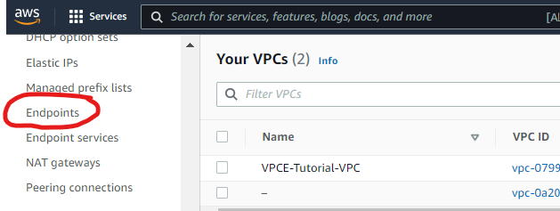

1. Click on create endpoint, On the Create Endpoint page, for Service category, keep the default choice of AWS services.

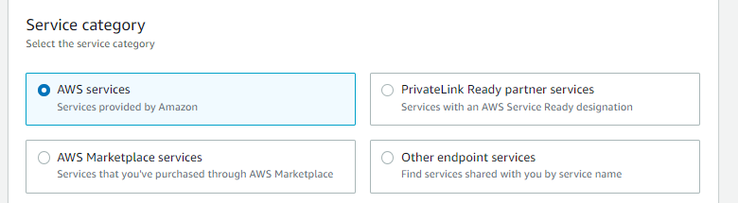

1. For Service Name, choose the service name for Amazon SNS.

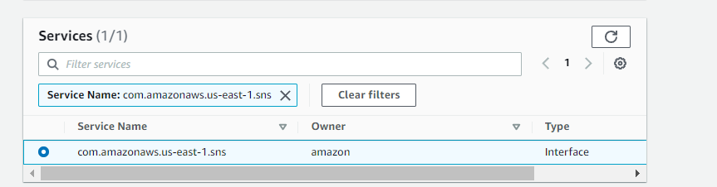

1. For VPC, choose the VPC that has the name VPCE-Tutorial-VPC.

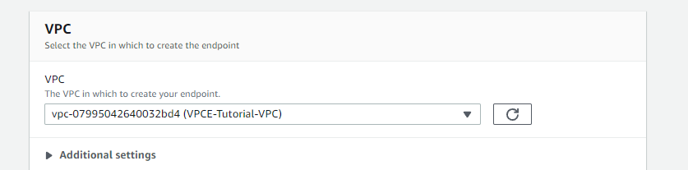

1. For Subnets, select the subnet that has VPCE-Tutorial-Subnet in the subnet ID.

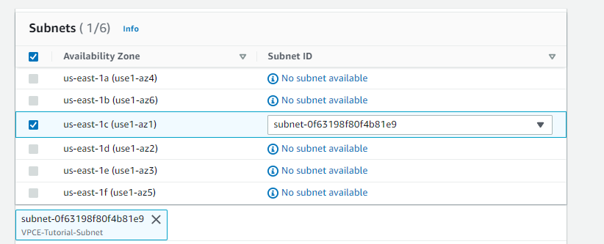

1. For Security group, choose Select security group, and select the one named Tutorial Security Group.

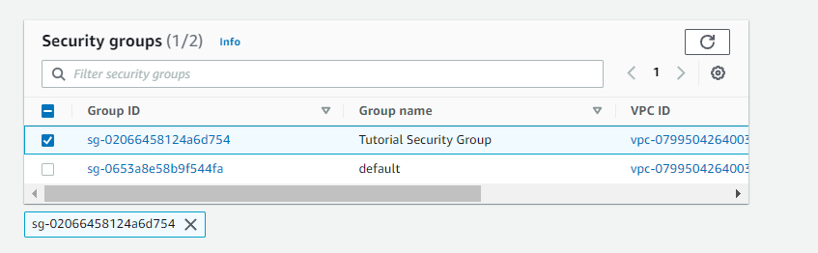

1. Choose Create endpoint. The Amazon VPC console confirms that a VPC endpoint was created.

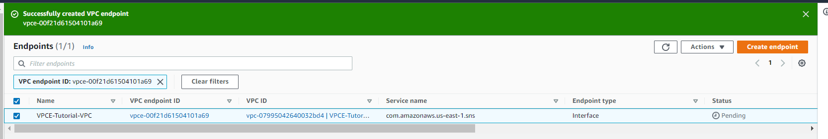

The Amazon VPC console opens the Endpoints page. The new endpoint has a status of pending. In a few minutes, after the creation process completes, the status changes to available.

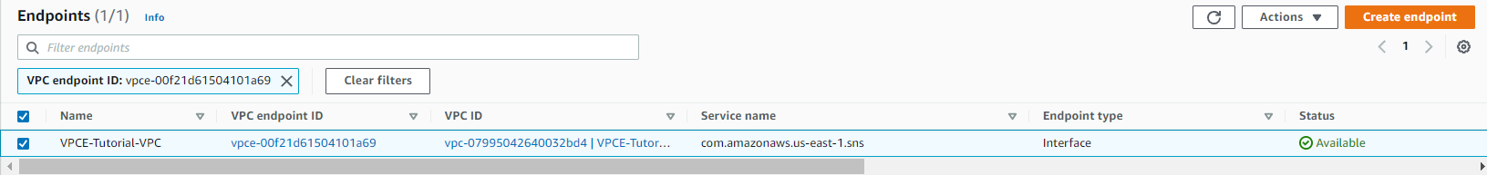

**Step 5: Publish a Message**

Publish a Message to Your Amazon SNS Topic.

As now the VPC include the endpoint for the Amazon SNS, now will try to login in our EC2 and publish the message again. And its working we got the msg ID.



**Step 6: Verify**

To verify that the Lambda functions were invoked.

Go to the Lambda console and choose the VPCE-Tutorial-Lambda-1 and choose Monitoring

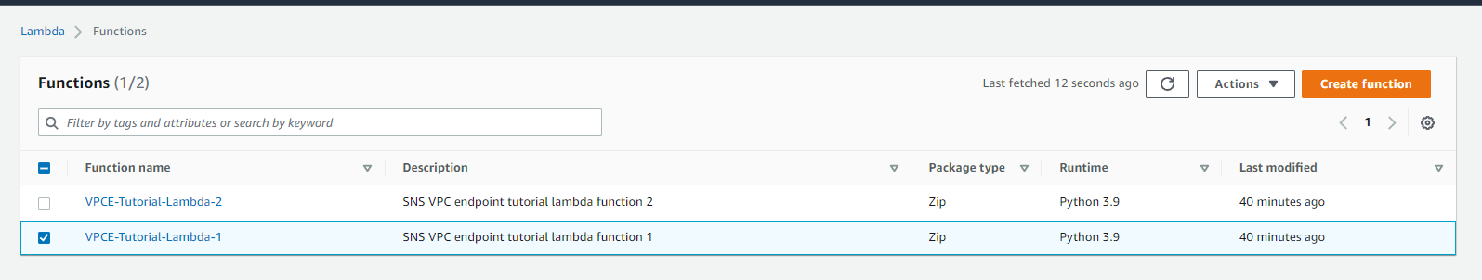

Check the Invocation count graph. This graph shows the number of times that the Lambda function has been run.

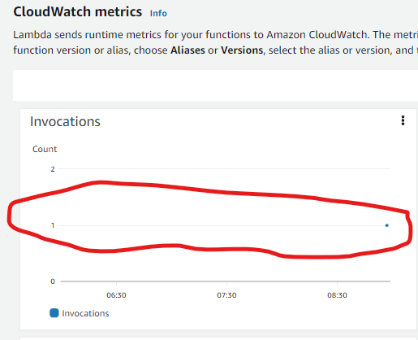

To verify that the CloudWatch logs were updated

1. Open cloud watch console.
2. Click on Log Groups
3. Select the function.

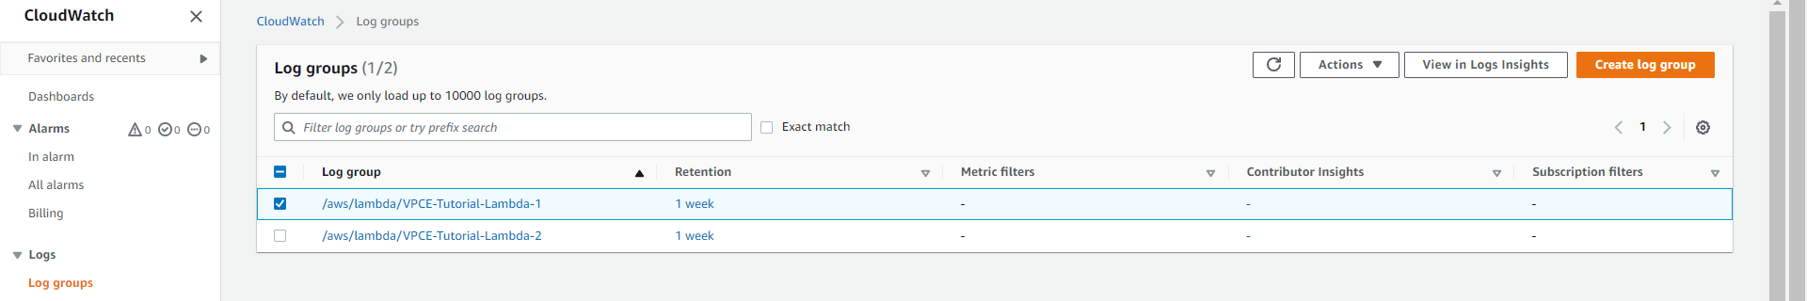

1. Click on log streams.

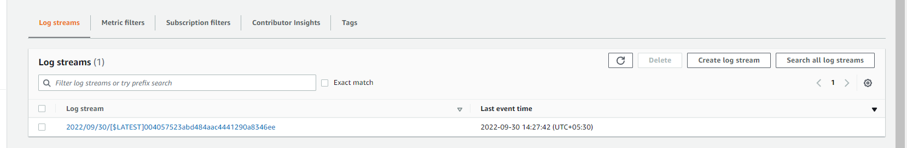

1. Now you will able to see the logs.

