**DevOps Project**

1. Git workflow should be implemented. Since the company follows monolithic architecture of Development you need to take care of version control. The release should happen only on 25th of every month.

2. Code build should be triggered once the commits are made in the master Branch.

3. The code should be containerized with the help of the Docker file, The Dockerfile should be built every time if there is a push to Git-Hub. Create a custom Docker image using a Dockerfile.

4. As per the requirement in the production server, you need to use the Kubernetes cluster and the containerized code from Docker hub should be deployed with 2 replicas. Create a NodePort service and configure the same for port 30008.

7. Using Terraform accomplish the task of infrastructure creation in the AWS cloud provider.

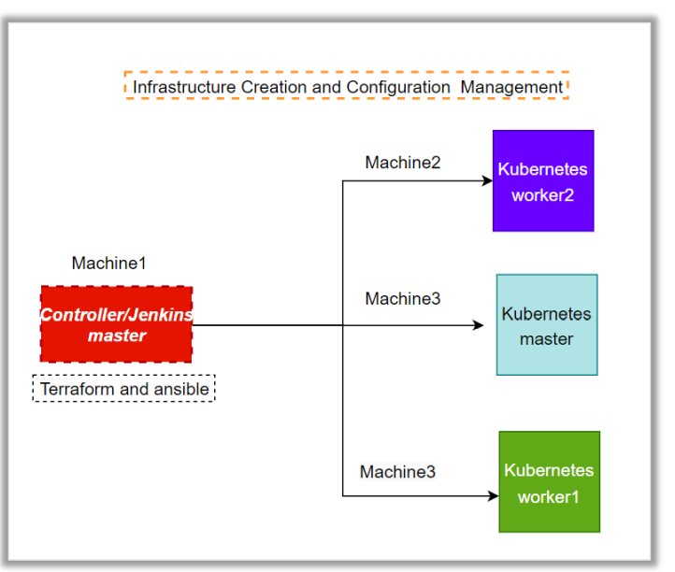

Ans: we need to make the above infra with terraform so first we will create a machine.

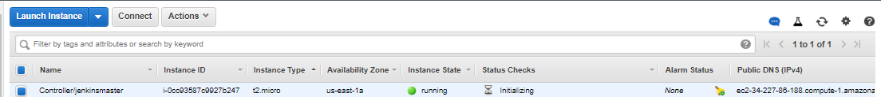

Machine1: Controller/jenkinsmaster

Software installed: terraform

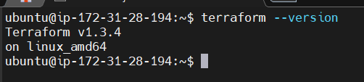

Now we will create the infrastructure.

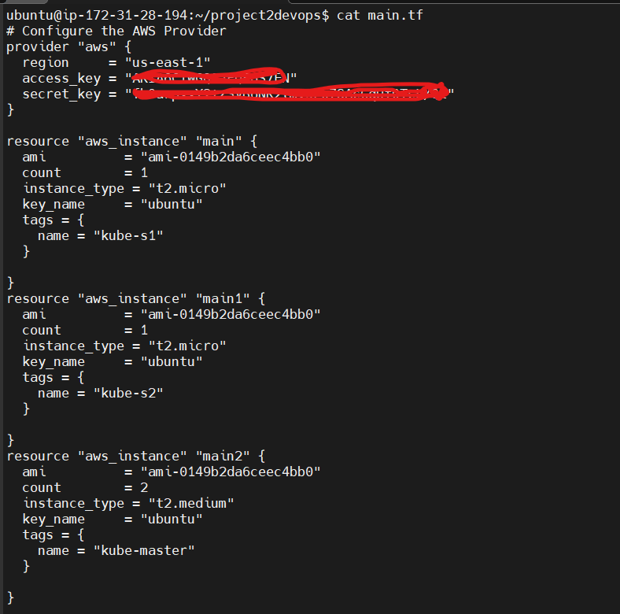

Now we will apply the code.

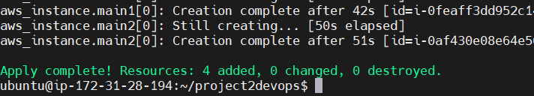

And our infrastructure is ready.

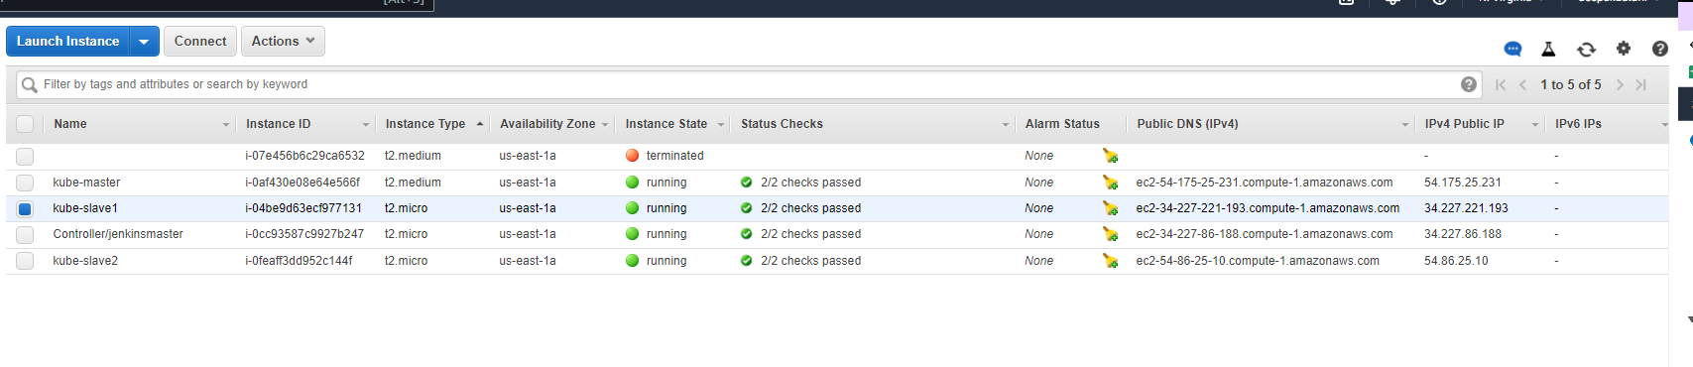

Now we are done with infra part.

**6. For configuration management of the infrastructure, you need to deploy the configuration on the servers to install necessary software and configurations.**

Ans: now we need to install the required software.

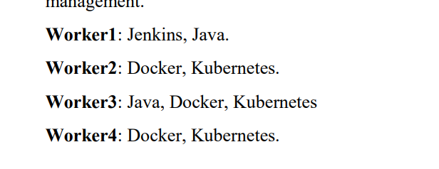

We have installed ansible in our Controller/jenkinsmaster and added all the machines with it.

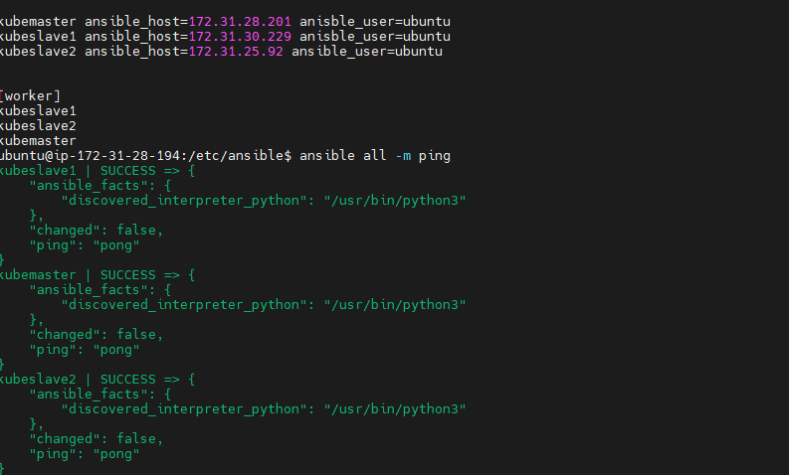

Now we will create scripts to install software and create yaml file for the same.

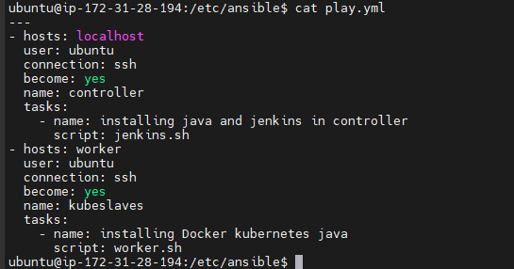

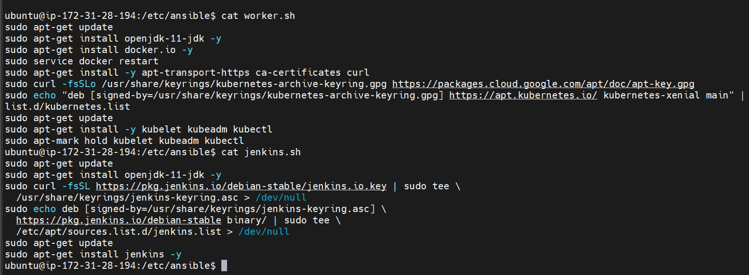

And after we will play this yaml file as now we will create the cluster by adding the k8s token on worker nodes.

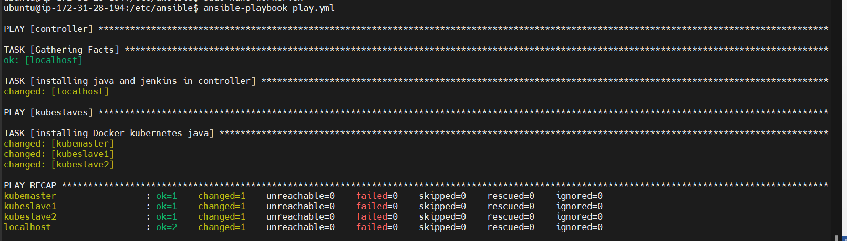

Now to create the cluster we will do the configuration on master node and worker-nodes

On Master nodes we will run following commands:

As root user:





As regular user: 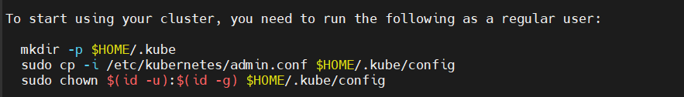

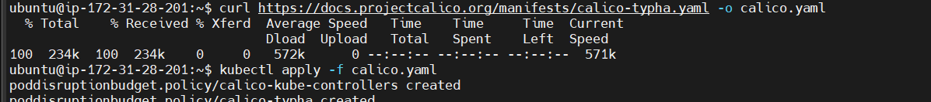

Now on worker-nodes we will add the token as root user.

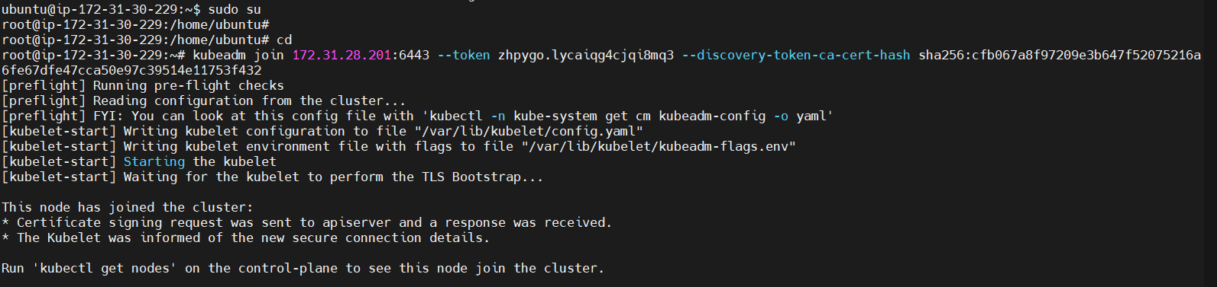

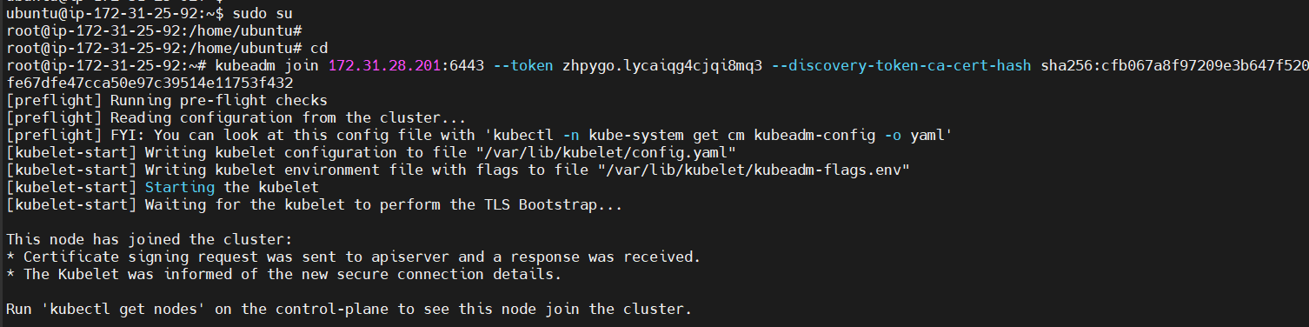

Now we will get kubectl get nodes to check if our cluster is working or not.

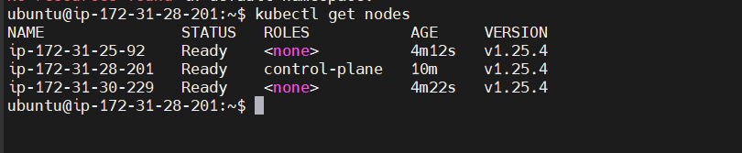

Now our cluster is ready now we will got to next step to create Jenkins pipeline.

**1. Git workflow should be implemented. Since the company follows monolithic architecture of Development you need to take care of version control. The release should happen only on 25th of every month.**

**2. Code build should be triggered once the commits are made in the master Branch.**

**Ans:**  to trigger this option we need to click on build trigger and select github hook trigger for gitscm polling.

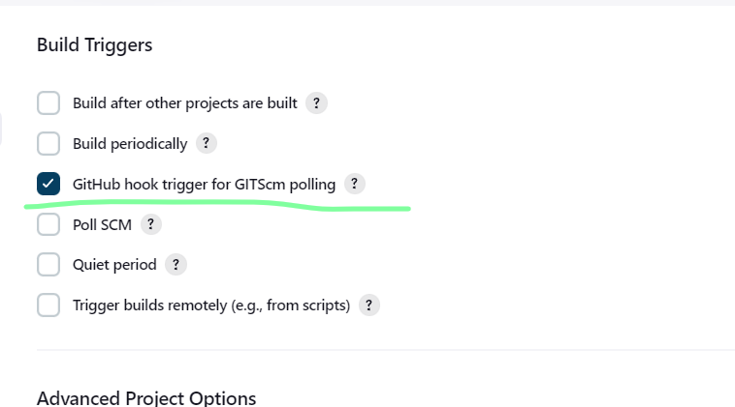

And on github we need to add webhok.

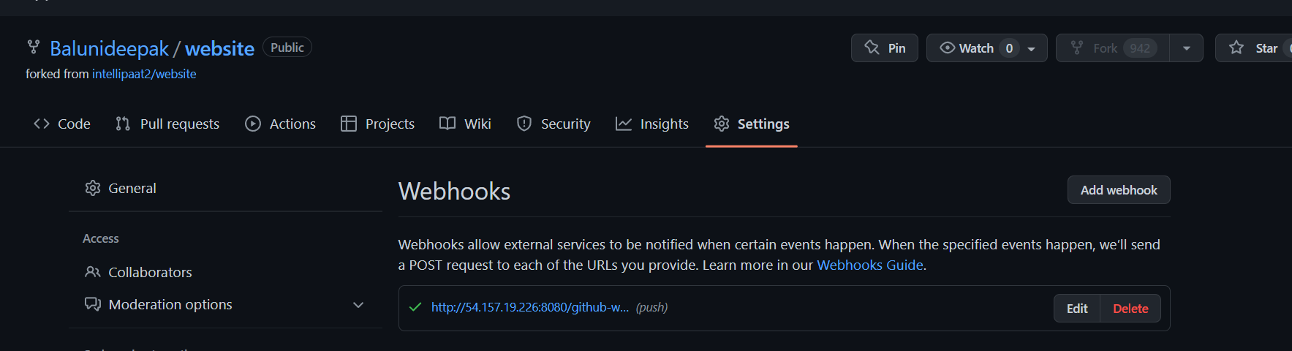

**3. The code should be containerized with the help of the Docker file, The Dockerfile should be built every time if there is a push to Git-Hub. Create a custom Docker image using a Dockerfile.**

**Ans:**

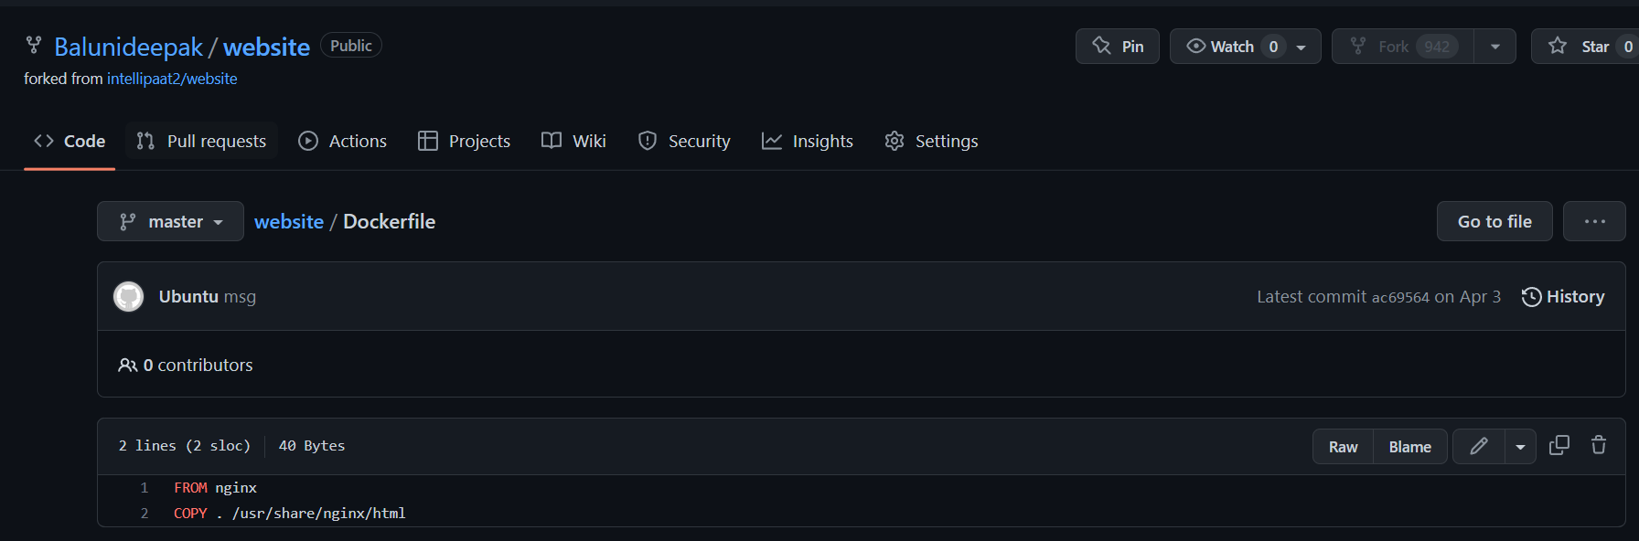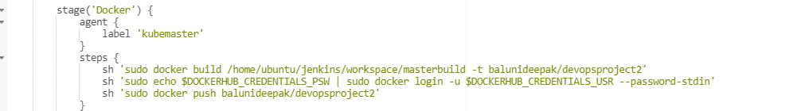

**4. As per the requirement in the production server, you need to use the Kubernetes cluster and the containerized code from Docker hub should be deployed with 2 replicas. Create a NodePort service and configure the same for port 30008.**

ANS: As asked we have created the yaml for the deployment and service.

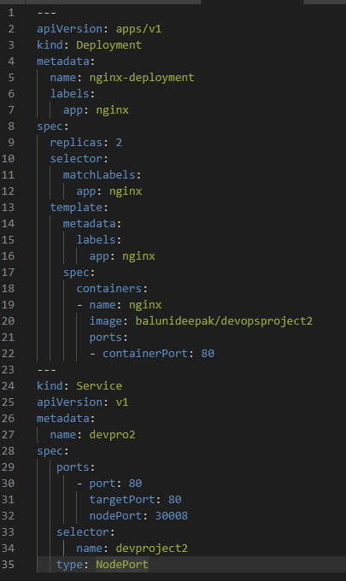

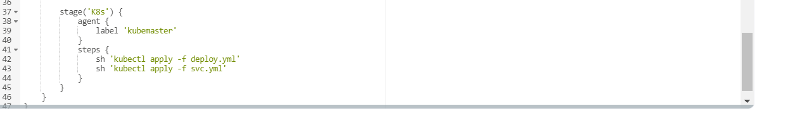

**5. Create a Jenkins pipeline script to accomplish the above task.**

Ans: For Jenkins we will copy the public ip of controller machine and add :8080 port no and create Jenkins admin user.

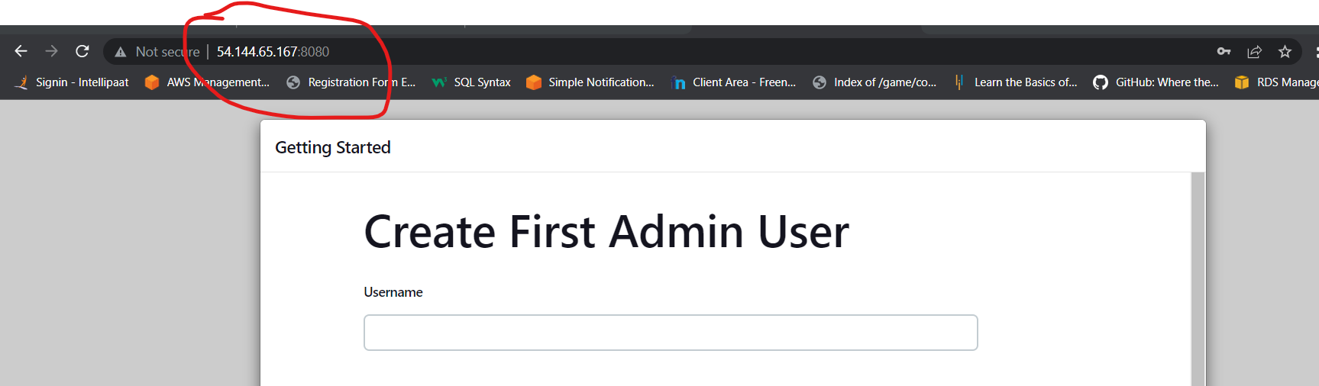

Once it’s done we need to add kubemaster node in jenkins.

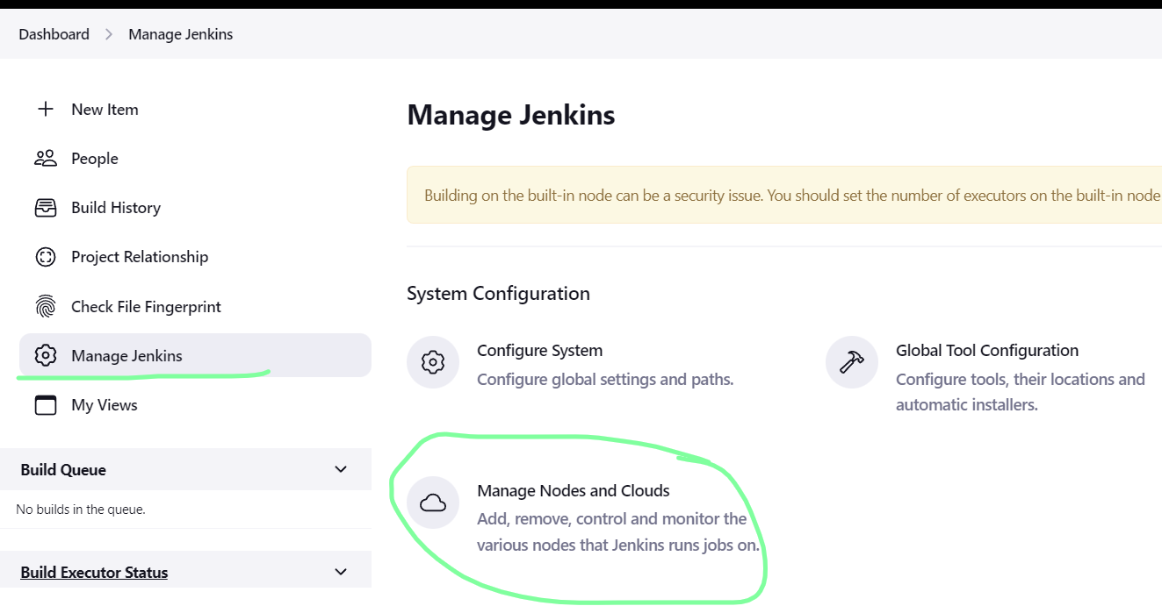

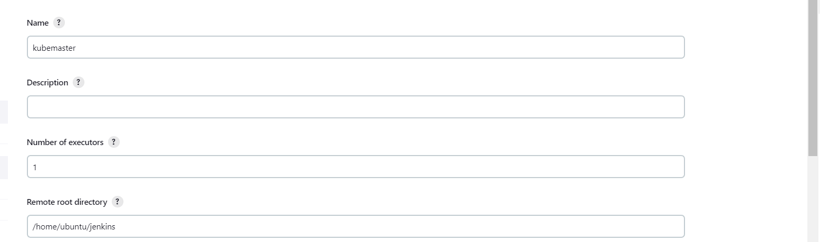

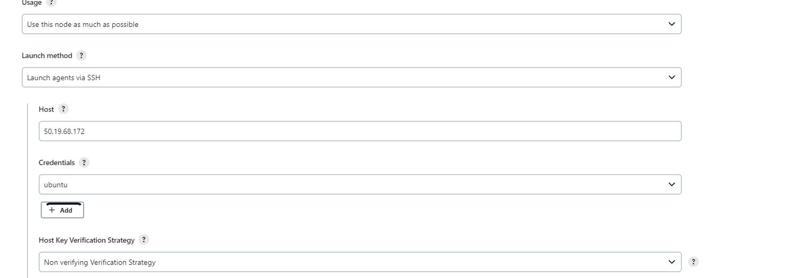

Now we will save this and now we will see the kubemaster node has been connected to Jenkins-controller node

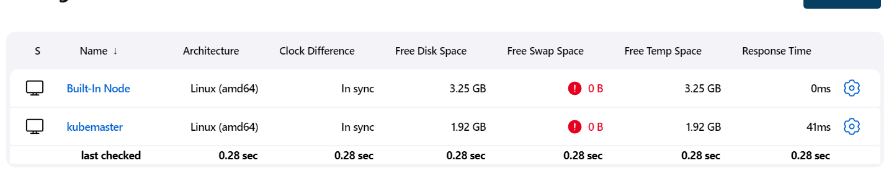

Now we will create a pipeline script for that we need to click on new item and give the item name and select the project type and click on ok.

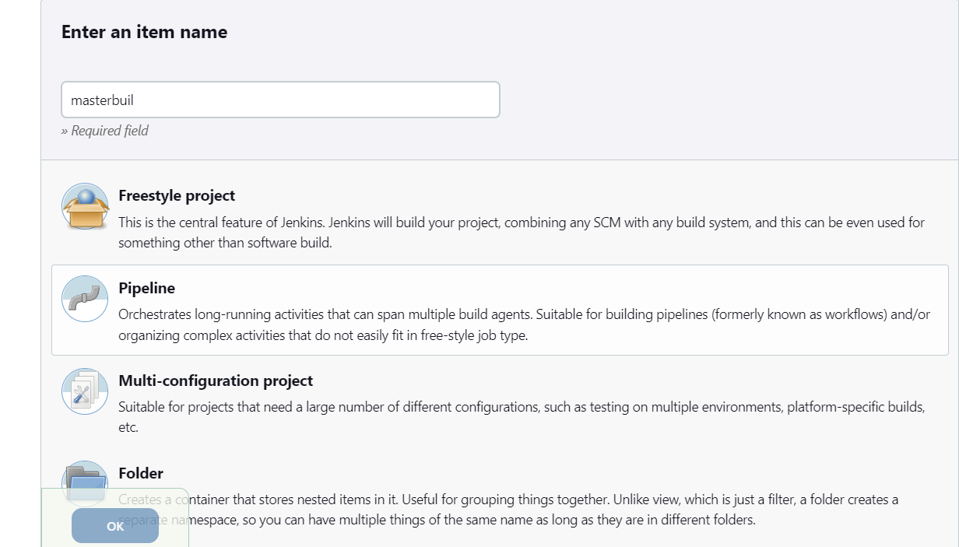

Now we will click on pipeline and create the script.

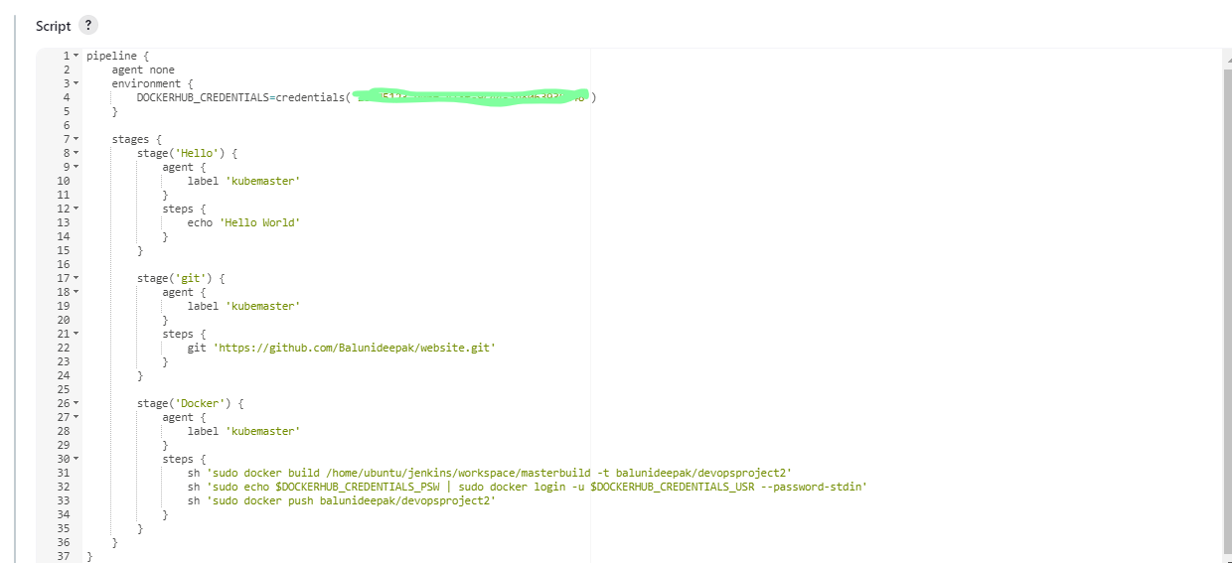

And will add the credentials for the dockerhub account and save it.

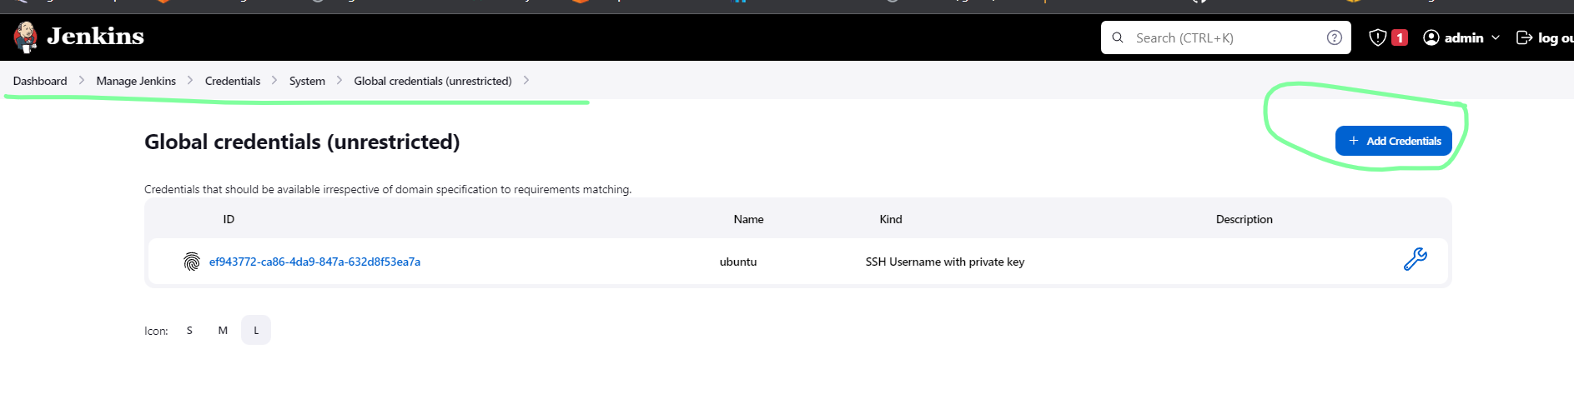

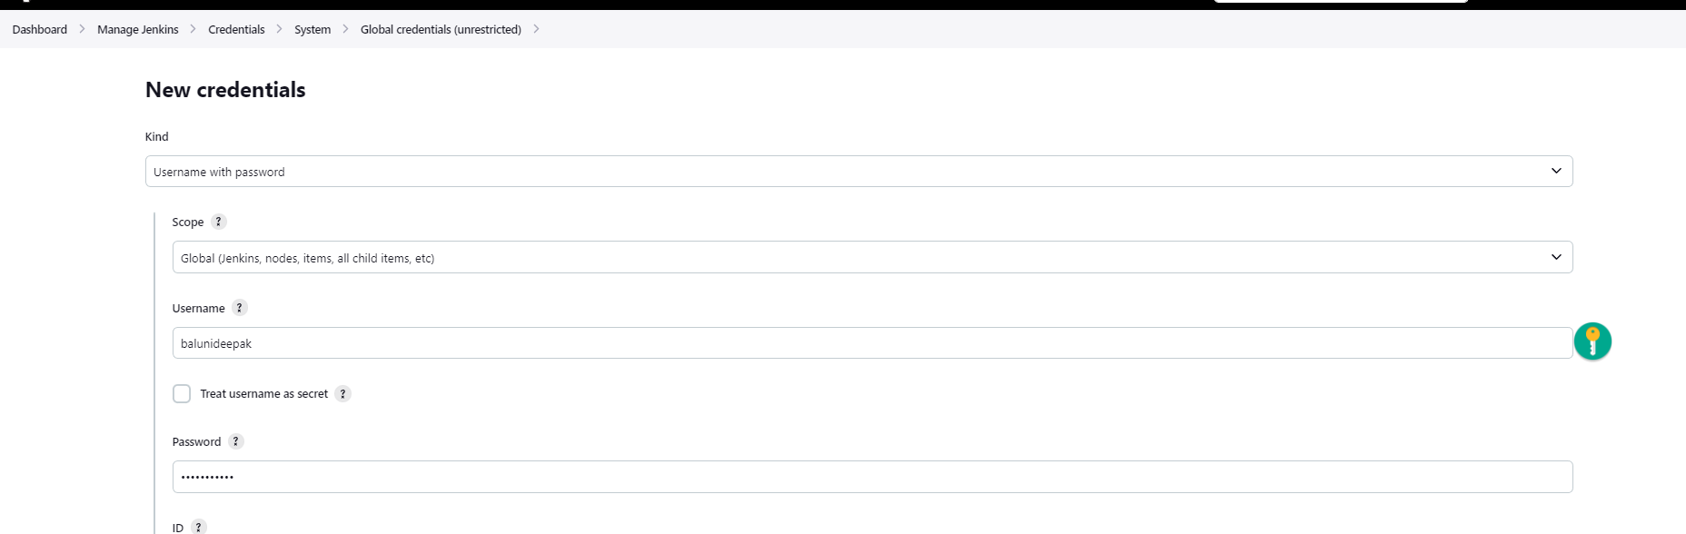

Once you create the new credentials you need to click on this sign and then you will we given the ID that you need to paste in the environment credential section.

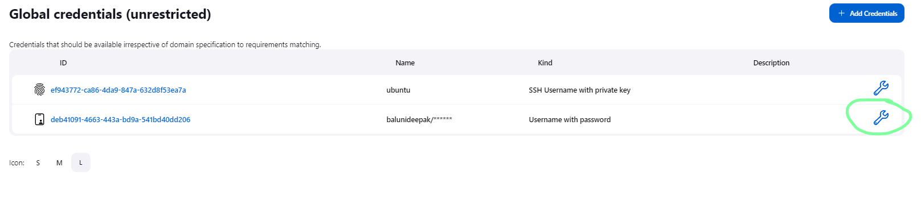

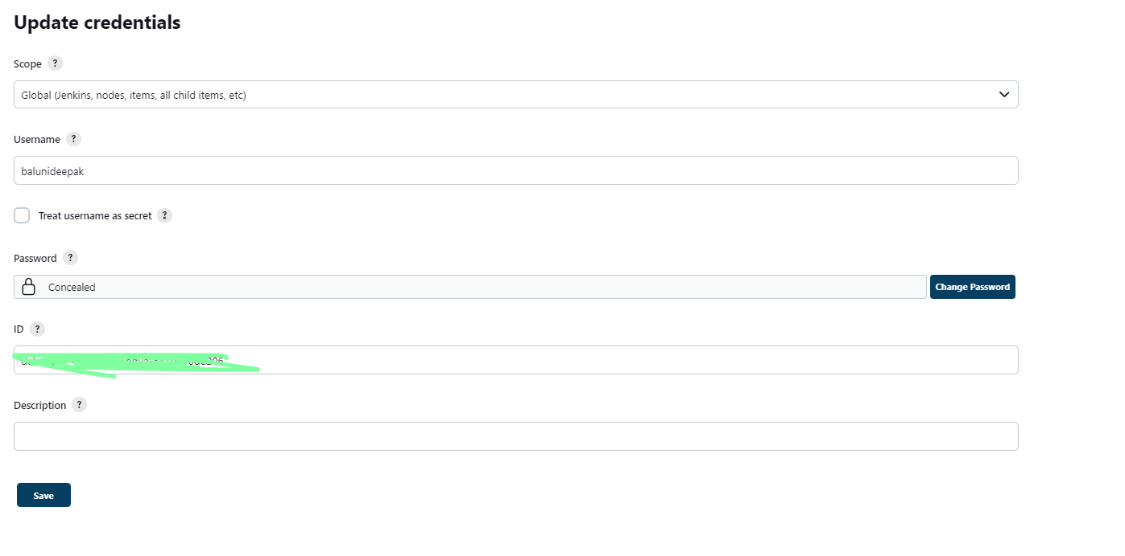

Once it’s done we need to click on build now and you docker hub account will be connected to the Jenkins.

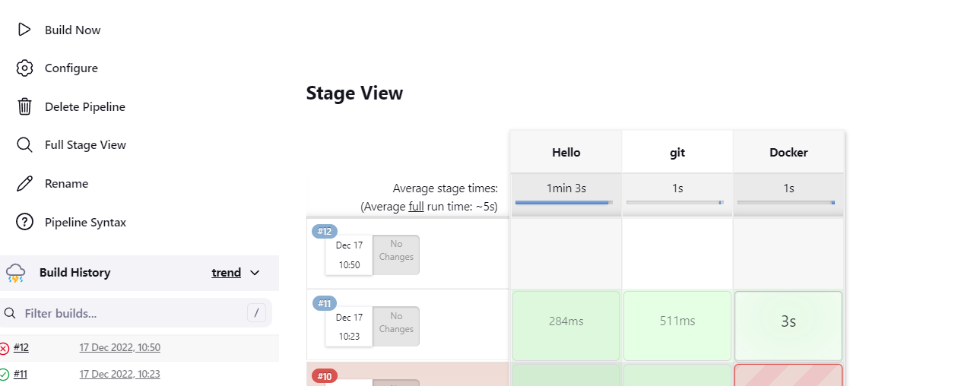

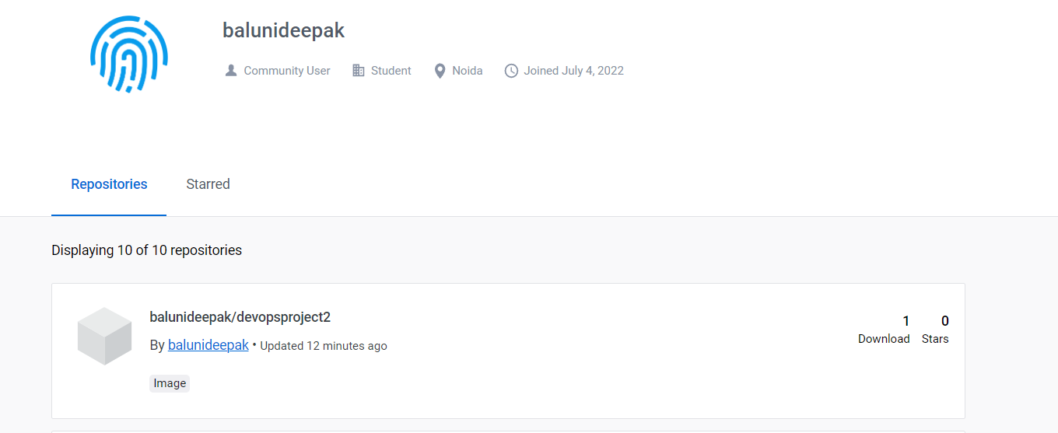



Now we will create the script for kubernetes to create the pods and run deploy.yml and svc.yml.

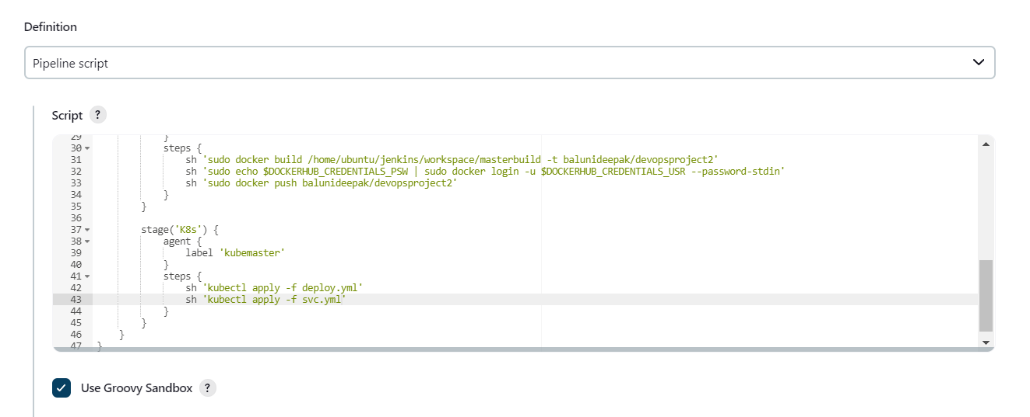

Now we will click on build now and our k8s cluster will be ready.

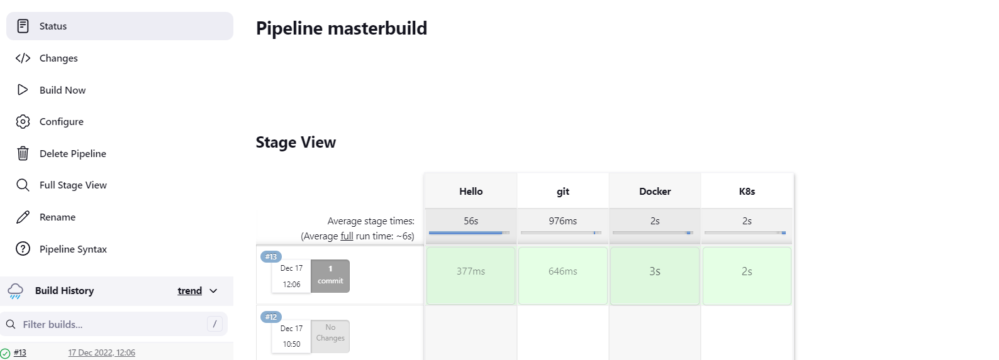

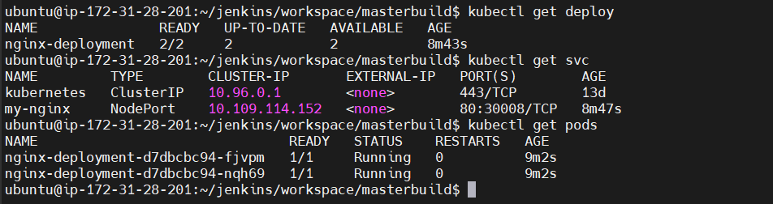

Now we will check the webpage is running on NodePort and its working.

