Node.js & MySQL ‘Bamazon’ Project

Bamazon is a storefront similar to Amazon. Through this app the customer can order products listed from the MySQL database which will reduce remaining number of the products in inventory when purchased. Below is an example of the interface being used by a customer who has viewed the listed items and purchased two Sega Dreamcasts.

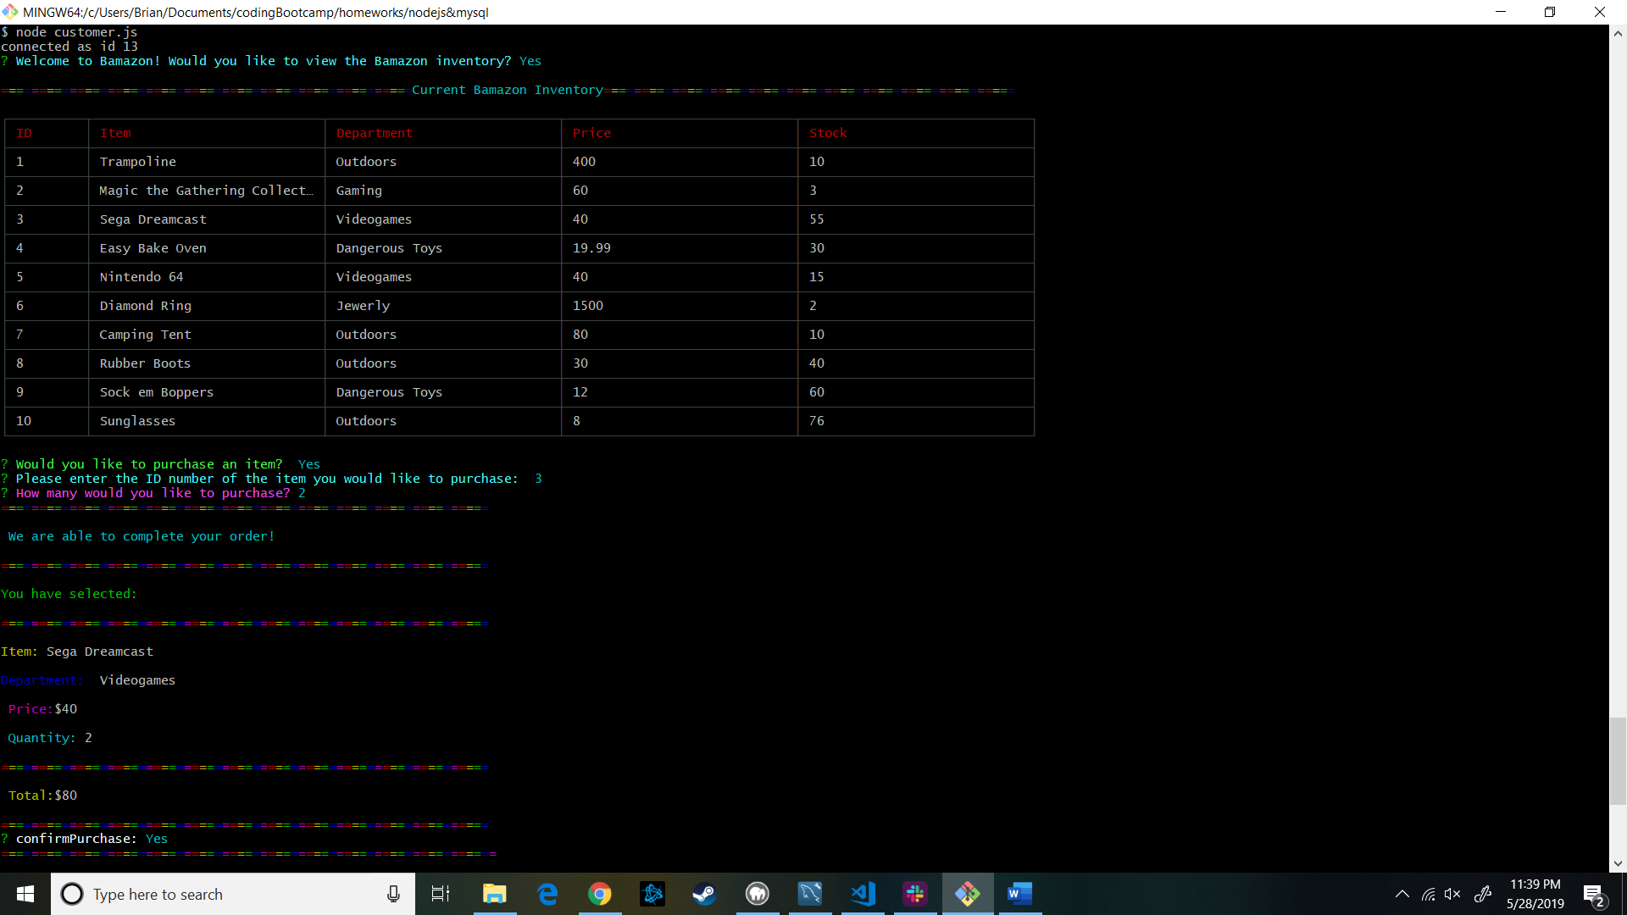

After the purchase is completed the customer is again given the option to view the Bamazon inventory updated with their recent purchase. Below you can see that if the customer declines to view the Bamazon inventory they receive a kind message to visit again soon.

