ASSIGNMENT-4
Question-1:
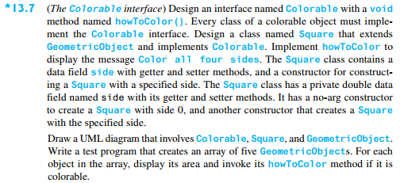
Solution:
package nidhi;
interface Colorable {
String howToColor();
}
abstract class GeometricObject {
private String color = "white";
private boolean filled;
private java.util.Date dateCreated;
protected GeometricObject() {
dateCreated = new java.util.Date();
}
protected GeometricObject(String color, boolean filled) {
dateCreated = new java.util.Date();
this.color = color;
this.filled = filled;
}
public String getColor() {
return color;
}
public void setColor(String color) {
this.color = color;
}
public boolean isFilled() {
return filled;
}
public void setFilled(boolean filled) {
this.filled = filled;
}
public java.util.Date getDateCreated() {
return dateCreated;
}
public abstract double getArea();
public abstract double getPerimeter();
}
class Square extends GeometricObject implements Colorable {
private double x;
private double y;
private double side;
Square() {
this(0,0,10);
}
Square(double x, double y, double side) {
this.x = x;
this.y = y;
this.side = side;
}
@Override
public double getArea() {
return side * side;
}
@Override
public double getPerimeter() {
return side * 4;
}
@Override
public String howToColor() {
return "Color all four sides.";
}
public double getX() {
return x;
}
public void setX(double x) {
this.x = x;
}
public double getY() {
return y;
}
public void setY(double y) {
this.y = y;
}
public double getSide() {
return side;
}
public void setSide(double side) {
this.side = side;
}
}
public class nidhi {
public static void main(String[] args) {
GeometricObject[] Shapes = new GeometricObject[5];
Shapes[0] = new Square();
Shapes[1] = new Square(1,1,50);
Shapes[2] = new Square(0,0,40);
Shapes[3] = new Square(0, 0, 100);
Shapes[4] = new Square(0,0,25);
for (int i = 0; i < 5; i++) {
System.out.println("Square " + (i + 1) + " area = " + Shapes[i].getArea());
System.out.println("How to color: "+((Square)Shapes[i]).howToColor());
}
}
}
Output:
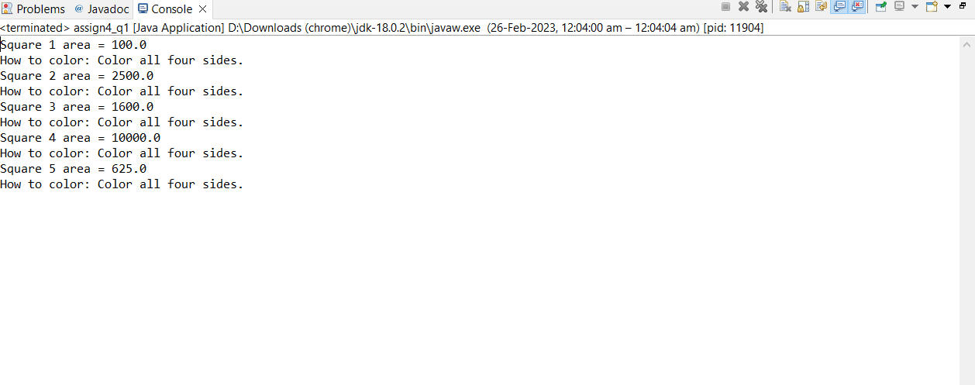
Question-2:
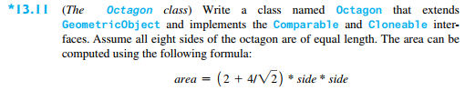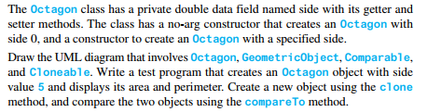
Solution:
package nidhi;
class Octagon extends GeometricObject implements Cloneable, Comparable<Octagon> {
private double side;
public Octagon() {
}
public Octagon(double side) {
this.side = side;
}
public void setSide(double side) {
this.side = side;
}
public double getSide() {
return side;
}
@Override
public double getArea() {
return (2 + 4 / Math.sqrt(2)) * side * side;
}
@Override
public double getPerimeter() {
return 8 * side;
}
@Override
public int compareTo(Octagon o) {
if(getArea() > o.getArea()){
return 1;
}
else if(getArea() < o.getArea()){
return -1;
}
else{
return 0;
}
}
@Override
public Object clone() throws CloneNotSupportedException {
return super.clone();
}
}
public class nidhi {
public static void main(String[] args) throws CloneNotSupportedException {
Octagon o1=new Octagon(5);
System.out.println("Area of Octagon:"+o1.getArea());
System.out.println("Perimeter of Octagon:"+o1.getPerimeter());
Octagon o2=(Octagon)o1.clone();
System.out.println("Comparing o1 and o2:"+o1.compareTo(o2));
}
}
Output:
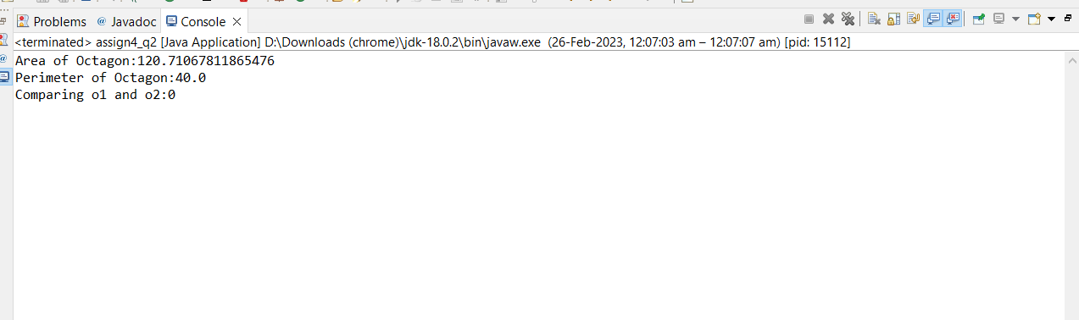
Question-3:
Solution:
package nidhi;
class Course implements Cloneable {
private String courseName;
private String[] students = new String[100];
private int numberOfStudents;
public Course(String courseName) {
this.courseName = courseName;
}
public void addStudent(String student) {
students[numberOfStudents] = student;
numberOfStudents++;
}
public String[] getStudents() {
return students;
}
public int getNumberOfStudents() {
return numberOfStudents;
}
public String getCourseName() {
return courseName;
}
public Object clone() throws CloneNotSupportedException {
return super.clone();
}
}
public class test {
public static void main(String[] args) throws CloneNotSupportedException {
Course dhull = new Course("Algorithms");
dhull.addStudent("Kirti");
dhull.addStudent("Sanyam");
dhull.addStudent("Nidhi");
Course course2 = (Course) course1.clone();
course2.addStudent("Vishwadev");
course2.addStudent("Anshika");
System.out.println("\nNumber of students in course1:" + course1.getNumberOfStudents());
String[] students = course1.getStudents();
for (int i = 0; i < course1.getNumberOfStudents(); i++) {
System.out.print(students[i] + ", ");
}
System.out.println();
System.out.println("\nNumber of students in course2:" + course2.getNumberOfStudents());
String[] students2 = course2.getStudents();
for (int i = 0; i < course2.getNumberOfStudents(); i++)
System.out.print(students2[i] + ", ");
System.out.println();
}
}
Output:
