How to Install CYPOS
- Extract the downloaded file and double click the setup.exe file
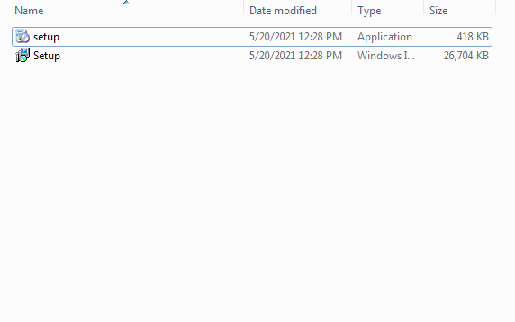
2. Double-click on the downloaded file to install.
3. Click on Next.
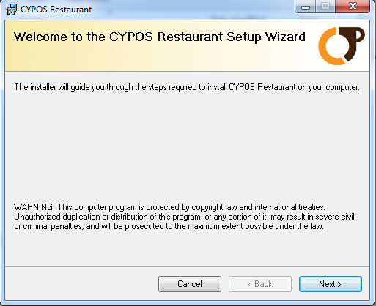

4. The default installation folder is selected, and click on Next.
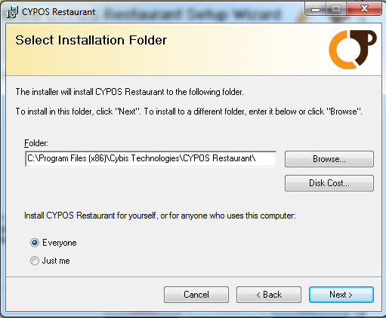
5. Click on Next to confirm installation.
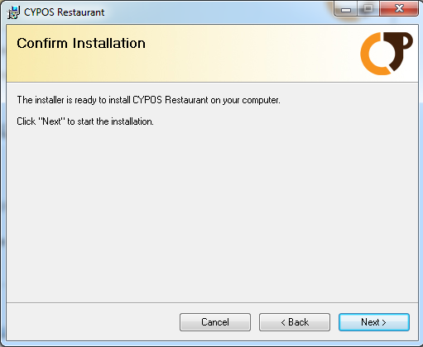

7. Wait till the installation is completed.
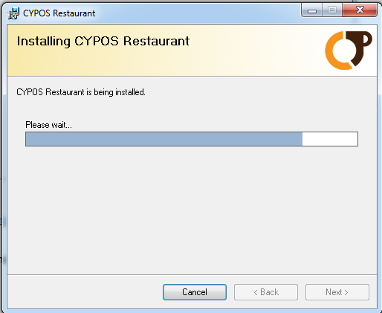

8. Click on Close after installation to close the window and run the CYPOS application.
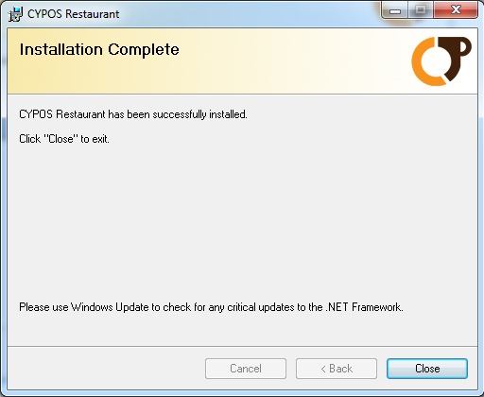
Before you run the application attach the downloaded database files
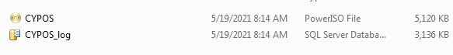
Attach SQL Database Via SQL Server Management Studio
If you want to attach SQL database MDF file through SQL Server Management studio then you need to connect to an instance of the SQL DB Engines and explore it.
- Firstly open SQL Server Management Studio
Go to Start button -> All Programs –> MS SQL Server -> SQL Server Management Studio
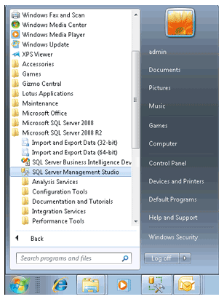

- Please wait for few moments so that it opens and then Login in it by entering its credential details
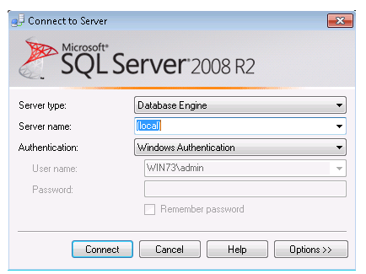

- Then suddenly next window showing the object explorer items on left side (local)(SQL Server 10.50.1600 – WIN 73/Admin) click on it. After clicking on it its sub elements list opens.
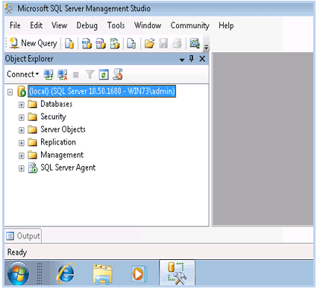

- Select and Right click on Databases then choose Attach option
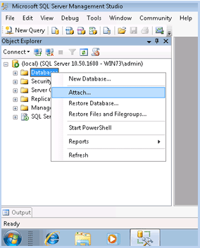
- On clicking Attach option the window appears on the screen call Attach Database Window then click on Add button
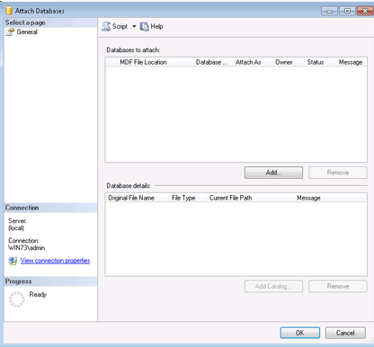

- It displays a list of SQL Server database Files select it and click on Ok Button
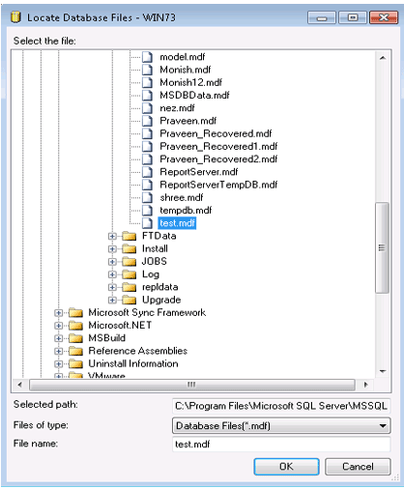
- Now Confirm the MDF file and LDF file location and go to Ok Button
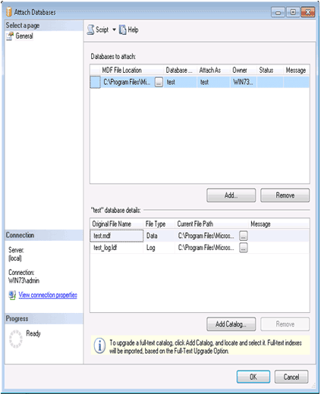

- Now successfully you have attached Database Name Test to the SQL Server through SQL Server Management Studio
