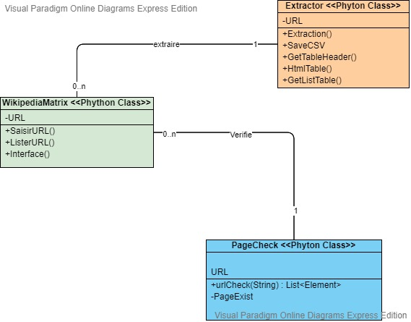

DIAGRAMME DE CLASS

USE CASE DIAGRAM

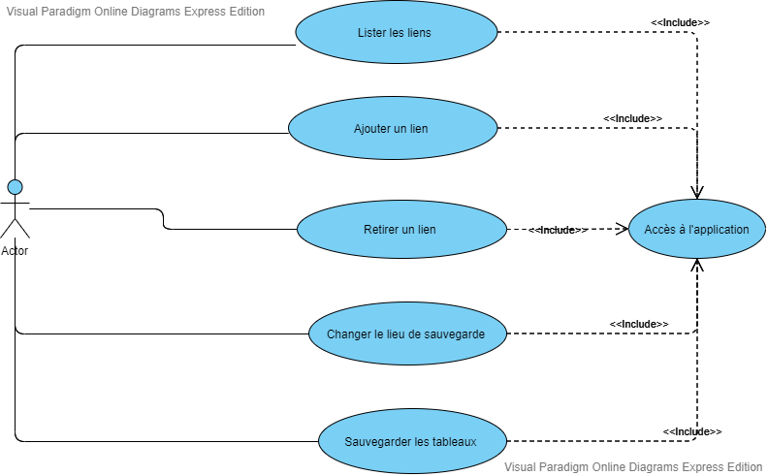

SEQUENCE DIAGRAM ADD LINK

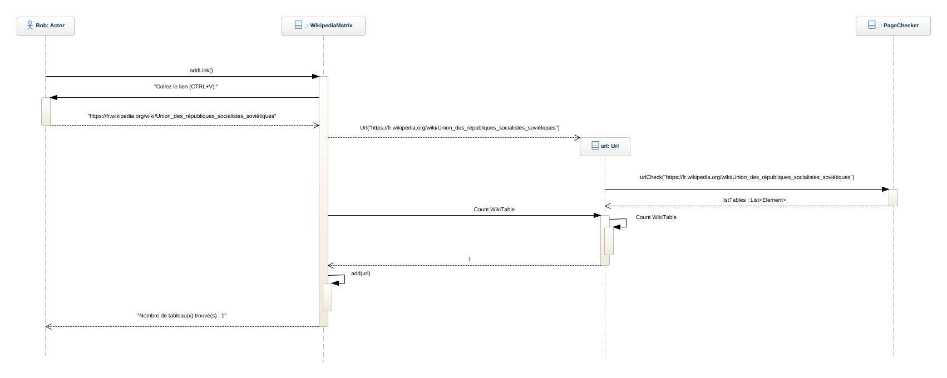

SEQUENCE DIAGRAM ADD CSV

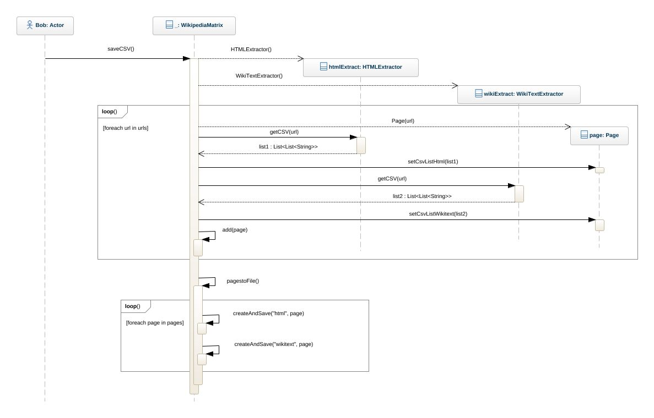

**Diagramme de class**

* The class extractor extracts 0 or more wiki pages
* The PageCheck class checks if the links are Wikipedia

**Diagramme Use Case**

* The user can put Wikipedia links in wikipedia_links_list.txt file to extract the tables from the page. He can add and remove several.
* The user can choose the backup path to save the tables in save_path.txt file.
* We found that the previous diagram did not correctly describe all the use cases. We therefore mean the 5 features developed for said project, namely a user can:
* List the links
* Add a link
* Remove a link
* Change the save location
* Save tables