OHIO SCIENTIFIC
Superboard II
Model 600 Rev D – Cherry MX keyboard edition
Assembly and test guide
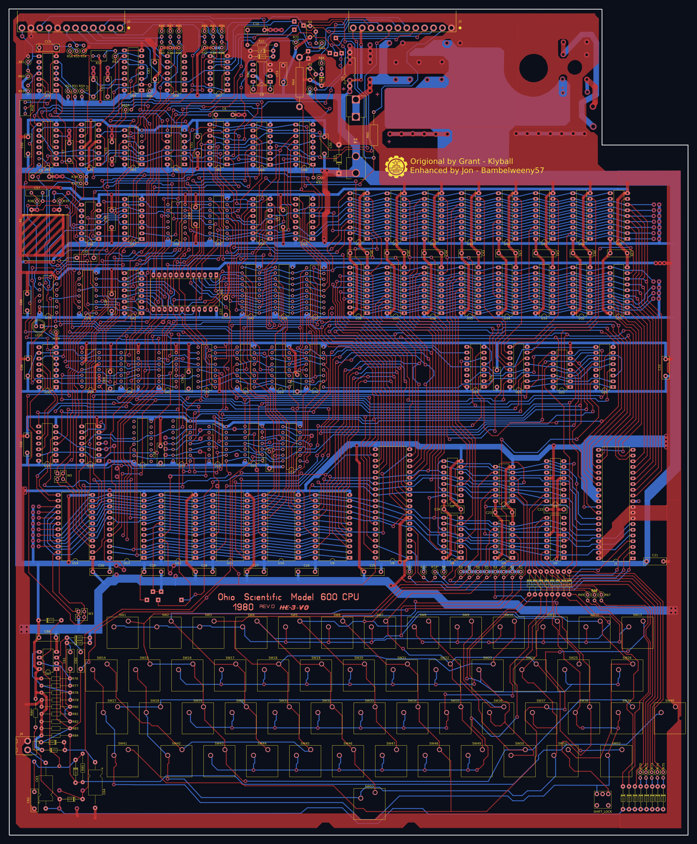
For board rev 1.0 (KiCad 10 project). Based on the Ohio Scientific Superboard Kit Assembly Manual, April 1982.
Original copper reconstruction: Grant – Klyball. Enhanced edition: Jon – Bambelweeny57, Submeson Brain Corporation.

Contents

If the contents list is empty, right-click it in Word and choose Update Field.

About this guide
This guide takes you through building the Superboard II Model 600 Rev D reproduction board with Cherry MX keyswitches, from a bare printed circuit board to a working computer that greets you with D/C/W/M ?.
It follows the order of Ohio Scientific’s 1982 Superboard Kit Assembly Manual: low-profile parts first, then the keyboard, then the video section, and finally the processor, ROMs and RAM, with a test after each stage. Every step has been rewritten for this board. Part references, values, orientations and test points all come from the rev 1.0 KiCad design, so where this guide and the 1982 manual disagree, follow this guide.

What is different from the 1982 kit
- Keyboard: 54 Cherry MX keyswitch positions in place of the original keys, including a choice of two shift-lock positions.
- ROMs: the monitor (U13) and BASIC (U9–U12) sockets take 27C16 EPROMs or 2816 EEPROMs; the character generator (U41) is a 2716-type EPROM.
- Options: the original wire-jumper blocks are replaced by pin headers W3 and W5.
- Power: 5 V enters at the +5V_IN holes and passes through fuse F1 before the protection diode D15.
- Some reference designators were renumbered so the design works in KiCad (see Appendix E).

How to use this guide
- Read the whole guide before you start, as the original manual advises.
- Each step has a parts table and a board figure showing where the parts go. Tick the box beside each part as you fit it.
- Compass directions are used throughout. Hold the board component side up with the notched corner at the top right: the top edge, with the J2 and J3 connectors, is North and the keyboard is South.
- Do not skip the tests. Each one catches problems while they are still easy to fix.
Caution Never insert or remove chips while power is applied. Disconnect the supply before every IC step.

Tools and materials
Item | Notes
Temperature-controlled soldering iron | A fine conical or 1.6 mm chisel tip, set around 330–350 °C for leaded solder
Solder | 0.5–0.7 mm rosin-cored solder; leaded 60/40 or 63/37 is easiest to work with
Flux pen, desoldering braid or pump | For cleaning up bridges
Side cutters and fine-nose pliers | For trimming and forming leads
Digital multimeter | Resistance, continuity, DC and AC voltage
Logic probe (optional) | Useful for the video and clock checks in Test 5
Isopropyl alcohol and a brush | For removing flux residue
EPROM programmer | To program the monitor, BASIC and character ROMs (see Section 9)

To use the finished computer
- A regulated 5 V DC supply rated at 3 A, regulation better than 4 % and ripple under 4 %.
- A composite video monitor, or a TV with a composite video input or an RF modulator.
- A cassette recorder for loading and saving programs (optional).
- A small speaker on J4 for the sound DAC (optional).

1 Getting to know the board and the parts
Figure 1-1 shows the board with every part position. The numbering follows the original: chips are U-numbers, resistors R, capacitors C, diodes D, and the keyswitches SW. The silkscreen on the board shows each reference, so you can always check a position against the figure.
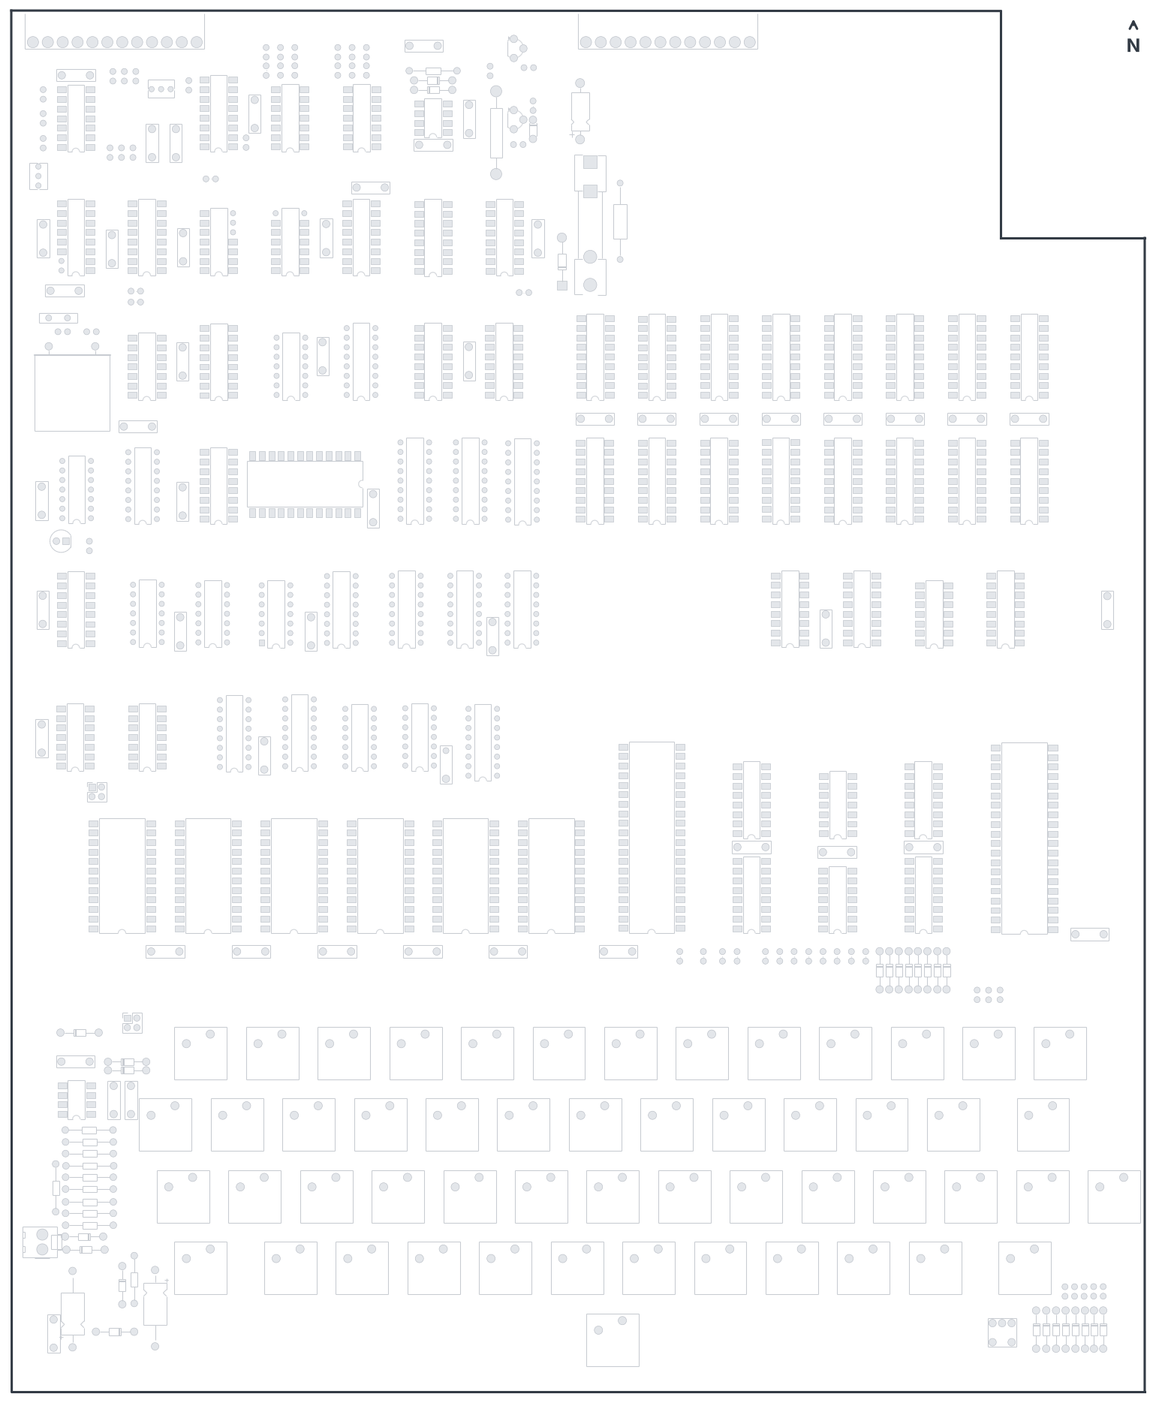
Figure 1-1 Board layout, component side, North at the top.

Board sections
Area | What is there
North-west | Oscillator, video timing counters, cassette interface (U29, U30, U57–U66, X1)
North centre | Serial (ACIA) and RS-232 parts, J2 and J3 edge connectors
North-east | Fuse F1, power entry and the program RAM (U31–U38, U45–U52)
Centre | 6502 processor U8, monitor ROM U13, BASIC ROMs U9–U12, address decoding
West centre | Video RAM, character generator U41, video output
South | Keyboard switches SW1–SW54, keyboard decoding (U2–U5), sound DAC and reset circuit

Orientation rules
Part | How to orient it on this board
IC sockets and chips | Notch (pin 1 end) faces South on every chip except U41, whose notch faces East. The square pad is pin 1.
Diodes | The band (cathode) goes to the square pad and matches the band printed on the silkscreen. Each diode step says which way the band faces.
Electrolytic capacitors | The + lead goes in the square pad. C5 and C63 have + to the South; C64 has + to the North.
LED1 | Flat side (cathode, shorter lead) faces East, into the square pad.
Transistors Q1, Q2 | Match the flat face to the silkscreen outline.
Resistors | Not polarised. Fitting them all with the first colour band the same way makes checking easier.

Resistor colour codes
Value | Bands (4-band) | Value | Bands (4-band)
100 Ω | brown black brown | 4.7 kΩ | yellow violet red
220 Ω | red red brown | 8.2 kΩ | grey red red
390 Ω | orange white brown | 10 kΩ | brown black orange
470 Ω | yellow violet brown | 16 kΩ | brown blue orange
510 Ω | green brown brown | 33 kΩ | orange orange orange
1 kΩ | brown black red | 68 kΩ | blue grey orange
2 kΩ | red black red | 100 kΩ | brown black yellow
3.9 kΩ | orange white red | 1 MΩ / 10 MΩ | brown black green / brown black blue

The fourth band (gold, 5 %) is the tolerance. 1 % metal-film resistors have five bands; check them with your meter if in doubt.

Capacitor markings
Small film and ceramic capacitors are marked with a three-digit code: the first two digits are the value and the third is the number of zeros, in picofarads. So 104 = 100 000 pF = 0.1 µF, 103 = 0.01 µF, 102 = 0.001 µF, 151 = 150 pF, 680 or 68 = 68 pF and 270 or 27 = 27 pF.
Note Do a dry run of each capacitor step: place all the parts loosely, check the values against the table, then solder.

2 Stage I – sockets and low-profile parts
Stage I fits everything that lies close to the board: IC sockets, diodes, resistors, capacitors and the smaller fittings. Work from the lowest parts to the tallest so the board sits flat while you solder.

Part 1 IC sockets
Use good-quality sockets throughout; turned-pin sockets are best. For each socket:
- Insert it with the notch facing South (U41 faces East).
- Turn the board over and bend two opposite corner pins to hold it.
- Check the position and orientation, then solder every pin. Solder the larger sockets first within each area.

Step 1 40-pin sockets
☐ | Ref | Part | Notes
☐ | U8 | 40-pin socket | 6502 processor
☐ | J1 | 40-pin socket | Expansion connector for a 610 board; fit it now if you may expand later

Step 2 24-pin sockets
☐ | Ref | Part | Notes
☐ | U9 | 24-pin socket | BASIC 1 ROM
☐ | U10 | 24-pin socket | BASIC 2 ROM
☐ | U11 | 24-pin socket | BASIC 3 ROM
☐ | U12 | 24-pin socket | BASIC 4 ROM
☐ | U13 | 24-pin socket | Monitor ROM
☐ | U14 | 24-pin socket | 6850 ACIA
☐ | U41 | 24-pin socket | Character generator – notch faces East

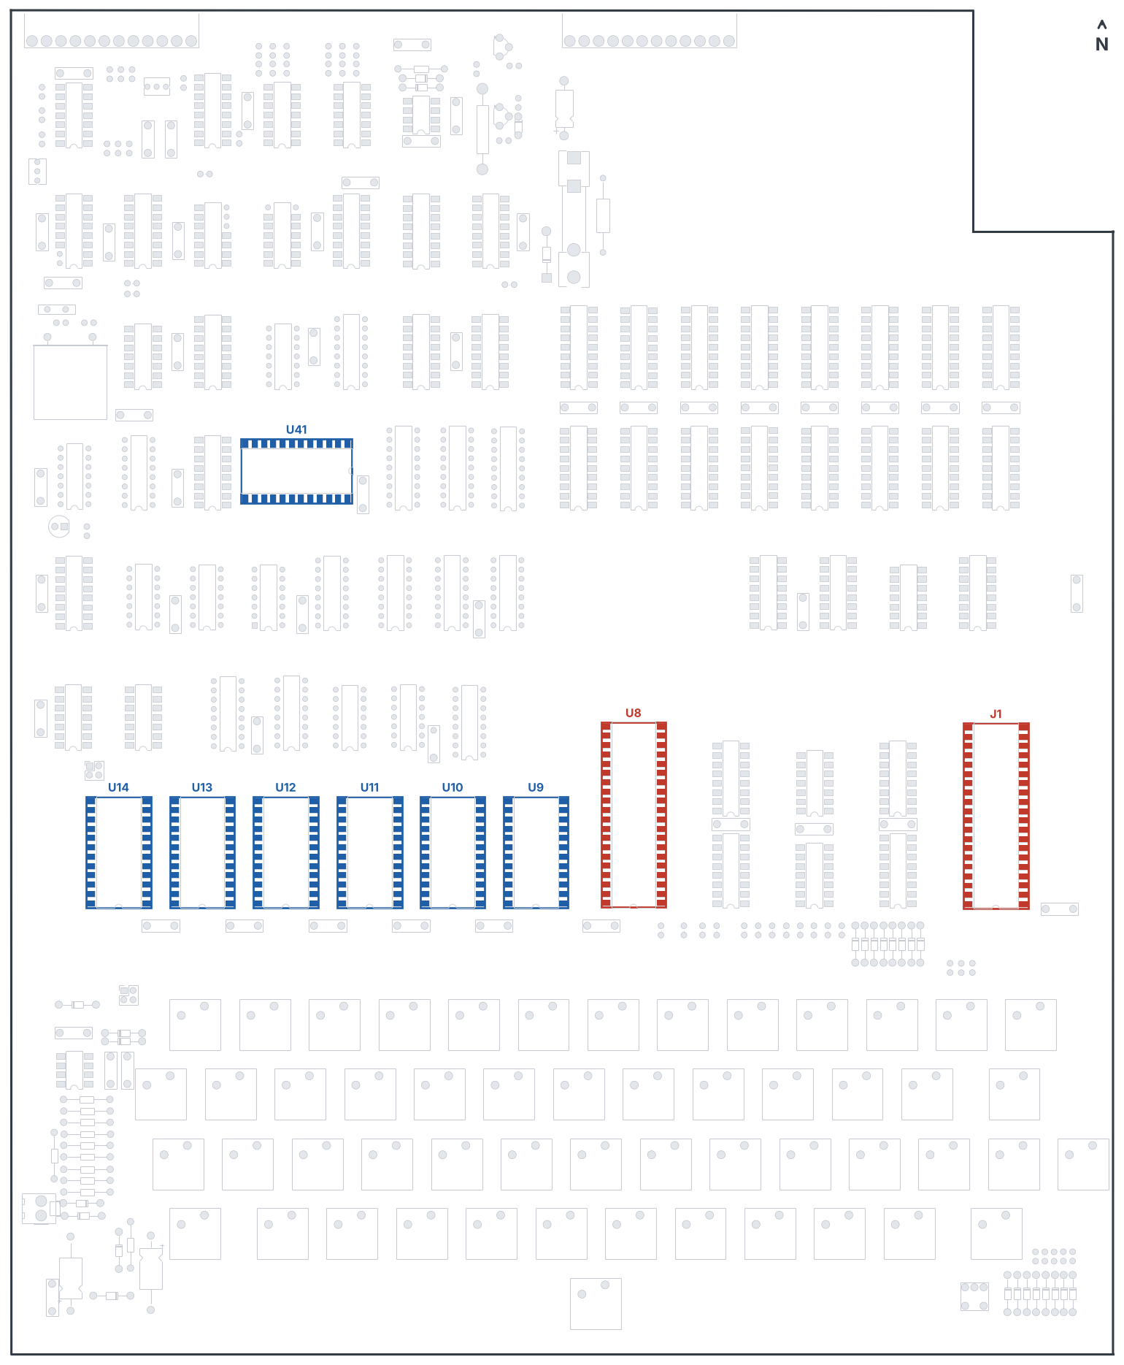
Figure 2-1 Steps 1 and 2: 40-pin sockets (red) and 24-pin sockets (blue).

Test 1 ROM socket wiring (after Step 2)
Purpose: check for solder bridges and confirm the ROM socket power pins. Use the resistance range of your meter on socket U9.
- Pins 12 and 18 should read as a short (both are ground: pin 18 is the ROM chip-enable, tied low for the 27C16).
- Pins 21 and 24 should read as a short (both are +5 V).
- Every other pair of pins should read open. Check pin 1 against pins 2–24, then pin 2 against pins 3–24, and so on.
Note The 1982 manual expects pins 18, 21 and 24 to be connected together. That was for the original 2316B ROM. On this board pin 18 goes to ground instead.

Step 3 18-pin sockets
Program RAM U31–U38 and U45–U52, video RAM U39 and U40, and colour RAM U77.
☐ | Refs | Count | Notes
☐ | U31–U38, U45–U52 | 16 | 2114 program RAM
☐ | U39, U40 | 2 | 2114 video RAM
☐ | U77 | 1 | 2114 colour RAM (optional, used with the colour option on J75)

Step 4 16-pin sockets
☐ | Refs | Count | Notes
☐ | U2, U3, U17, U20, U22, U23, U24, U25, U30, U42, U53, U54, U55, U57, U59, U60, U61, U64, U65, U69, U72, U73, U78 | 23
☐ | U6, U7 | 2 | 8T28 bus buffers to J1 – only needed with an expansion board
☐ | U74, J75 | 2 | Colour option (U74 8T28, J75 colour connector) – optional

Step 5 14-pin sockets
☐ | Refs | Count | Notes
☐ | U4, U5, U15, U16, U18, U19, U21, U29, U43, U56, U58, U62, U63, U70, U76, U79 | 16
☐ | U67, U68 | 2 | External serial buffers on J2 – normally not fitted

Step 6 8-pin sockets
☐ | Refs | Count | Notes
☐ | U66, U80 | 2 | CA3130 and LM393. The 1982 kit soldered these in directly; sockets make replacement easier.

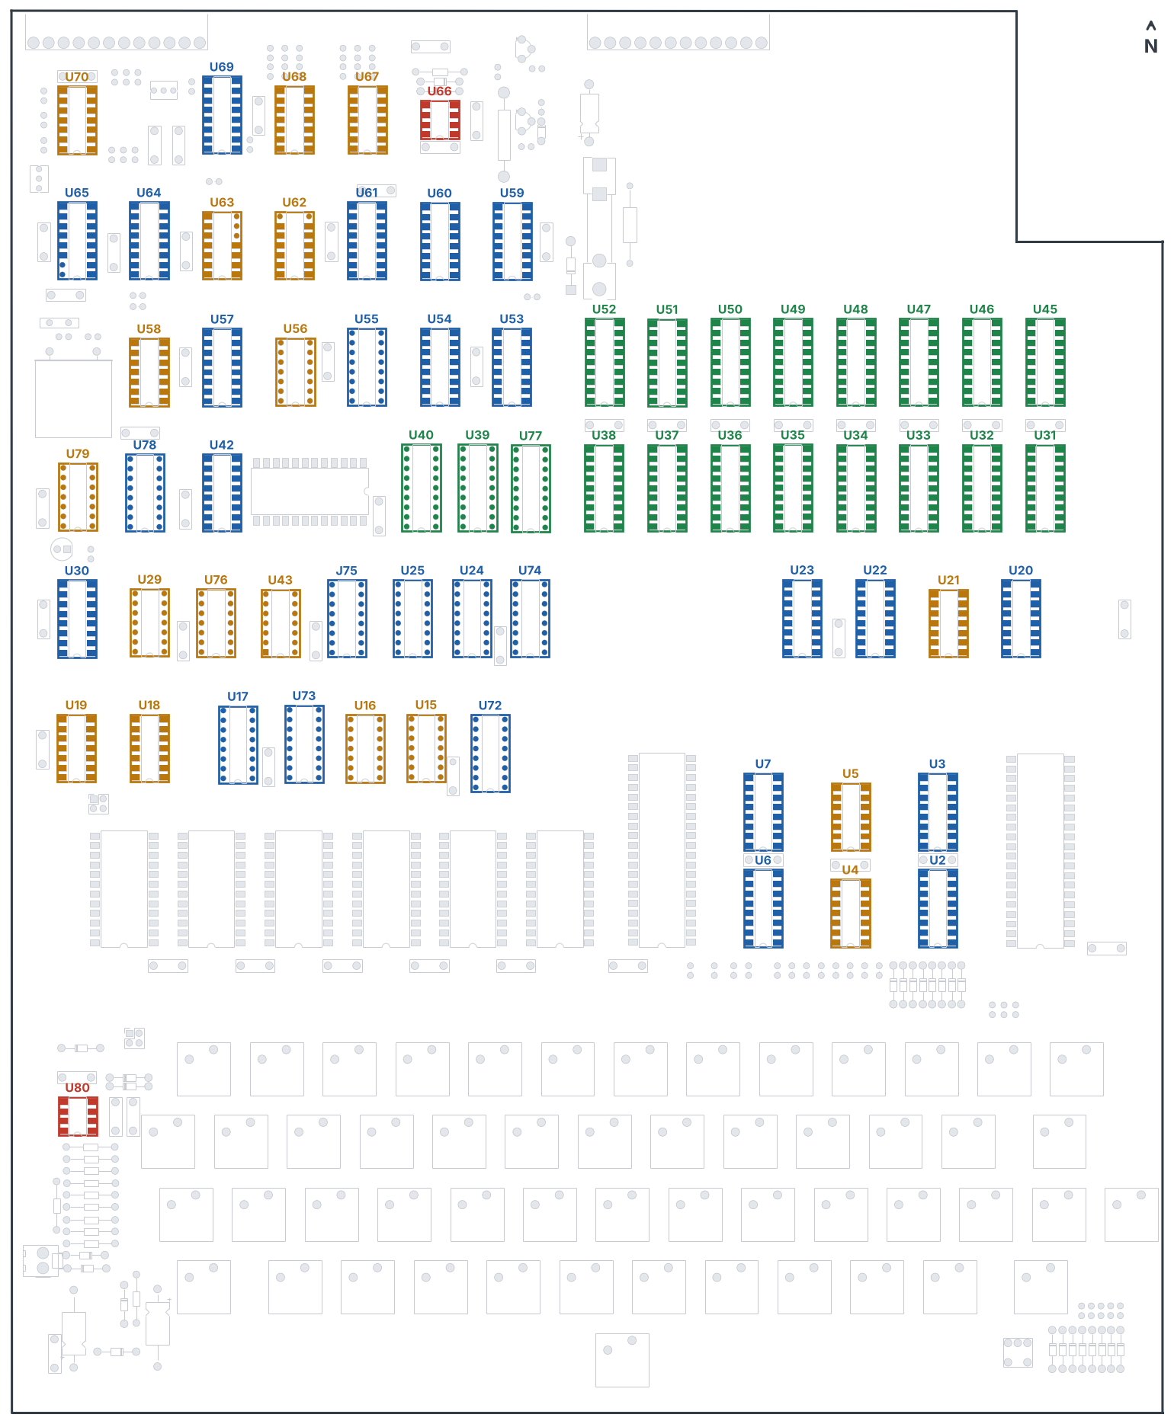
Figure 2-2 Steps 3–6: 18-pin (green), 16-pin (blue), 14-pin (orange) and 8-pin (red) sockets.

Test 2 Solder bridges (after Step 3)
On socket U31 check every pin against every other pin (1 to 2–18, 2 to 3–18 and so on). All should read open, including pin 9 (ground) to pin 18 (+5 V). Because U31 connects to the rest of the RAM and many other sockets, this also checks those for bridges.

Test 3 Address and data continuity (after Step 6)
Each line below should read as a short circuit between all the pins listed.
Line | U8 pin | U13 pin | U31 pin
A0 | 9 | 8 | 5
A1 | 10 | 7 | 6
A2 | 11 | 6 | 7
A3 | 12 | 5 | 4
A4 | 13 | 4 | 3
A5 | 14 | 3 | 2
A6 | 15 | 2 | 1
A7 | 16 | 1 | 17
A8 | 17 | 23 | 16
A9 | 18 | 22 | 15

Line | U8 pin | U13 pin | RAM pin
D0 | 33 | 9 | U31-14
D1 | 32 | 10 | U31-13
D2 | 31 | 11 | U31-12
D3 | 30 | 13 | U31-11
D4 | 29 | 14 | U45-14
D5 | 28 | 15 | U45-13
D6 | 27 | 16 | U45-12
D7 | 26 | 17 | U45-11

If a line reads open, look for an unsoldered pin on that socket, then check the track with the meter step by step.

Part 2 Diodes
There are 26 small-signal diodes (1N914 or 1N4148) and one rectifier (1N4001). Bend the leads to fit the hole spacing, insert with the band towards the square pad, solder and trim. 1N4148 is a direct replacement for 1N914.

Step 7 Keyboard row diodes
☐ | Refs | Part | Band faces
☐ | D1–D8 | 1N914 | North

Step 8 Sound DAC diodes
☐ | Refs | Part | Band faces
☐ | D17–D24 | 1N914 | North
☐ | D29 | 1N914 | East

Step 9 Reset and Break-key diodes
☐ | Refs | Part | Band faces
☐ | D25, D26, D31, D32 | 1N914 | West
☐ | D27 | 1N914 | North
☐ | D30 | 1N914 | East

Step 10 Cassette, RS-232 and power diodes
☐ | Refs | Part | Band faces
☐ | D9 | 1N914 | East
☐ | D10 | 1N914 | West
☐ | D16 | 1N914 (short 5 mm spacing) | North
☐ | D15 | 1N4001 | South

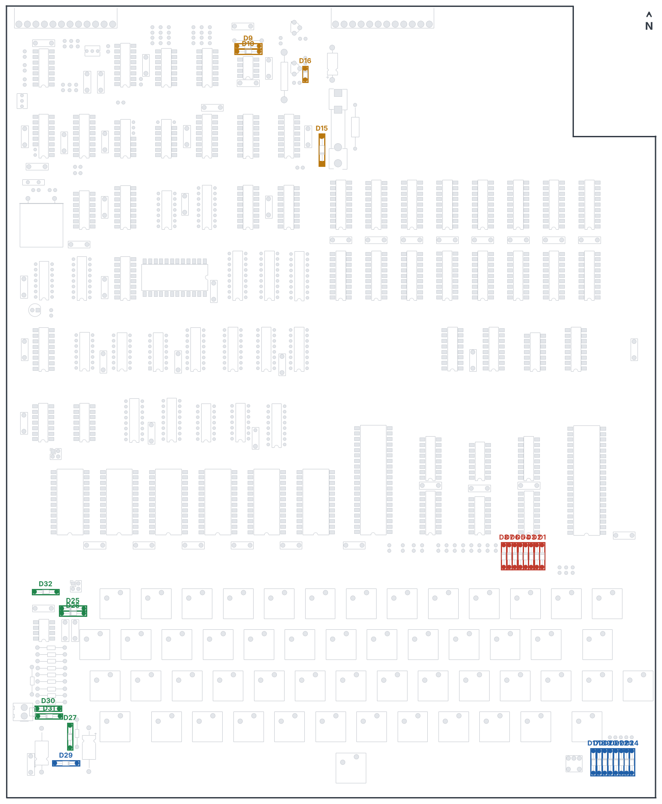
Figure 2-3 Steps 7–10: keyboard (red), DAC (blue), reset (green), cassette, RS-232 and power (orange) diodes.

Part 3 Resistors
Most resistors stand upright in holes 2.54 mm apart: bend one lead back over the body. The ones marked “flat” lie on the board in holes 12.7 mm apart (R64 and R65 are longer ½ W parts). Resistors are not polarised.

Step 11 Keyboard pull-ups
☐ | Refs | Value | Mounting
☐ | R1–R8 | 4.7 kΩ | Upright

Step 12 Sound DAC
☐ | Ref | Value | Mounting
☐ | R67 | 8.2 kΩ | Upright
☐ | R68 | 3.9 kΩ | Upright
☐ | R69 | 2 kΩ | Upright
☐ | R70 | 16 kΩ | Upright
☐ | R71 | 33 kΩ | Upright
☐ | R73 | 68 kΩ | Upright
☐ | R74 | 510 Ω | Upright
☐ | R75 | 1 kΩ | Upright
☐ | R89 | 510 Ω | Flat

Step 13 Reset and Break key
☐ | Ref | Value | Mounting
☐ | R76 | 4.7 kΩ | Flat
☐ | R77 | 1 MΩ | Flat
☐ | R78 | 100 kΩ | Flat
☐ | R79 | 100 kΩ | Flat
☐ | R80 | 1 MΩ | Flat
☐ | R81 | 1 MΩ | Flat
☐ | R82 | 1 MΩ | Flat
☐ | R83 | 10 kΩ | Flat
☐ | R84 | 100 kΩ | Flat
☐ | R85 | 10 MΩ | Flat

Step 14 Processor and bus
☐ | Ref | Value | Mounting
☐ | R9 | 220 Ω | Upright
☐ | R10, R11 | 4.7 kΩ | Upright
– | R88 | 390 Ω | Do not fit

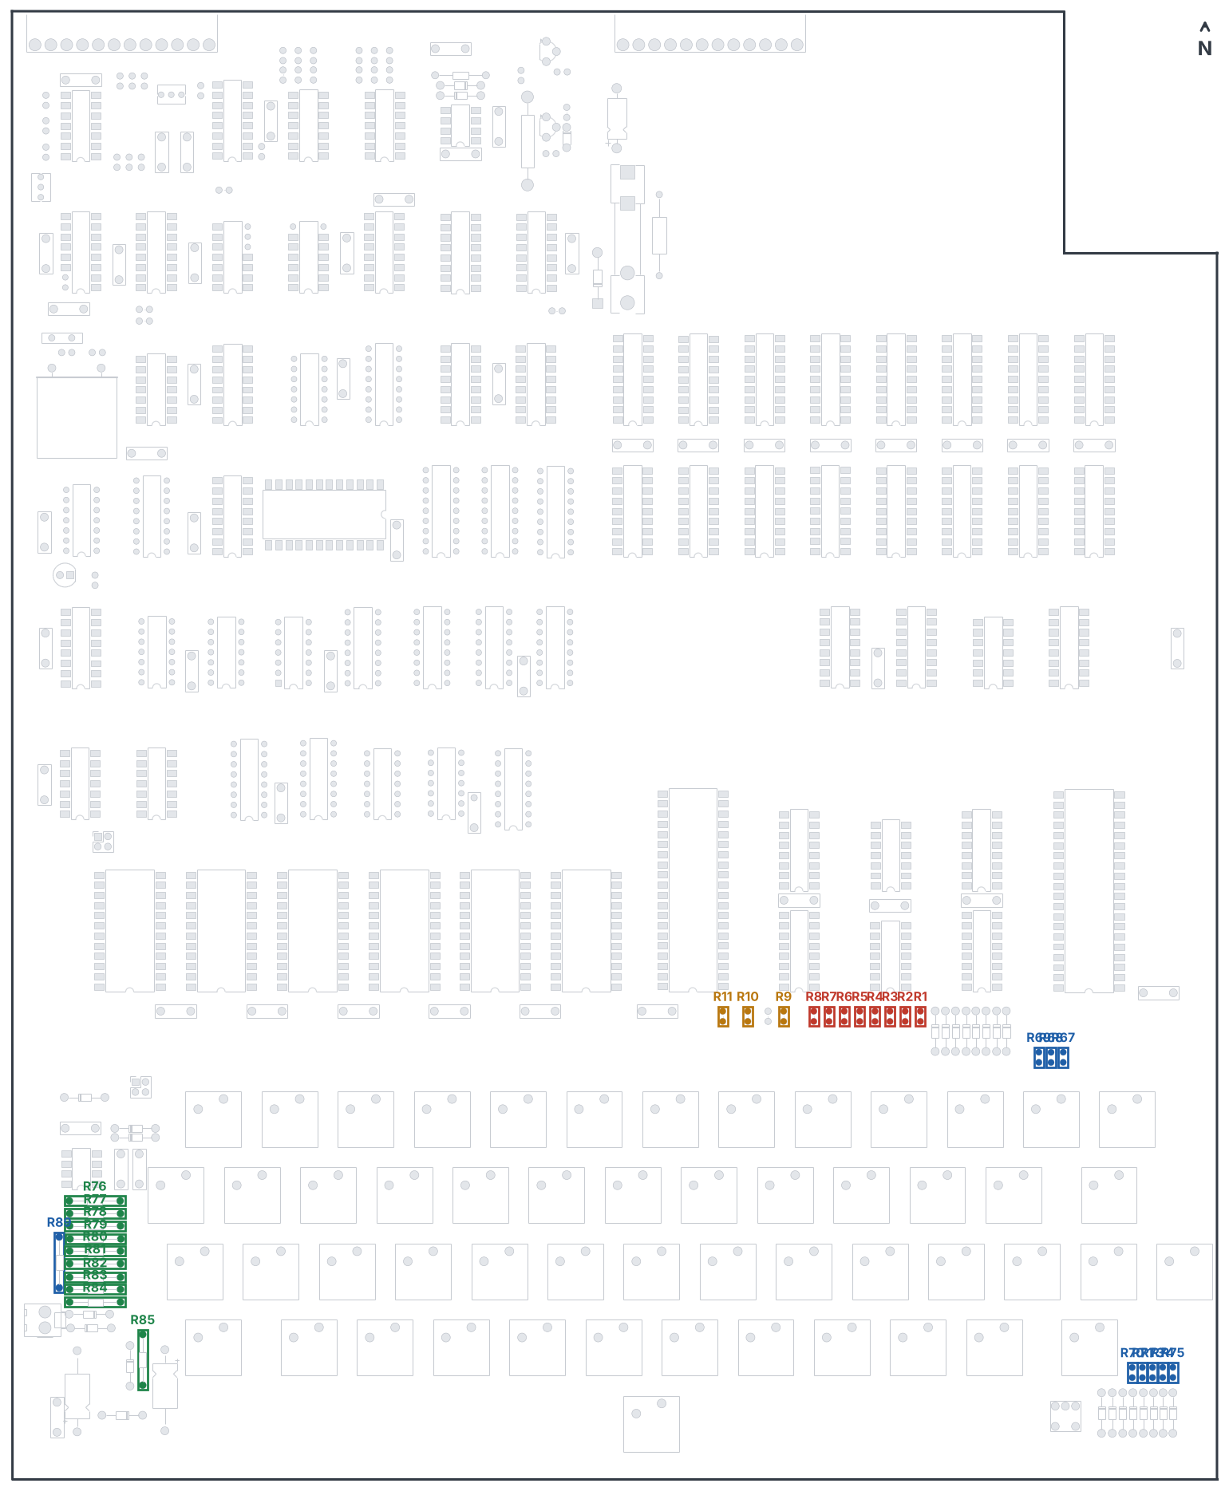
Figure 2-4 Steps 11–14: keyboard (red), DAC (blue), reset (green), processor (orange).

Step 15 Oscillator and video
☐ | Ref | Value | Mounting
☐ | R32 | 1 kΩ | Upright
☐ | R33 | 10 kΩ | Upright
☐ | R34 | 10 kΩ | Upright
☐ | R35 | 470 Ω | Upright
☐ | R36 | 470 Ω | Upright
☐ | R50 | 10 kΩ | Upright
☐ | R51 | 220 Ω | Upright
☐ | R52 | 1 kΩ | Upright
☐ | R59 | 1 kΩ | Upright
☐ | R60 | 470 Ω | Upright
☐ | R61 | 220 Ω | Upright
☐ | R86 | 1 kΩ | Upright

Step 16 Cassette, RS-232 and LED
☐ | Ref | Value | Mounting
☐ | R37 | 10 kΩ | Flat
☐ | R53 | 10 kΩ | Upright
☐ | R54 | 1 kΩ | Upright
☐ | R55 | 10 kΩ | Upright
☐ | R56 | 100 kΩ | Upright
☐ | R90 | 100 Ω | Upright
☐ | R62 | 4.7 kΩ | Upright
☐ | R63 | 10 kΩ | Upright
☐ | R66 | 10 kΩ | Upright
☐ | R72 | 1 kΩ | Upright
☐ | R64 | 1 kΩ ½ W | Flat, long
☐ | R65 | 1 kΩ ½ W | Flat, long
☐ | R87 | 470 Ω | Upright

Note R38–R49 are the termination resistors for the external serial port on J2. They were normally not installed; leave them out unless you are fitting U67 and U68.

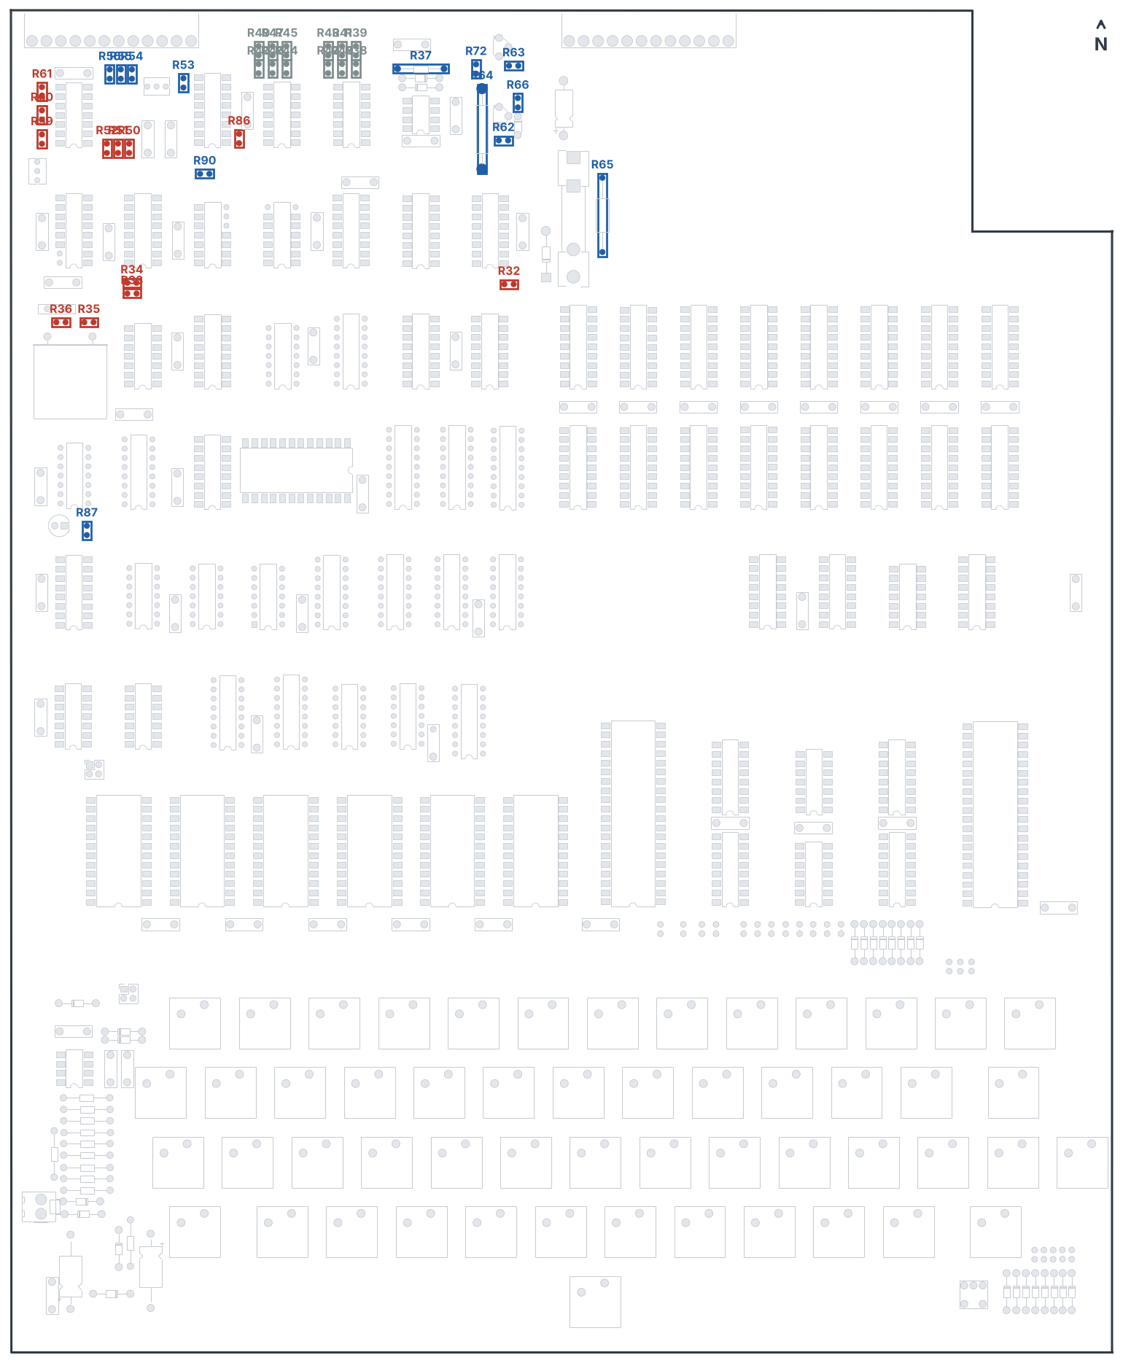
Figure 2-5 Steps 15 and 16: oscillator and video (red), cassette, RS-232 and LED (blue). Grey: optional R38–R49.

Part 4 Capacitors

Step 17 Decoupling capacitors
39 capacitors of 0.1 µF (marked 104), one beside each group of chips.
☐ | Refs | Value | Count
☐ | C21–C30, C32, C33, C35–C54, C56, C58, C59, C66–C69 | 0.1 µF | 39

Step 18 Timing and signal capacitors
☐ | Ref | Value | Marking
☐ | C6 | 150 pF | 151
☐ | C7 | 0.001 µF | 102
☐ | C8 | 0.1 µF | 104
☐ | C9 | 68 pF | 68 or 680
☐ | C10 | 0.01 µF | 103
☐ | C11 | 0.1 µF | 104
☐ | C12 | 0.001 µF | 102
☐ | C13 | 0.01 µF | 103
☐ | C55 | 0.001 µF | 102
☐ | C57 | 27 pF (disc) | 27 or 270
☐ | C65 | 150 pF | 151

Step 19 Reset capacitors
☐ | Ref | Value | Marking
☐ | C60 | 0.001 µF | 102
☐ | C61 | 150 pF | 151
☐ | C62 | 0.1 µF | 104

Step 20 Electrolytic capacitors
These are polarised. Fit them lying flat, + lead in the square pad, rated at 16 V or more.
☐ | Ref | Value | + lead faces
☐ | C5 | 47 µF | South
☐ | C63 | 33–35 µF | South
☐ | C64 | 47–50 µF | North

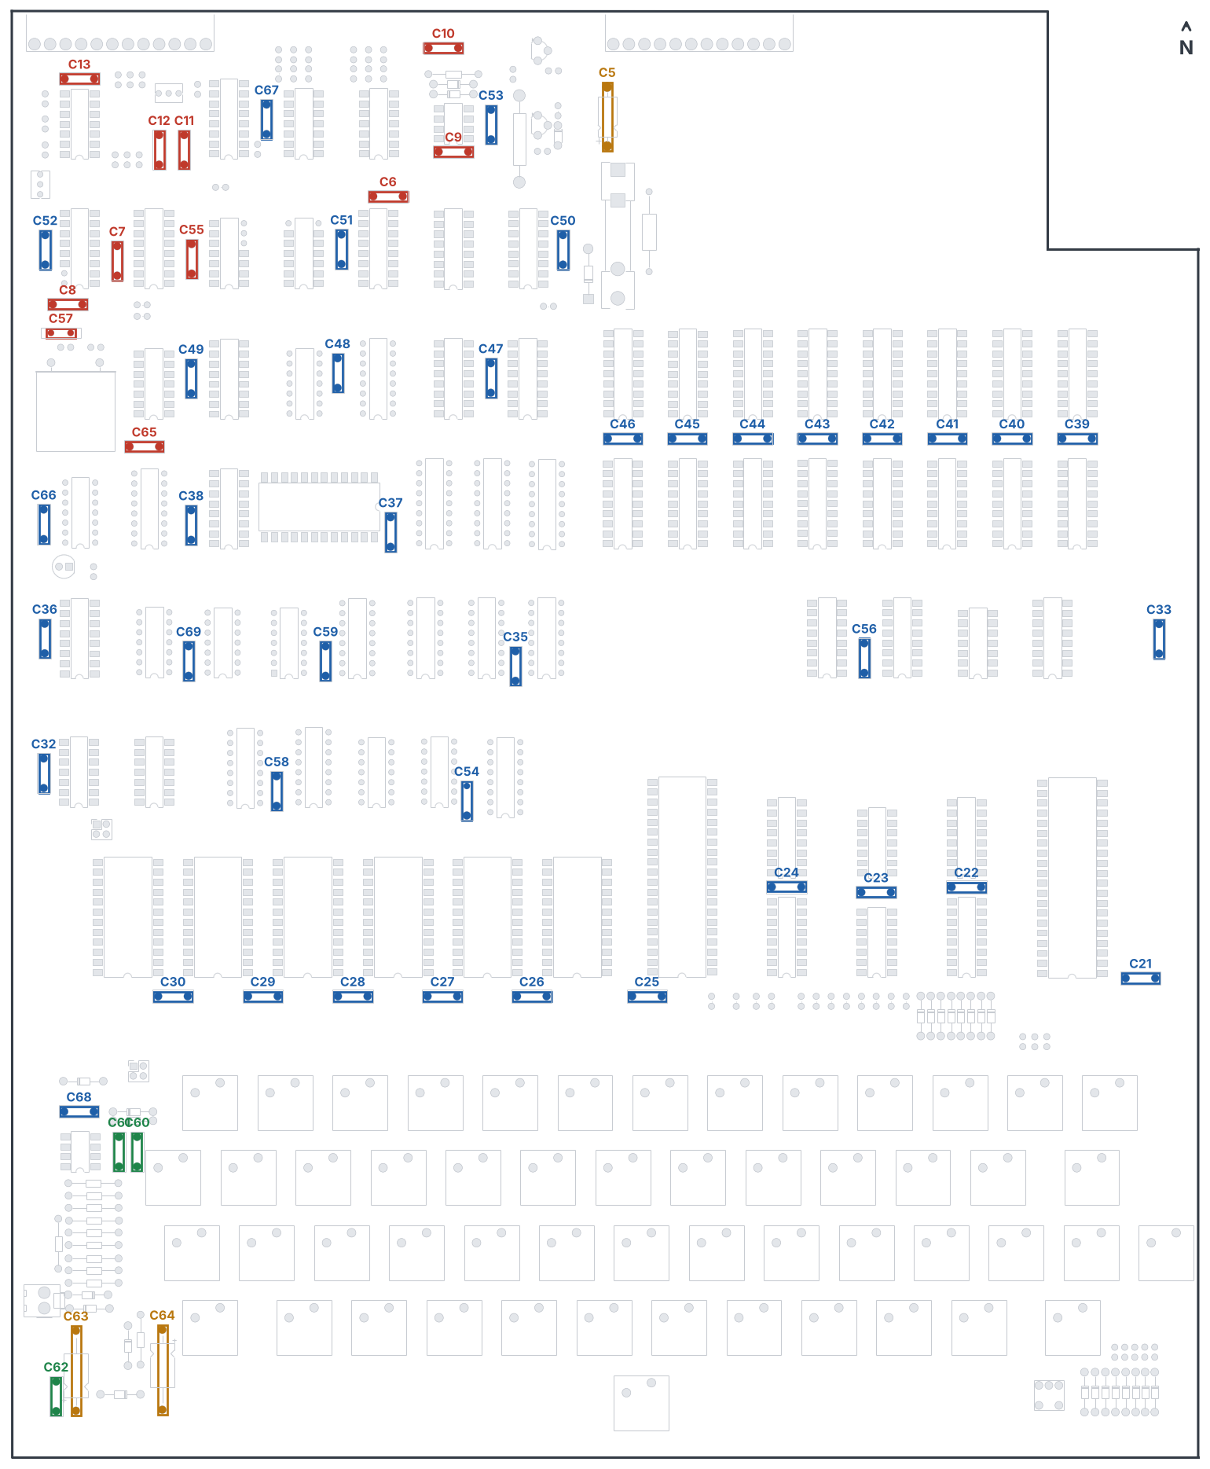
Figure 2-6 Steps 17–20: decoupling (blue), timing (red), reset (green), electrolytic (orange).

Part 5 Other components

Step 21 Trimmers and transistors
☐ | Ref | Part | Notes
☐ | R57 | 10 kΩ trimmer (Bourns 3266Y or similar) | Cassette input level
☐ | R58 | 5 kΩ trimmer | Video level
☐ | Q1 | 2N5226 PNP | Flat face to the silkscreen. Pads: 1 collector, 2 base, 3 emitter
☐ | Q2 | 2N5225 NPN | Flat face to the silkscreen. Pads: 1 collector, 2 base, 3 emitter

Note 2N5225 and 2N5226 are long obsolete. 2N3904 (NPN) and 2N3906 (PNP) work in this circuit, but their legs are in a different order. Bend the leads so collector, base and emitter land in pads 1, 2 and 3.

Step 22 LED and crystal
☐ | Ref | Part | Notes
☐ | LED1 | 5 mm red LED | Flat side (cathode) East, in the square pad
☐ | X1 | 3.93216 MHz crystal (HC-51 can) | Lay it flat on its silkscreen outline. Avoid heating the can.

Step 23 Connectors, headers and fuse clips
☐ | Ref | Part | Notes
☐ | J2 | 12-way right-angle Molex header | Video, cassette and external serial
☐ | J3 | 12-way right-angle Molex header | Serial options and baud rate (see Section 8)
☐ | J4 | 2-way Molex KK-396 header | Speaker output from the sound DAC
☐ | W3, W5 | 2×2 pin headers | ACIA CTS and receive-clock options
☐ | F1 | Fuse clips for 6.3 × 32 mm fuse | Do not fit the fuse yet

Step 24 Power leads and feet
- Solder a red lead to the +5V_IN holes and a black lead to the ground holes beside the fuse clips in the north-east corner. Use wire rated for at least 3 A, and add a strain relief.
- Fit rubber feet or standoffs in the mounting holes. Keep the two holes either side of the space bar free for the space-bar fitting.
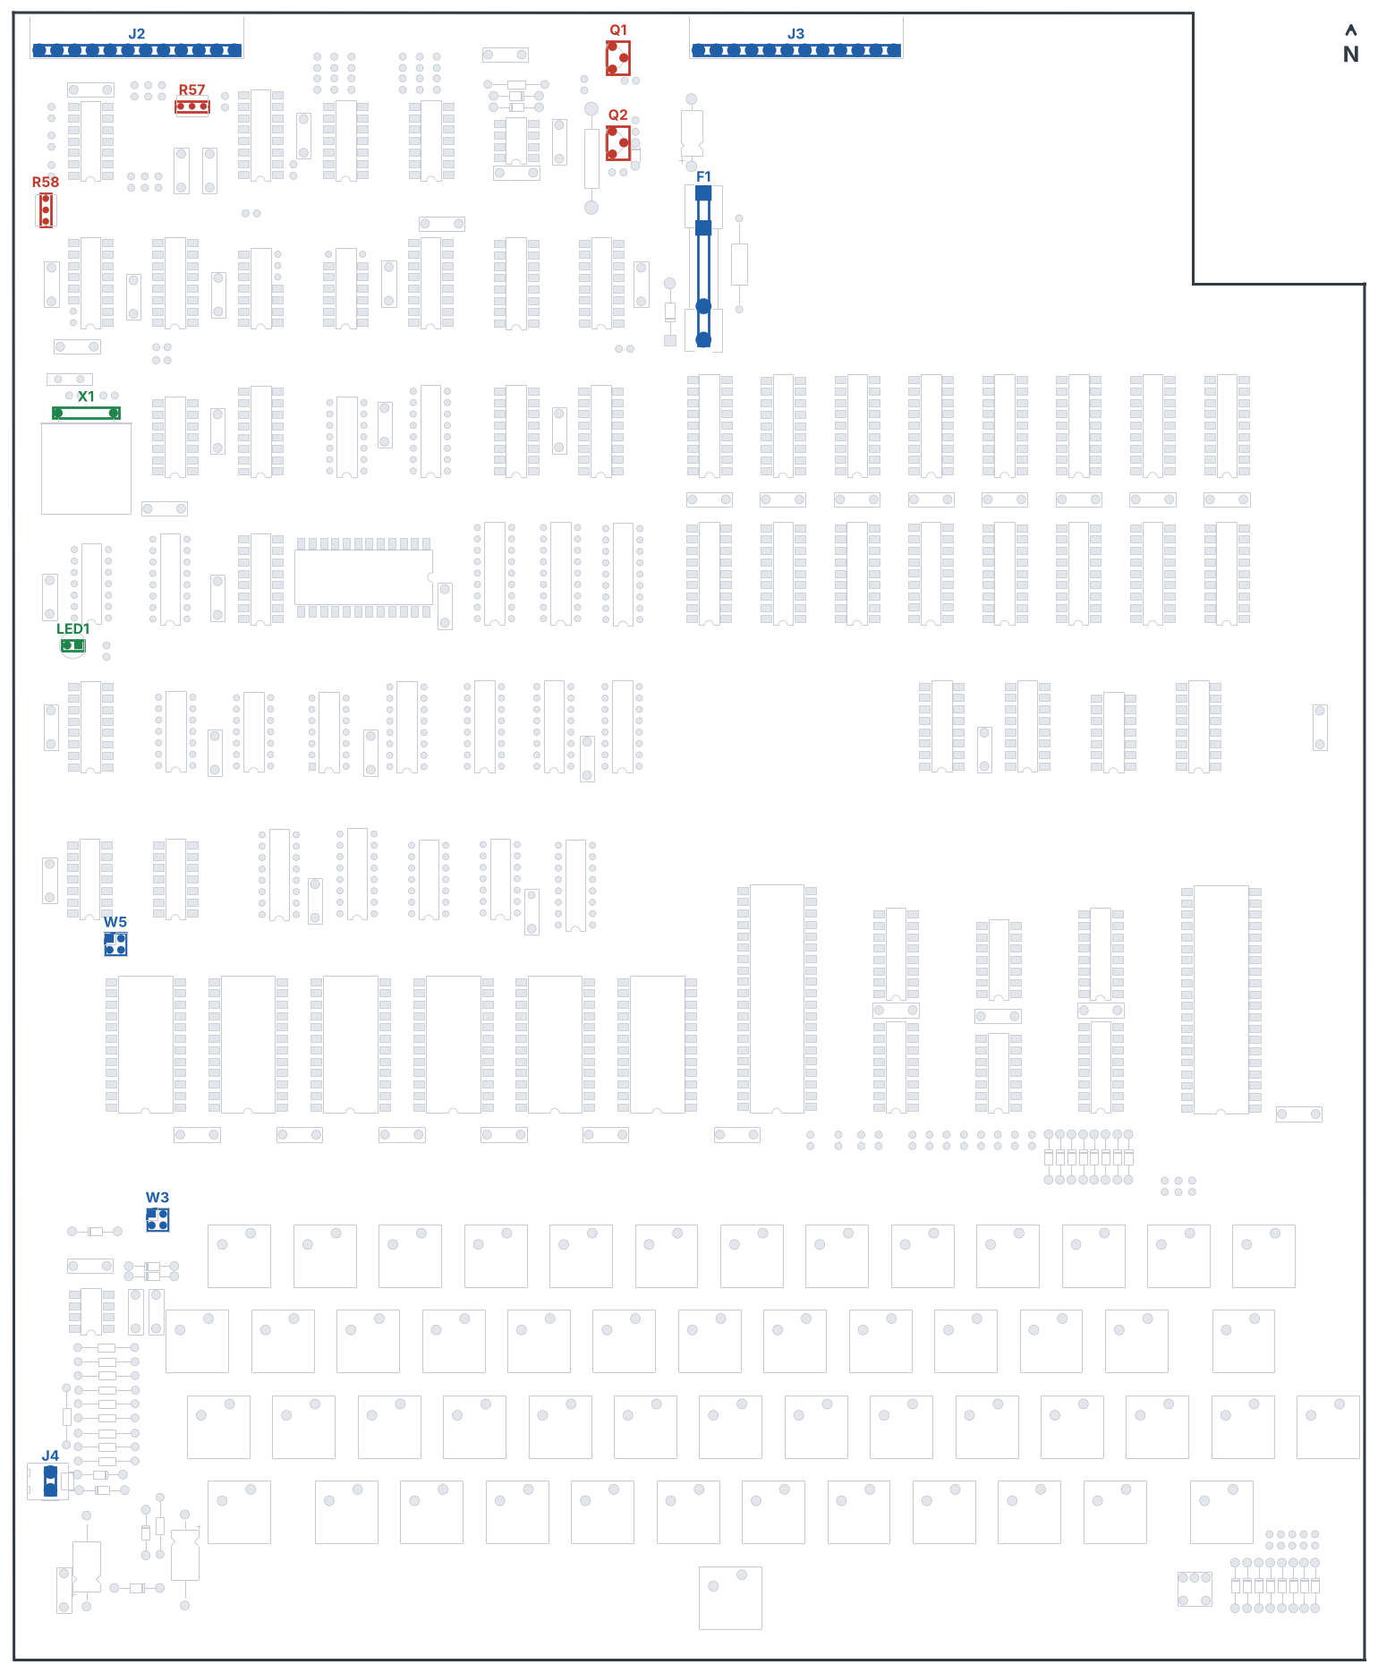
Figure 2-7 Steps 21–23: trimmers and transistors (red), LED and crystal (green), connectors and fuse clips (blue).
Note This completes Stage I. Clean off flux residue with isopropyl alcohol and check every joint under a good light before you start the keyboard.

3 Stage II – keyboard
The keyboard uses PCB-mount Cherry MX keyswitches. The five-pin type, with two extra plastic pegs, locates itself in the board; three-pin plate-mount switches also fit but need more care to keep straight.

Key positions
Table 3-1 lists every switch position in keyboard order, from the top row to the space bar. Use it to place your keycaps.
Row | Switch and key
Row 1 (top) | SW1 1, SW2 2, SW3 3, SW4 4, SW5 5, SW6 6, SW7 7, SW8 8, SW9 9, SW10 0, SW11 :, SW12 -, SW13 RUB OUT
Row 2 | SW14 ESC, SW15 Q, SW16 W, SW17 E, SW18 R, SW19 T, SW20 Y, SW21 U, SW22 I, SW23 O, SW24 P, SW25 LINE FEED, SW26 RETURN
Row 3 (home) | SW27 CTRL, SW28 A, SW29 S, SW30 D, SW31 F, SW32 G, SW33 H, SW34 J, SW35 K, SW36 L, SW37 ;, SW38 SHIFT LOCK, SW39 REPEAT, SW40 BREAK
Row 4 | SW41 L SHIFT, SW42 Z, SW43 X, SW44 C, SW45 V, SW46 B, SW47 N, SW48 M, SW49 ,, SW50 ., SW51 /, SW52 R SHIFT
Space bar | SW53 SPACE
Shift lock (alternative) | SW54 SHIFT LOCK

RETURN (SW26) and the two SHIFT keys (SW41, SW52) are 1.5-unit positions; all the others are 1 unit wide.

Step 25 Prepare the special keys
- Shift lock: choose one position. Either fit a latching Cherry MX Lock switch at SW38 (in the home row, as on the original OSI layout), or fit a latching switch at SW54 in the south-east corner. Never fit both, because they are wired in parallel.
- Break key SW40: snip off the right-hand (east) plastic locating peg, flush with the switch base, before fitting. That hole was removed from the board because it cut into the ground strip. The spot is marked SNIP PEG on the silkscreen.
- Space bar SW53: the board has no Cherry stabiliser footprint. The two holes either side of the space bar are the original OSI space-bar mounting holes. Decide how you will support the space bar before soldering SW53.

Step 26 Fit and solder the switches
- Work one row at a time, starting with the top row.
- Push each switch fully home so its base sits flat on the board, with all pegs in their holes.
- Solder one pin of every switch in the row, check that they are all square and flat, then solder the second pin. Re-melt a joint and press the switch down if one has lifted.
- Do not hold the iron on a switch pin for more than a few seconds; the plastic housing softens.
- Fit SW40 (Break) after the home row, with its peg snipped.

Step 27 Space bar and keycaps
- Fit SW53 and your space-bar support.
- Fit the keycaps using Table 3-1. Check that every key moves freely and does not rub on its neighbours.

Test 4 Keyboard matrix (optional, before chips are fitted)
With the meter on continuity, put the probes on the two pins of a switch from underneath and press the key: it should read closed only while the key is held. A quick pass over all 54 positions catches unsoldered pins.
Note This completes all the soldering. The rest of the build is fitting chips and testing.

4 Stage III – power and video
In this stage you first check the power wiring with no chips fitted, then fit the video chips and get a picture on the screen. The video section works without the processor, so a screen full of characters proves a large part of the board.

Chip handling
- Pin 1 of each chip goes to the notched end of its socket: notch South everywhere, except U41 whose notch faces East.
- Straighten the legs by pressing each row gently against a flat surface before inserting.
- Start the pins at one end, check that they all line up, then press the chip home. Support the board underneath while you push.
- After fitting, look along each side of every chip for legs that have folded under.
- NMOS and CMOS chips (6502, 6850, 2114, EPROMs, CA3130) are static sensitive: touch a grounded surface first and handle them by the body.

Step 28 Power-up with no chips
- With no chips fitted and the supply disconnected, measure the resistance between +5V_IN and ground. It must not read as a short (under about 10 Ω); a few hundred ohms is normal, because of the resistors connected across the supply.
- Measure between the ground holes and pin 18 of U31 (that is +5 V on the board side of the fuse). Again it must not be a short.
- Fit a 5 A fuse in F1.
- Connect the red lead to +5 V and the black lead to the supply’s negative terminal.

Test 5 Power supply
- Switch on briefly. LED1 should light. If it does not, switch off at once and check the supply polarity.
- Measure the DC voltage between U8 pin 8 (+5 V) and U8 pin 21 (ground). It should be between 4.8 V and 5.2 V. More than 5.2 V can damage the chips.
- Set the meter to AC and measure across C5. The ripple must not be more than 0.2 V.
- Spot-check +5 V on pin 24 of the ROM sockets, pin 18 of the 2114 sockets, and pin 14 or 16 of a few logic sockets.
- Switch off.

Step 29 Fit the video chips
☐ | Refs | Chip
☐ | U58 | 74LS00
☐ | U70 | 74LS03
☐ | U43 | 74LS08
☐ | U65, U69 | 74LS123
☐ | U63, U76 | 74LS74
☐ | U62 | 74LS04
☐ | U53, U54, U55, U78 | 74LS157
☐ | U30, U57, U59, U60, U61 | 74LS163
☐ | U42 | 74LS165
☐ | U19, U56 | 74LS20
☐ | U64 | 74LS76
☐ | U79 | 74LS86
☐ | U29 | 74LS93
☐ | U24, U25 | 8T28
☐ | U39, U40 | 2114 (video RAM)
☐ | U41 | Character generator 2716 – notch East
☐ | U66 | CA3130
☐ | U80 | LM393

Note Fit U74 (8T28) and U77 (2114) as well if you are using the colour option on J75.

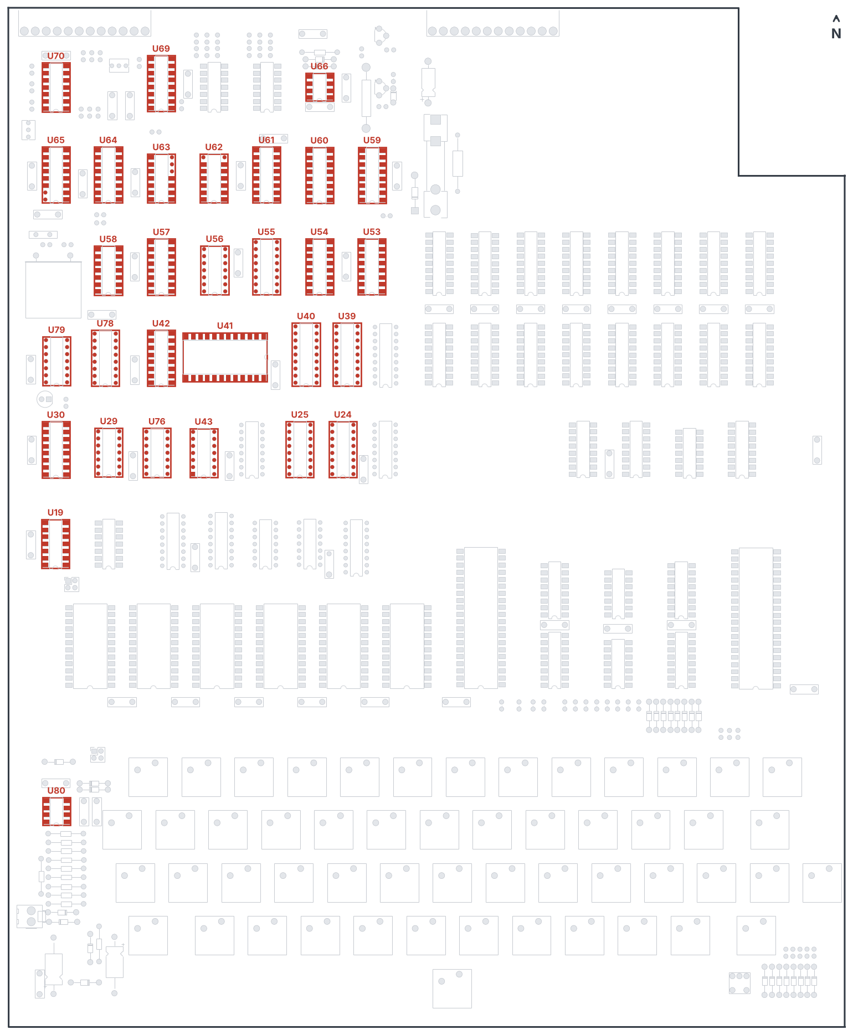
Figure 4-1 Step 29: video, timing and cassette chips.

Step 30 Connect the monitor
J2 carries video and cassette signals:
J2 pin | Signal | Connect to
12 | Video out | Monitor video input (centre)
11 | Ground | Monitor video screen
10 | Tape in (MON) | Recorder earphone or line output
9 | Aux out | Optional
8 | Ground | Recorder ground
7 | Tape out (MIC) | Recorder microphone input

Test 6 Video
- Turn on the monitor, then the board.
- Adjust R58 until the picture is steady and clear. You should see a screen full of the same graphics character, or a random mixture of characters – either is correct at this stage.
- Set R57 fully clockwise, then back a quarter turn. This sets the cassette input and can be fine-tuned later.
- With a logic probe you can check for pulses on J2 pin 12 (video), U60 pin 14, U30 pins 11–15 (video counters), U8 pin 37 (CPU clock, present even with no CPU) and U58 pin 8 (the 3.93 MHz oscillator; some probes are too slow to see it).
- Switch off.

5 Stage IV – processor, ROMs and RAM
Disconnect the power before each step. All chips in this stage fit with the notch to the South.

Part 1 Processor, decoding, monitor ROM and the first 1K of RAM

Step 31
☐ | Refs | Chip
☐ | U8 | 6502 processor
☐ | U4, U5 | 74LS125
☐ | U2, U3 | 74LS75
☐ | U20, U22, U23, U73 | 74LS138
☐ | U16, U18, U21 | 74LS04
☐ | U15 | 74LS02
☐ | U17 | 74LS139
☐ | U72 | 74LS174
☐ | U13 | Monitor ROM (SYN600 image)
☐ | U12 | BASIC 4 ROM
☐ | U31, U45 | 2114 – the first 1K of RAM at $0000

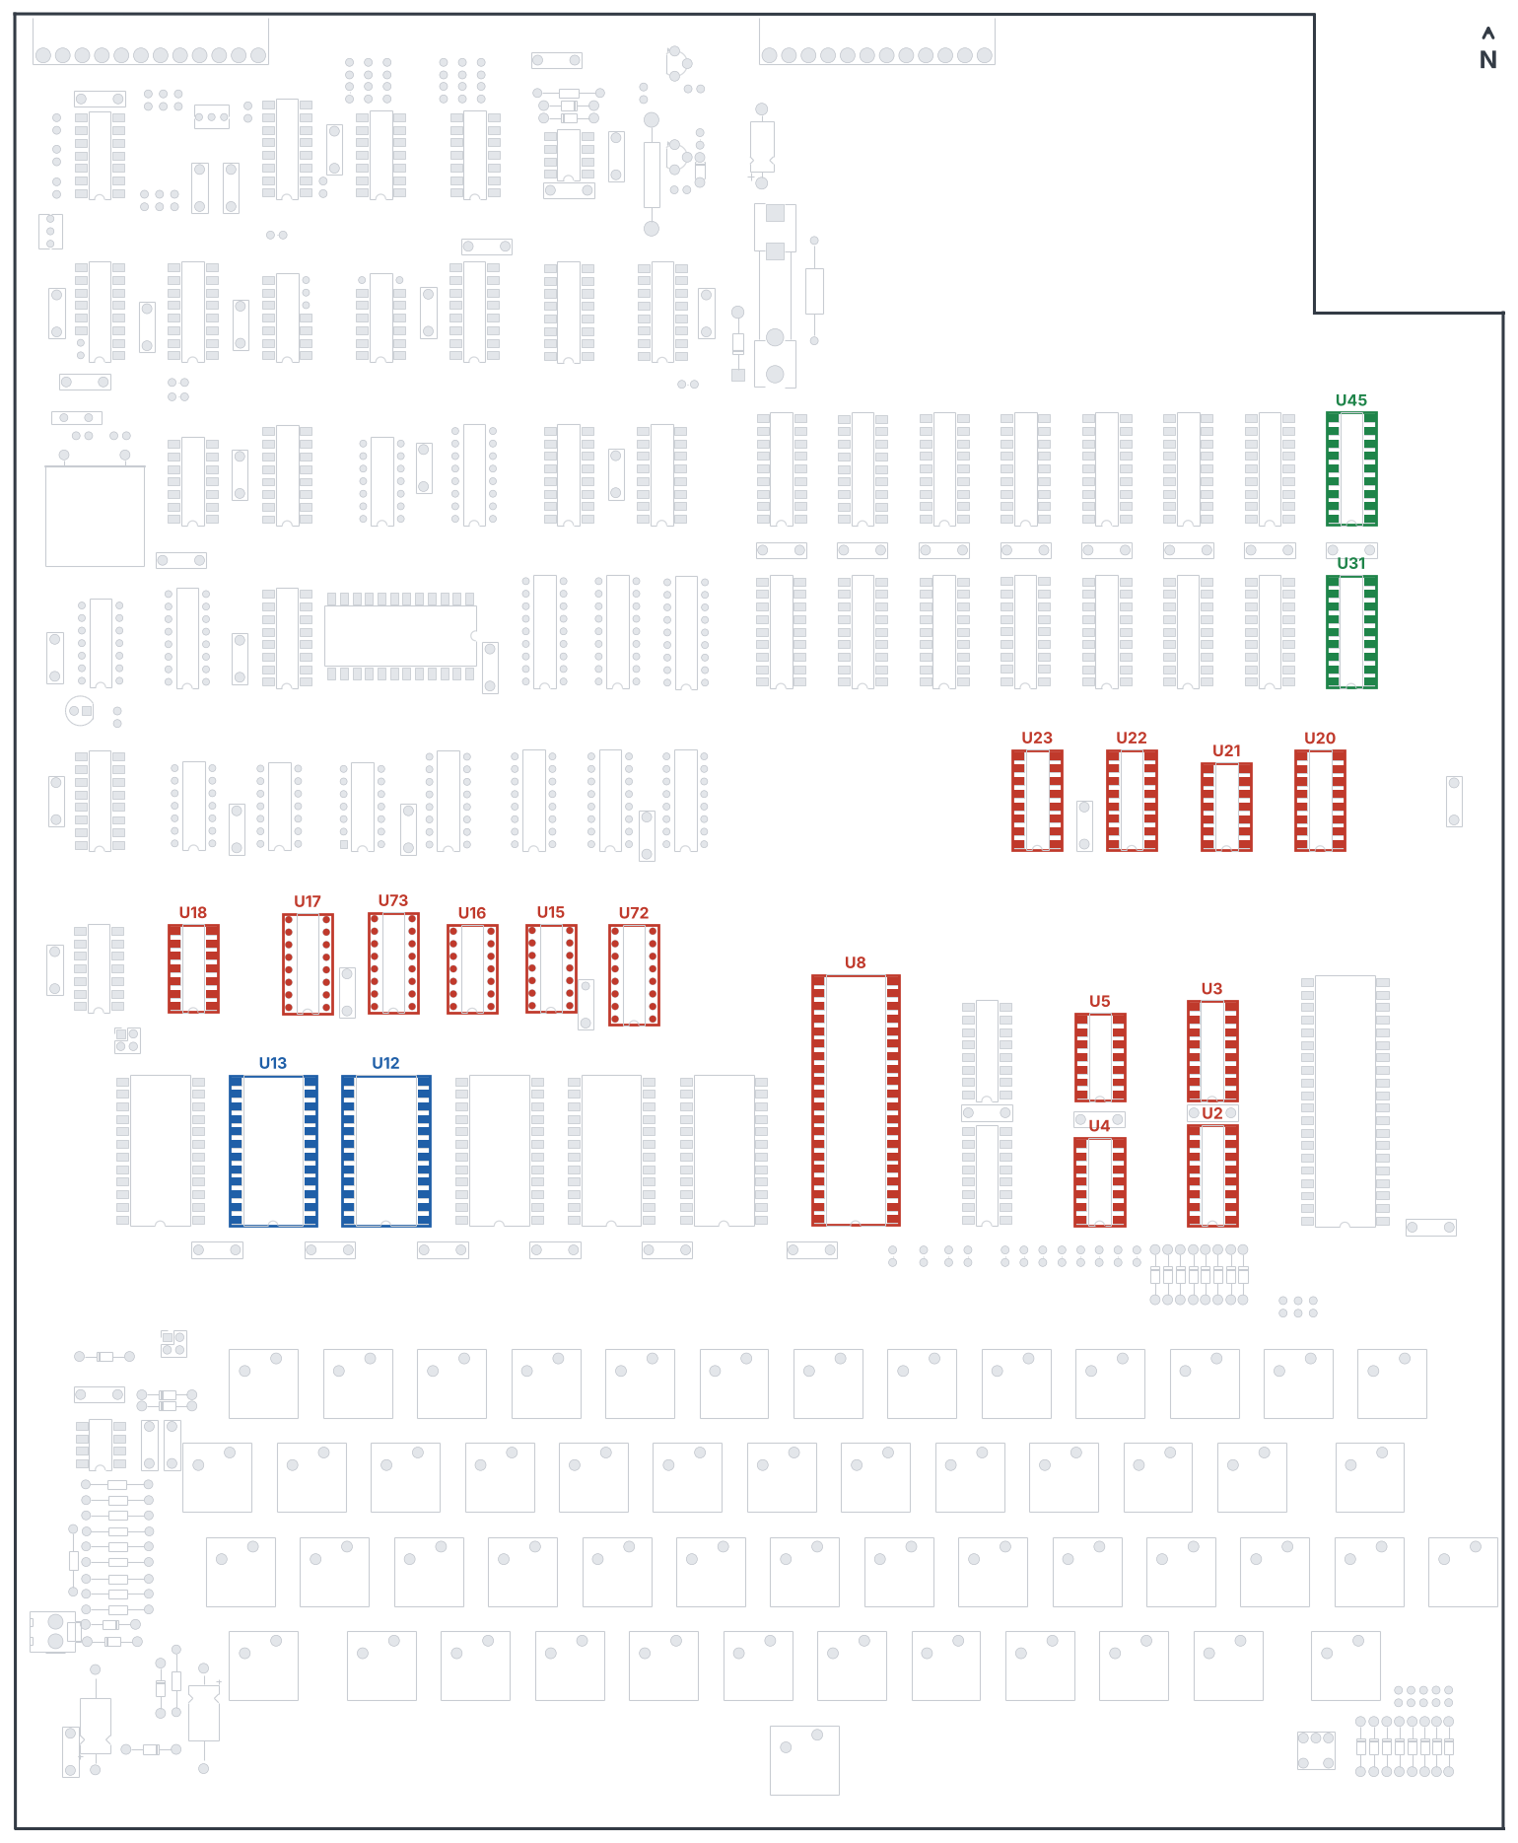
Figure 5-1 Step 31: processor and logic (red), monitor and BASIC 4 ROMs (blue), first 1K of RAM (green).
Note BASIC 4 goes in with the monitor in this step, as in the original build order.

Test 7 Monitor
- Apply power with the monitor connected. D/C/W/M ? should appear at the bottom left of the screen. If it does not, see Section 10.
- Make sure SHIFT LOCK is down. At this point only the M and BREAK keys do anything.
- Press M. The screen shows 0000 followed by two hexadecimal digits: the address and the contents of the first memory location.
- Type an address with the number keys and A–F. Press / to change the contents, type a value, and press RETURN to step to the next address. Press . to enter a new address.
- Try writing and reading back a few values in the first 1K ($0000–$03FF). At $F800 the monitor ROM reads A0 and cannot be changed.
- If nothing happens, check SHIFT LOCK, hold BREAK for about two seconds, release it and press M again.

Part 2 ACIA and BASIC ROMs

Step 32
☐ | Refs | Chip
☐ | U14 | 6850 ACIA
☐ | U11 | BASIC 3 ROM
☐ | U10 | BASIC 2 ROM
☐ | U9 | BASIC 1 ROM

Test 8 BASIC
- Apply power. At D/C/W/M ? (SHIFT LOCK down) press C. MEMORY SIZE? appears.
- Press RETURN. TERMINAL WIDTH? appears. Press RETURN again.
- The screen should show 255 BYTES FREE, the OSI 6502 BASIC version message and OK.
- Hold BREAK until D/C/W/M ? appears, then press W (warm start). The OK prompt should return.

Part 3 The remaining RAM

Step 33
☐ | Refs | Chip
☐ | U32–U38, U46–U52 | 2114 RAM, 14 chips

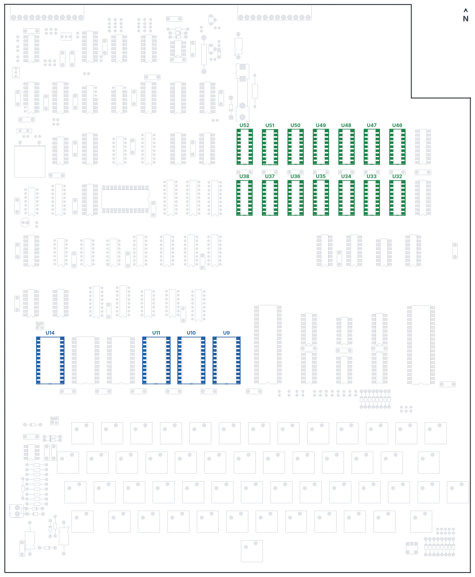
Figure 5-2 Steps 32 and 33: ACIA and BASIC 1–3 (blue), remaining RAM (green).

Test 9 Memory size
- Cold start with C and press RETURN twice.
- The screen should show 7423 BYTES FREE. Any other number points to a RAM chip or the RAM select logic (U22, U23).
Done Congratulations – your Superboard II is complete. It works the same as an Ohio Scientific Challenger 1P, so the original user manuals and software apply.

6 Optional parts
Parts | Purpose | Fit when
U6, U7 (8T28) | Buffers the data bus to the J1 expansion connector | You attach a 610 or other expansion board to J1
U74 (8T28), U77 (2114), J75 | Colour RAM and colour connector | You use a colour board on J75
U67 (74LS14), U68 (74LS17), R38–R49 | External serial port on J2 pins 1–6 | You use the external serial lines
R88 (390 Ω) | DD line pull-down | Normally not fitted

7 Jumper settings

W3 – ACIA CTS
The 6850 ACIA will only transmit when its CTS input is low. Fit a link across W3 pins 1–2 (or 3–4) to tie CTS to ground. This is needed for saving to cassette and for serial output. The same job can be done on J3 (pins 7 and 9).

W5 – receive clock
Leave W5 open: the ACIA transmit and receive clocks are joined on the board and driven by the baud-rate divider. Link pins 1–2 only if you fit the optional external-serial parts and want the receive clock from J2 pin 2.

8 J3 option connector
J3 selects the serial data source and the baud rate, using a plug with wire links (the original kit used a shorting plug).
J3 pin | Signal | J3 pin | Signal
1 | Ground | 7 | Ground (–V IN, tied to ground on this board)
2 | RS-232 out | 8 | Baud divider input
3 | RS-232 in | 9 | ACIA CTS
4 | ACIA receive data | 10 | 124.8 kHz clock
5 | Cassette receive data | 11 | +5 V
6 | RS-232 receive data | 12 | 499.2 kHz clock

Setting | Links
Cassette at 300 baud (standard) | 4–5, 8–10 and 7–9 (or use W3 for CTS)
Cassette or serial at 1200 baud | Replace 8–10 with 8–12
RS-232 serial | 4–6 instead of 4–5; signals on pins 2 and 3

Note Because –V IN is tied to ground, the RS-232 output only swings between 0 and +5 V. Most modern USB serial adapters accept this, but a true ±12 V device may not.

9 Programming the ROMs
Socket | Contents | Address | Part
U13 | Monitor (SYN600) | $F800–$FFFF | 27C16 or 2816
U9 | BASIC 1 | $A000–$A7FF | 27C16 or 2816
U10 | BASIC 2 | $A800–$AFFF | 27C16 or 2816
U11 | BASIC 3 | $B000–$B7FF | 27C16 or 2816
U12 | BASIC 4 | $B800–$BFFF | 27C16 or 2816
U41 | Character generator | Video only | 2716 or 27C16

- Each image is 2 KB. Use the Superboard II / Challenger 1P images; images from other OSI machines will not start correctly.
- Use parts with an access time of 450 ns or faster.
- A 2816 EEPROM works in the program sockets with no change; its write-enable pin (21) is tied to +5 V, so the board can only read it.
- The character generator image must be the OSI 600 character set in 2716 layout, as on the original character ROM.

10 Troubleshooting
Symptom | Likely causes
Blank screen at power-up | Video cable; R58 setting; crystal oscillator (X1, U58); video timing (U29, U30, U59–U61); monitor ROM U13; BASIC 4 (U12)
Random characters, or BREAK does nothing | Reset circuit: U80, R76–R85, C60–C62, C64, D25–D27, D30–D32
Picture rolls | Vertical sync one-shot U65 and its parts; timing counter U61
Split screen (2 or 4 images) | Video timing U59; video address multiplexers U53–U55
Wrong number of bytes free | A faulty 2114, or the RAM selects U22 and U23
No OK prompt after cold start | BASIC 1 (U9)
Goes to the monitor but will not cold start | A BASIC ROM; ROM select U73; the first 1K of RAM (U31, U45)
No lower-case characters | Character generator U41
One key or a group of keys dead | That switch’s solder joints; keyboard decoding U2–U5; diodes D1–D8
Cassette will not load | R57 setting; recorder volume; J3 links; U66 and U62
Cassette will not save, no serial output | CTS not grounded (W3 or J3 7–9); U14

Appendix A Bill of materials
Ref | Value | Qty | Refs
IC | 6502 | 1 | U8
IC | 6850 | 1 | U14
IC | 27C16 or 2816 (programmed) | 5 | U9–U13
IC | 2716 character generator | 1 | U41
IC | 2114 RAM | 19 | U31–U40, U45–U52, U77*
IC | 8T28 | 5 | U24, U25, U6*, U7*, U74*
IC | 74LS00 | 1 | U58
IC | 74LS02 | 1 | U15
IC | 74LS03 | 1 | U70
IC | 74LS04 | 4 | U16, U18, U21, U62
IC | 74LS08 | 1 | U43
IC | 74LS14 | 1 | U67*
IC | 74LS17 | 1 | U68*
IC | 74LS20 | 2 | U19, U56
IC | 74LS74 | 2 | U63, U76
IC | 74LS75 | 2 | U2, U3
IC | 74LS76 | 1 | U64
IC | 74LS86 | 1 | U79
IC | 74LS93 | 1 | U29
IC | 74LS123 | 2 | U65, U69
IC | 74LS125 | 2 | U4, U5
IC | 74LS138 | 4 | U20, U22, U23, U73
IC | 74LS139 | 1 | U17
IC | 74LS157 | 4 | U53, U54, U55, U78
IC | 74LS163 | 5 | U30, U57, U59, U60, U61
IC | 74LS165 | 1 | U42
IC | 74LS174 | 1 | U72
IC | CA3130 | 1 | U66
IC | LM393 | 1 | U80
Socket | 40 / 24 / 18 / 16 / 14 / 8 pin | 2 / 7 / 19 / 27 / 18 / 2 | See Stage I, Part 1
Diode | 1N914 or 1N4148 | 26 | D1–D10, D16–D27, D29–D32
Diode | 1N4001 | 1 | D15
LED | 5 mm red | 1 | LED1
Transistor | 2N5225 NPN | 1 | Q2
Transistor | 2N5226 PNP | 1 | Q1
Crystal | 3.93216 MHz HC-51 | 1 | X1
Resistor | 100 Ω | 1 | R90
Resistor | 220 Ω | 3 (+6*) | R9, R51, R61 (R38, R40, R42, R44, R46, R48*)
Resistor | 390 Ω | 0 (+7*) | R39, R41, R43, R45, R47, R49*, R88 (not fitted)
Resistor | 470 Ω | 4 | R35, R36, R60, R87
Resistor | 510 Ω | 2 | R74, R89
Resistor | 1 kΩ | 7 | R32, R52, R54, R59, R72, R75, R86
Resistor | 1 kΩ ½ W | 2 | R64, R65
Resistor | 2 kΩ | 1 | R69
Resistor | 3.9 kΩ | 1 | R68
Resistor | 4.7 kΩ | 12 | R1–R8, R10, R11, R62, R76
Resistor | 8.2 kΩ | 1 | R67
Resistor | 10 kΩ | 9 | R33, R34, R37, R50, R53, R55, R63, R66, R83
Resistor | 16 kΩ | 1 | R70
Resistor | 33 kΩ | 1 | R71
Resistor | 68 kΩ | 1 | R73
Resistor | 100 kΩ | 4 | R56, R78, R79, R84
Resistor | 1 MΩ | 4 | R77, R80, R81, R82
Resistor | 10 MΩ | 1 | R85
Trimmer | 10 kΩ (3266Y) | 1 | R57
Trimmer | 5 kΩ (3266Y) | 1 | R58
Capacitor | 0.1 µF | 42 | C8, C11, C62 and 39 decoupling (Step 17)
Capacitor | 0.01 µF | 2 | C10, C13
Capacitor | 0.001 µF | 4 | C7, C12, C55, C60
Capacitor | 150 pF | 3 | C6, C61, C65
Capacitor | 68 pF | 1 | C9
Capacitor | 27 pF disc | 1 | C57
Electrolytic | 47 µF 16 V | 1 | C5
Electrolytic | 33–35 µF 16 V | 1 | C63
Electrolytic | 47–50 µF 16 V | 1 | C64
Connector | 12-way right-angle Molex | 2 | J2, J3
Connector | 2-way Molex KK-396 | 1 | J4
Header | 2×2 pin header and link | 2 | W3, W5
Fuse | Clips for 6.3 × 32 mm, 5 A fuse | 1 | F1
Switch | Cherry MX PCB-mount | 53 | SW1–SW53
Switch | Latching (shift lock) | 1 | SW38 (MX Lock) or SW54
Keycaps | OSI layout (Table 3-1) | 54

* Optional parts, see Section 6.

Appendix B Memory map
Address | Contents
$0000–$1FFF | 8K program RAM (U31–U38, U45–U52; 1K per pair)
$A000–$BFFF | BASIC ROMs U9–U12
$D000–$D3FF | Video RAM (U39, U40)
$D400–$D7FF | Colour RAM (U77, optional)
$D800 | Control register U72 (32/64 characters, colour, sound DAC)
$DC00 | Keyboard (write row, read column)
$F000 | ACIA 6850
$F800–$FFFF | Monitor ROM U13

Appendix C Connector pinouts
J2 pin | Signal | J2 pin | Signal
1 | External Rx data* | 7 | Tape out (MIC)
2 | External Rx clock* | 8 | Ground
3 | CTS* | 9 | Aux out
4 | External Tx data* | 10 | Tape in (MON)
5 | External Tx clock* | 11 | Ground
6 | RTS* | 12 | Video out

* Uses the optional U67, U68 and R38–R49. J4: pin 1 ground, pin 2 sound output. J3: see Section 8.

Appendix D Original manual references
The original Ohio Scientific Superboard Kit Assembly Manual (April 1982) remains useful for its character graphics chart, BASIC error codes and operating notes. Its step numbers, part bags and test pin numbers do not match this board.

Appendix E Reference changes from the OSI schematics
On the OSI sheets | On this board | Part
R74 (sheet 1) | R88 | 390 Ω DD pull-down, not fitted
R62A (sheet 3) | R90 | 100 Ω cassette input
R86 (sheet 5) | R89 | 510 Ω sound DAC pull-up; R86 on sheet 3 keeps its number
D3 LED (sheet 5) | LED1 | Power LED
R73 470 Ω (sheet 5) | R87 | LED resistor
Shift lock | SW54 or SW38 | Shift-lock switch
Keys | SW1–SW53 | Cherry MX switches; SW40 is Break

